Knowledge Transfer Documentation

## Understanding EoL Test Framework

# Steps to add ssh key –

1. **Identify the Issue:**  
   If you encounter an SSH key error while cloning a repository, follow the steps below.

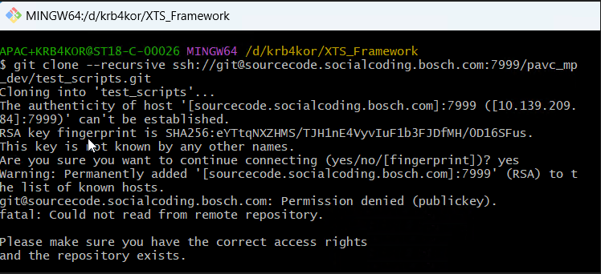

1. **Generate a New SSH Key:**  
   Open your terminal and run the following command to generate a new SSH key using the Ed25519 algorithm:

**ssh-keygen -t ed25519**

1. **Locate and Copy Your SSH Key:**  
   After generating the key, navigate to your SSH directory (typically ~/.ssh/). Open the public key file (ending in .pub) and copy its contents.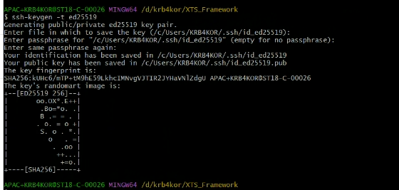
2. **Add Your SSH Key to Your Account:**  
   Go to your Git hosting service’s SSH key management page (for example, GitHub, GitLab, or Bitbucket) and paste the copied public key into the designated field.

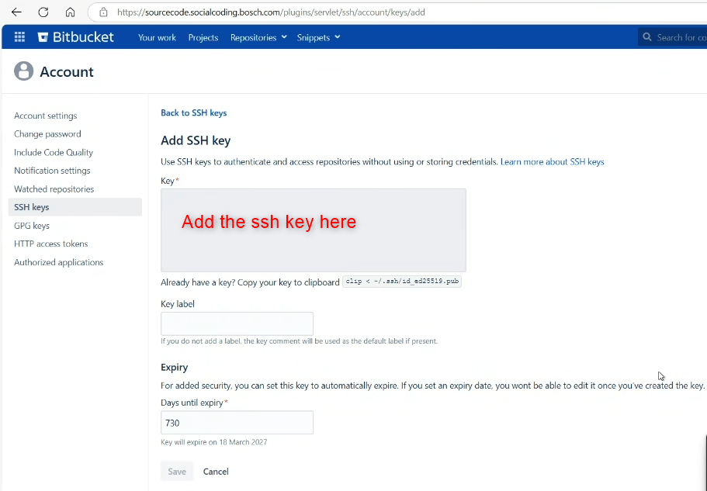

1. **Retry Cloning the Repository:**  
   Once your SSH key has been added, try cloning the repository again.

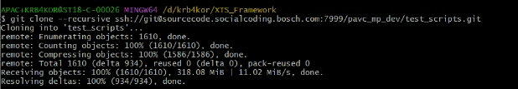

### Steps to Clone

**1. git clone --recursive ssh://git@sourcecode.socialcoding.bosch.com:7999/pavc_mp_dev/test_scripts.git**

**2. cd test_scripts**

**3. git checkout feature/initial_scripts**

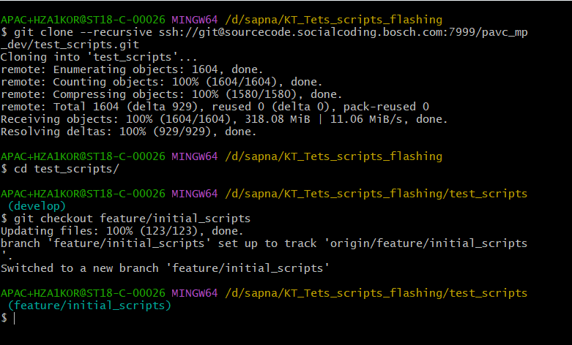

### Requirements

* Ensure the EoL image has been flashed.
* Verify network connectivity by pinging pfe1, pfe2, or eth0.

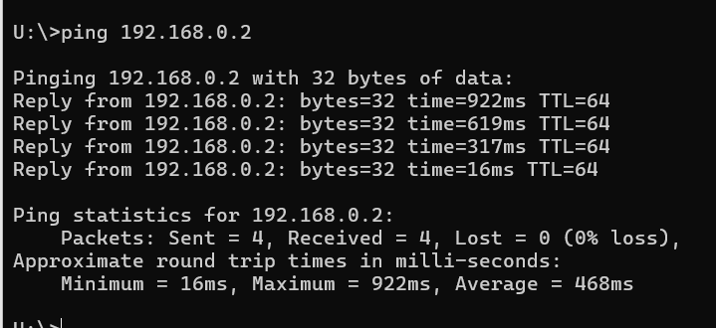

### Test Scripts Information

* a) Hardware Specifications:
* Includes setup IP, board IP, MAC addresses for the target (board) and tester (setup), and payload details.
* Location: test_scripts\tester\VPC-P_Testing_Framework\config\board_specifications\sample-name\hardware_specification
* b) Test Cases (Excel):
* Location: test_scripts\tester\VPC-P_Testing_Framework\config\board_specifications\sample-name\test_cases
* c) Additional Configurations:
* Canoe configuration, CAPPL scripts, and database files can be found at:
* test_scripts\tester\VPC-P_Testing_Framework\config\board_specifications\sample-name\canoe_config

### Script Execution Process

1. Run the build script by executing build.ps1.
2. Reports (HTML and XLSX) will be generated and saved in: test_scripts\tester\VPC-P_Testing_Framework\reports
3. Ensure Trace32 is active by following these steps:

* Connect to the quadspi interface (10C).
* Establish connection to the A53 core.
* Execute the command 'sys.a'.
* Run 'cpu > in target reset'.
* Click the 'Go' (Run) button.
* In PuTTY, when prompted with 'hit any key to interrupt', type 'run initram_boot' (do not power cycle once Trace32 is running).

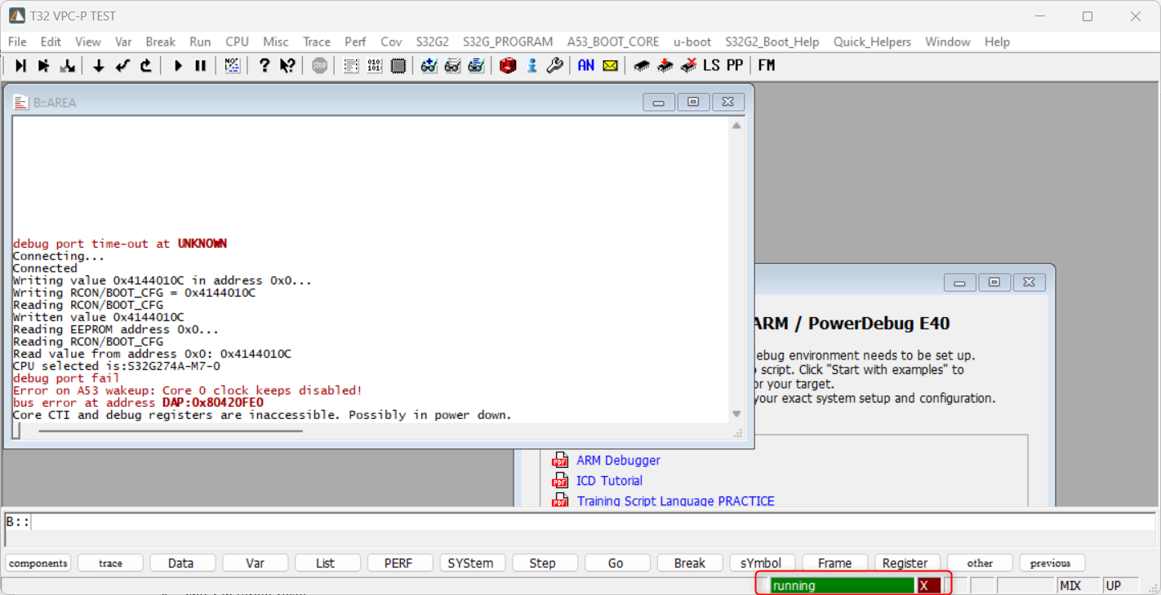

### Running XTS Framework via Automator (Without Flash)

1. Clone the automator repository following the standard procedure.
2. Execute the yocto_tester.ps1 script and select the xts_tests.json file (ensure that power supply/HCS and Trace32 are not active).
3. The build.ps1 script will run and the resulting XTS report will be saved in: test_automation\test_scripts\tester\VPC-P_Testing_Framework\reports

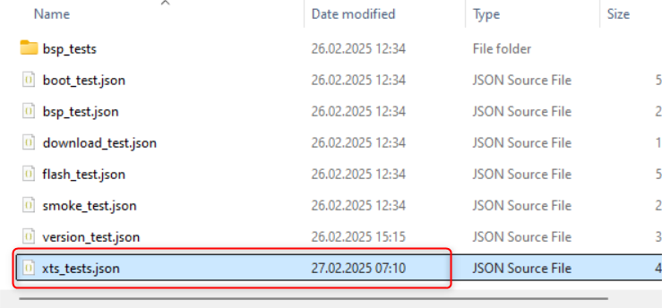

### Running XTS Framework via Automator (Using Flash)

1. Enable the flash option and start the automation process.

