# How to Use Pipe in Linux | Linux TEE and XARGS Command [HINDI]

* Pipes are used to redirect a stream from one program to another program
* Or in simple words, the output of one command is redirected as input to another command
* We use | symbol to separate 2 commands
* Ouput of first command is passed or redirected to second command
* Command1 | command2
* Exercise 1 – find the no of files and folders present in a directory
* Use the command ls -1 | wc -l( don’t use ls -lh or ls -l because it shows an extra line with total that shows how much disk space is used by the items in that directory
* 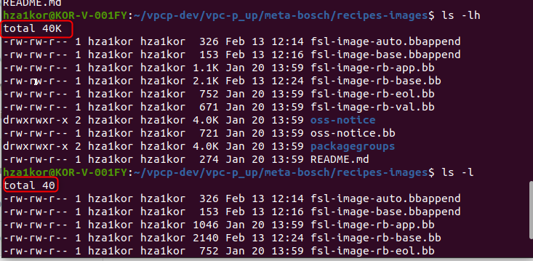
* 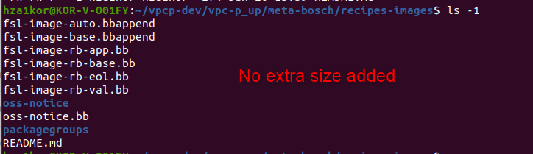
* Exercise 2 – there are 2 files given to you named names.txt and country.txt, you need to merge and sort them
* Command - cat names.txt country.txt | sort
* Exercise 3 – how to find all the unique records from a file
* Remember – to use the uniq command you have to first sort the data
* Command – sort names.txt | uniq **or** cat names.txt | sort | uniq
* Exercise 4 – how to see 30-37th line in a file of 100 lines
* Command - cat names.txt | head 37 | tail 8
* TEE COMMAND – Tee reads standard input and copies it both to stdout and to a file
* Example – if I want to print output to console and also paste it to a file, we can use the tee command – ls -l | tee ouput.txt
* XARGS COMMAND - it converts the standard input into command line argument
* If I run ls command I see the list of files and directories in that directory, say I want to echo it on the terminal, if I just run – ls -lh | echo, we would think this o/p will go as i/p to echo and it will print the list of files and directories
* 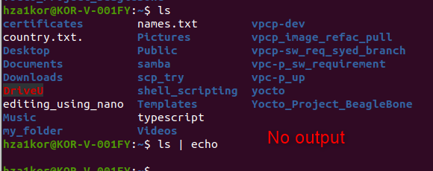
* This is because echo and other commands, only take command line arguments only, now ls will give up a standard o/p, this cant be used as command line argument
* But if I give command as ls | xargs echo , then the stdout of the ls command is converted to command line argument
* 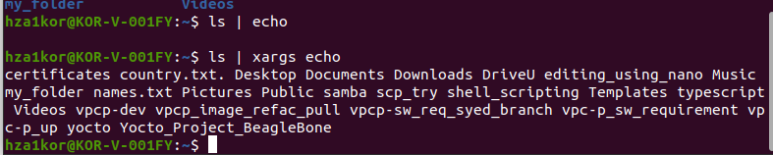
* Exercise 5 – take/ read names from filenames.txt and create those no of files in the directory
* So you will have a filnames.txt which has many filenames, right no those files are not present in your directory, you need to use xargs to read from file and create these files in the directory
* Command - cat filenames.txt | xargs touch
* 