# Linux Redirects | Linux Stdin Stdout Stderr [HINDI]

* Types of redirection

1. Standard input (stdin)
2. Standard output(stdout)
3. Standard error(stderr)

* File descriptors – in linux, a file descriptor is an integer that represents an open file. There are 3 standard file descriptors:

1. Standard input(stdin): File descriptor 0
2. Standard output(stdout): File descriptor 1
3. Standard error(stderr): File descriptor 2

* These descriptors help the system understand here to send or receive data

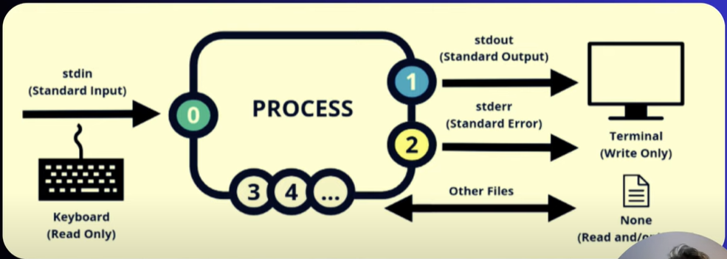

* Output(stdout- 1) – output of a command is shown in terminal
* To route output in a file using > - hostname > filename
* To append output in existing file using >> - pwd >> filename
* To copy contents of 2 files into a third file – cat file1 file2 > file3
* > is file descriptor 1, so if you get errors, you cant use > sign, because this will only redirect the o/p not the error, to redirect the error you need to use 2>
* Error(stderr- 2) – if any command gives you error then it is considered as stderr.
* We redirect the error to a file – cd /root/ 2>error_file
* Note that 2> will only redirect the error not the o/p, so if you try doing – ls 2> files.txt, this will not redirect the stdout, it will print the o/p on the console itself,
* So if you want to redirect boot o/p and error into a file use – cd /root/ > error_file 2>&1 or cd /root/ &> errors.txt, this will append both o/p and error into the same file
* Input(stdin -0) – input is used when feeding file contents to a file
* Example – cat < file_name or cat << EOF (I don’t get this)