# What Is Linux File System in Hindi? | Linux FileSystem Explained for Beginners [HINDI]

* Os stores and manages data on disk or partitions using a structure called filesystem
* Filesystem includes files, directories and its related permissions
* Linux stores data in heirarchy of directories and files
* 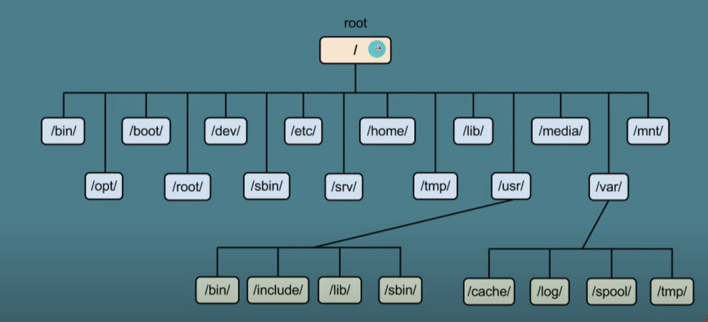
* In windows path is saved using backslash(\) and in linux path is saved using forwardslash(/)
* Example – windows - C:\Program Files\CMake
* In linux path - /etc/ssh
* Linux is case sensitive so you can make file as well as File
* And linux doesn’t care about extensions so you can create files without any extensions and it will work, not like windows
* The different type of file systems are –
  + Ext3
  + Ext4
  + XFS(extended file system) like ubuntu, Debian, fedora, centos, redhat
  + BtrFS(B-tree file system) like OpenSUSE and SUSE Linux enterprise server
  + FAT(File allocation table)
* To check which file system you are using you can use the below commands –
  + lsblk -f
  + df -Th
  + cat /etc/fstab
* The difference between xfs and ext4 is
  + XFS is optimized for large files and volumes offering superior performance and scalability
  + Ext4 performs well across various file sizes but less efficient with extremely large files
* For high throughput and extensive parallel processing capabilities , XFS is typically more efficient than ext4
* Inode – an inode in linux is a data structure that stores metadata about a file or a directory
* The filesystem uses the inode number to locate the file/directory which then contains pointers to the data blocks here the actual file data is stored
* To check the inode numbers use – ls -li | grep filename
* /(root) directory – the linux filesystem starts at the root directory, denoted by a single slash(/) from which all other files and directories branch out
* /bin – contains essential user binaries(executables) such as common commands like ls, cp etc
* /etc – holds system configuration files, eg – user, network, services, systemapps
* /home – contains all personal directories for all users
* /root – the home directory for the root user
* /var – where variable data such as logs and databases are stored
* /tmp – temporary files created by system and users
* To get information about all the different users – less /etc/passwd
* To get info about the DNS(Domain name system) server – cat /etc/resolv.conf
* To get info on all the boot logs, system logs – cd /var
* /boot – holds files needed for system boot up, including the linux kernel, an initial ram disk image, bootloader configuration like GRUB
* /dev – this directory contains device files which represent and provide access to hardare devices such as hard drives, sound devices etc
* /lib, /lib64 – these directories contain essential shared libraries and kernel modules that are needed to boot the system and tun the commands in the root file system. The /lib64 directory exists on systems that support 64-bit applications
* /media – this is the mount point for removable media such as USB drives, CD-ROMs. when these devices are mounted typically directories corresponding to their mount points are created within /media
* /mnt – similar to /media this is a traditional mount point where system administrators can mount temporary filesystems while using or configuring them
* /opt – intended for the installation of add-on application software packages. Large software packages that are not a part of the default installation can be placed here to avoid cluttering the system directories
* /proc – a virtual and dynamic directory as it only exists in memory. It does not use disk space. It contains information about system resources, hardware and running processes. It’s a pseudo filesystem that provides an interface to kernel data structures
* /run – a temporary filesystem, that stores transient state files, like process ids or lock files since it is cleared and recreated at every boot
* To get info on cpu info – cat /proc/cpuinfo
* To get info on memory info – cat /proc/meminfo
* /sbin – contains binary(executable) files that are mostly needed by the system administrator. These include system management commands like fdisk, shutdown, ip etc
* /srv – contains data which servers hosted on the system may need, such as web pages served by web server
* /sys – similar to /proc, this is another virtual filesystem that provides an interface to the kernel. It contains information and settings about the system’s devise, drivers and some kernel features
* /usr(unix system resource) – considered the secondary hierarchy because it contains all user applications and a variety of other things for day-to-day operations, including libraries, documentation and much more. Subdirectories include /usr/bin, /usr/sbin, /usr/local and /usr/share among others