**Linux File Permissions For Beginners [HINDI] | Linux CHMOD Command**

* If you want to check the permissions of a file or directory run – ls -l or ls -ltr
* Each file will have a set of permissions like read®, write(w) and execute(x)
* r means the file is readable
* w means the file is writable
* x means the file is executable
* - means no permission
* And these permissions are given to 3 set of users.
* The owner, group and others
* If you are not able to use cd foldername and the error states permission denied, then check who is the owner and who has the group permission, if you are not the owner and you are not the group user, if you are other, then you need execute permission, add the execute permission, because to run cd command, execute permission is needed
* Add the execute permission and then cd command will work
* Basic command to modify permissions of a file
* Command – chmod <name>+rwx filename
  + u means user
  + g means group
  + o means other
  + a means all
* to remove permission use chmod <name>-rwx filename
* to use these commands you have to make sure you are the owner of the file or directory, if you are not the owner then you wont be able to modify the permissions of the file
* to check who is the owner and the group owners when you run ls -l, the 3rd and 4th column shows the owner and group owner
* 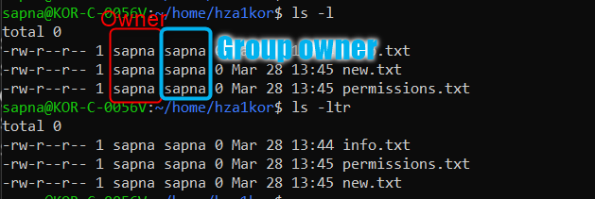
* Say you have a file named specifications.txt and you don’t want any other use to be able to read, write or execute this file then you can run – chmod o-rwx specifications.txt
* Or say I want owner to have rwx, group to have rx and other to have no permissions then run – chmod u=rwx, g=rx, o= specifications.txt (keep the other field empty)
* Say you have a main directory named test_dir and inside it you have 10 files test_1, test_2 .. test_10, you want to change the user permissions of test_dir and all these files inside test_dir at the same time then we use the recursive option –
* Say I want user permissions to be changed to rwx at once run – chmod -R u=rwx test_dir
* 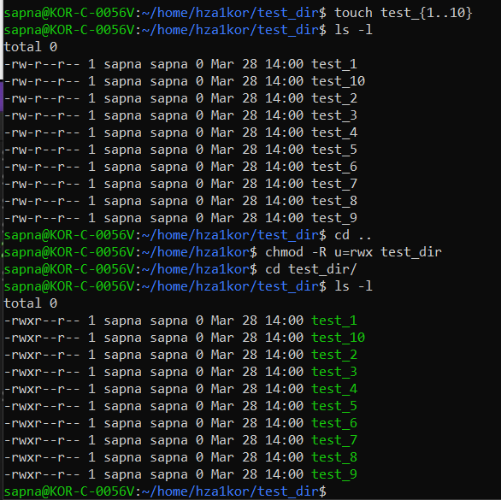
* **T**here is another way which is the numerical or octal method to change the file permissions
* Read is 4 write is 2 and execute is 1, so if you give chmod 777 file.txt that means you are providing all permissions for all users, rwx for owner, rwx for group and rwx for others
* Say I give chmod 644 file.txt means owner has read and write permission, group and others have only read permission
* To remove all permissions for all users In one go – chmod 000 file.txt
* To change the owner or group owner use the command chown new_user:new_group filename
* Here chown means change owner, if you only want to change the owner, then just add the new owner name, keep the group owner as it is, if you want to change only the group owner, then keep the owner as it is and only change the group owner
* Note that you can perform these operations only if you are the owner of the file
* Another way to change the group owner use chgrp <new_grp_owner_name> filename