**Linux Access Control List (ACL) | Linux File Permissions Using getfacl & setfacl**

* ACL allows you to give more specific set of permissions to a file or directory without changing the base ownership and permissions meaning we are not really modifying the current permissions, just providing a special permission to only one user, say I want only sampreeth to have permission to read or write but he is not owner or group owner, then if I add read and write permissions to others, anyone would be able to read and write, so to avoid this mess and give permissions to a specific user or group we can use setfacl command
* Command - setfacl and getfacl(set file ACL) and (get file ACL)
* Say you want to write a string into multiple files in one go use the tee operator - echo "hello world" | tee test_{1..10}
* You can get proper details of a file like the filename, owner name, group name, and permissions using getfacl command
* But to use getfacl, setfacl you need to install acl pkg using command – sudo apt install acl
* 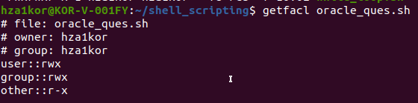
* To add permission for only one user – setfacl -m u:username :rw filename(here -m means modify)
* 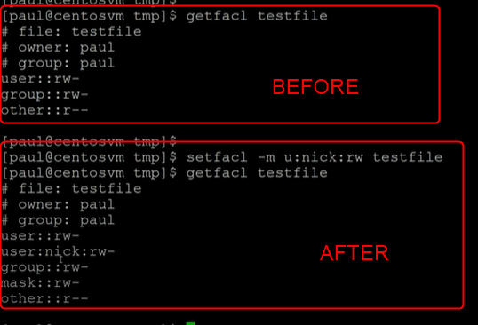
* In the above example earlier owner had rw, group had rw and others had only r, then we ran the command saying add another owner named nick with permissions rw, so now owner has rw along with it owner nick has rw permissions
* But note that setfacl can only be performed by the owner, so in the above case, paul has given nick rw permissions
* Similarly we can add permissions for a group as well
* Using command setfacl -m g:group_name:rwx filename
* 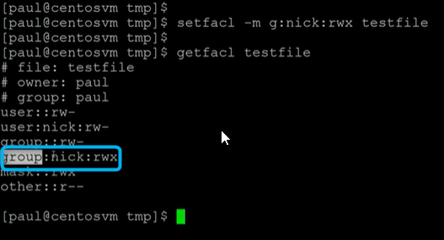
* To remove permissions for a specific user or grp
* Command for user – setfacl -x u:user_name:rw filename
* Command for group – setfacl -x g:group_name:rw filename
* 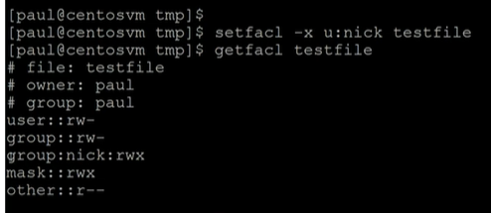
* To remove all entries of users and groups in one go use command – setfacl -b filename
* 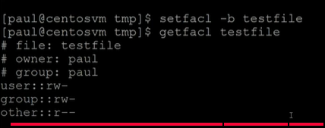
* To add permission for a specific user but for all the files inside a folder, instead of adding setfacl for each file, we can do it in one go using – setfacl -Rm u:username:rwx filename
* 