**Linux DISK SPACE Monitoring Commands - DF DU FREE [HINDI]**

* df command shows information about the file system
* we can use df -h command
* where -h means human readable
* 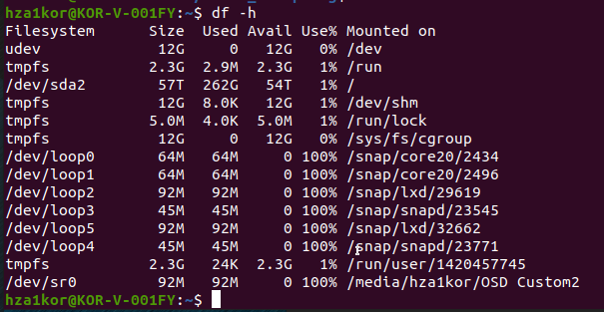
* du command is used to summarize usage of the set of files recursively for directories
* you can run du -h name/path command to check the disk usage of a folder/file
* 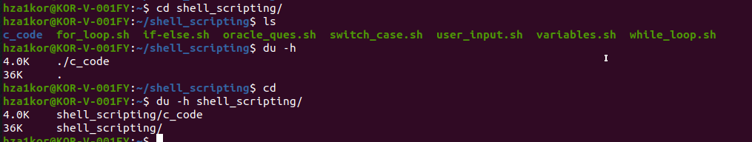
* Note that when you run du -h folder_mame it only shows size of the directories and directories inside it, say I want to see sizes of all the files as well, we can run du -ah folder_name (-a means all)
* 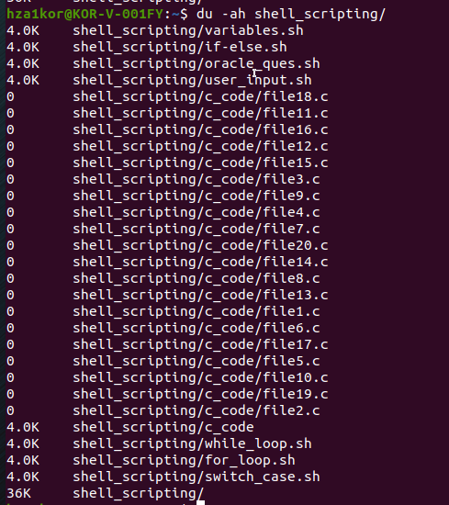
* free command is used to display the amount of free and used memory in the system
* we can run free -h command
* 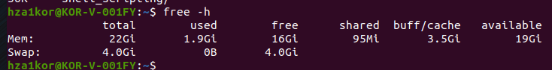
* **df and du:** These commands report on your disk usage. They show how much space is used and available on your physical storage devices (like your hard drive or SSD). This storage is non-volatile memory that holds your files permanently.
* **free:** This command shows information about your system’s RAM (Random Access Memory), which is volatile memory used by your computer for running processes.
* **S**ay you are deploying something on server, and you want to constantly check how much memory is being used, then you can use free -s <sec> where sec is after what time you want to keep refreshing memory
* Say I want to check the new memory after every 5 sec, then free -s 5
* Example for check memory after every 1sec, this will run infinitely till you stop it
* 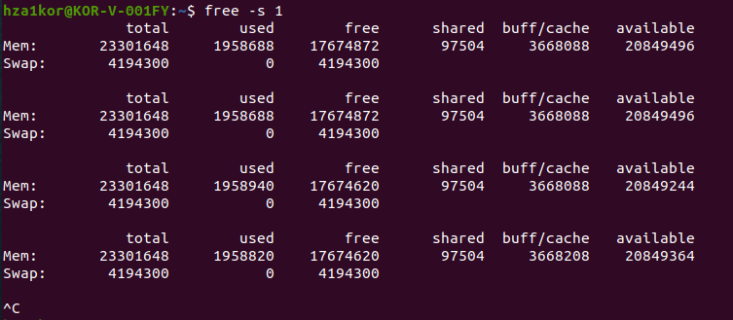
* And if you want to exit after sometime, then free -c <secs> where secs means exit after this time, like free -c 5 means exit after 5 sec
* In the below example for each sec, it will print and after 5sec are done, it will exit
* 