**How to use the PS command in Linux | What is PS command | What is PS -ef?**

* ps (process status) is used to display all the running processes in linux system
* 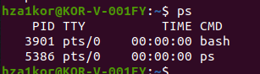
* Here bash is the current shell we are using to run the ps command, and because we ran ps command , a process is created for this command with PID 5386
* PID means the unique process ID
* TTY means the termimal type
* Time means the amount of cpu in hr:min:sec that process has been running and cmd is the name of the command that launched the process
* ps only shows processes running on one shell, to see processes running on all shells, we can use ps -e or ps -A, both are the same
* 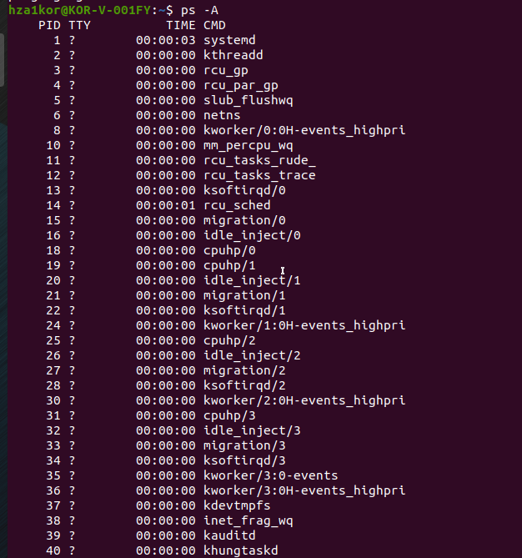
* We can also use ps -Af for detaild info about the processes
* 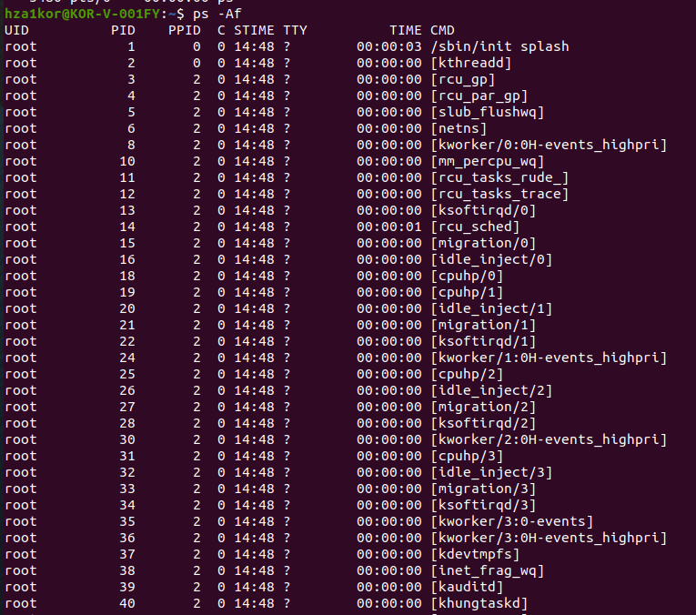
* To see all the running processes in BSD(Berkeley Software Distribution) format use ps aux, this shows the cpu usage, memory usage as well
* 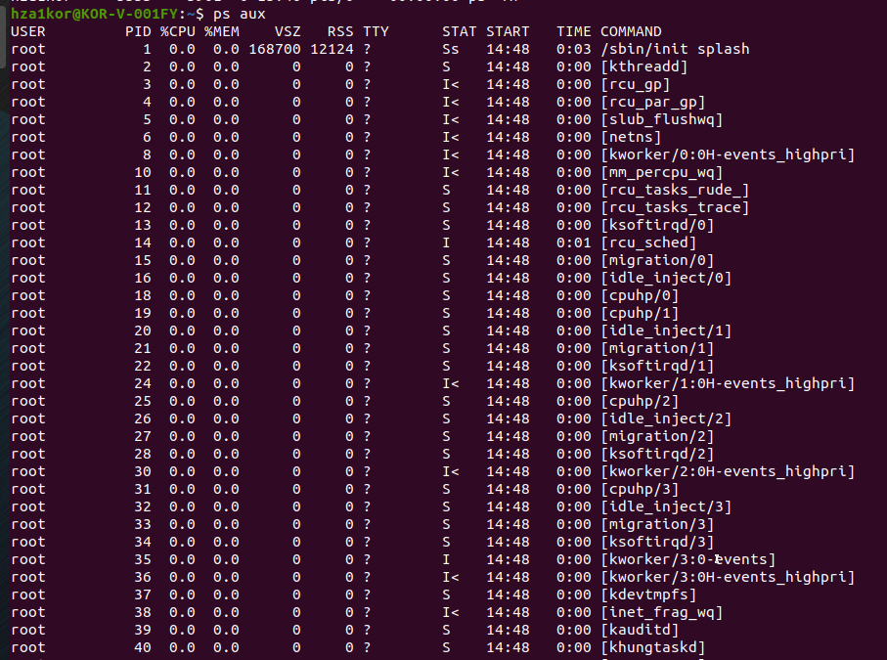
* To check if a particular process is running or not, use ps aux | grep process_name
* 
* 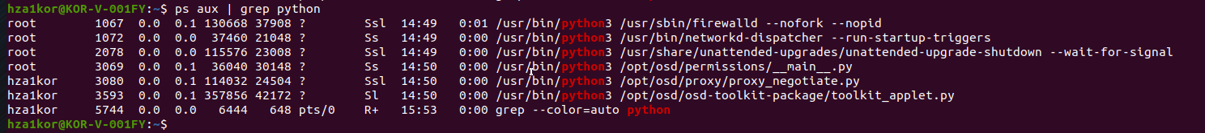
* To see all the process associated with a user or a group use
* For user – ps -u user_name
* For group- ps -G group_name
* 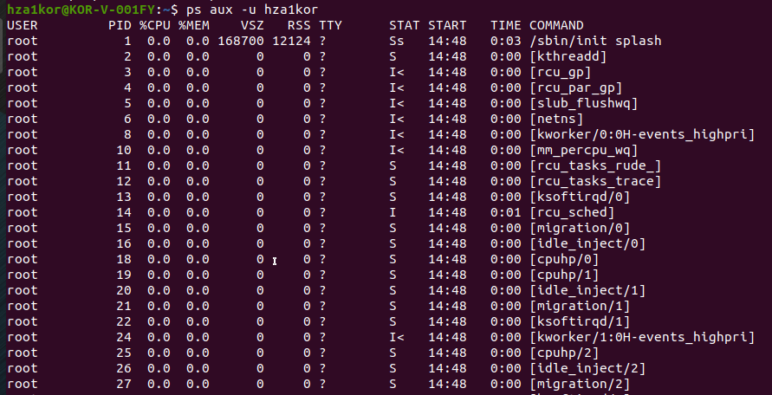
* To see an entire process tree, like the main process, and all the sub processes running inside use ps -ejH
* 
* Inside bash there are 2 subprocesses running named bash and whiptail
* 
* To get the tree for one process –
* Command – ps -ejH | grep process_name