**How to Use Kill Command? | Linux Kill Command Tutorial in Hindi | MPrashant**

* Kill command is used to terminate a process manually
* Syntax – kill [OPTIONS] [PID]
* Here OPTIONS is the signal name or number and PID is the process ID
* To see all the signal names use kill -l
* 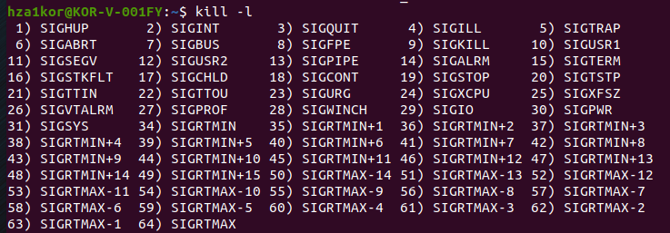
* To kill a process kill PID
* To restart a process – kill -1 PID
* To interrupt from keyboard like ctrl +c use kill -2 PID
* To forcefully terminate a process – kill -9 PID
* To kill a process gracefully – kill -15 PID
* Note that you cant kill someone else’s process, for that you need to be the root user