**Top Command: A Linux Command for Quickly Seeing What is Running on Your System**

* The top(table of processes) command shows real time view of running processes in linux and displays kernel-managed tasks
* The command also provides a system information summary that shows resource utilization, including CPU and memory usage
* 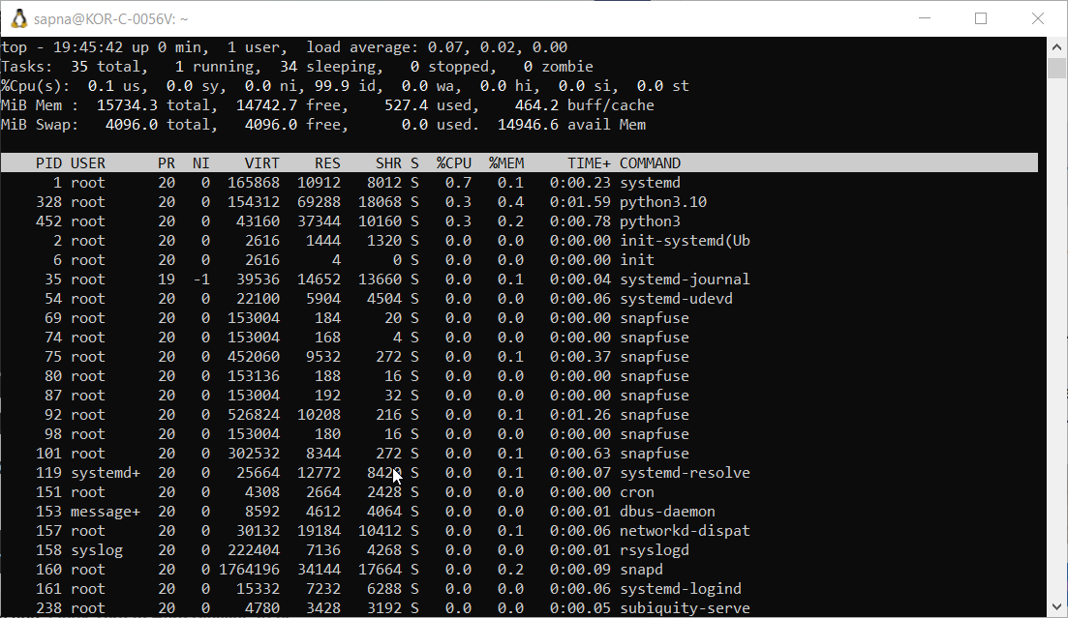
* When you run the top command, in the top you see a summary where you have all the total tasks, the running tasks, sleeping tasks, zombie tasks
* Cpu and memory usage are shown as well
* Below we can also see cpu and memory utilization for each process
* To check the absolute path of the commands, first type top and enter, you will see all the processes then press c, all the commands actual path will be displayed
* 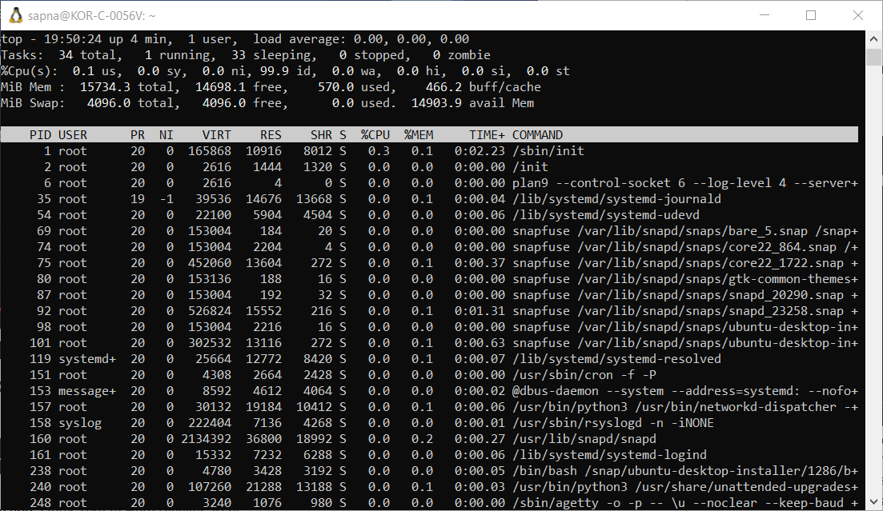
* To kill a process, first type top, enter, then press k, it will ask you which PID you want to kill, give the id, then for signal press 9 to forcefully kill the process
* 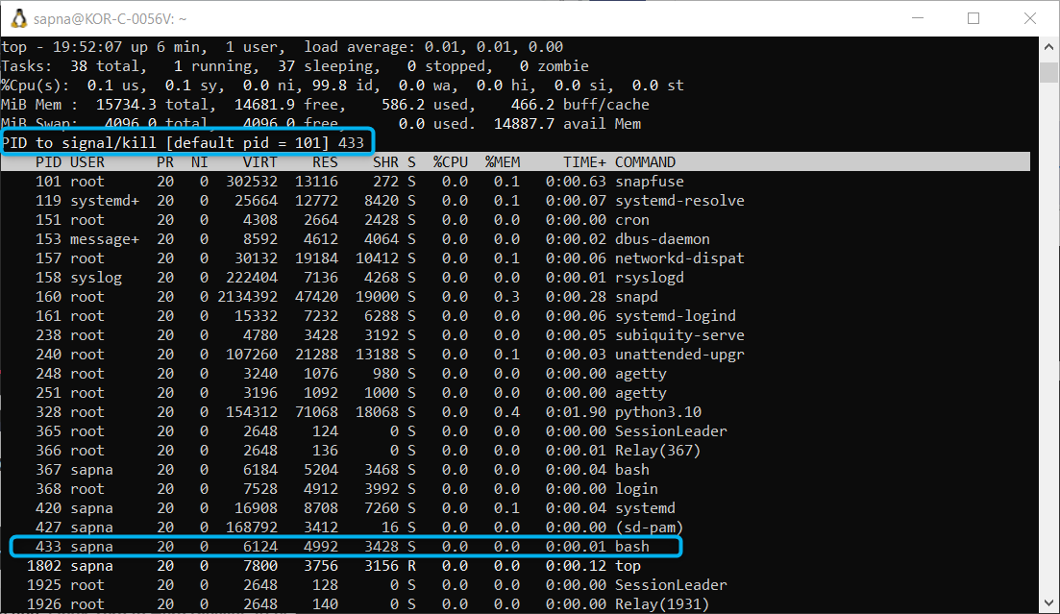
* 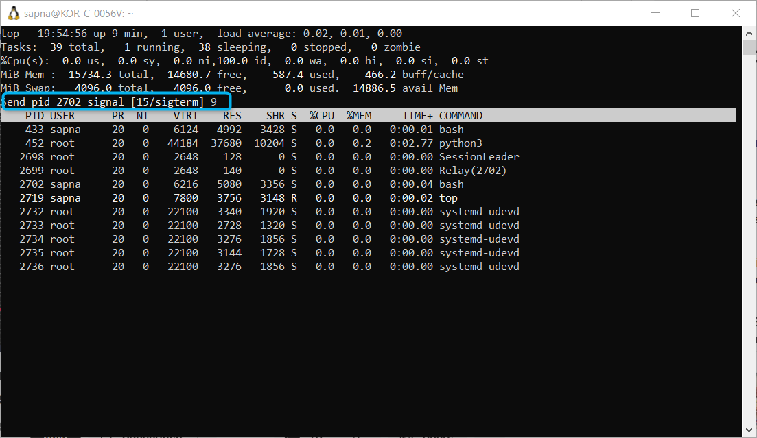
* To only show a certain number of processes on the screen, because there are many processes appearing you can again enter top, then enter, then press n and give the number of processes you want to see
* 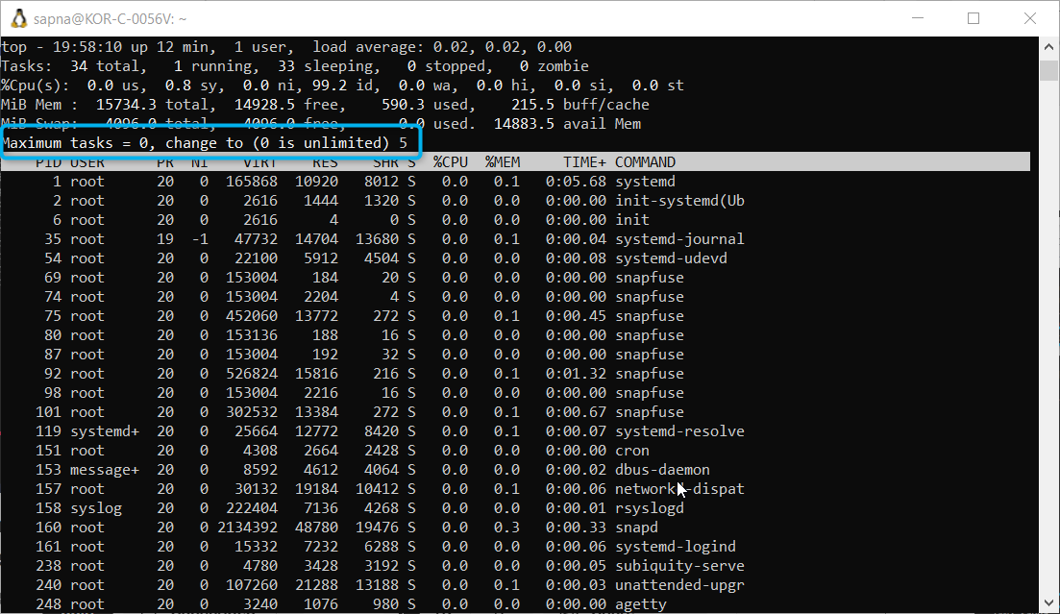
* Now only 5 processes are shown
* 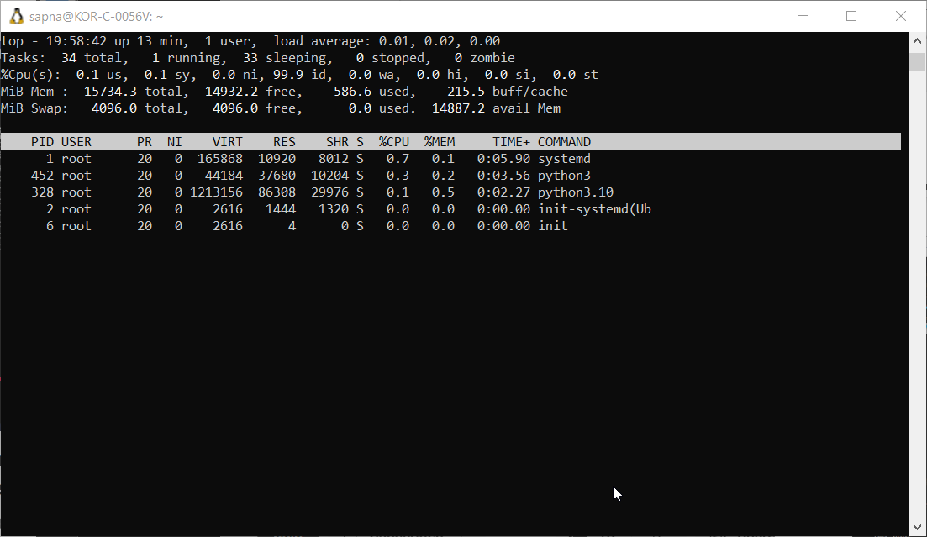
* By default every 3sec the processes are refreshed, if you want to change this and refresh at a slower or faster rate you can us top then enter, then press s
* 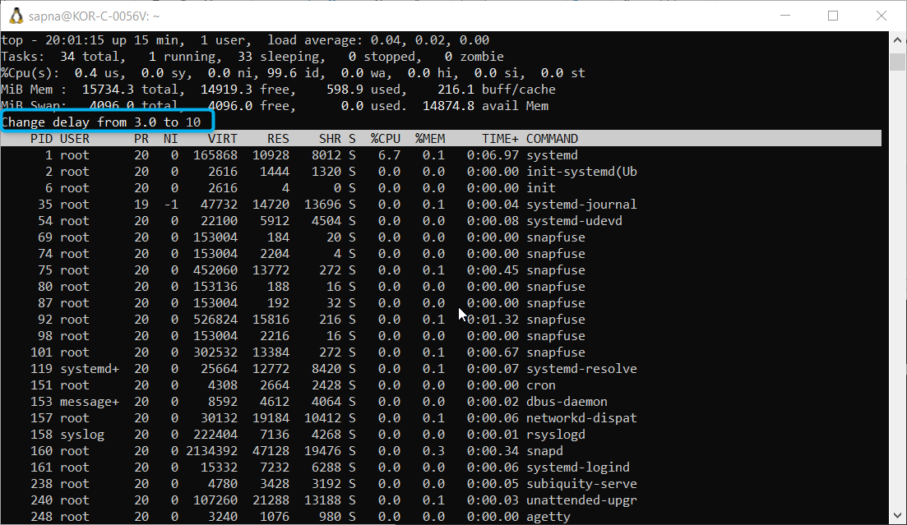
* Now after 10sec the processes will be refreshed
* If you want to sort the processes based on the memory usage – top – enter – m
* 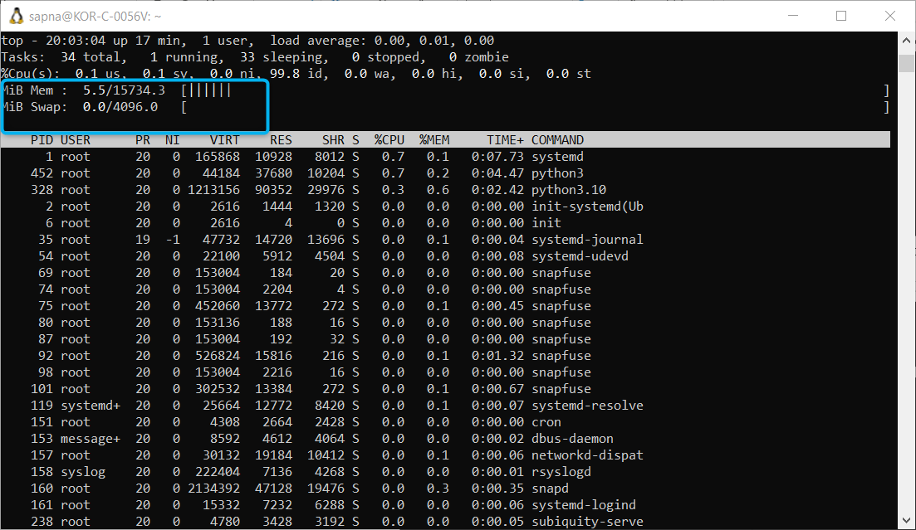
* Nice value tells you the priority of the process, the lesser the nice value the more the priority
* We can change the nice value by a process using top – enter – press r
* Currently the nice value of PID 433 is 0, we can assign it to any other value
* 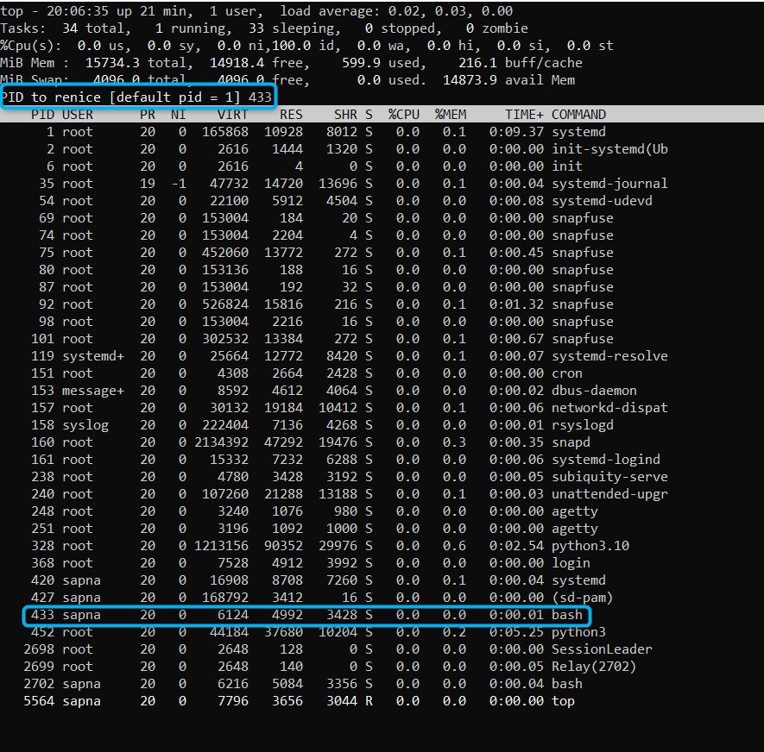
* Now I have tried to renice it to 5
* 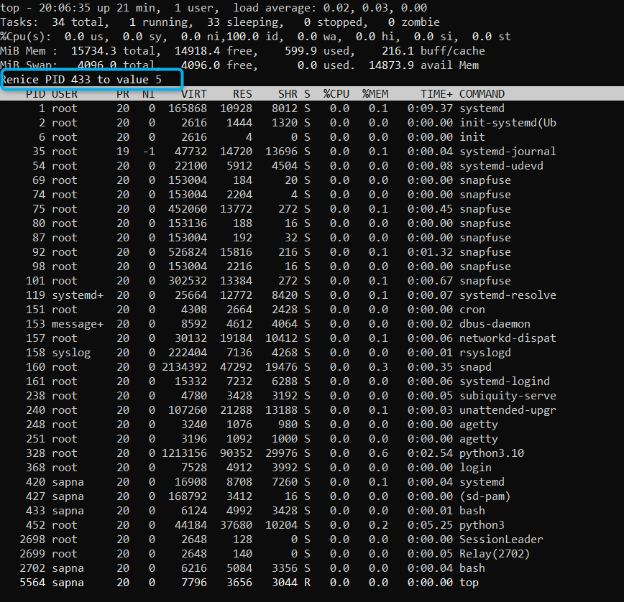
* Now the nice value for 433 process id is 5
* 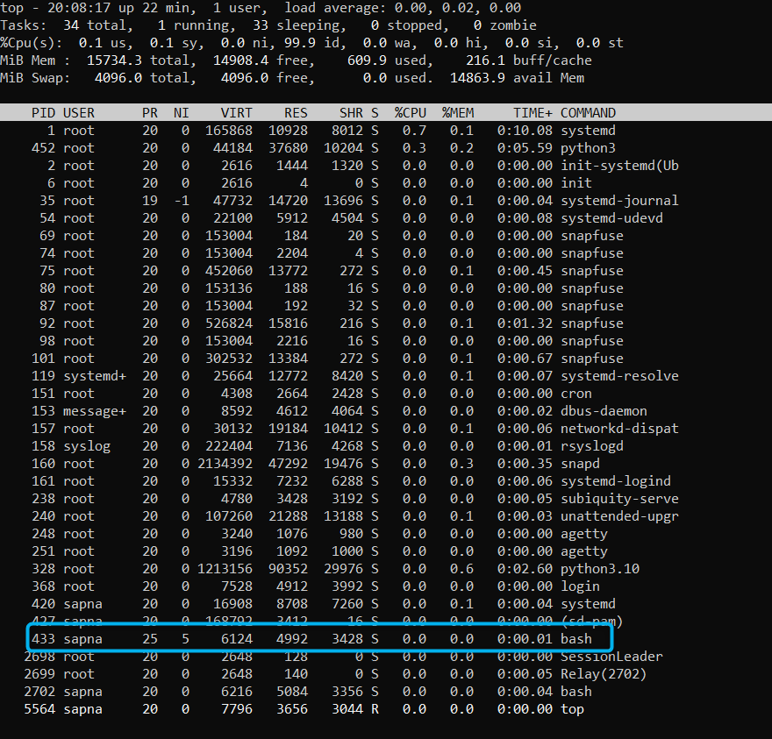
* Say currently top shows processes for all users, if I only want to check for a specific user, use top – enter -press u
* 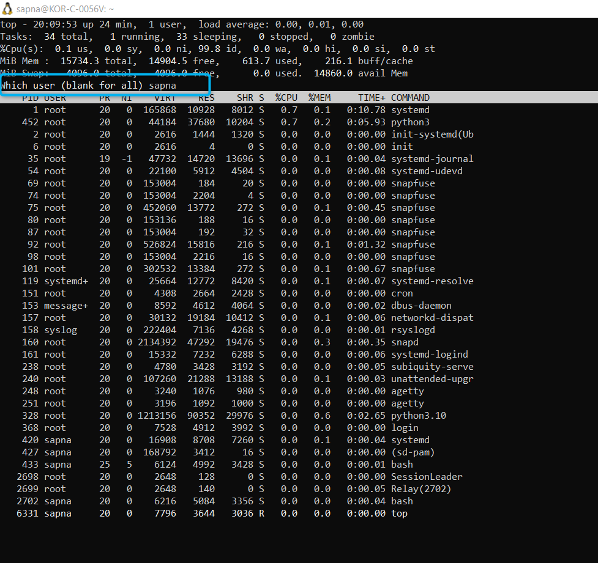
* Now we will only see processes of **sapna**
* 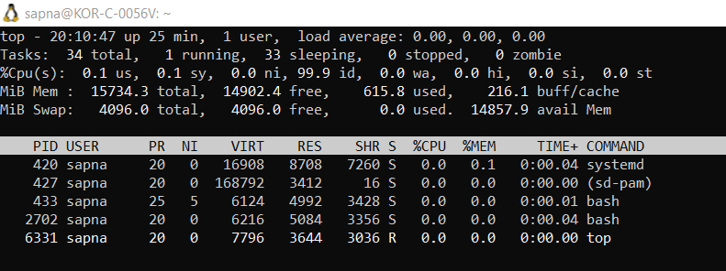’
* To get info on which commands to use for which action we can use help, top – enter – press h
* 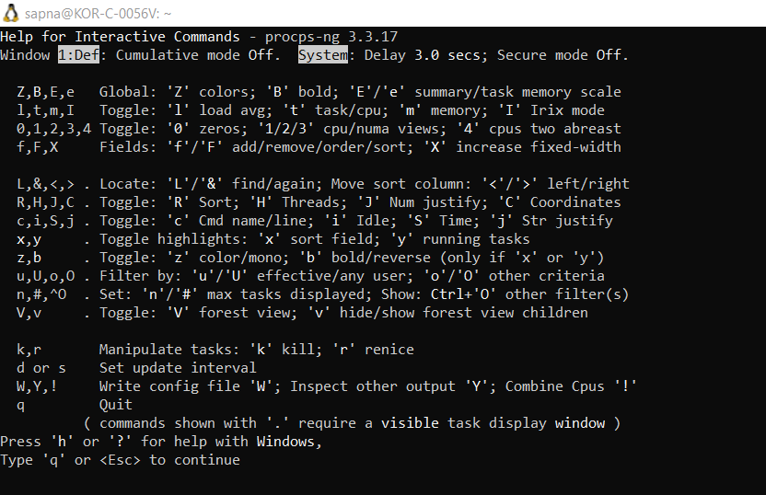
* When we run the top command we have so many columns like PID, USER, PR, NI, VIRT, RES, SHR, %CPU, %MEM, TIME+COMMAND say I just want a few fields like - PID, USER, NI, %CPU, %MEM, TIME+COMMAND, first type top, then enter, then press f, here you will have info on all the fields that are added, which will be displayed with *, there will be many other fields as well, that you can add, say I want to remove the current fields shown, go to that field, and press space, the * will be removed then press q
* 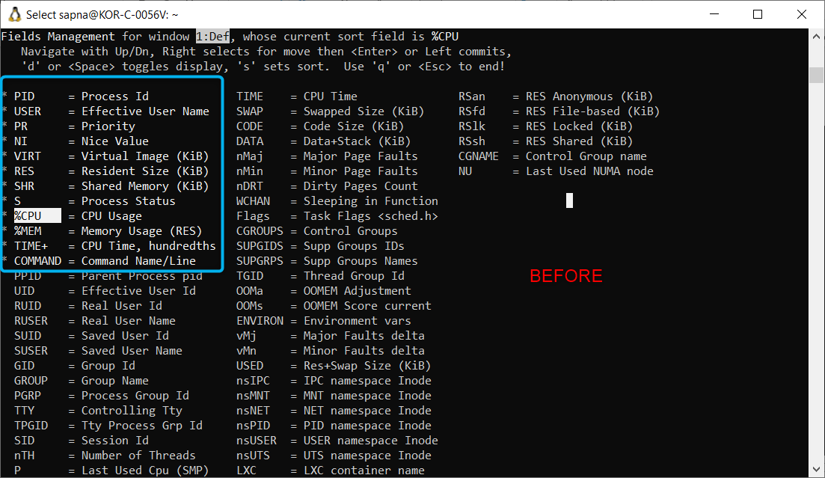
* 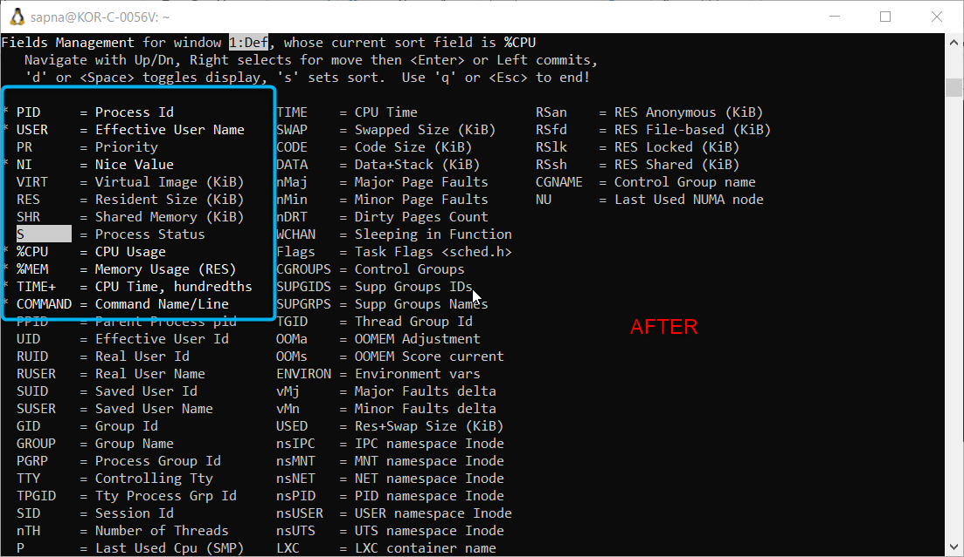
* 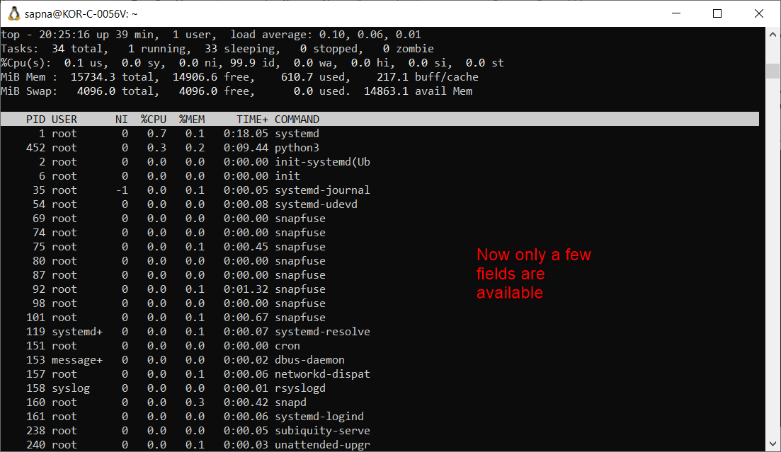
* All the other shortcuts that you can use
* 