**Linux AT Command | Schedule Task in Linux To Run at Once | Linux Basic Commands for Beginners**

* At command can be used to schedule a job only once
* Name of the service is atd
* To create a job use – at HH:MM month/day/year

Example say I want to start a job at 8 pm on 1st April 2024 and now the time is 20:02, we can do it using command – **at 20:04 04/01/2025**

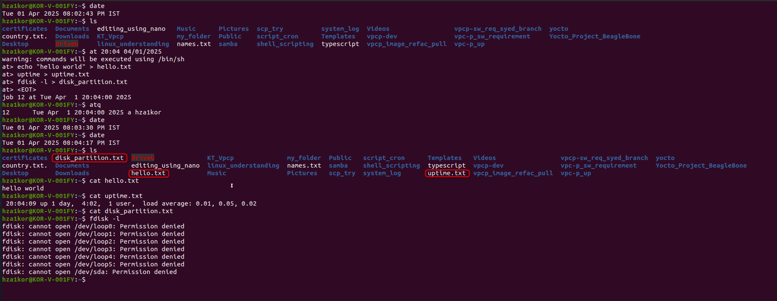

* To list all the at jobs – atq
* To remove all the pending jobs – atq | awk '{print $1}' | xargs -r atrm
* To delete a particular at job we can use – atrm <id>
* 