**Master Linux Anacron: Schedule Tasks on Your Terms | Anacrontab | MPrashant**

* Anacron is a linux utility that executes scheduled tasks periodically even if the system is not running continuously
* Anacron is suited for systems that donot run 24/7
* To check if anacron is present or not you can run any of the below commands –
  + dpkg -l | grep anacron
  + cat /etc/anacrontab

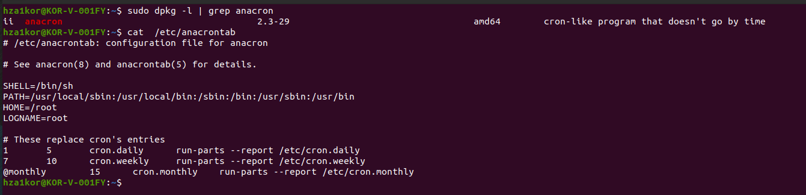

* if anacron is not installed, you can install it using sudo apt install anacron
* if you want to schedule your tasks using anacron tab, you will have to modify the /etc/anacrontab file
* if you look at the content of anacrontab we see
  + a few environmental variables are set like SHELL, PATH, HOME and LOGNAME
  + To define a task we have to follow the same format as bellow
  + 1 5 cron.daily run-parts --report /etc/cron.daily
  + 1st is the period in days, which means in how many days you want to keep running the task, here its 1 means every day run the task
  + If period is 7 days means run it every week
  + 2nd is the delay in minute, means once anacron is triggered, after how much time this task should be executed
  + This is helpful when you have multiple tasks, say I have all tasks at exactly 0th sec once anacron is triggered, then all the tasks will be triggered and there will be a lot of load on the server
  + To avoid this we give a delay time, here the delay is 5 mins , meaning after 5 mins trigger this task
  + In Prashant’s video he also had a variable START_HOURS_RANGE which means trigger anacron from hours 3-22, but in my anacrontab file there is no such variable
  + 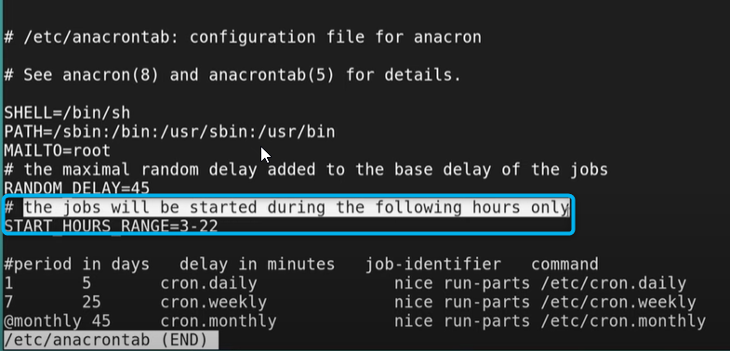
  + He also has RANDOM_DELAY variable means say there are multiple tasks with the same delay then RANDOM_DELAY will give one more priority and execute within the same delay time and some can have more delay till the RANDOM_DELAY value
  + Then the 3rd value is the job identifier, means how do you identify this job, you can name it like cron.daily, cron.weekly, cron.monthly anything that you like
  + The 4th value is the command
  + Say I want to create a anacrontab which executed every fifteen days once, with delay of 5 mins, job identifier as backup_trigger and command as /home/hza1kor/backup/backup.sh
  + Then the command would be - **15 5 backup_trigger /home/hza1kor/backup/backup.sh**
  + 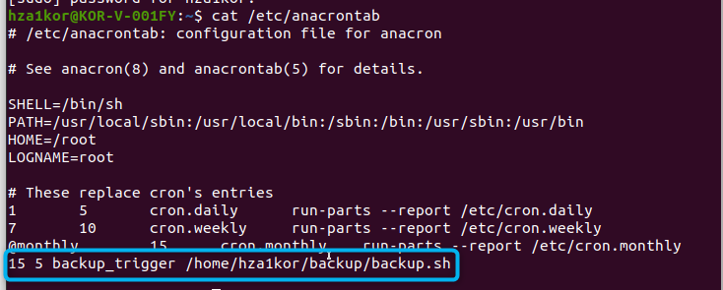
  + Then save this command in /etc/anacrontab
  + Here backup.sh is a simple script whose job is to find all the powershell scripts in /home/hza1kor and save it in /home/hza1kor/backup folder

**#!/bin/bash**

**# Find and copy all .py files from /home/hza1kor to the current directory**

**find /home/hza1kor -type f -name "*.ps1" -exec cp {} . \;**

**echo "Backup complete!"**

* Say you don’t want to wait for so long, like 15 days, you want to trigger it now itself, then just run sudo anacron -fd
* -f means forcefully and -d means debugging
* 
* Say you don’t want to wait for 5 mins or 10mins or 15 mins, and want to start the jobs right now then run **sudo anacron -fdn**
* Also if already anacron jobs are running you will get this o/p
* 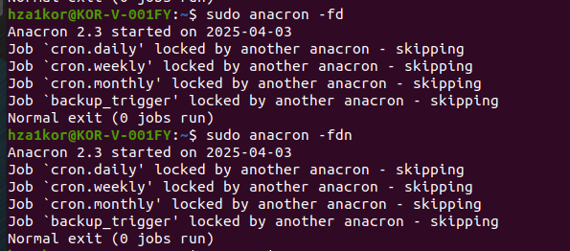
* Then you will have to kill the existing anacron jobs first check all the anacron process using ps aux | grep anacron
* 
* Then kill all these processes and run **sudo anacron -fd/-fdn again**
* 
* Somehow sudo anacron -fdn is not working for me
* 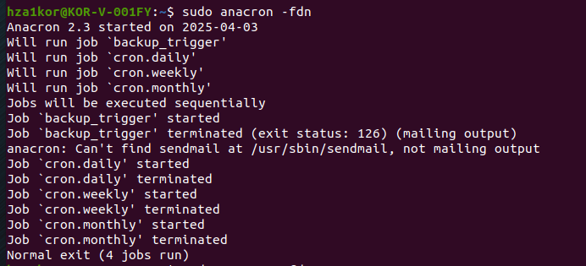
* To debug we can also look into cat /var/logs/syslog folder 0r run the command - grep CRON /var/log/syslog
* 
* But I don’t see any info related to backup.sh or backup_trigger
* Anacron can be used for
  + Daily system backups
  + Weekly log file cleaning
  + Monthly reports generation
  + Software updates
  + Database maintenance

