**How to Use Linux Ping Command to Troubleshoot Network Issues | Ping Command Tutorial in Hindi**

* Ping stands for Packet Internet Groper
* Ping command is used to
  + check network connectivity
  + check internet connection
  + check network interface card
  + check latency on network
  + DNS resolution
* How does ping command works
  + We run the ping command
  + Example – ping 192.168.0.2

Ping uses ICMP(Internet control message protocol) to send an echo request packet to the server(192.168.0.2)

* + The server receives the ICMP echo request and replies with an ICMP Echo reply
  + Your computer measures how long it took to get the reply(called round-trip time or latency)
  + You see o/p like this - **64 bytes from 8.8.8.8: icmp_seq=1 ttl=119 time=20.3 ms**

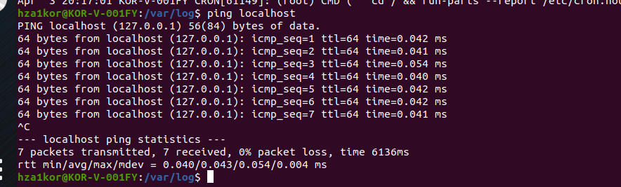

* + It keeps sending packets till you stop it using ctrl+c or provide the cound using -c
* If the o/p of ping is a timeout or server unreachable then these could be the reasons
  + Server has a firewall due to which you are unable to connect
  + Server could be down
  + Your setup would not have internet connectivity
  + If a few packets are received but not all, then this could be due to network traffic
* If you want to send only certain no of packets – ping -c <number> <ip>
* By default the time interval for sending packets is 1sec, so after 1sec packets are sent, say I want to change it 5 or 6, then – ping -i 5 <ip>
* To only see the summary and not the icmp_seq, time then run ping -q -c 5 <ip>
* Say I want to send packets as fast as possible to test the network performance, then we can use – ping -f <ip>
* To change the size of packets(in bytes) – ping -s <size> <ip>
* To stop the pinging after certain time – ping -w value <ip> (say I give ping -w 10 192.168.0.10 then after 10sec the packets will be stopped sending, else if we just normally run ping 192.168.0.2 it will keep sending packets till you terminate it)
* To also save the timestamp values – ping -D <ipaddress>
* To listen to sound when packet is sent – ping -a <ip_address> it will just beep when packets are sent