**How to Use Linux Netstat Command to Troubleshoot Network Issues | Netstat Command In Hindi**

* Netstat stands for network statistics tool
* Netstat is a command line tool used to get info related to network
* Netstat is used for -
  + It shows information related to different network protocols like TCP, UDP
  + Shows information related to the connections on the linux server
  + It also shows information related to ports and routing tables
  + Shows info related to the different network interfaces
  + Info on network protocol statistics
* **Case 1** – I want to test connectivity with apache server, but somehow the connection is not getting established, so I first test the ping, and ping works, so I get the echo replies, that means server is accessible, so now we should check the PORT NUMBER
* We know that server is listening on PORT 12345, so we have to make sure that on our end is PORT 12345 available, or is it being used, you check check it using netstat -anp | grep 12345
* 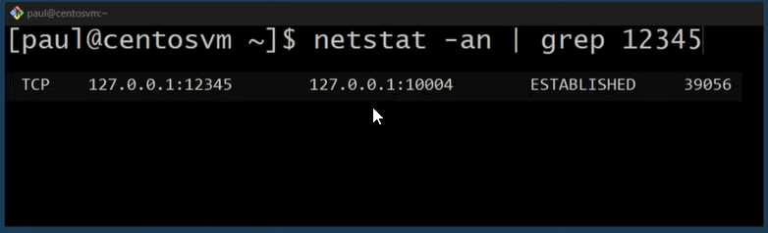
* If the port is already being used, we can kill this process that is using port 12345
* Now when we try to access the apache server we are able to do it
* **Case2 –** say if the ping is working, the port is free, but I can still not access the web server, what to do then
* It is possible that the we server could be down
* Or the web server would be listening on a different port
* Command to identify the number of connections on a given port or ip – netstat -putan | grep <PORT/IP>
* p means show the PID
* u means all the udp connections
* t means all the tcp connections
* a means all connections and listening ports
* n means show the numerical address
* example – command to print all the connections established on port 22(ssh port) – netstat -putan | grep :22
* 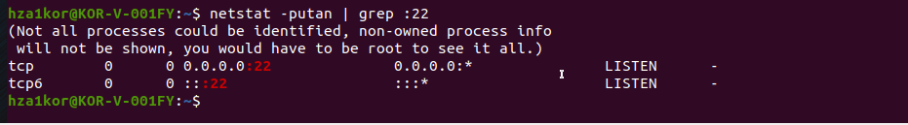
* Command to list all the listening ports – netstat -l
* Command to print all the listening and connected ports – netstat -a
* Command to print only tcp connections – netstat -at
* Command to print only udp connections – netstat -au
* Command to print tcp version 6 info or udp v6 info – netstat -at6 / netstat -au6
* Command to print the numerical address/ip address – netstat -an
* Command to view the pid of the process – netstat -ap
* Command to view the routing table – netstat -r
* Command to check no of connections from a specific ip address – netstat -an | grep ip_address
* Command to list all the interfaces – netstat -i
* Command to print which port a process is using – netstat -ap | grep process_name
* Command to see statistics by protocol – netstat -s