**How to Use Linux TraceRoute for Network Troubleshooting | MPrashant**

* traceroute is used to track the route packets on how the data travels on internet from your computer to destination
* the only required parameter is the name or ip address of thr destination host
* command – traceroute <IP>
* traceroute basically shows you the route or the path that the packets have to go through to finally see the packets transmitted/ received
* its like when you order something from amazon, its not like your’s is the only thing that ordered, first the order is placed, then the order is shipped, then brought to the nearest delivery location then your package comes to you, all these locations are like routers, any place there is an issue arises, traceroute will help us figure out why
* 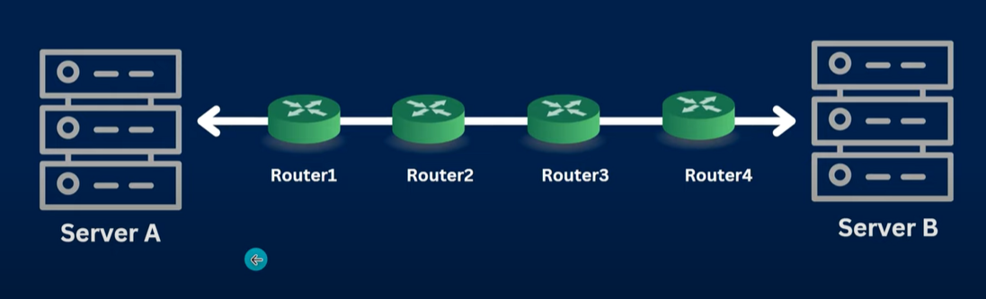
* If traceroute is not installed, you can install it using sudo apt install traceroute
* When I run traceroute [www.google.com](http://www.google.com) or traceroute 8.8.8.8 I get the below response
* 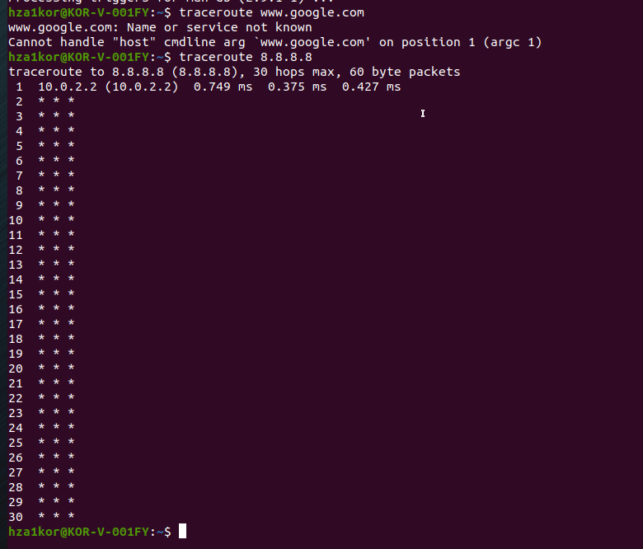
* Here * means either the routers don’t have ICMP configured or packets are dropped
* Command to change the default packet length from 60Bytes to 100Bytes – traceroute google.com 100
* Command to change the default number of packet per hop from 3 to 1 – traceroute -q 1 google.com
* How to change the default from 33434 to 21101 – traceroute -p 21101 google.com
* Command to use IPV6 or IPV4 – traceroute -4/6 google.com
* Command to route through gate – traceroute -g 192.168.42.45 google.com