**Linux Package Management | Linux YUM, DNF, RPM | Rollback Patches**

* Package management is used to install, upgrade, delete, view and configure a package
* Red-hat linux systems like CentOS uses YUM/DNF and RPM as their package manager
* Debian based systems like ubuntu, kali linux uses APT
* **YUM(Yellow-Dog Updater Modified)**
  + YUM is the primary package management tool for redhat
  + YUM performs dependency resolution when installing, updating and removing software packages
  + YUM can manage packages from installed repositories in the system or from .rpm packages
* Commands for YUM
  + To install a package- yum install <pkg-name> -y
  + To remove a package- yum remove <pkg-name>
  + To update a package – yum update <pkg-name>
  + To upgrade a package- yum upgrade <pkg-name>
  + To check all the available options – yum -option
  + To check the available updates for packages – yum check-update
  + To see the history of packages like the date and time – yum history
  + To undo an action – yum history undo <id>
  + To redo an action – yum history redo <id>

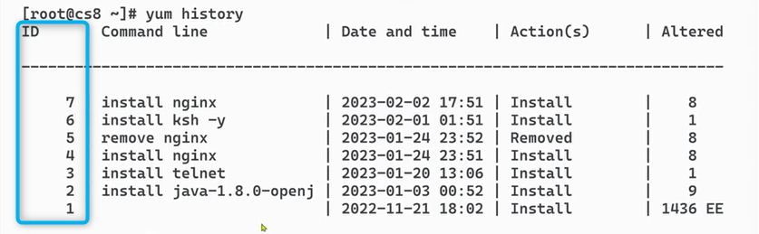

* Difference between update and upgrade
  + When we run sudo apt upgrade <pkg-name> say currently I have python 3.17 In my system, now online 3.20 is present, then when I run sudo apt upgrade python, 3.17 package will be replaced with 3.20, so now no 3.17 version will be present
  + When we run update, it will basically update the local package database. It will retrieve the latest package information from /etc/apt/sources.list and /etc/apt/sources.list.d/). When we run sudo apt update, the debian package manager downloads the current list of available packages and versions, allowing your system to know if there are any newer versions or updates available. It reads from online sources and refreshes the local database with the most recent package metadata.  **Note that no packages will be installed in this step, it is basically only updating the local database to have all the newer versions available**
  + When we run upgrade command after the update command, the database is updated so we can easily get the latest version, at the upgrade step the downloading of newer version happens
  + Always run sudo apt update before sudo apt upgrade to ensure that you are upgrading to the latest available version.
* RPM(Red-hat Package Manager)
  + Using RPM we can install, unistall and query individual software packages
  + Issue- it cannot manage dependency resolutions like YUM
  + RPM maintains a database of installed packages, which enables powerful and fast queries
* Commands for RPM
  + To install a package – rpm -ivh <package.rpm>
  + To remove/erase a package- rpm -evh <package.rpm> (here v means verbose and h is hash to show the progress)
  + To upgrade a package – rpm -U <package.rpm>
  + Wget command can be used to download files/packages

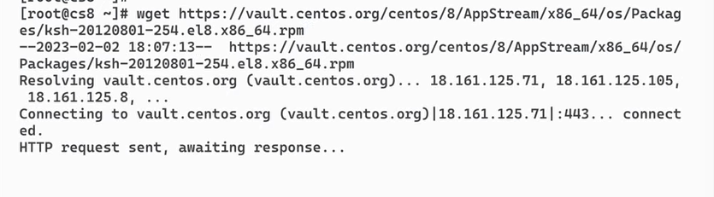

* + To query all the installed packages – rpm -qa
  + To get info about a package – rpm -qi <pkg-name>
  + To get info about config files for a package – rpm -qc <package-name>
  + To check if a certain package is installed or not – rpm -qa | grep <pkg-name>
* DNF(Dandified YUM)
  + To list all the available packages – dnf list available
  + To list all the installed packages – dnf list installed
  + To update – sudo dnf update
  + To upgrade – sudo dnf upgrade
  + To install a package – sudo dnf install <pkg-name>
  + To remove a package – sudo dnf remove <pkg-name>
  + To get info about a package – sudo dnf info <pkg-name>
  + To search for a package – sudo dnf search <pkg-name>
* APT
  + To install a package – apt install <pkg-name>
  + To remove a package – apt remove <pkg-name>(**Note when we run apt remove, the dependencies that were installed for the package are not removed, to also remove the dependencies use sudo apt auto-remove)**
  + To autoremove all pkg-dependecies – apt auto-remove <pkg-name>
  + To update – apt update
  + To upgrade – apt upgrade
  + To search for a package – apt-cache search <pkg-name>