**Linux User Account Management | USERADD, USERMOD, Examples | MPrashant**

* You will need root access to execute the below commands
* To add a user – useradd <username>
* To check if a user is added – id <username>
* To check info on groups – cat /etc/group file
* To check user passwords(its in encrypted format though) – cat /etc/shadow
* To check info about users(uid,gip, home_dir, shell_type – cat /etc/passwd file
* With id command you can also check details like userid, groupid and groups

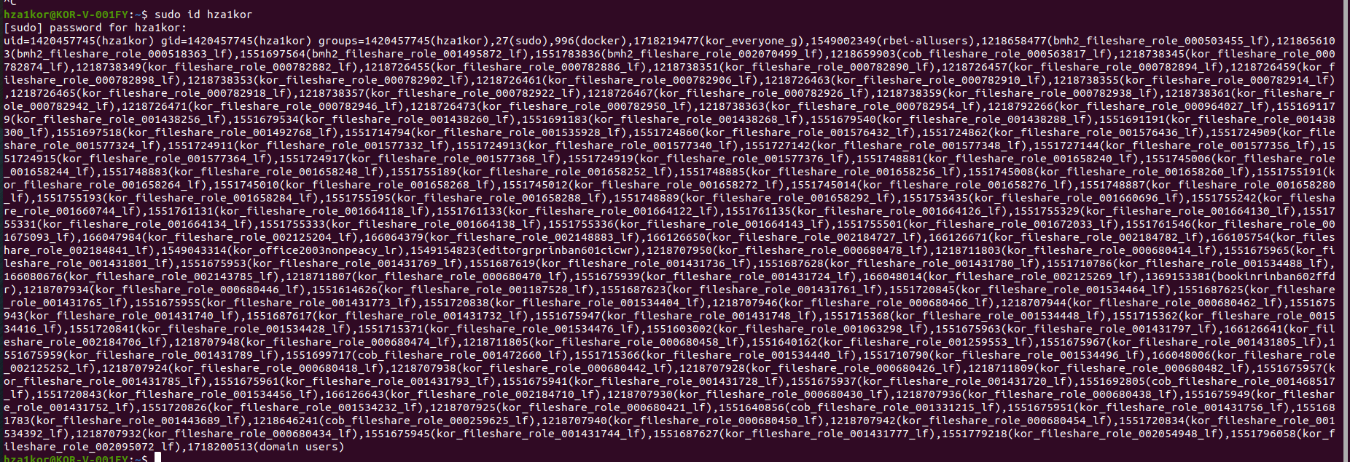

* To create a user based on a few conditions –
  + useradd -g <group_name> -s /bin/bash -c “description” -m -d /home/username username
  + g for group name
  + s for shell
  + c for comment
  + **m** flag tells the system to create the user's home directory if it doesn't already exist.
  + d for directory location where the home directory should be present. When you use this flag along with the **-d** option (which specifies the home directory path), the system will create home directory for the user
  + username – the username you want to name
  + this command is userful when you want to specifically provide a group, comment, shell type etc

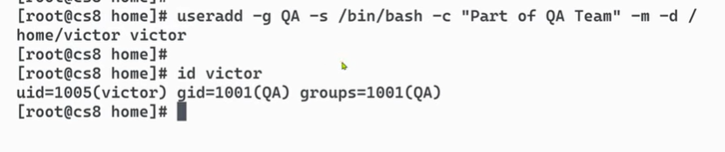

* To delete a user
  + userdel <username> (This will not remove the home directory of the user)
  + userdel -r <username> (this will remove the home directory of the user as well)
  + userdel -f <username> (this will forcefully remove the user even if he/she is logged in)
* To modify a user
  + To add a user to a new group(not changing the default group just adding a new group)
    - usermod -G <group_name> <username>

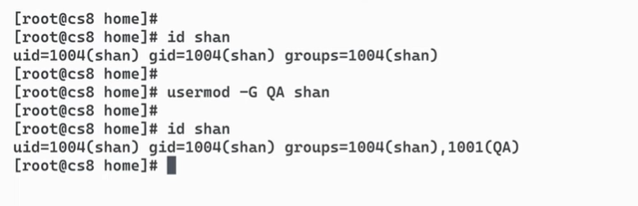

* To change the default group of a user
  + Usermod -g <group_name> <username>

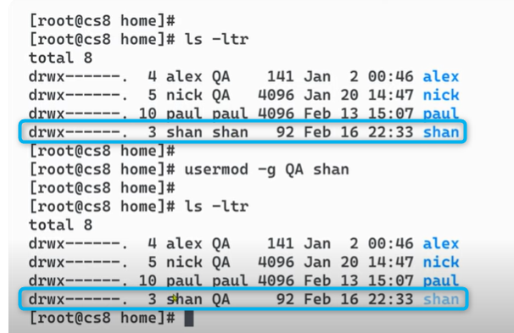

* To remove a user from a group
  + sudo deluser <username> <groupname>
  + here I have sam added as a member in group sudo, if I want to remove him from the sudo group use – sudo deluser sam sudo

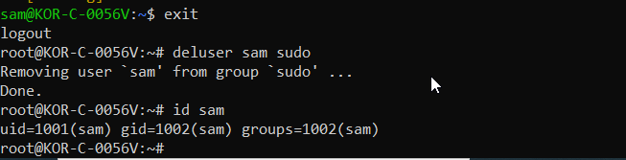

* Other usermod options
  + usermod -m -d /home/new_folder username(to move the content of home folder to new_folder)

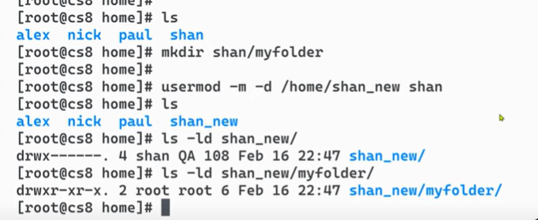

* + usermod -p username (to change the passwd, but its recommended to use password command instead of -p)

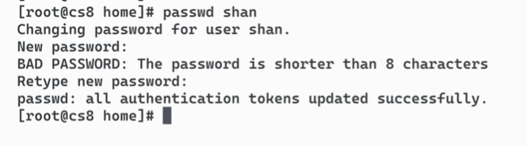

* + usermod -s /bin/zsh username (used to change the shell type)
  + usermod -L username (To lock a user)
  + usermod -U username (To unlock a user)
* Group options
  + How to create a group - groupadd <group_name>
  + How to delete a group – groupdel <group_name>