**Linux Password Aging | Linux CHAGE Command | MPrashant**

* **Password aging is basically used to change passwords after a certain time for a certain user or multiple users, set a fixed min days, max days, warning days, expiration days etc. Its important if you want to make sure password should be changed after x number of days for user/users**
* There are 2 ways to set the password aging options
  + If I want to age the password only one time and only for one user we can use the **chage** command
  + To make it default for every new user, we can make changes in /etc/login.def file
  + Command – chage [-m mindays] [-M maxdays] [-d lastday] [-I inactive] [-E expiredate] [-W warndays] username
  + -m – minimum number of days after which user is allowed to change the password
  + -M – max number of days the password is valid
  + -d - Days since Jan 1, 1970 that the password was last changed
  + -I – No.of days after password expire, account is disabled
  + -E – days since Jan1, 1970, that password was last changed
  + -W – No.of days before password expires, user will be warned
* To check the properties related to password run – grep root | /etc/shadow

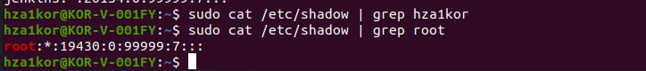

* Note- for hza1kor there was no data so I am using root properties

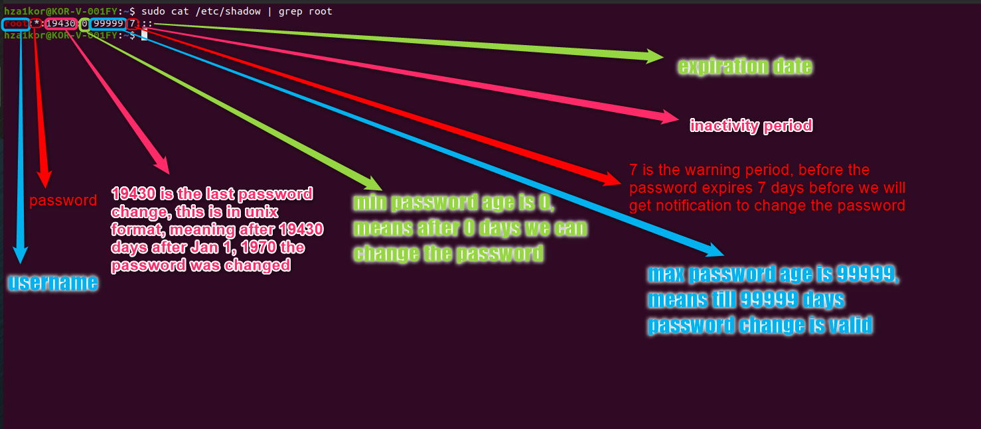

* Example in prashant’s video –

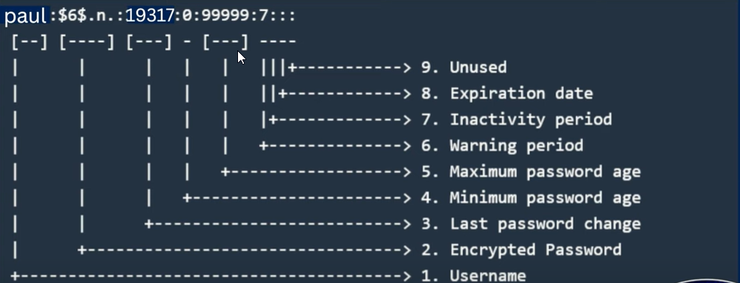

* If I don’t like these values of 99999 as max days the password is valid, we can change these values using chage command
* Say I want that after every 90 days the password should expire then I set -M to 90 and warning value as 10
* I tried it on wsl, command – **sudo chage -M 90 -W 10 sapna** , and this is the o/p

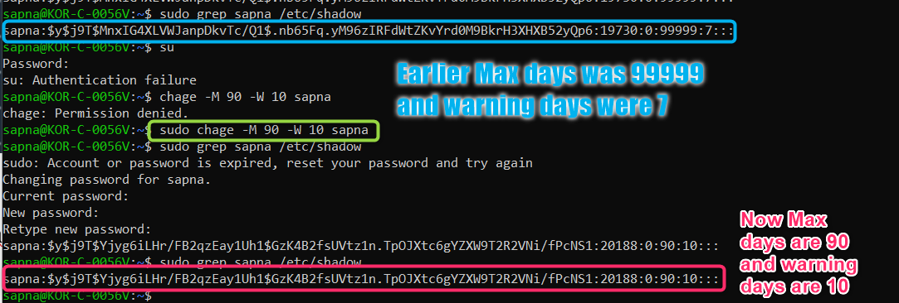

* Now chage can be used if I want to set the max days or the warning days, expiration day for **one user only**
* Say I want the max 90 days till password expires and warning days as 10 for all the users, then I will have to modify the /etc/login.defs file
* The login.defs is a huge file fyi
* We have to focus on the section called password aging controls

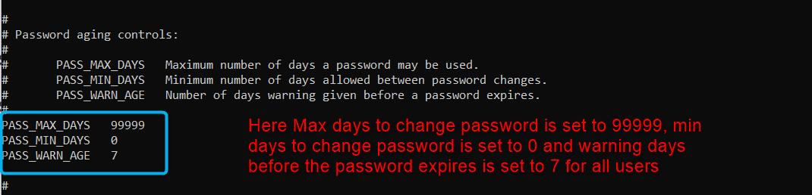

* To change these values just sudo vi /etc/login.defs and give your values and save it

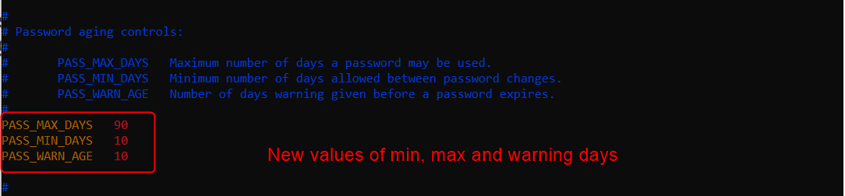

* Now the new values are as follows

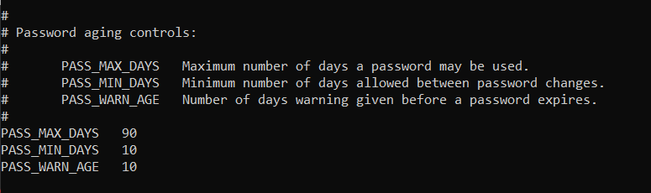

* Now when I create a new user and check the password details of sam I see the new values of min, max and warning

