**Linux SU and SUDO Commands | How to Give SUDO Access to a User using SUDOERS | MPrashant**

* Different ways to switch a user
  + su - <username> - will hyphen option your directory will be changed to the username directory
  + su <username> - without hyphen you will be in the old directory itself
* say I am currently logged in as sapna, now I want to switch to sam, if I just do su sam, and I run whoami, I will see that I am logged in as sam, but when I run pwd, the o/p will still be /home/sapne, to make sure my current directory is also changed to the sam home directory I can use the hyphen option

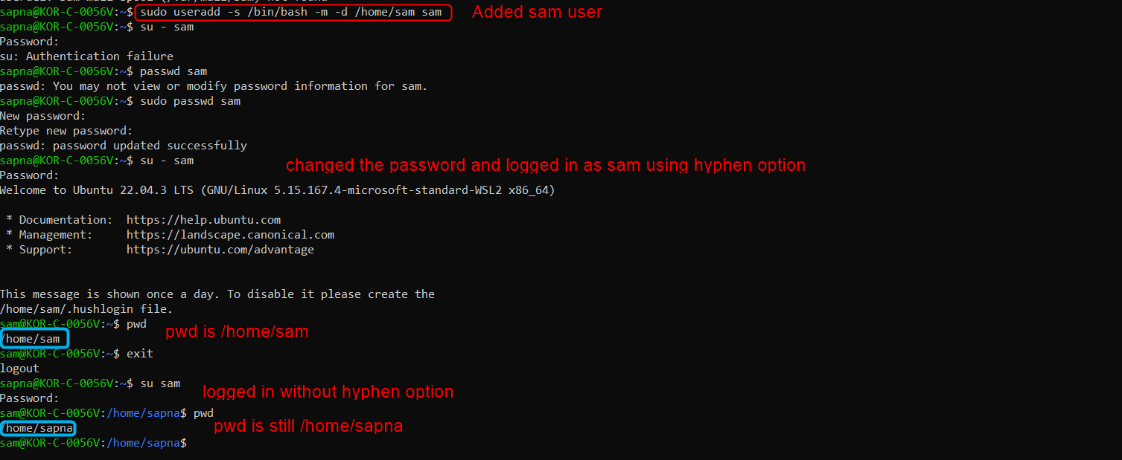

* to switch the user to root, use command **su –**
* I first changed the root password since I was not able to login then ran su – again

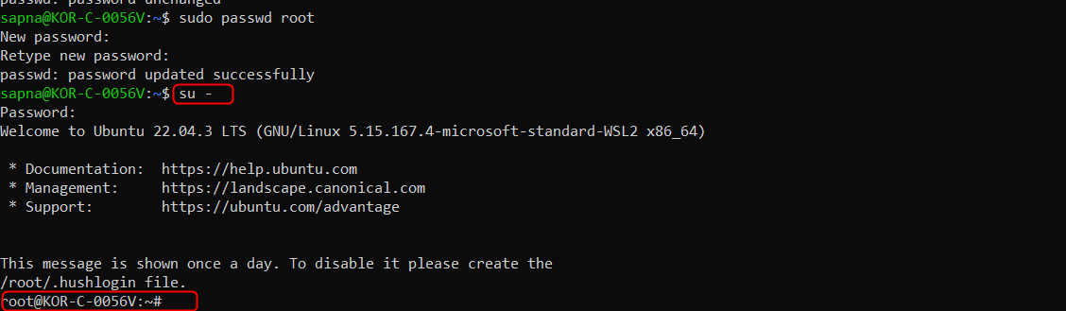

* When you are logged in as root, you can directly login as sapna or sapne without giving any password since you are the super user

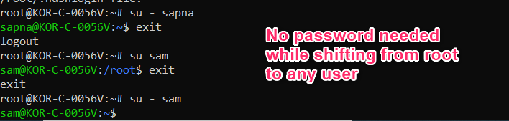

* How to exit as the current user or exit from the shell use **exit** command
* What is **SUDO – Super user DO** 
  + **It is a way to temporarily grant a user administrative rights**
  + Sudo permissions are required when you have to change the user, or install some packages, add a new user, delete a user, create a group etc
* To run sudo command also we need some permissions else we get the below error

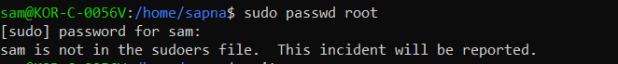

* The permissions on who can use the sudo commands are used /etc/sudoers fil

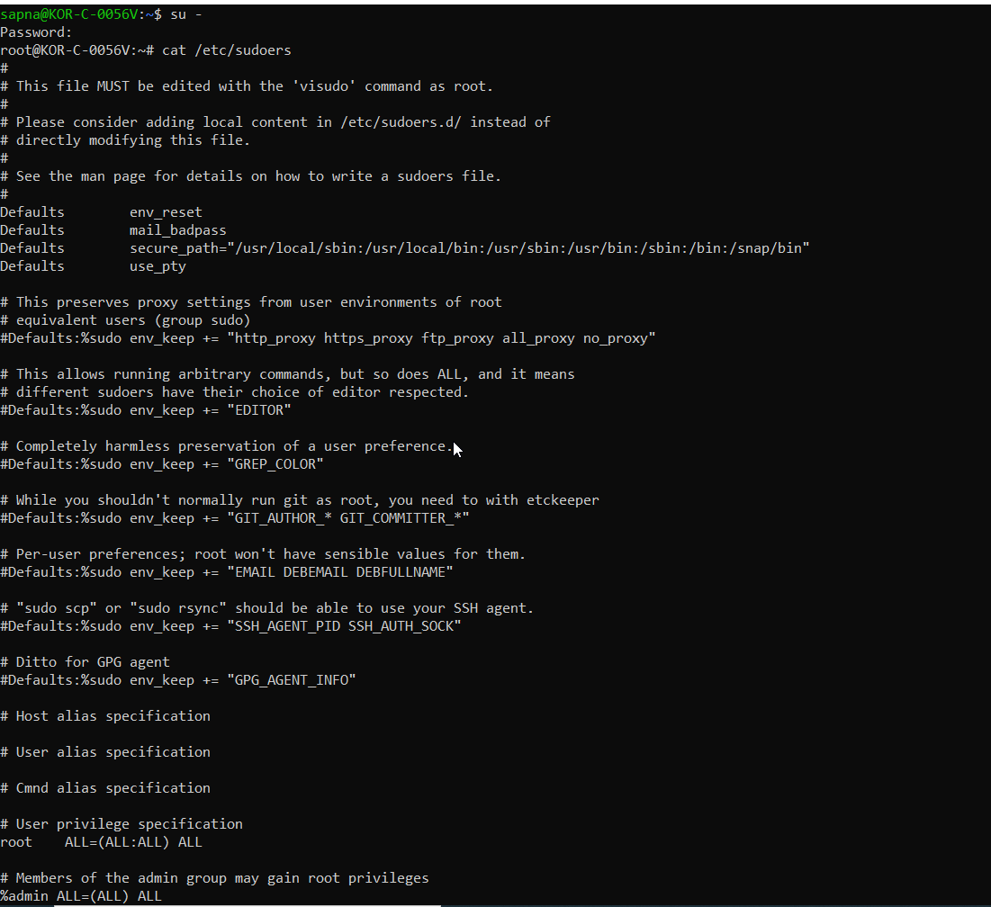

* We can edit sudoers file using visudo
* Current privileges given –

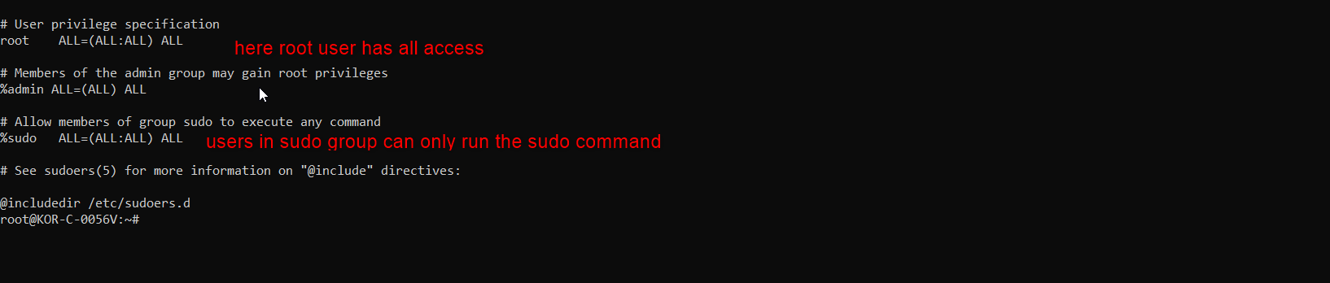

* Here we can see that sudo permissions are given to only users who are in sudo group
* now when we check the groups for sapna and sam, we see that sapna belongs to the sudo group but sam does not



* now since I want to add sam in the sudo group I will run – usermod -aG sudo sam

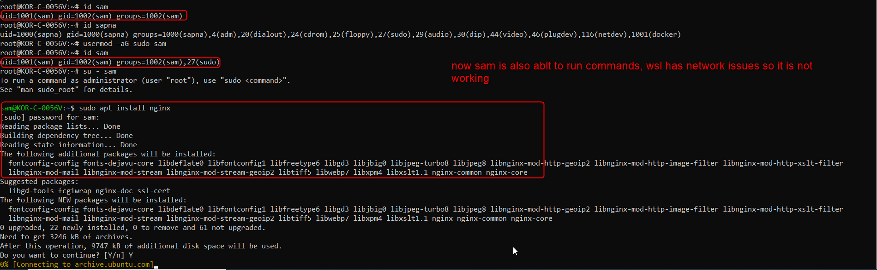

* say now for the sam user I don’t want to give it all sudo access, just access to run updated and nothing else, then we will have to run visudo command from any location and it will open the below file

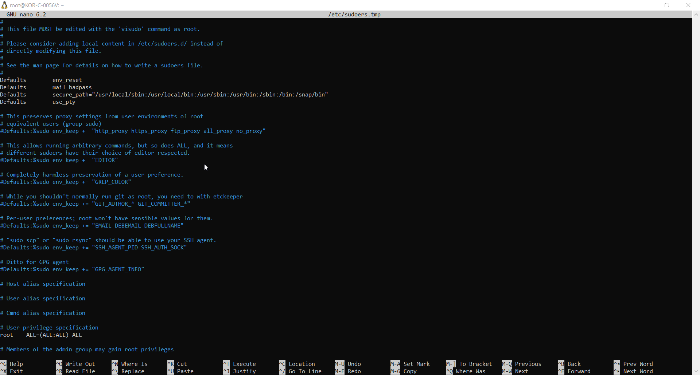

* first I will need to remove sam from sudo group using command – deluser sam sudo

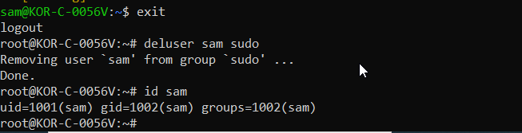

* Now in the /etc/sudoers.tmp file which I opened using visudo command I have added the below data

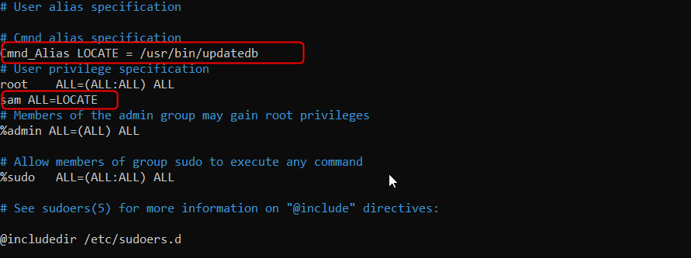

* An alias for updatedb and permission for sam to only be able to run updatedb nothing else
* Now I will only be able to run updatedb and not any other commands(for sam)