**Learn Linux SSH Basics - How to Connect to a Server | Linux SSH Tutorial Part-1**

* SSH or secure shell is a network communication protocol that enables 2 computers/devices to communicate and share data
* SSH is called secure shell because communication between host and client will be in encrypted format
* The default port for ssh client connection is 22
* We can change the default port and use any port between 1024 and 32767
* Ssh is also a command in linux
* It is used to access an another linux server or accessing a linux server from a terminal
* Syntax – ssh user_name@host(IP/Domain_name)
* To use SSH, ssh service must be installed on linux server
* You can check using rpm -qa | grep ssh(rhel) or dpkg -l | grep openssh-server(Ubuntu Machine) or check the file /etc/ssh/sshd_config

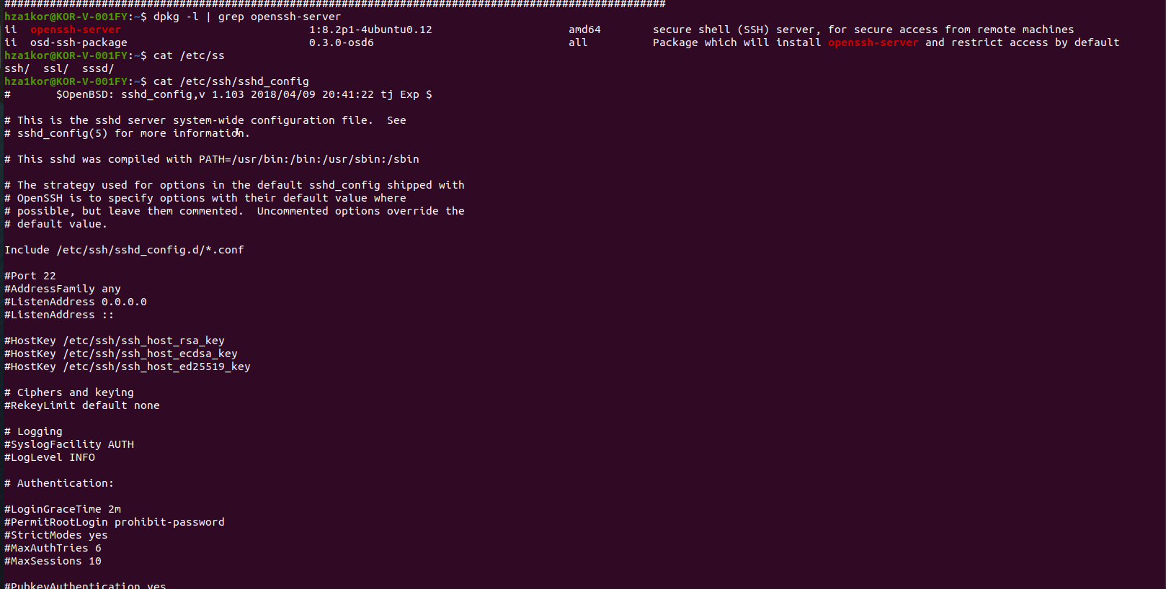

* If not already installed then install the below 2 packages
  + sudo apt install openssh-clients openssh-server
* and to enable ssh or to check if ssh is enabled or not using **systemctl status sshd**

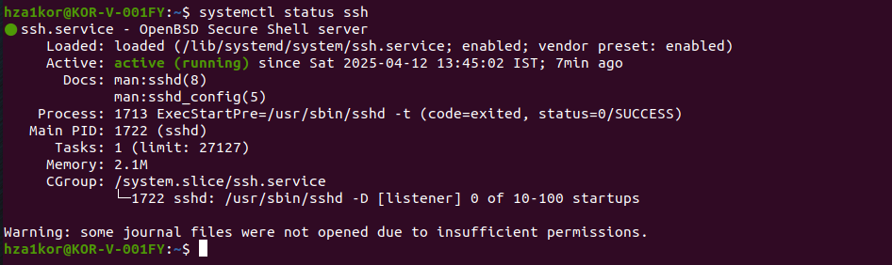

* now lets try to establish connection using putty from windows machine to the vm
* for that first we need the ip address of the vm

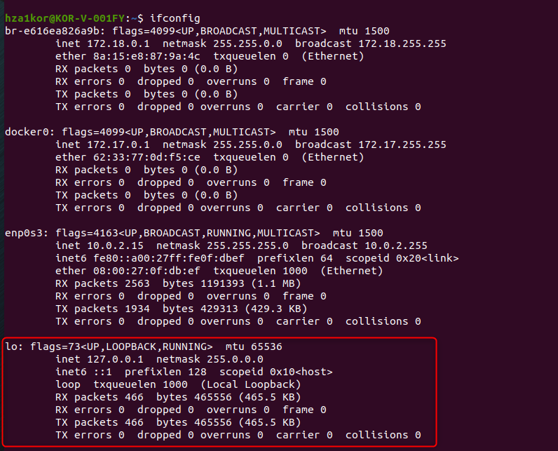

* we will use the port forwarding as well since directly via NAT network we cant access the vm

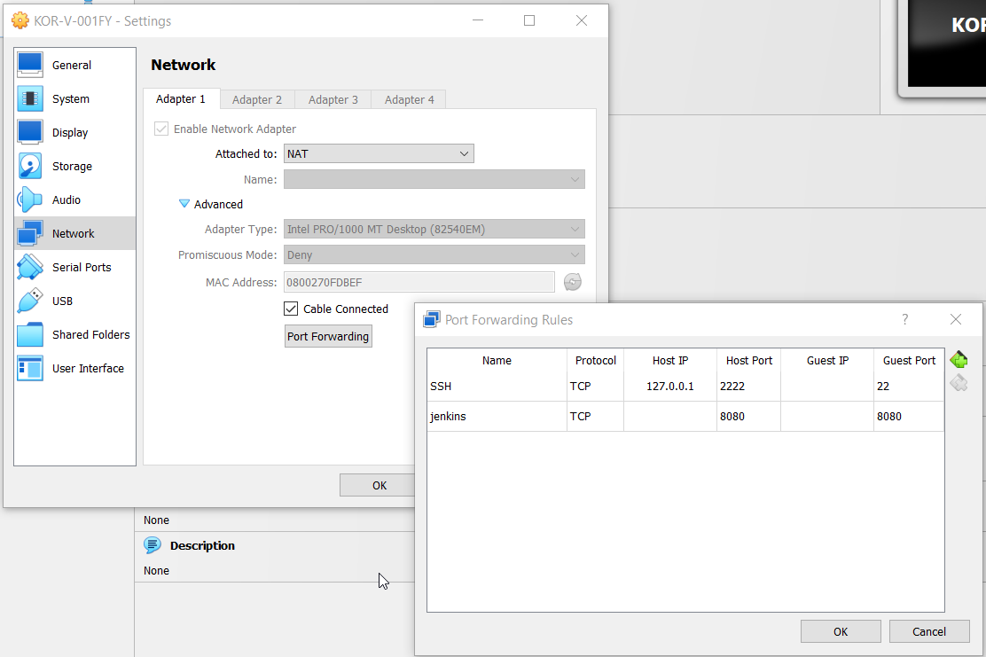

* now once you open putty, give the below details, hostname – 127.0.0.1, port – 2222, then login as hza1kor and password, your vm password

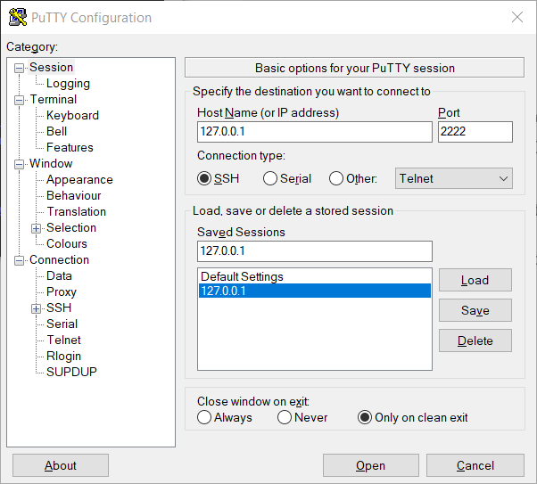

* then you will be able to login(for me it takes around 1-2 mins to properly login) and this is the window you will see

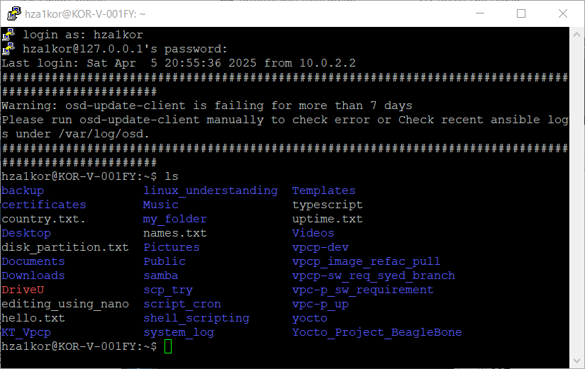

* we can also login to another vm or linux server using ssh, we have to just make sure that the server/vm you want to login in should have ssh and ssh service should be enabled, and you should have the username and password on that server/vm

