**How to SSH Login Without a Password on a Linux Server | Linux SSH Tutorial Part-2**

* There are 2 ways to access a remote server
  + Using password
  + Without password(by passing ssh key)
* Ssh key is useful if you frequently access the server then it’s a good idea to configure ssh keys so that you can login without password
* Steps to generate an ssh key
  + Generate a new ssh key pair on the local machine using ssh-keygen command

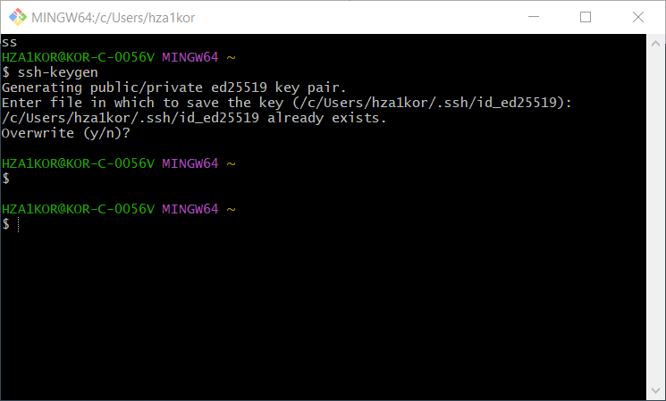

* + Copy public key to remote machine using command ssh-copy-id -p 2222 [hza1kor@127.0.0.1(Note](mailto:hza1kor@127.0.0.1(Note) that first time it will ask you to give the password, then next time you can directly login since your ssh key is already added)

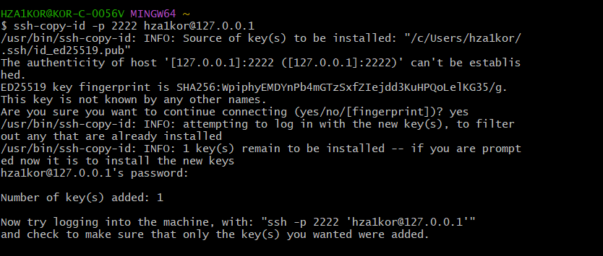

* + Login to the remote server without password using command ssh -p 2222 hza1kor@127.0.0.1

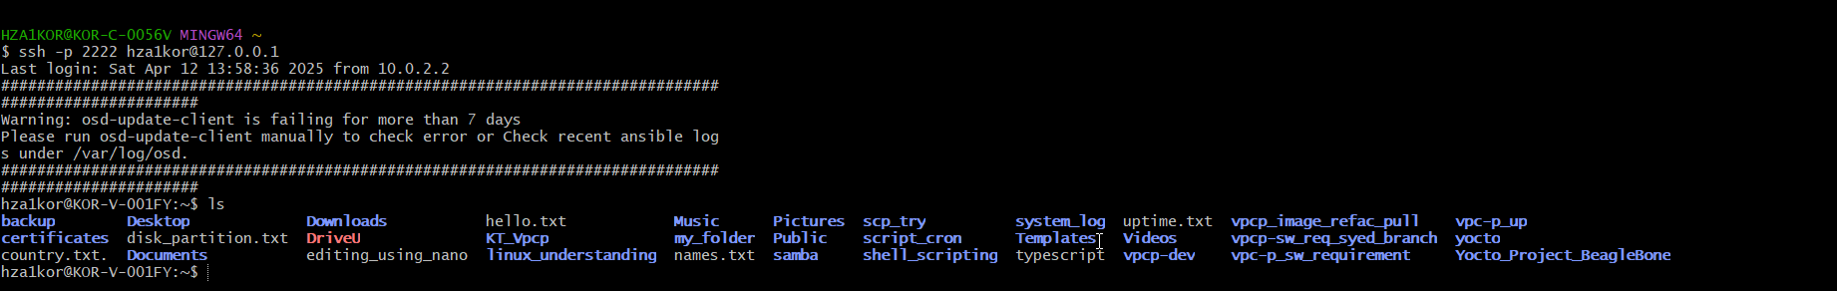

* Now next time(not on putty) on gitbash whenever you want to login to the vm, you can directly just run ssh -p 2222 [hza1kor@127.0.0.1](mailto:hza1kor@127.0.0.1), just make sure to give port as 2222, else by default it uses port 22 and gives an error

