**Linux Sticky Bit in Hindi | MPrashant**

* Sticky bit is also called restriction deletion flag
* These files/directories can only be deleted by file owner, group owner
* It is shown as ‘t’ or ‘T’
* It is used for sensitive files/folders so that no one can just come and delete it
* Example
* Say sapna create a folder called QA_Testing inside /tmp folder so that everyone can access it with owner as Sapna and group owner as testing



* Note that I have given all permissions to QA_Testing
* Now sapna is creating a file called sapna_01, here owner will be sapna and group owner will be testing since, I already gave sudo chmod g+s testing /QA_Testing, so that all files inside QA_Testing will have the same owner

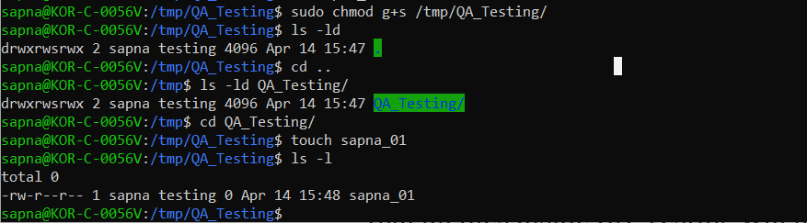

* Now say sam(who is also in testing tam) logs in and sees this file sapna_01, now ideally he should not be able to delete this file since group only has read permission



* But oopsie he did, its gone

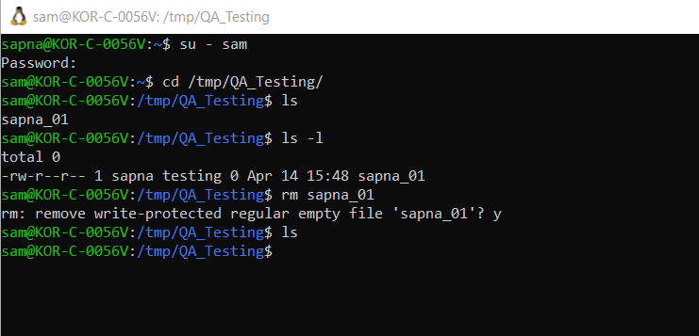

* This is happening because the parent directory that is /tmp/QA_Testing has given all the permissions to the group owners, so any files inside it, if they are the group owners(testing) they can delete it, it doesn’t matter if file doesn’t give the group owner permissions, if the parent directory has the permissions any file inside it can be deleted

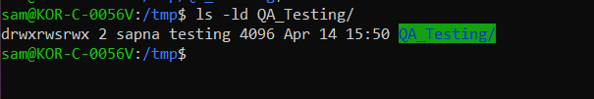

* To avoid these issues, I will again login as sapna, then add the sticky bit using command – sudo chmod o+t /tmp/QA_Testing

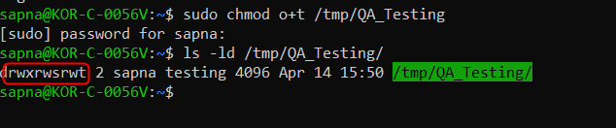

* Now I create a new file named sapna_01 since the old one was deleted by sam

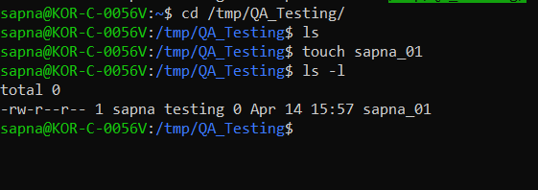

* Now I again login as sam and lets try to see if it gets deleted now

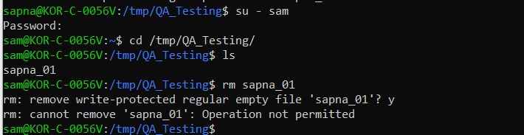

* Voila, sam is not able to delete it now, Gotcha sam
* Note that only the owner of sapna_01 that is sapna can delete this file, no one else

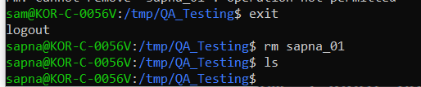

* We now learnt how to use sticky bit ‘t’.
* There is one more sticky bit ‘T’ which is used when we are setting sticky bit, but the file doesn’t have execute permissions
* So first lets remove t option

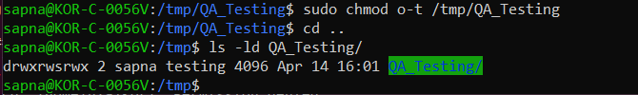

* Now lets remove the execute permission also from others

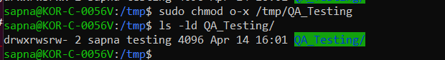

* Now when I add sticky bit ‘t’ the bit will be added as T

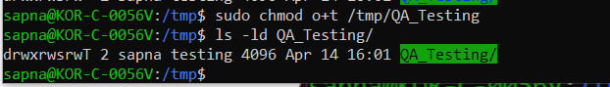

* So the difference between t and T is if a file doesn’t have executable permission and you add a special permission then its added as capital(like Capital T, capital S)