**How to Change Default Permission in Linux with UMASK | MPrashant**

* Whenever we create a file or a folder we get certain permissions for owner, group and others like rwx
* Say I create a file named sapna_01, and run ls -l I can see that default permissions are given

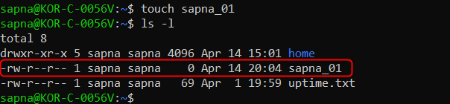s

* Say I don’t like the permissions currently i.e I don’t want others to have read permission also or I was owner to have execute permission, so if I want to change the default permissions I can use umask
* When we run umask command, we see the o/p in octal format
* Umask value ranges from 0022 to 0002

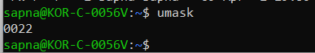

* Note that 0777 is usually used for directories since when need execute permissions to run commands like cd, ls etc
* When you create a folder subtract 0022 from 0777

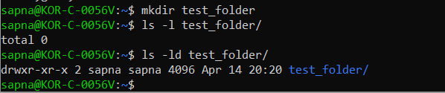

* But for simple files subtract it from 0666, since its not safe to have execute permissions for files



* Now we have the umask of 0022, to figure out what this means just subtract 0022 from 0666.
* 0777 – 0022 = 0644
* Read – 4 bytes
* Write – 2 bytes
* Execute – 1 byte
* Meaning owner has rw, group has r and others also have r
* If you don’t want to calculate and you directly want to check the owner, group and others permissions run – umask -S



* Say I want to change the permissions to u=rwx,g=rwx and other to remove rx
* Then just run – **umask u=rwx,g=rwx,o=**

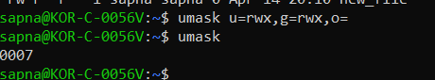

* Note that with new changes, I see that directories have proper permissions but for files still the execute permissions are missing, I guess its standard to not have execute permission
* We would need to explicitly add it

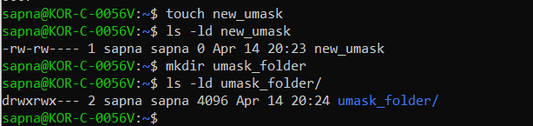

* Note that when we change the default umask values, it only for temporary basic, say I log out or close the terminal, the umask temporary values will also be changed again
* Now sapna has a umask of 0007, now say I login as sam and see the umask value there

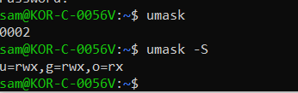

* Umask for sam is different, it 0002, but umask for sapna was 0022
* 0777 – 0002 = 0775, owner has rwx, group = rwx and other rx
* To set the default permissions permanently we will have to change the .bashrc file
* If we want to globally change permissions for all users change the permissions in /etc/bash.bashrc file

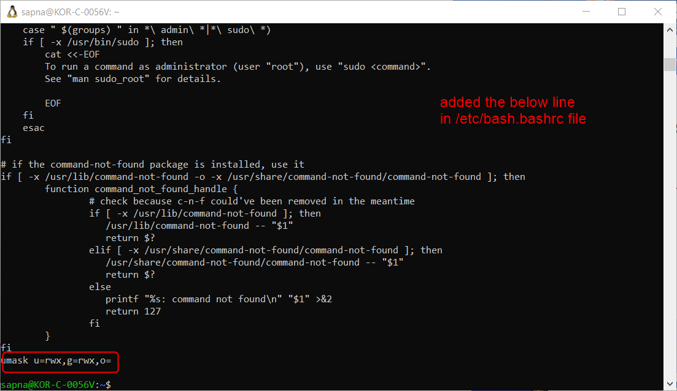

* Then run command – source /etc/bash.bashrc
* Then login from any other user like sam and see the value

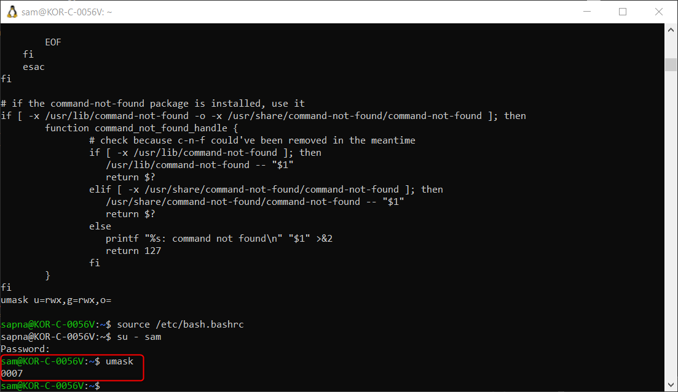

* Now the value of umask for any user is 0007
* To change it only for the current user in the home directory there is a .bashrc file
* To change permissions globally for all users using /etc/bash.bashrc file
* To change permissions for only your user modify the .bashrc file
* Now I set umask u=rwx,g=rwx, o= , and saved it then ran source .bashrc, and wow, now when I run umask I see 0007(Thala for a reason)

