**Linux Chown, Chgrp Command in Hindi | Linux File Ownership Command**

* chown is used to change user ownership
* chgrp is used to change group ownership
* say from sapna I create a folder called test_changes and inside it I create a file called test_01
* now say sam wants to do changes in this file
* but when sam tried to enter test_changes, he gets permission denied because he is other, and other doesn’t have any execute permission

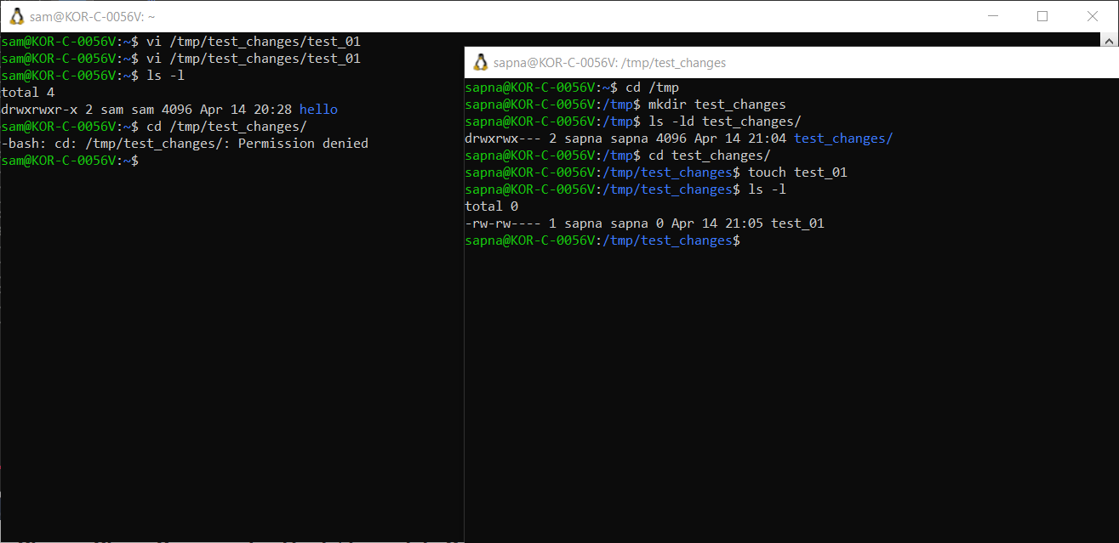

* so sapna tries to change owner to sam using chown command – sudo chown -c sam test_changes/
* after changing the owner, now sam can enter and change the files as well

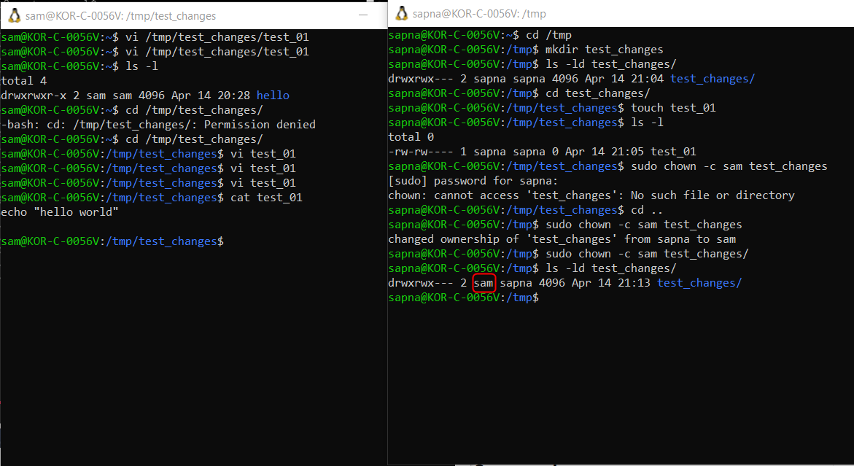

* to change the group owner, just command – sudo chgrp -c testing test_changes

