**Linux POSTFIX Tutorial to send EMAIL | MPrashant**

* PostFIX command is used to send emails and also attach files in email
* First we would need to install the postfix package using sudo apt install postfix and sudo apt install mailutils
* Postfix provides all the functionalities but mailutils is the command that is used to send emails
* To check if these packages are already present – dpkg -l | grep <pkg-name>
* To check the postfix configuration – cat /etc/postfix/main.cf

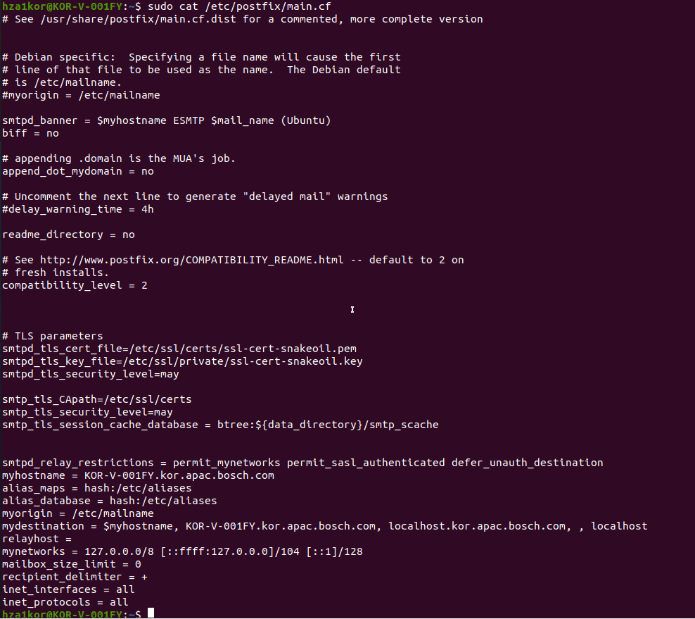

* While doing any changes to these cfg files, make sure you always have a backup, so I create a copy using – sudo cp /etc/postfix/main.cf /etc/postfix/main_backup.cf



* Now to send mails we will have to add the below configuration inside main.cf file

relayhost = [smtp.gmail.com]:587

myhostname = KOR-V-001FY

* So myhostname was already set so I am not disturbing it, relayhost was set to nothing so I gave the value

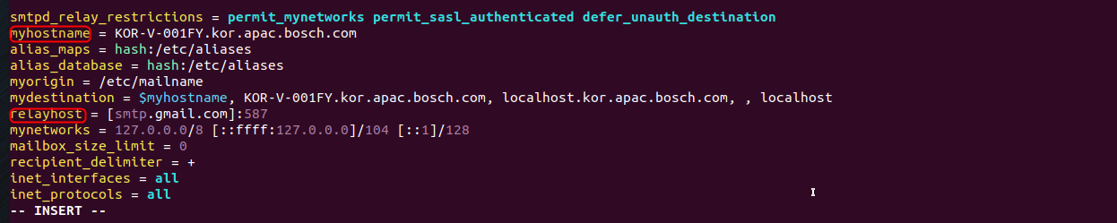

* We also need to add the below lines at the end –

#Changed the smtp_tls_security_level to encrypt instead of may

smtp_tls_security_level=encrypt

#Location of sasl_password we saved

smtp_sasl_password_maps = hash:/etc/postfix/sasl/sasl_password

#Enables SASL Authentication for postfix

smtp_sasl_auth_enable = yes

#Disallow methods that allow anonymous authentication

smtp_sasl_security_options = noanonymous

Next step is to create a sasl_password file that we have given in line smtp_sasl_password_maps = hash:/etc/postfix/sasl/sasl_password

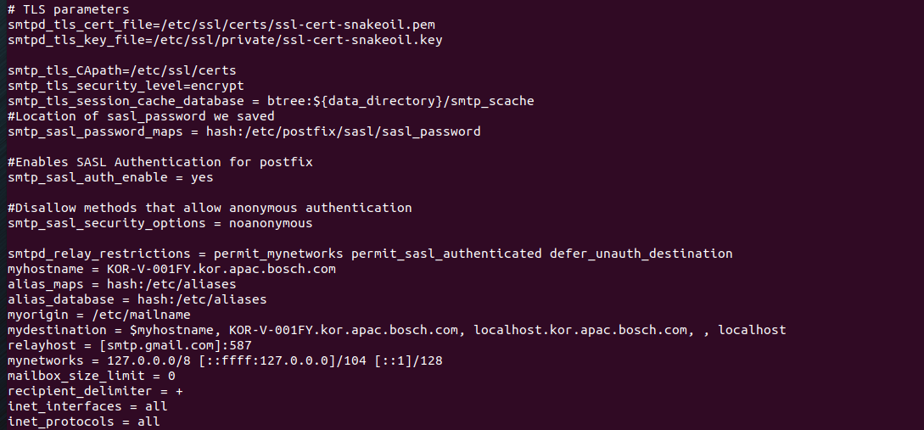

* Add the below line in sasl_password

[smtp.gmail.com]:587 sapnajha9390@gmail.com:password

* Here password is tricky for that you need to go to your gmail account and manage account

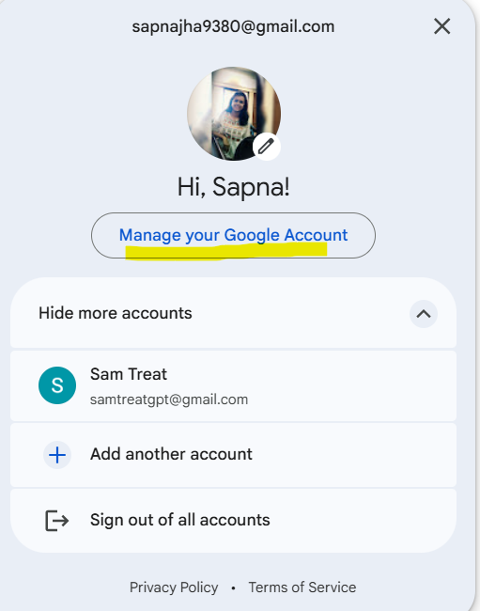

* In manage account click on security and make sure the 2 step verification is on

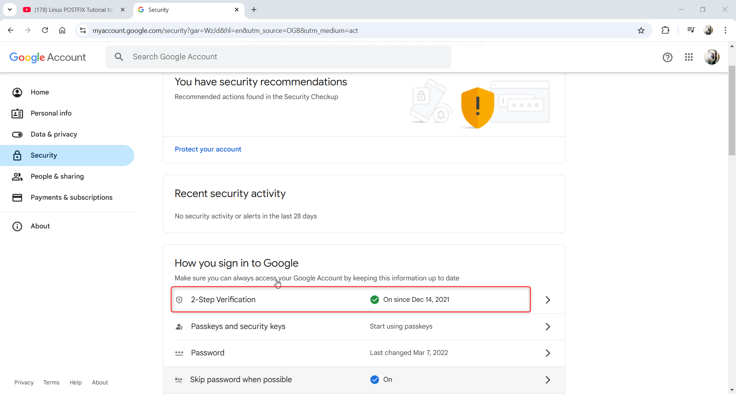

* Then in the search Google account type **app passwords**

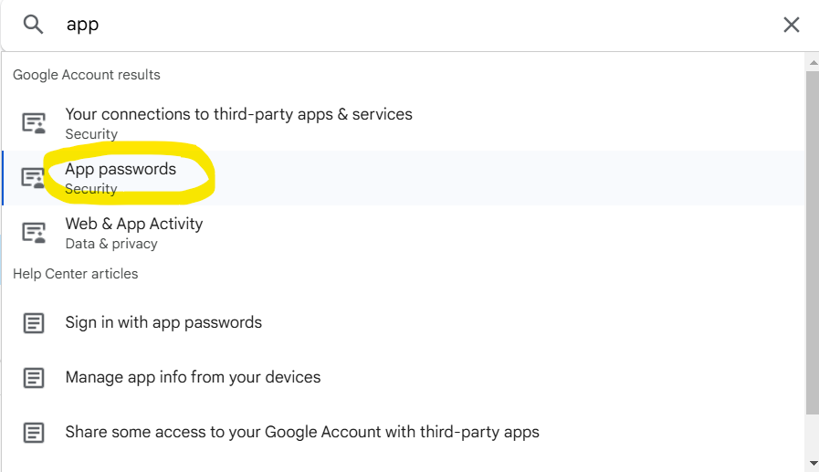

* Then it will ask you to put in your password, do it
* Then it will ask you to give the app name, give smtp

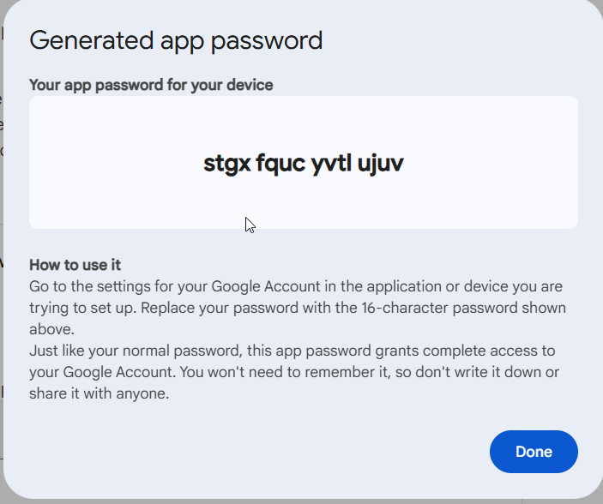

* Now give the same password in the sasl_password file - smtp.gmail.com]:587 sapnajha9380@gmail.com:stgxfqucyvtlujuv

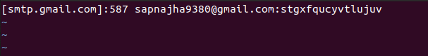

* Content in sasl_password

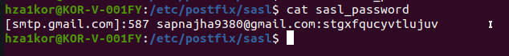

* Next step is to convert the sasl_password file into a database file

sudo postmap /etc/postfix/sasl/sasl_password

* Now we have a sasl_password file and a sasl_password.db file

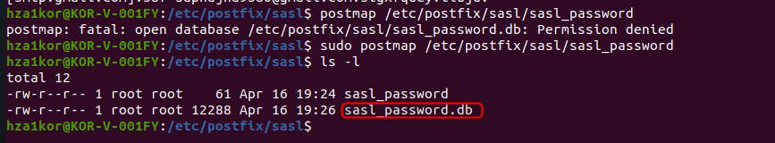

* Now we can start the postfix service using sudo systemctl start postfix.service
* Once the service is started verfifying it using sudo systemctl status postfix.service

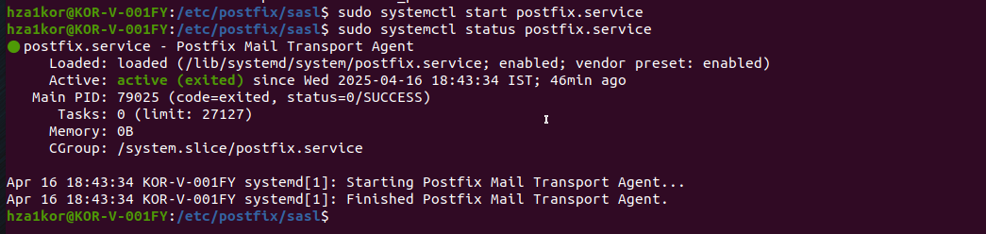

* Now to send the mail run command – echo "Test MAIL" | mail -s "Postfix TEST" [sapnajha9380@gmail.com](mailto:sapnajha9380@gmail.com)
* To attach a file also in the mail - echo "Test MAIL" | mail -s "Postfix TEST" -a “file_name/file_path” [sapnajha9380@gmail.com](mailto:sapnajha9380@gmail.com)

For me I was not able to send any mails, mostly due to proxy issues