**How to Use Linux DMESG Command for System Monitor in Hindi |**

* dmesg is also know as device message or driver message or diagnostic message or display message
* dmesg is a linux utility that displays kernel-related messages retrieved from the kernel ring buffer
* the ring buffer stores information about hardware, device driver initialization and messages from kernel modules that take place during system startup
* How to use dmesg command
  + dmesg
  + dmesg -HTx (humar readable, timestamp, decode)
  + dmesg | more
  + dmesg | less
  + dmesg | head -10
  + dmesg | tail -10

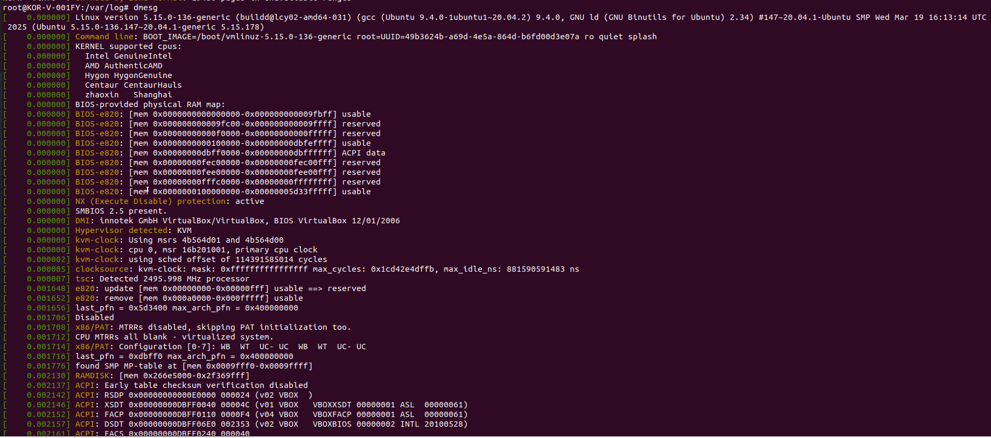

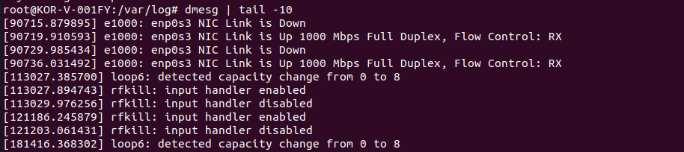

* using dmesg with grep we can search for import keywords like –
  + memory
  + usb
  + sda
  + ram
  + tty
  + error
  + warning
* for live monitoring use – dmesg -w

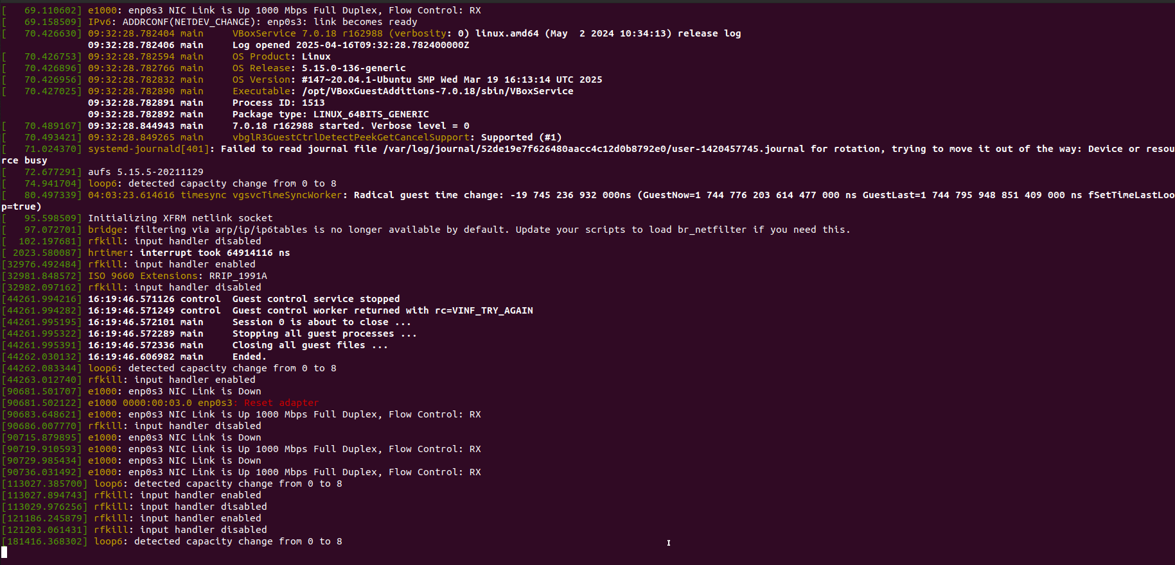

* to clear the ring buffer – dmesg -c

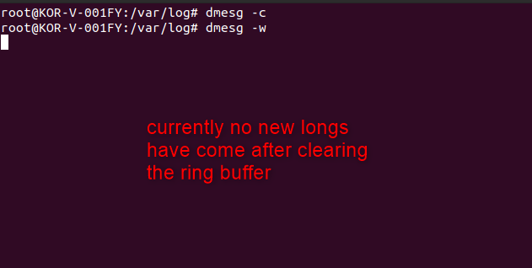

* to filter the messages based on different level - dmesg -l <level>
  + level can be emerg
  + alert
  + crit
  + err
  + warn
  + notice
  + info
  + debug