**Linux LogRotate with Example [HINDI] | MPrashant**

* Logrotate is a linux utility tool used to manage log files on linux server
* Logrotate uses rotation, compression and deletion
* When we see the log files inside /var/log, we can see that there are multiple log files with .1,.2 and so on, those are the previous boot logs and all the old logs are being deleted and being replaces by new logs, like rotation

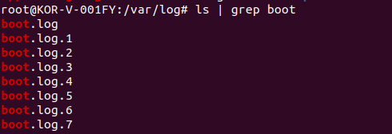

* Config files for log rotate are in /etc/logrotate.conf file or /etc/logrotate.d/ directory

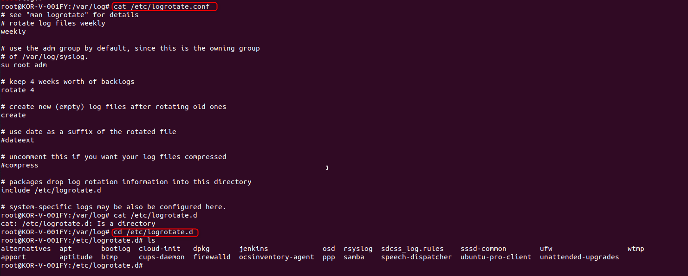

* If we look into the content of logrotate.conf

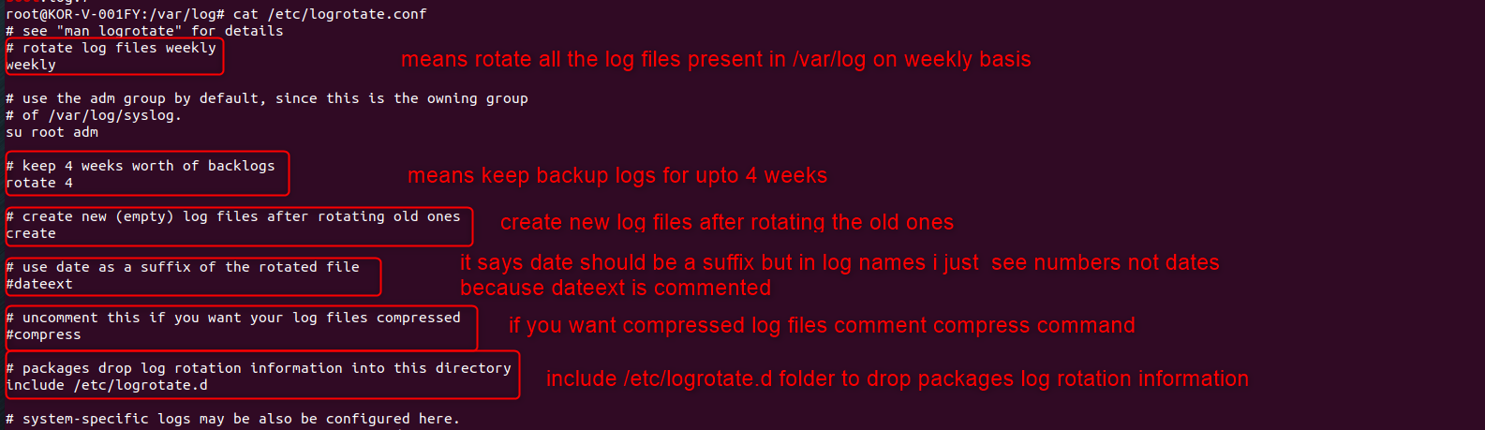

* Next lets look into data of folder /etc/logrotate.d

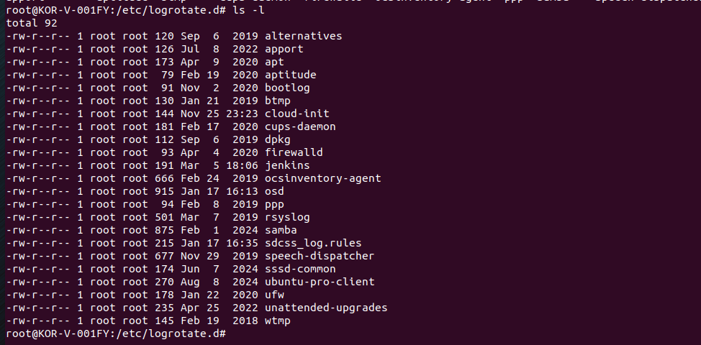

* All the files that are present here will be rotated, meaning for 4 weeks there will be backup logs and it will keep deleting the old logs and replacing it with new logs
* Say I want any of the logs to be rotated, I will have to create a file in /etc/logrotate.d folder
* The logs will be created as given in this file
* Simple example for Jenkins

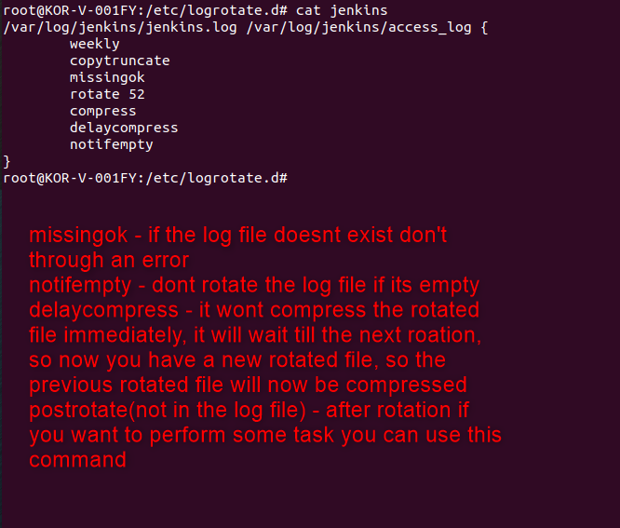

* Another example for firewalld –

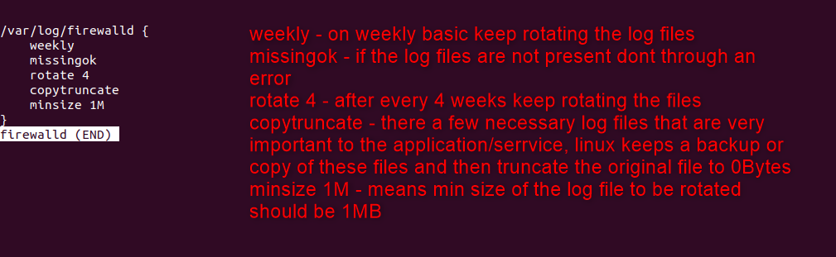

* Say I want to add my own application using logrotate –
  + I create a folder called my_app inside /var/log folder
  + I create a simple log file inside my_app folder

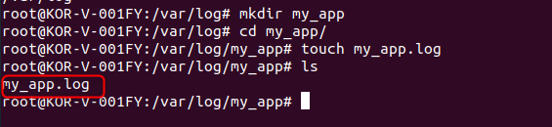

* + Next we will move to location /etc/logrotate.d folder
  + Then we create a file here called myapp, give the same name as the application

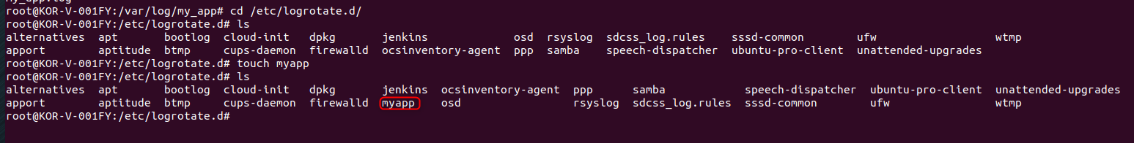

* + Now we will edit the myapp file

/var/log/my_app/*.log{

daily

size 10M

}

* + Here size 10M means the second the log file my_app.log crosses 10M of size rotate it
  + Content inside myapp file –

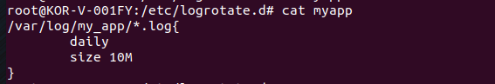

* + Now if we check the size of my_app.log its 0 Bytes



* + Now wither we can add a log of content so that the size is greater than 10MB or we can use truncate command to change the size
  + Now using truncate command we set the size of my_app.log to 15MB – truncate -s 15M my_app.log

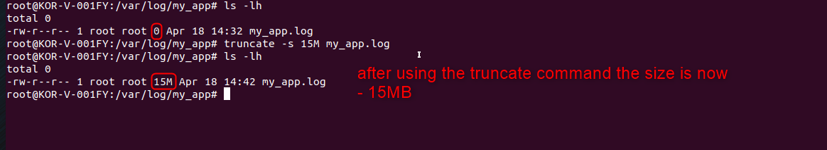

* + Now in the my_app file we had given that after the size of my_app.log crosses 10M rotate it but in the o/p we still don’t see any rotated file
  + To debug we have to run command – logrotate -d /etc/logrotate.conf

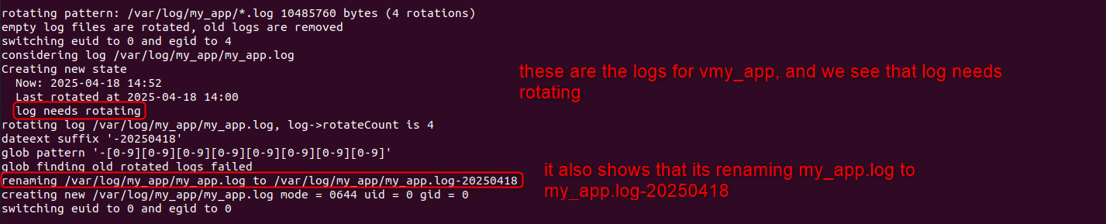

* + Here I guess rotation will happen every week so we are not seeing the new file
  + Say I want to trigger the rotation right now run – logrotate /etc/logrotate.conf
  + Now if we check my_app folder we have the rotated file present

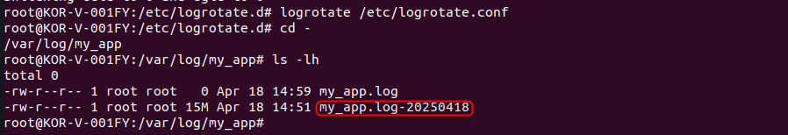

* Say now my requirement is to put all the rotated files into a folder called archieve instead of same path, we can again change the my_app file in logrotate.d folder

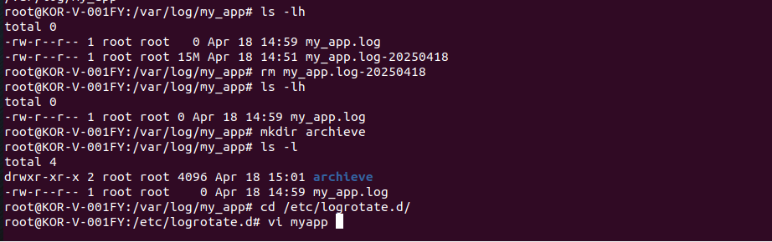

* In the myapp file change the location to /var/log/my_app/archieve/*.log

/var/log/my_app/*.log{

daily

size 10M

olddir /var/log/my_app/archieve

compress

}

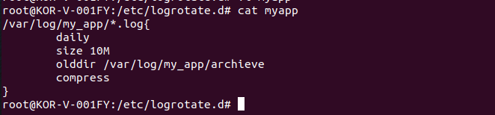

* Now olddir will basically put all the logs into archieve folder in a compressed form
* Again we will run the truncate command since my_app.log size was 0B(I don’t know how), then manually trigger logrotate and now the compresses rotated log file will be saved in archieve folder

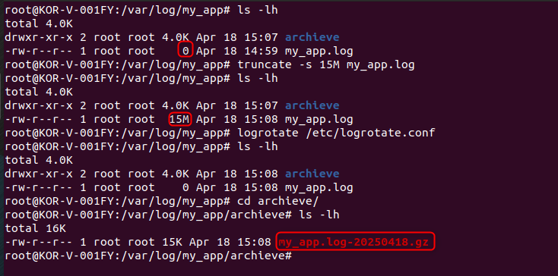

* The question that I had was without manual trigger we didn’t see any files created and I thought its done every week, but no, the logrotate wont keep checking your log files when it becomes greater than 10MB it will rotate it, logrotate is triggered at a certain time
* We can check it using systemctl status logrotate.timer

