**Linux RSYNC Tutorial in [Hindi] | MPrashant**

* rsync means remote synchronization
* RSYNC is a utility for efficiently transferring and synchronizing files across different systems or locations
* Its known for its speed, flexibility and efficiency
* Rsync optimizes file transfer by sending only the chnages made and ensures that file permissions, ownership and timestamps are preserved
* It is similar to scp but the difference we rsync is it uses synchronization so first time its usually slower that scp but after that rsync is much faster than scp
* Syntax for rsync – rsync [options] /source_loc username@ip_address:destination_loc
  + Options : -a or –archive for archiving files
  + -v or –verbose for verbose output
  + -z or –compress for compression
  + –progress to show progress during transfer
  + -b for taking backup before deletion
  + -d to delete files before copying
  + –backup-dir=/tmp/

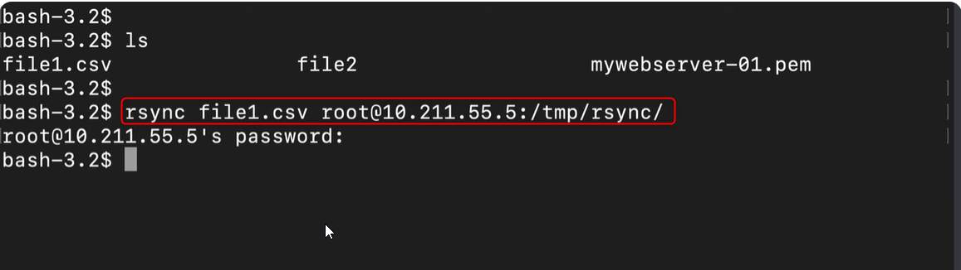

* Output of rsync using options verbose, compress and progress

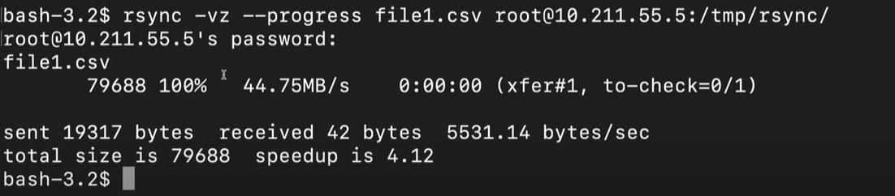

* If you use -a or –archive option that means the date and time will also be preserved
* Say now I change only 1 line in my source file and want to send it gain, so instead of copying all the content of the file, it will only copy the change and modigy the destination file

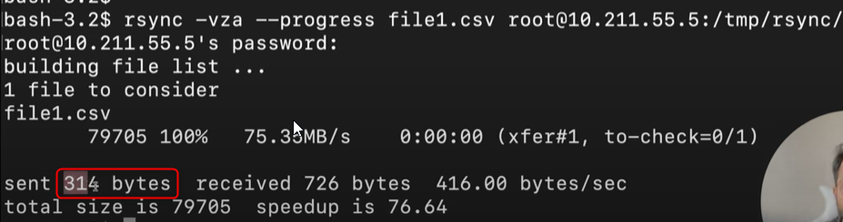

* With -b option when you run rsync command, in your destination location along with the file you transfer you will also have filename~ this is your backup file, which will have the old content, say I transfer file1.csv first time, then I realize ok I need to do a change, I change the file1.csv send it but with backup enables, then the old file1.csv will be saved as backup file(~) and a new file1.csv will be saved with the new content that you added
* But note that everytime you make a change and run rsync command it wont generate a backup file for each change, it will keep updating the file1.csv and file1.csv~ with the previous change (so if I have done 3 changes to file1.csv, third change is saved in file1.csv 2nd change in file1.csv~)

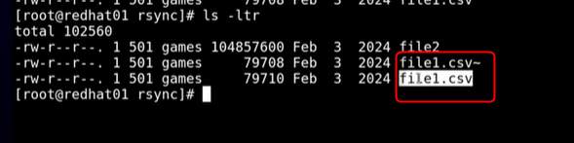

* Now as we can see all the backup files are saved in the same location as the main file, if I don’t want it like this, I want all the backup files to be saved in a backup folder run – rsync -b –progress –backup-dir=/backup_path /source username@ip:/destination_path

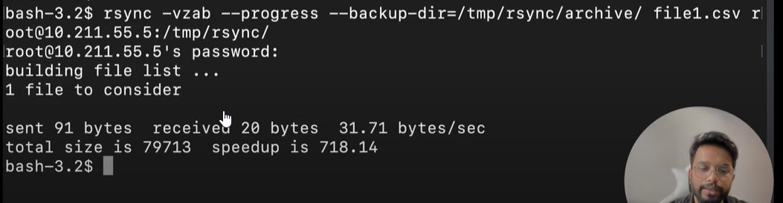

* Note that archive files in the backupfolder don’t have a ~ sign
* Say I want all the backups to be saved, not just the previous backup like an entire history of backup needs to be saved then we can run - rsync -b –progress –backup-dir=/backup_path/$(date + %Y%m%d-%H%M%S) /source username@ip:/destination_path

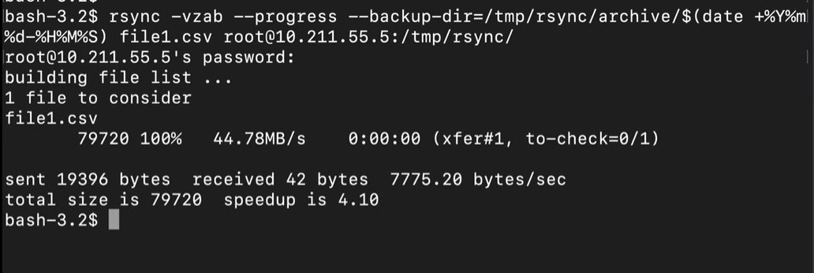

* Now in the archive folder we can see backup folders with date and time

