**Linux Apache Web Server HTTPD | Setup with Example in Hindi | Beginners**

* HTTPD or HTTP Daemon is a software program that runs in the background of a web server and waits for incoming server requests
* The daemon answers the request automatically and serves the hypertext and multimedia documents over the internet using HTTPD
* To install httpd run - sudo apt install -y apache2
* What is apache and httpd

• **Apache** usually refers to the **Apache HTTP Server** project (and the Apache Software Foundation that maintains it).

• **httpd** literally means “HTTP Daemon” and is the name of the **server binary** (and the package name) on RHEL/CentOS systems.

* To check the apache2 version run - apache2 -v

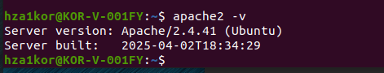

* Config file for apache – cat /etc/apache2/apache2.conf

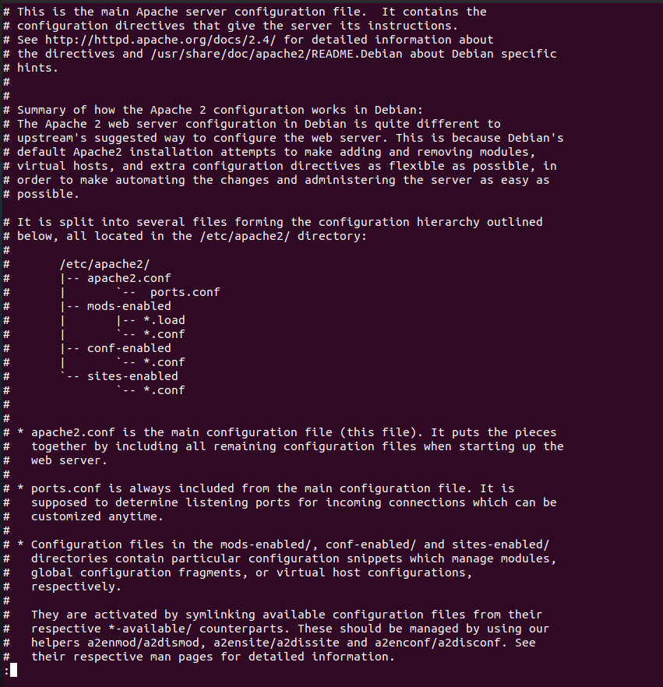

* Log files for apache - cd /var/log/apache2/
* To start the apache2 service - sudo systemctl start apache2
* To enable the apache2 service - sudo systemctl enable apache2
* In the /etc/apache2/apache2.conf file we can see that we have ports.conf file that has all the listening ports

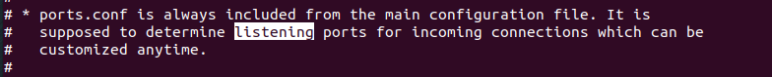

* Content inside /etc/apache2/ports.conf

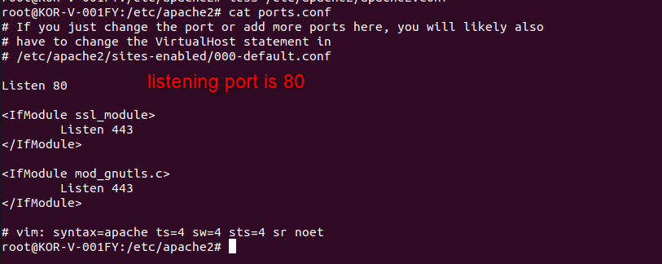

* All the error messages are saved under error.log

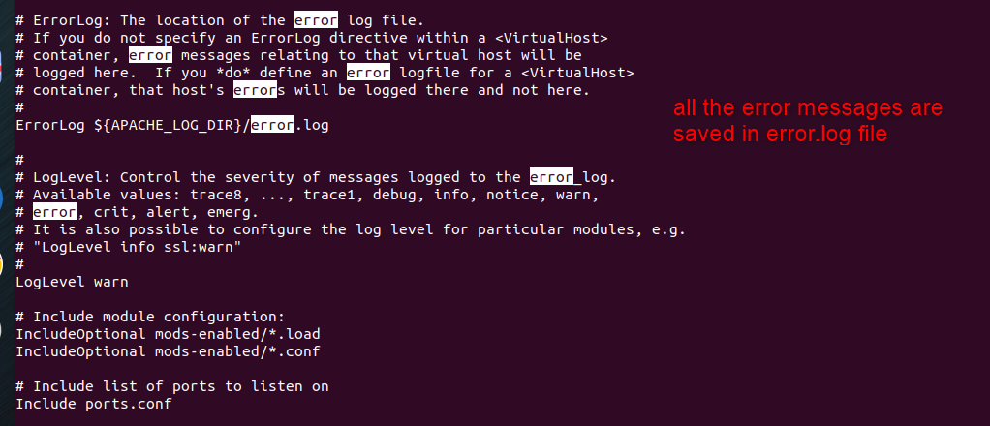

* content inside /var/log/apache2/error.log file



* now lets move to html root folder which is cd /var/www/html

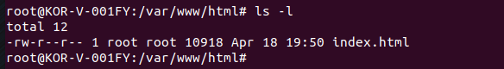

* here we already have a index.html file present so either we can just show index.html content or we could change index.html to the below content and run it
* content in index.html

<!DOCTYPE html>

<html lang="en">

<head>

<meta charset="UTF-8">

<meta name="viewport" content="width=device-width, initial-scale=1">

<title>My First Web Page</title>

</head>

<body>

<h1>Hello, welcome to your first ever web page because you stopped watching CWH HTML Course!</h1>

</body>

</html>

* next we will start the httpd service using command – systemctl start apache2.service

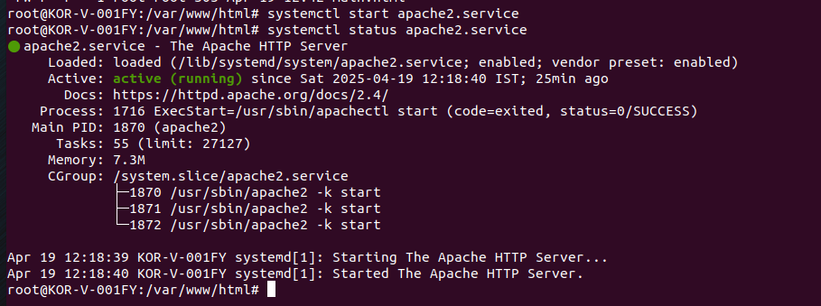

* Now to access our web page we need the linux server’s ip address, we will use 127.0.0.1(since for ssh also this ip works and I have already established port forwarding with this ip)

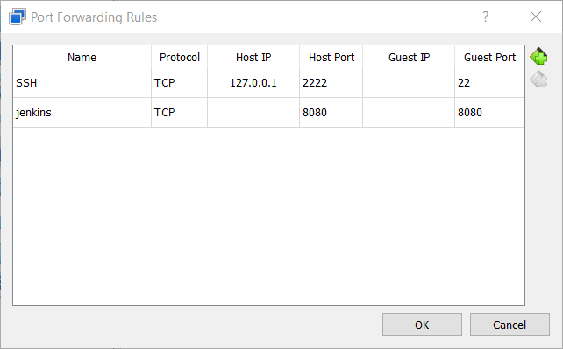

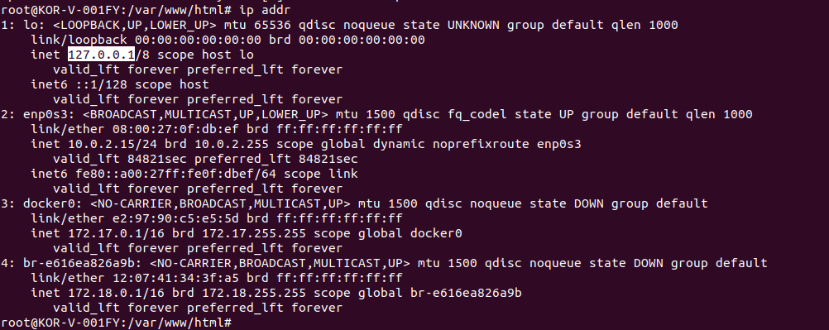

* Now on our linux firefox browser run 127.0.0.1:80(if web page doesn’t appear try stopping firewall service, for me even if it was active it worked)
* 127.0.0.1:80 o/p without any changes in index.html

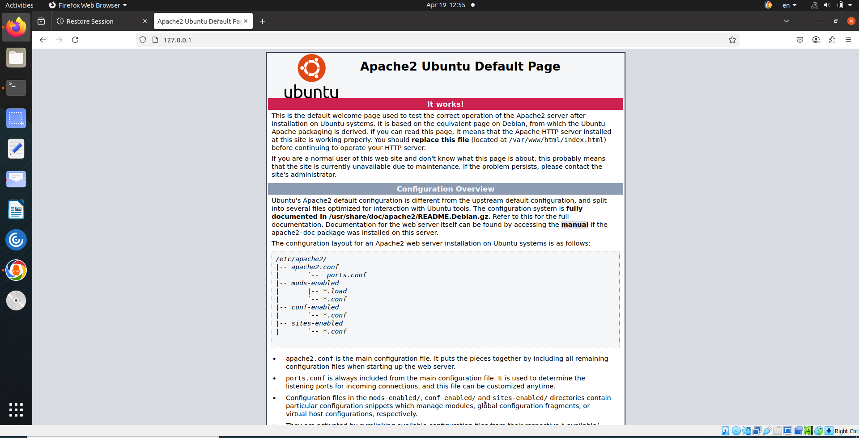

* 127.0.0.1:80 o/p with changes in index.html

