**What is NGINX WebServer With Example Setup on Linux [Hindi]**

* Nginx is a web server that accepts requests via HTTP/s and respond to display website content through storing, processing and delivering web pages to users
* This can also be used as a reverse proxy, load balancer, mail proxy and HTTP cache
* Companies like Airbnb, Netflix, WordPress.com and many others deploy NGINX for scalability and performance reasoning
* To install nginx on ubuntu follow the below steps –
  + sudo apt install nginx
  + sudo systemctl start nginx
  + sudo systemctl status nginx
* I was able to install nginx but when I was trying to start the service I got the below error –

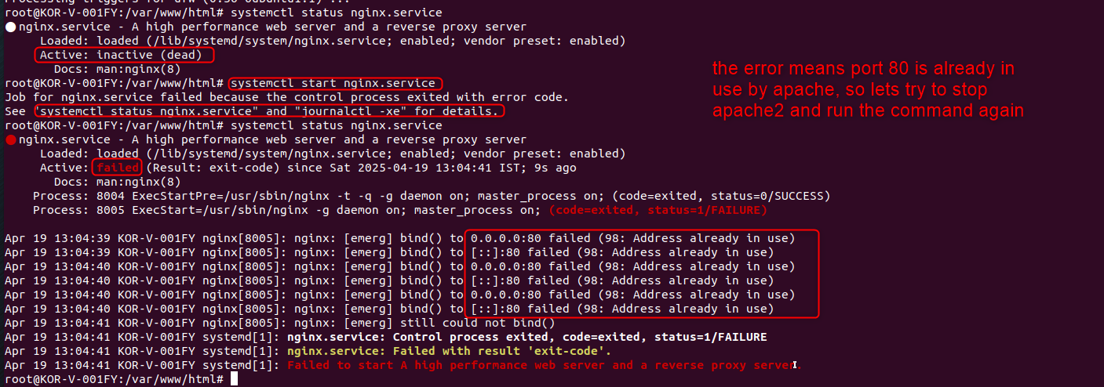

* Running systemctl stop apache2.service since apache2 is using port 80

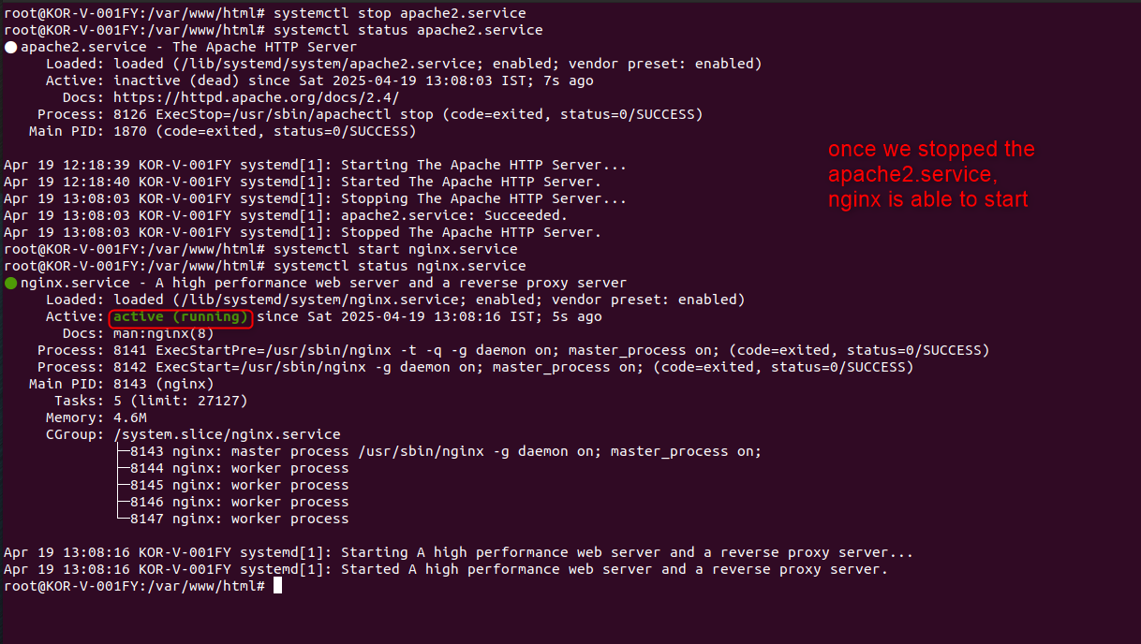

* Another way of verifying whether nginx is working or not is using – curl -I 127.0.0.1

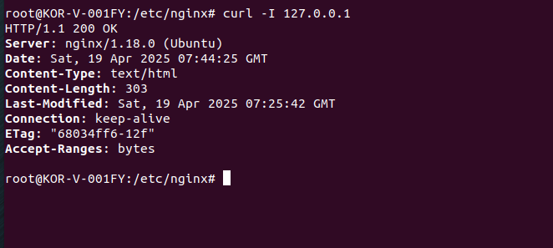

* Config file for nginx is present in - /etc/nginx/nginx.conf

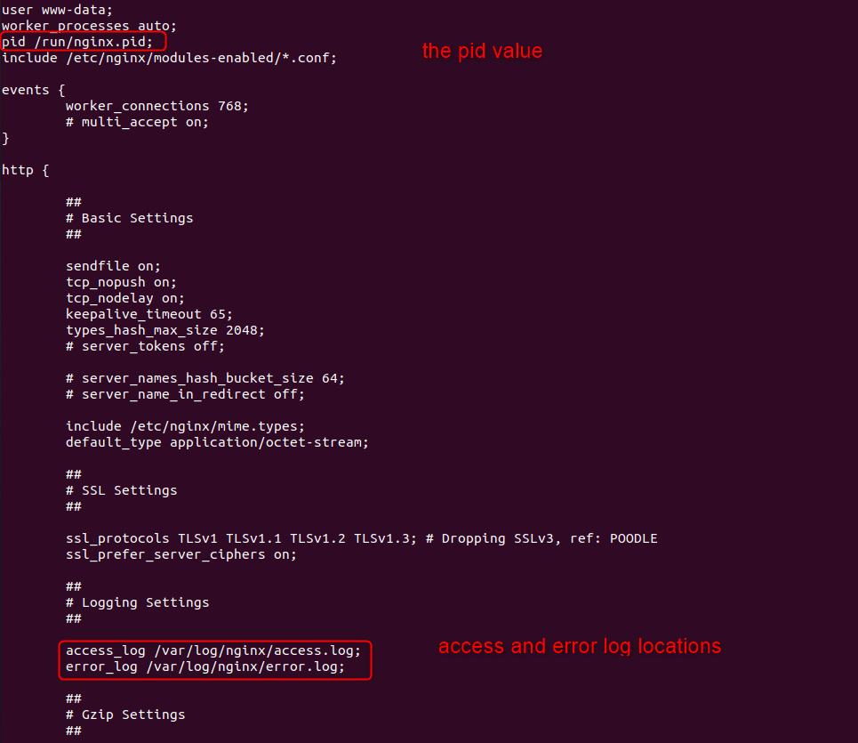

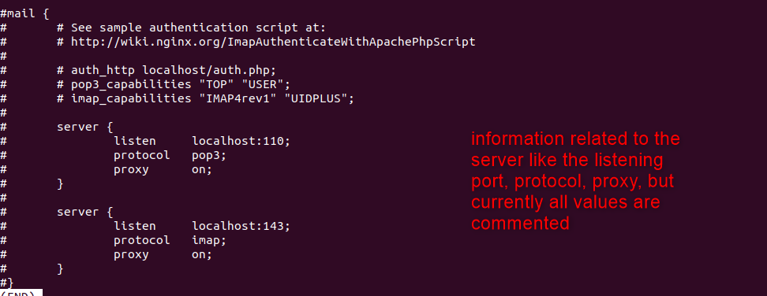

* Currently nginx uses 80 port so when we were trying to start the nginx service we were getting error saying port 80 is already used
* That is mentioned in the below file - /etc/nginx/sites-available/default

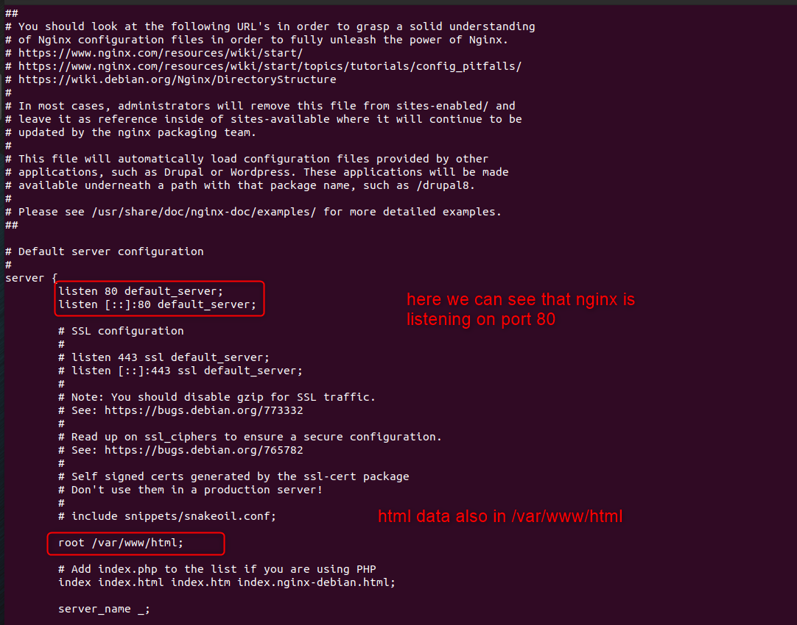

* One advantage of nginx over apache is that in nginx case for errors we already have html files created like 404.html, 50x.html and so on, in case of apache we will have to manually create it



* Now the nginx html file index.html is present in - /usr/share/nginx/html



* But when I run 127.0.0.1 I still see the apache2 webpage coming, though we have disabled apache2
* This is because in /etc/nginx/sites-available/default file the root is still set to location root /var/www/html;

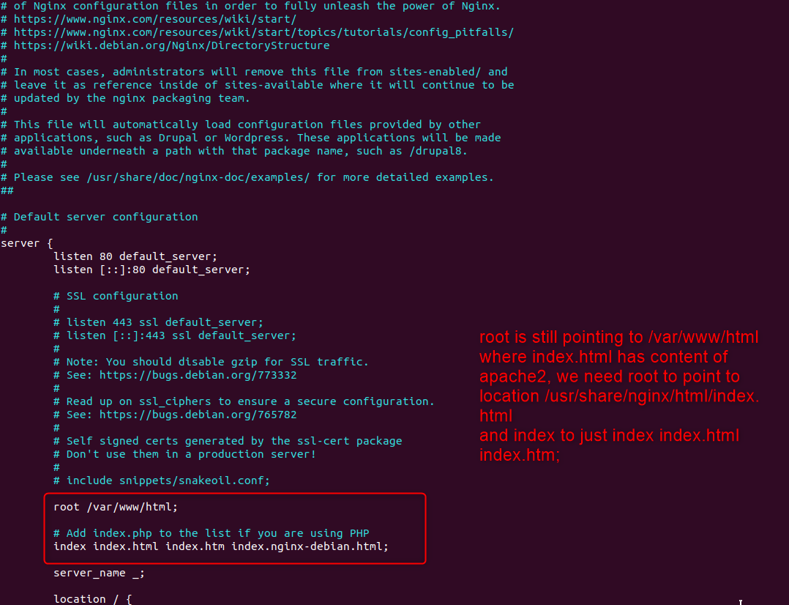

* Updates values in default file

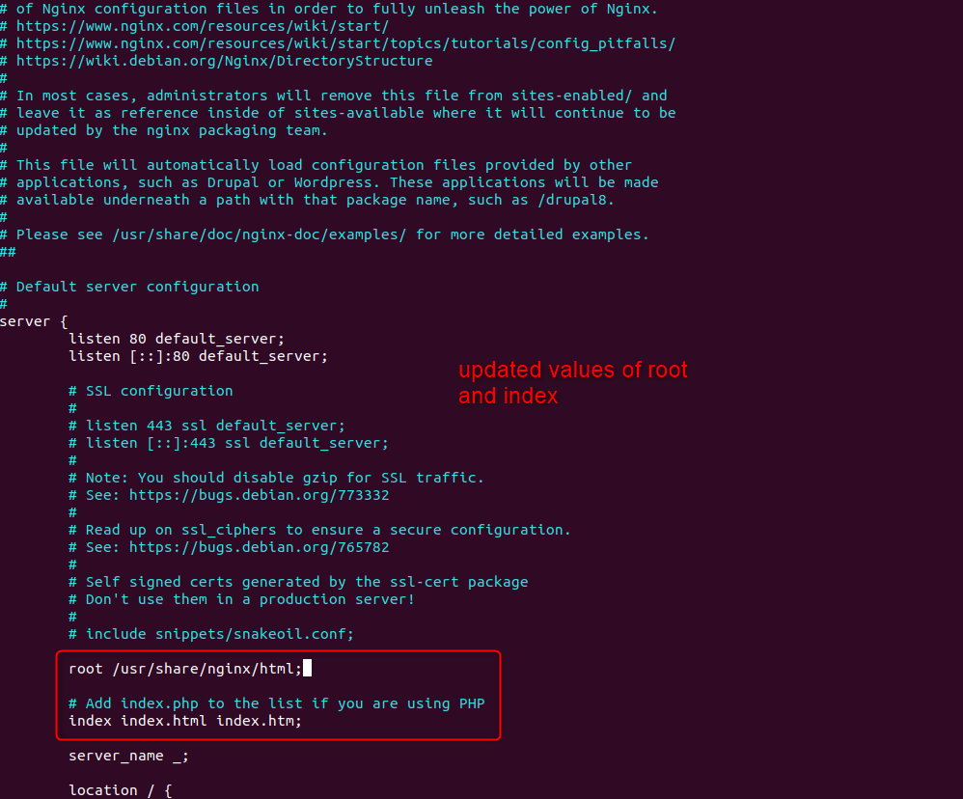

* Next just reload the nginx service using – systemctl reload nginx
* Then either refresh the link or again open 127.0.0.1.
* We will see nginx page opening

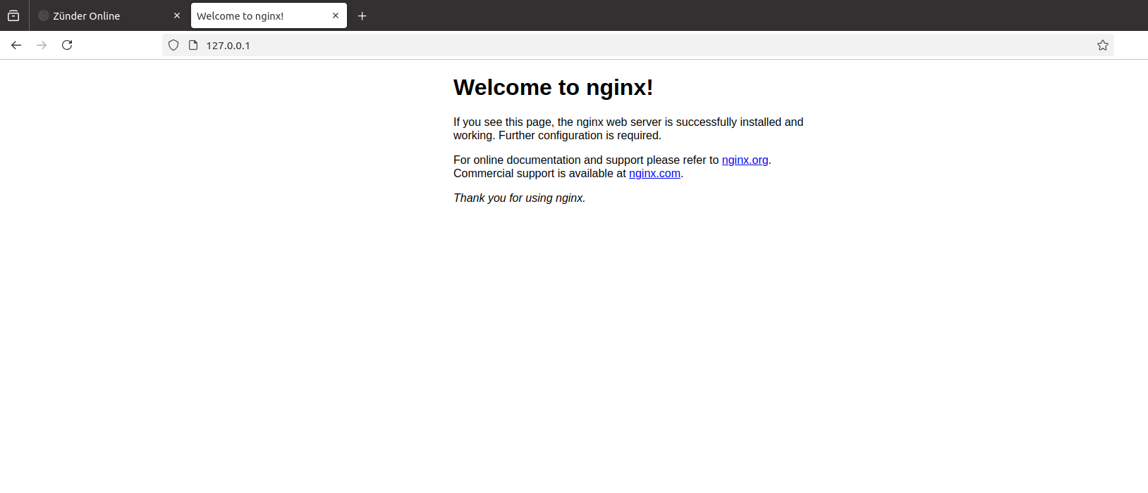

* Error logs are saved in /var/log/nginx/error.log
* Access logs are saved in /var/log/nginx/access.log

