**FTP in Linux | FTP Server in Linux | MPrashant**

* The File Transfer Protocol is a communication protocol used for the tranfer of computer files between a client and server on a computer network
* It uses TCP/IP
* FTP is also used to upload/download files from websites and servers
* To transfer files using ftp protocol we need ftp service installed on the client side and vsftpd service on the server side

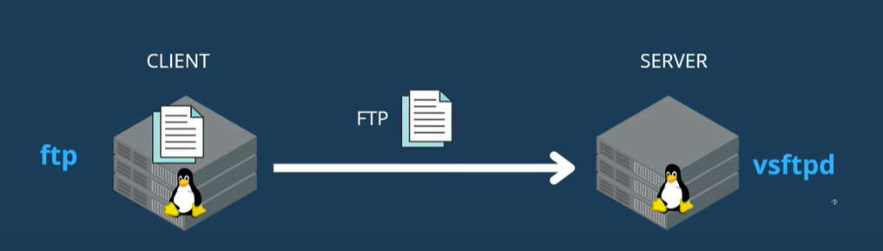

* To transfer files I have 2 vm’s one the KOR-V-001FY and one more VM for hza1kor and network is working in both unlike wsl so I will try to send files using ftp here
* Client will be kor-v-001fy so I will install ftp here and server will be hza1kor so I will install vsftpd on this end
* On client end I already have ftp present



* On server end we will need to install service vsftpd

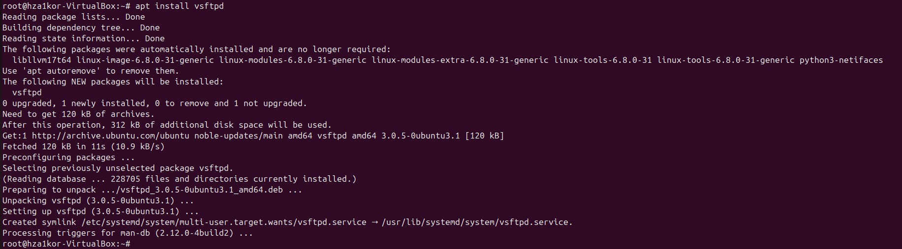

* Then we will have to do changes in vsftpd config file - /etc/vsftpd.conf
* In the vsftpd.conf file we have to make sure the below options are same

anonymous_enable = NO

ascii_upload_enable = YES (Uncomment this line)

ascii_download_enable =YES (Uncomment this line)

* use_localtime = YES
* In the conf file anonymous_enable was already set to NO, ascii_upload_enable and ascii_download_enable were commented I uncommented these lines and use_localtime was already set to YES
* Next step is to start the enable the vsftpd service using – systemctl enable vsftpd

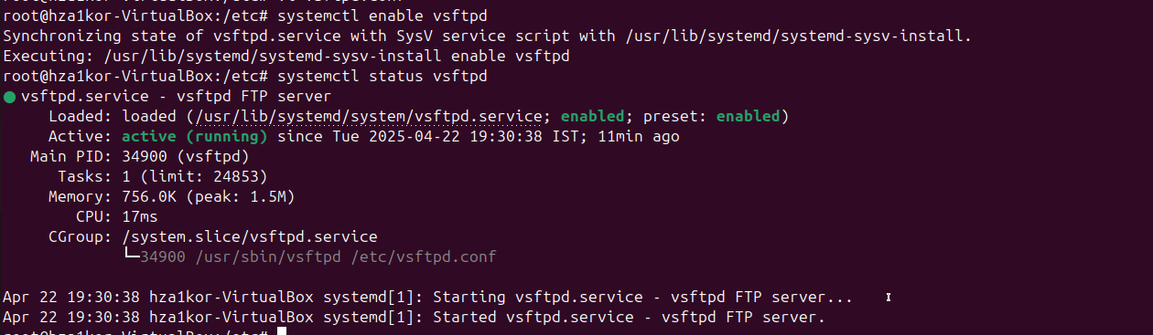

* We will also need to disable firewalld service since firewalld service usually don’t allow transfers due to security reasons– systemctl stop firewalld

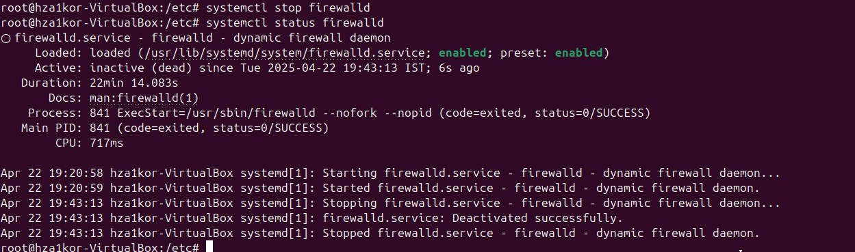

* Ip address that I will use for client end(though only server ip is required)

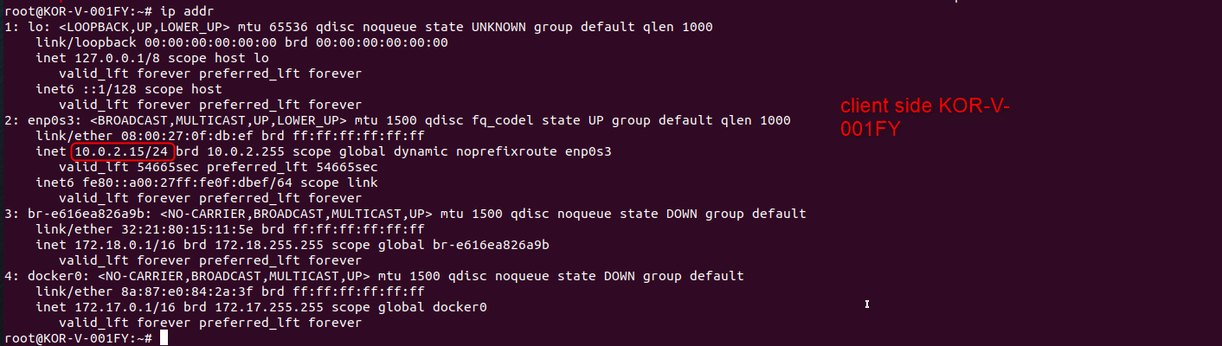

* Ip address of server that I will be using

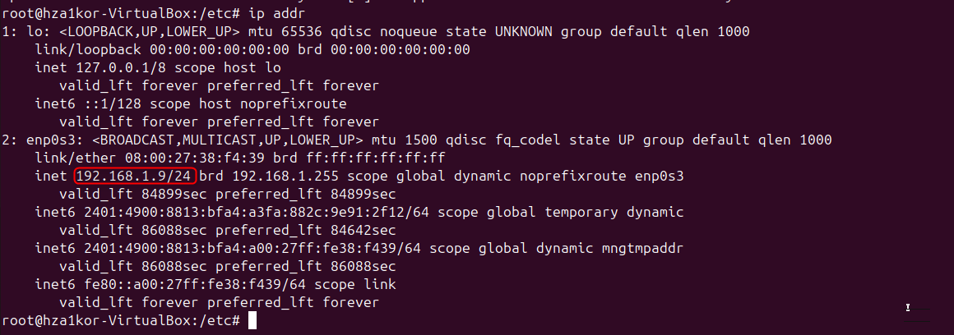

* Now on the client end we run – ftp 192.168.1.9
* With these changes ftp didn’t work I keep getting the connection timeout error



* chatgpt suggested to also change the below things

listen=YES

listen_ipv6=NO(Because 192.168.1.9 is a ipv4 address and not ipv6)

* also uncommented write_enable=YES since we want to upload files on the server
* next we will have to double check if port 21 is open and accessible - netstat -tuln | grep :21
* then we restart the vsftpd service - sudo systemctl restart vsftpd
* still connection timeout error
* chatgpt suggested to add listen_address=0.0.0.0 in vsftpd.conf file since vsftpd is currently bound to ipv6 but since we are trying with ipv4 we need to explicitly bind vsftpd to listen to ipv4
* tried everything, still not able to establish connection just gonna write the command from prashant’s video now
* run command ftp <ip-addr>
* once connection is established it will ask you for your username and password

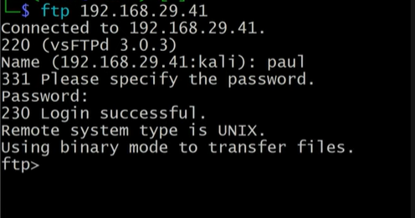

* now to send files run – put <file_name/file_path>

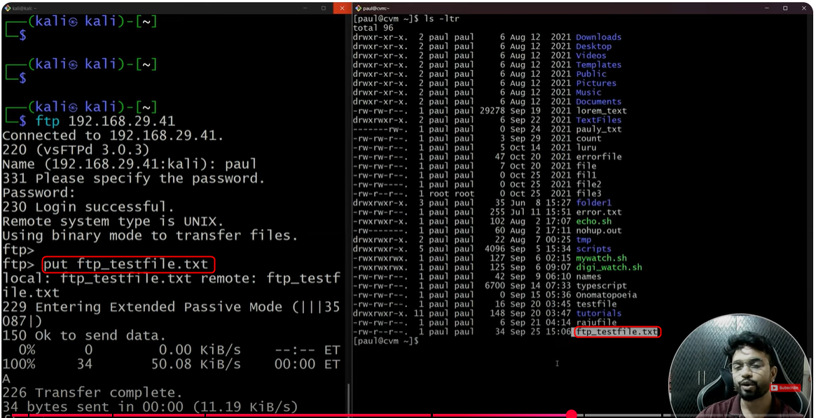

* with ftp its like you are accessing the server side, you can create files directly using touch or make directories using mkdir and on sever side those files will be created
* with scp you were not able to access the remote server, you could just send files, but with ftp you can literally login and send files, create on the go and so on

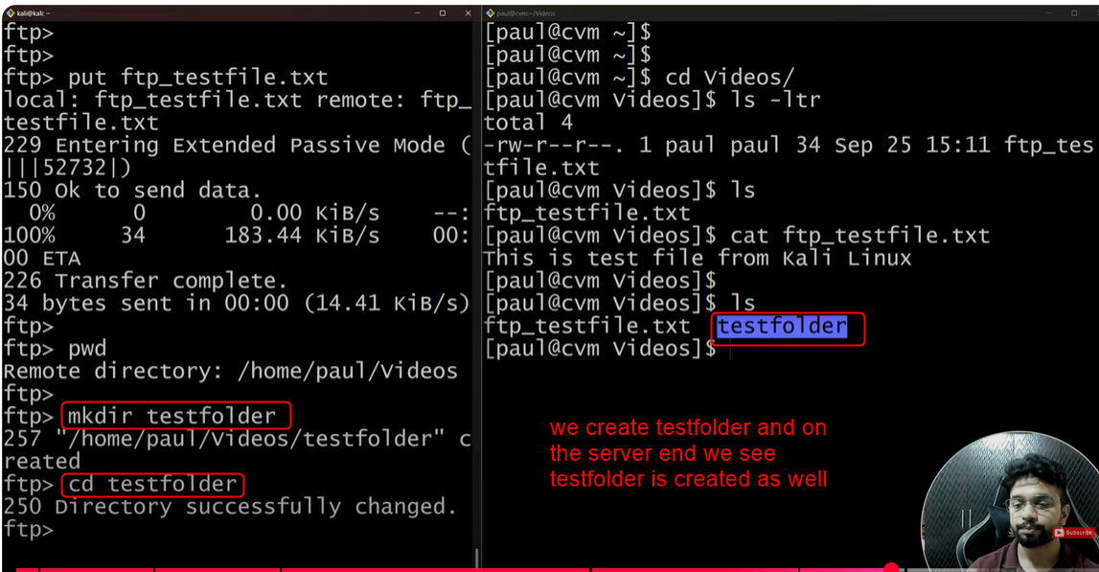

* for single files put can be used, but say you want to send multiple files then you can run – mput file1 file2 ..

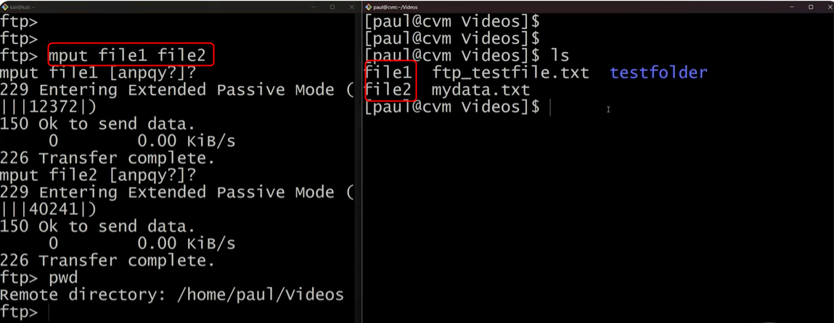

* now say I want to send files from server to host use command – get filename (on client side)

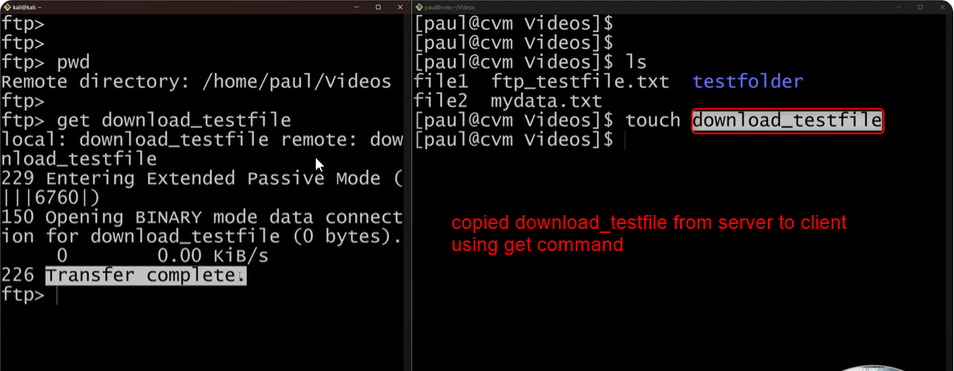

* ok in the end I was able to successfully connect to 2 VMs and perform the test
* I created 2 new ubuntu machines with bridged connection

Sapna_02

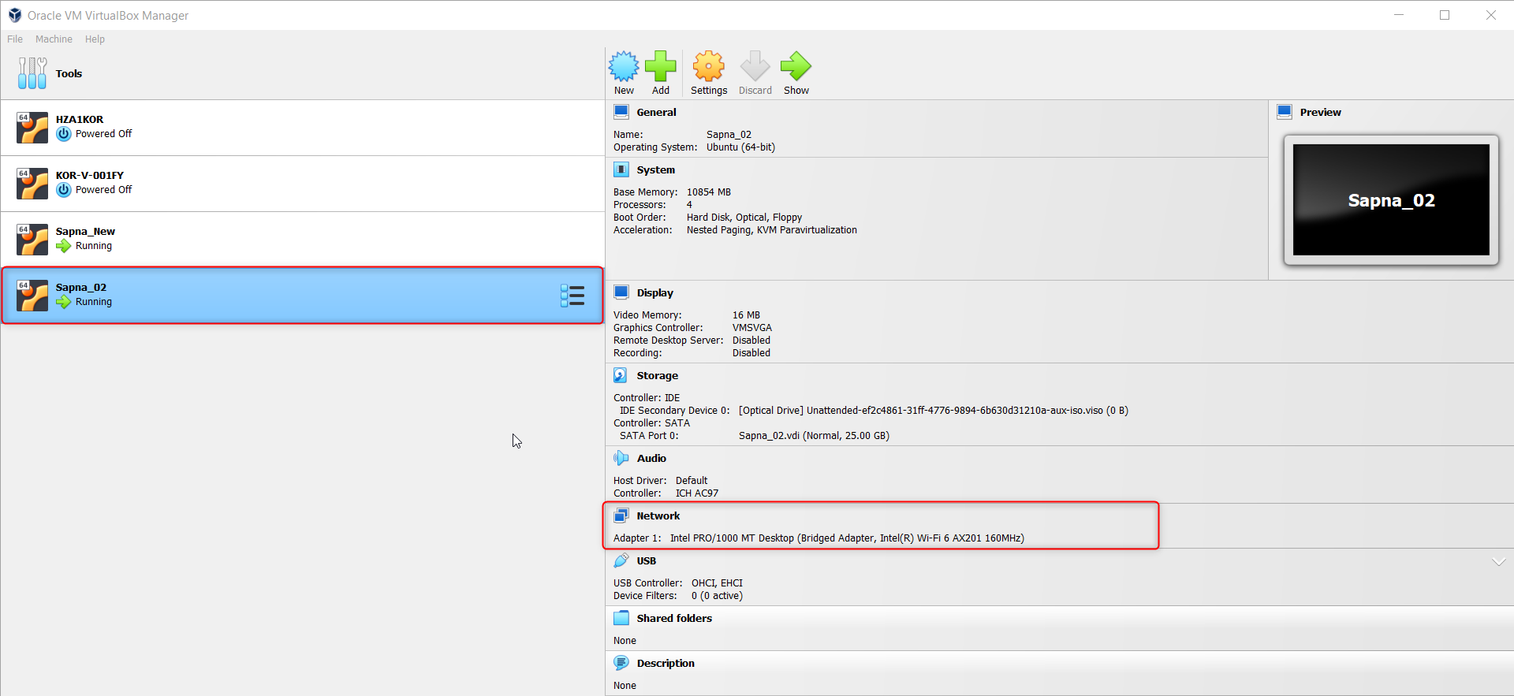

Sapna_New

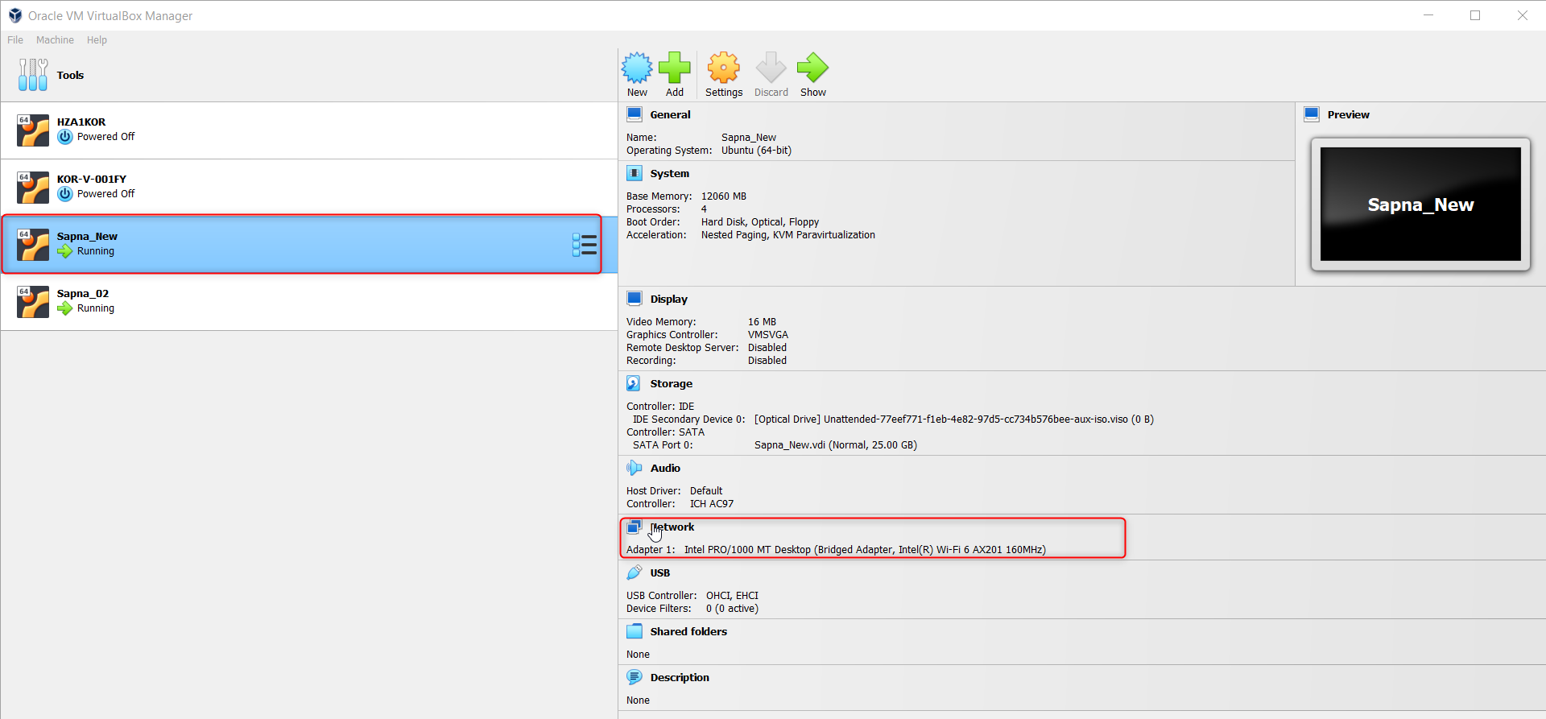

* Ip address of sapna_02 is – 192.168.1.8

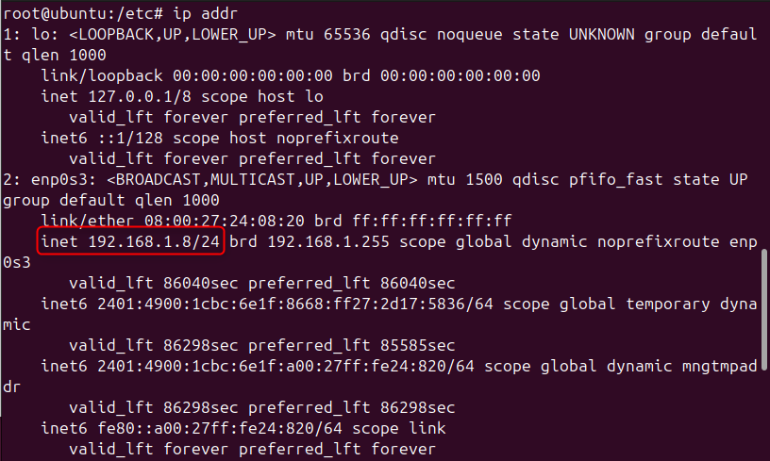

* Connection with server side from client end
* Command – ftp 192.168.1.8
* Created a folder in /home/ubuntu

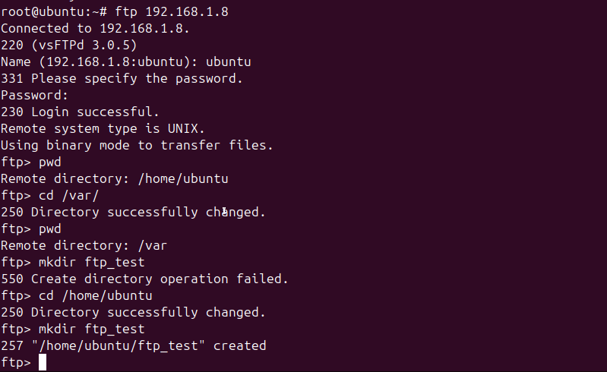

* Next to put files
* Created a simple log_file in the root directory, then established ftp connection and sent it

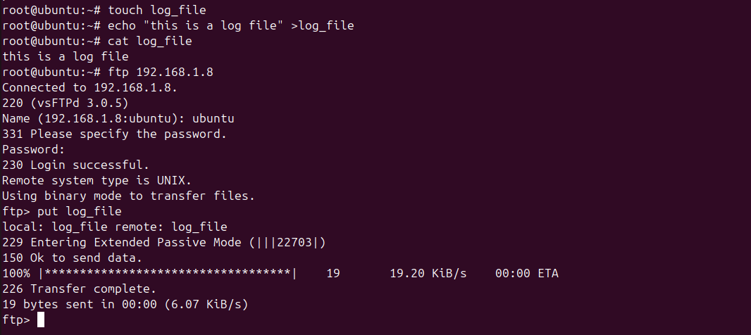

* On the other end int /home/ubuntu we now have the log file as well

