**Learn Linux NFS Fast--You WON'T BELIEVE What Happens Next! | MPrashant**

* NFS – Network file system
* NFS is a network protocol for distributed file system
* Using this, a user on the client computer can access the files on server side like as they are accessing locally
* The only tricky part is both client and server should be on the same network (like understood in the last video how same network is imp else connection is not possible)
* In simple words NFS I like a remote access to server, say I have a client who want to access apps folder present in server, modify it be able to see the content present in apps folder, it can easily do it using NFS

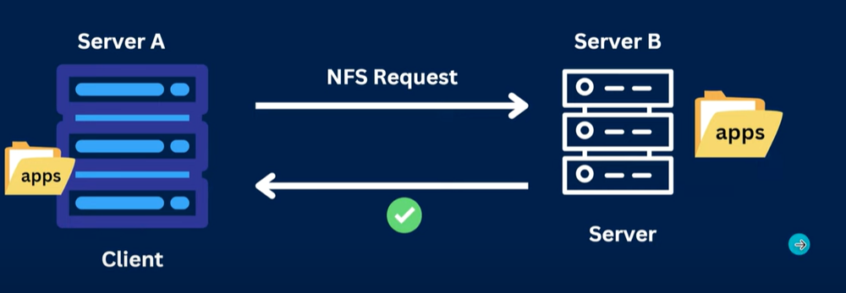

* To setup NFS, we need to configure both the client and the server
* Server side configuration –
  + Install NFS package – apt install nfs-common
  + NFS exports package - apt install nfs-kernel-server
  + To start NFS service - systemctl start nfs-kernel-server

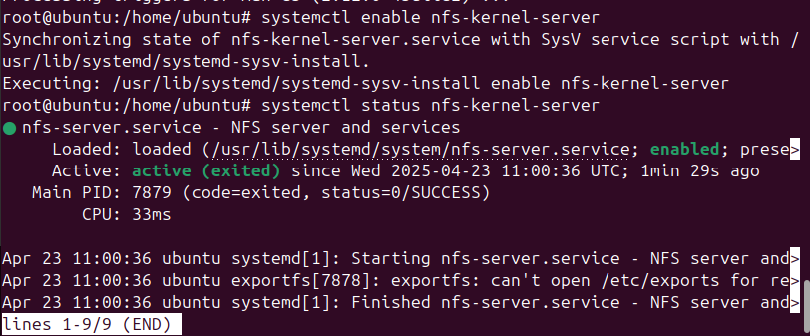

* + Create a new directory for NFS and give all permissions first change location to root – mkdir server
  + Then inside server folder make another folder called apps and give all permissions to server folder and apps folder

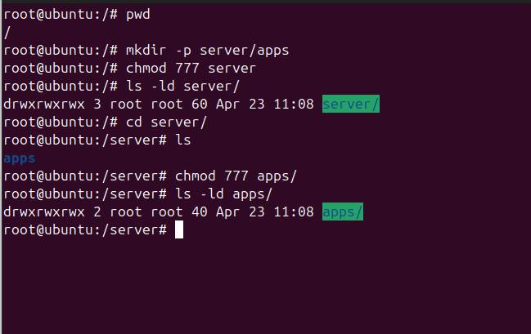

* + Now we need to modify the /etc/exports file and add the shared filesystem(server)
  + Example - /apps <IP_allow>(rw, sync, no_root_squash)
  + Here /apps is the folder name we want to share
  + IP allow is the aip address or hostname of the client server
  + In () we have all the rules
  + Like rw means read, write permissions should be present
  + Sync means all the changes from the client side should be updated on the server side as well
  + no_root_squash means no root privileges should be provided
  + Content I added - /server/apps 192.168.1.6(rw,sunc,no_root_squash,no_subtree_check)

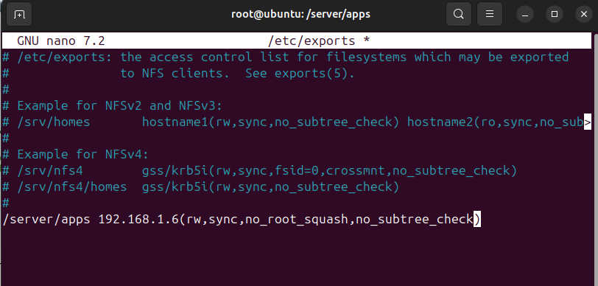

* + Next run command – exportfs -rv
  + When I ran this command I see the below error –

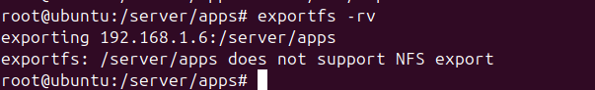

* + Here the problem is with server folder, when I see the file system type using command – df -T /server/apps it shows type as overlay

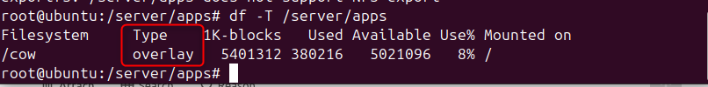

* + NFS cant support export of overlay type system
  + Chatgpt suggests to create a folder again in exports
  + mkdir -p /exports/server_apps and inside server_apps create folder apps and give all permissions

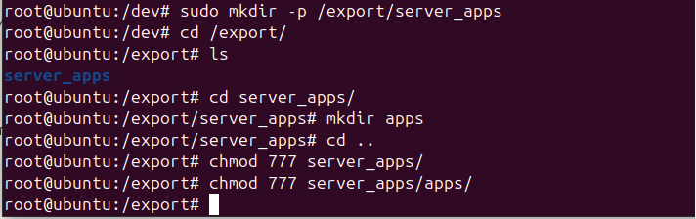

* + in /etc/exports now modify the file to /export/server_apps 192.168.1.6(rw,sync,no_root_squash,no_subtree_check)

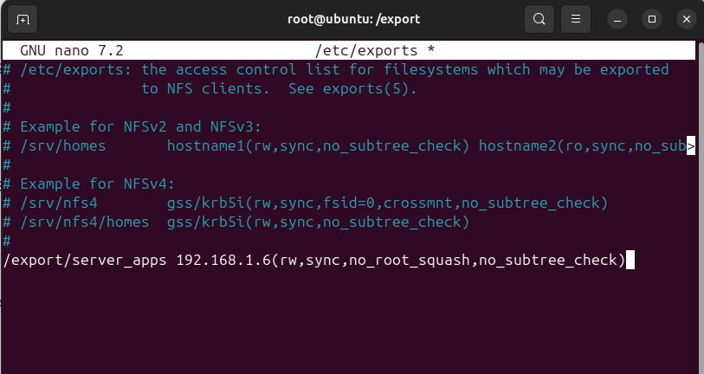

* + tried everything, the file system is the problem options are to mount an entire file system I need to add a new hard disk, it will take to long, just gonna follow the video now
* client side configuration –
  + install nfs on the client side as well
  + and enable the nfs service
  + stop firewall on both the client and server side
  + check the mount on the client side – showmount -e <server_ip> Eg- showmount -e 192.168.1.8
  + Example o/p –

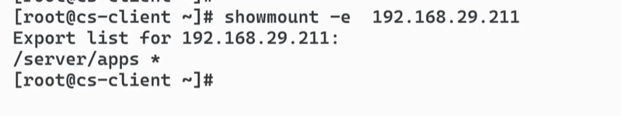

* + On client side create folder apps inside mount directory – mkdir /mount/apps
  + Mount the NFS file system – mount <IP_Server>:/server/apps /mnt/apps

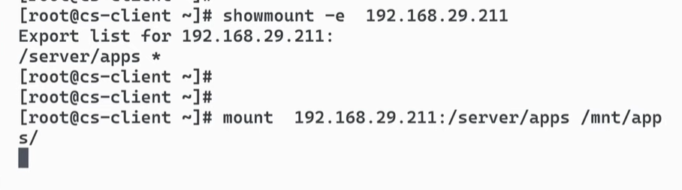

* + To confirm that the mounting is done run – df -h

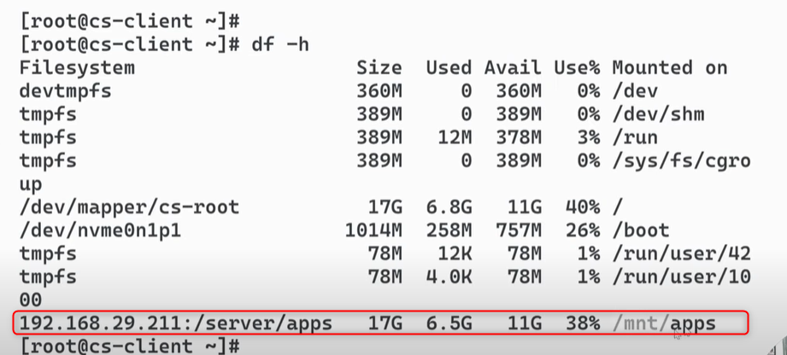

* Now you open /mnt/apps on client side and /server/apps on server side
* Now when you create any files on any side, the other side will also be updated

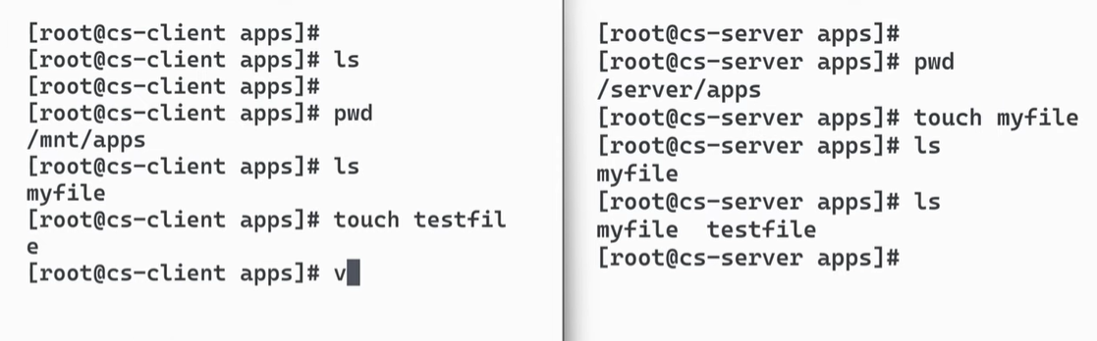

* Even if you edit files on any side the other side will also be updated

