**Learn Linux SAMBA Server Fast--You WON'T BELIEVE What Happens Next! | Mprashant**

* Samba is a linux utility or tool to share linux files and services to other OS
* Samba uses Server Message Block(SMB) and Common Internet File System(CIFS) protocols
* CIFS is just an extension of SMB
* Server side configuration
  + Install samba pkg – apt install samba-client samba-common

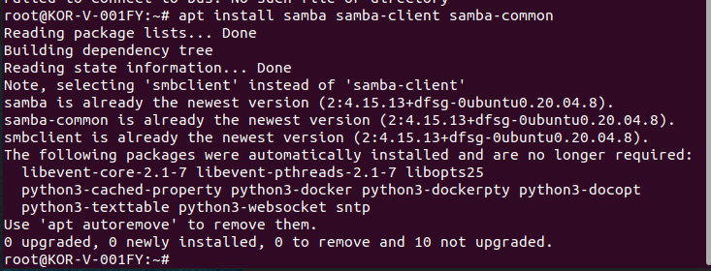

* + Firewall usually blocks samba so better to add the below cmd(but I mean you can just disable firewall) – firewall-cmd –permanent –zone=public –add-service=samba
  + Next run - firewall-cmd –reload

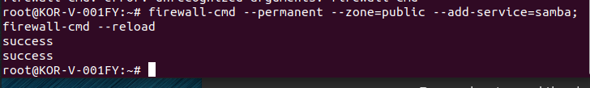

* + For now lets just disable firewalld using systemctl command

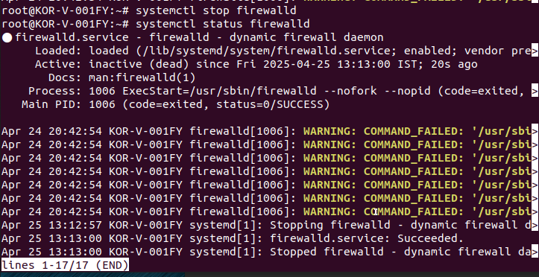

* + Then in root directory create folder /samba/apps

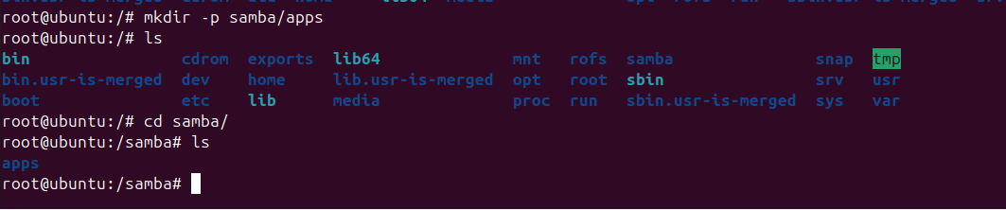

* + Inside apps folder create a file named samba_testfile
  + Then give all permissions to samba, apps and samba_testfile

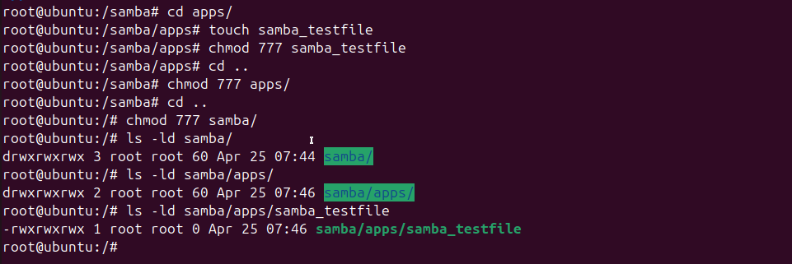

* + Next we need to change SElinux security context for samba shared directory in case SELinux is enabled – chcon -t samba_share_t /samba/apps
  + When I run the chcon command I get the below error –



* + Lets move on to the next step – in file /etc/samba/smb.conf file we need to add the shared dir
  + Content in smb.conf file to add –

[global]

workgroup = SAMBA

netbios name = UBUNTU ; any name is fine, upper-case is traditional

security = user

map to guest = bad user

dns proxy = no

hosts allow = 192.168.1.0/24 127.

[Apps]

comment = Shared Dir

path = /samba/apps

browsable = yes

read only = no

guest ok = yes

guest only = yes

guest account = nobody

force user = nobody

force group = nogroup

create mask = 0664

directory mask = 0775

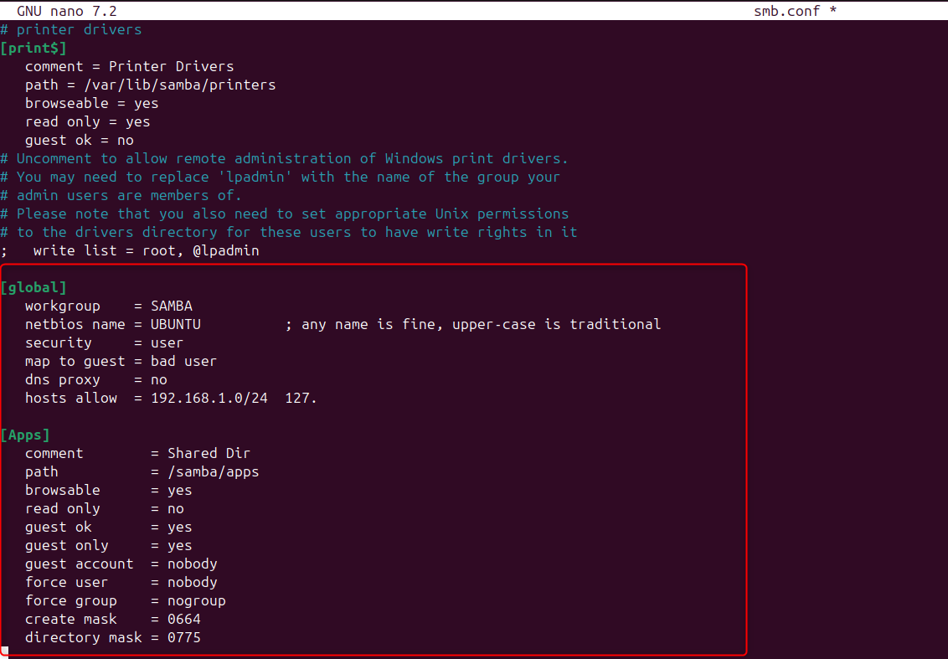

* + Next run testparm command to check the syntax then enter and if you see the global and apps then its all fine

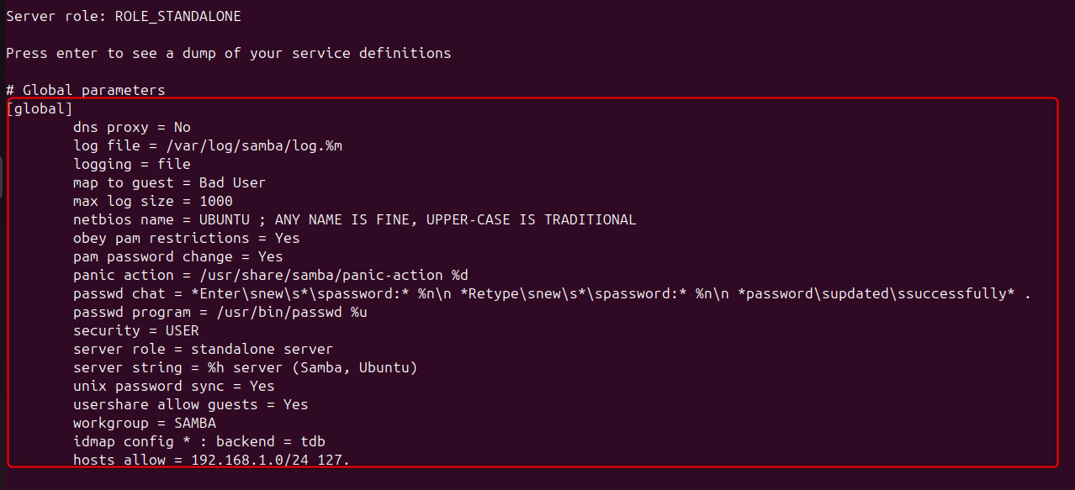

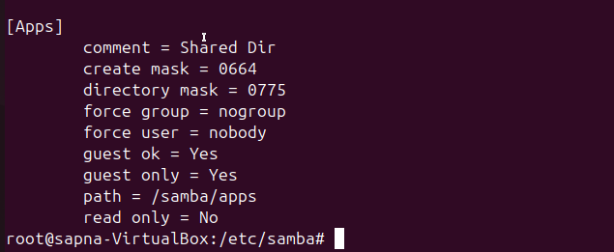

* + Next we can enable and start samba – systemctl enable smbd ; systemctl enable nmbd ; systemctl start smbd ; systemctl start nmbd
* Client side configuration –
  + On windows we just have to run - \\192.168.1.11 in file explorer, but I get the below error

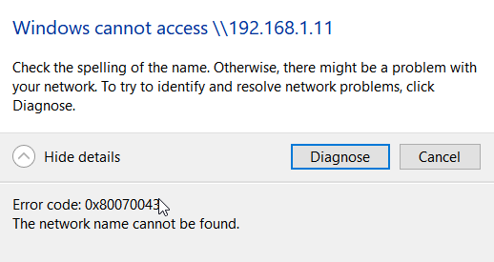

* + No use of doing all this, I am just gonna follow the video now
  + He access this location on windows and apps folder opened for him
  + Then he tried to create file on linux and see if its visible on windows and vice versa
* Next is to try from linux to linux
* Client side configuration on linux –
  + Install samba packages – apt install cifs-utils samba-client
  + Create a mount directory –cd /mnt; mkdir -p /samba/apps
  + Mount the samba directory – mount -t cifs //<Ip_address>/Apps /mnt/samba/apps
* Example - mount -t cifs //192.168.1.11/Apps /mnt/samba/apps

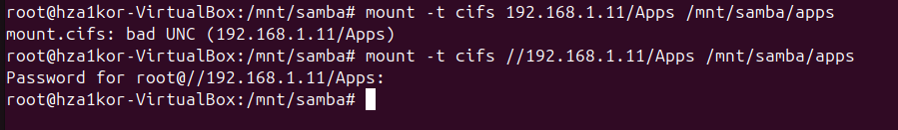

* To check if the mount was successful run command – df -h

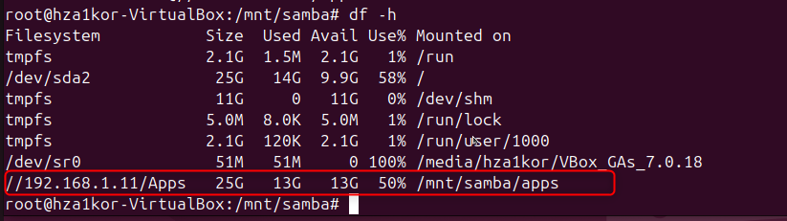

* Next go to – cd /mnt/samba/apps folder
* Now create a file – touch samba_clientfile

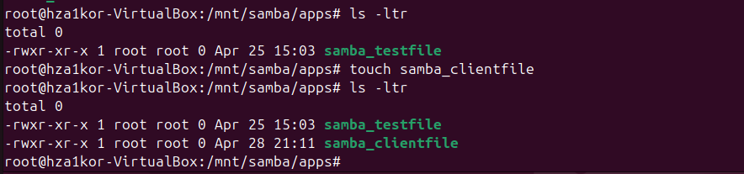

* Now when you check server side – cd /samba/apps you will see the samba_clientfile created

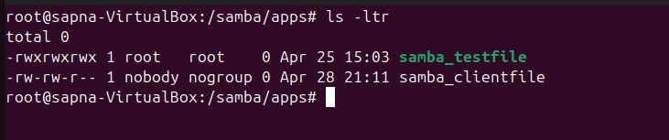

* Now say on server side I create a file named – touch samba_serverfile

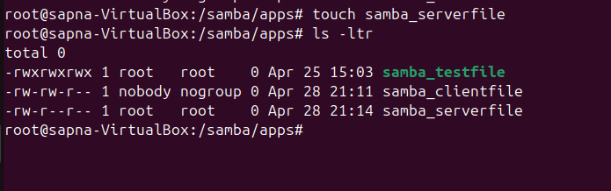

* Now when we check the client side we have the serverfile here as well

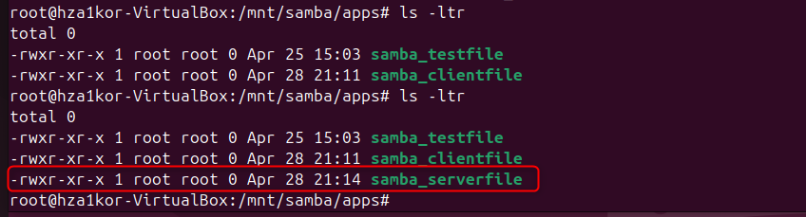

* How to secure SAMBA Server –
* For this we will create a group – groupadd smbgrp
* Next we will create a user named testuser – useradd -M -d /samba_secure -s /usr/sbin/nologin -G smbgrp testuser
* Check the id of testuser using – id testuser

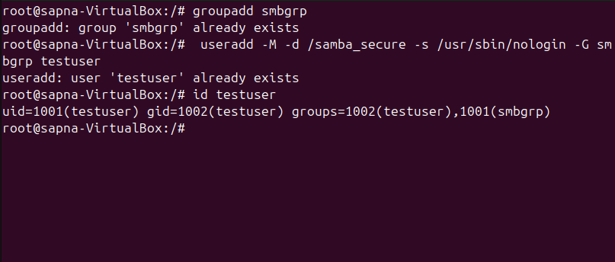

* Then in root directory we create a samba_secure folder – mkdir samba_secure
* Next we change the owner and group owner to testuser and smbgrp – chown testuser:smbgrp samba_secure

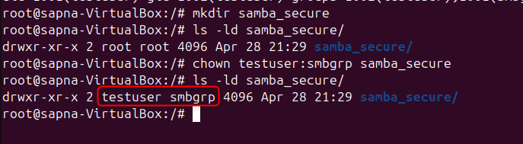

* Then we also change the permissions to – chmod 2770 samba_secure
* 2770 is octal permissions **2 770**: the leading **2** turns on the **set-gid bit**, and the remaining digits are normal modes—**7** (rwx) for the owner, **7** (rwx) for the group, **0** for others.
* So the owner and the group can read, write, and execute; everyone else has no access, and on a directory any new files created inside inherit the same group because of the set-gid flag.
* Next we run – chcon -t samba_share_t /samba_secure/

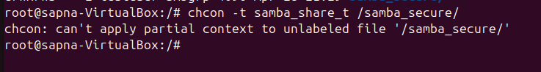

* This error I keep getting and I saw why this issue comes, I have to mount and the file system I have is not correct bla bla so I will leave to this
* Next we set password for testuser – smbpasswd -a testuser

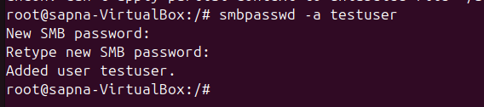

* Then we enable the user using - smbpasswd -e testuser

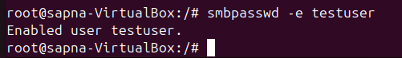a

* Add the below lines in /etc/samba/smb.conf file –

[Secure]

path = /samba_secure/

valid users = @smbgrp

guest ok = no

writable = yes

browsable = yes

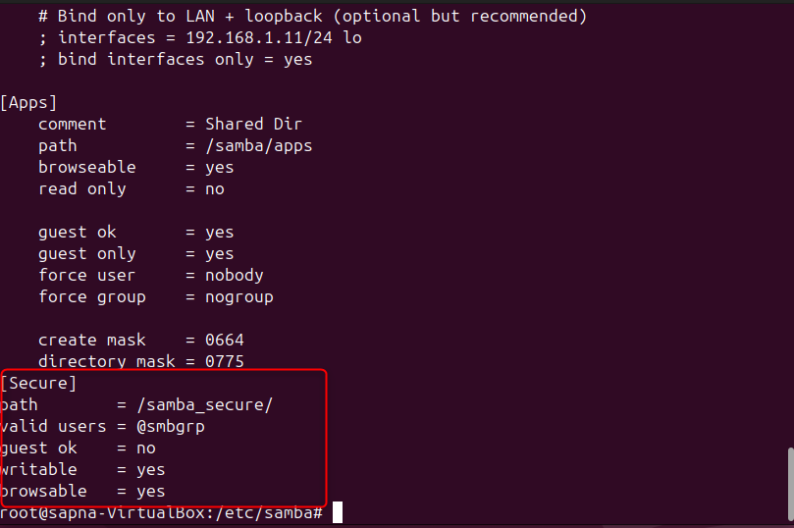

* Next we restart smb and nmb services using – systemctl restart smb nmb
* Next when you run windows + r and give server ip - \\192.168.1.11\Secure then it will ask for username and password, and if you login as testuser then you will be able to login else no

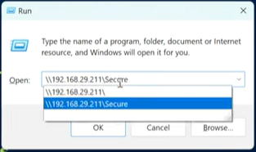

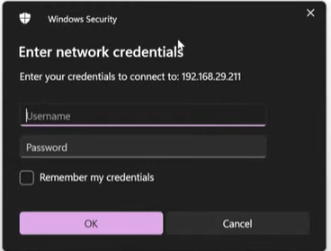

* Then you can again create files on windows server, I am not able to do it due to some issue with windows or linux network issues