**What is LVM in Linux with Example in Hindi | MPrashant**

* LVM or Logical Volume Manager or Logical Volume Management
* LVM is used to manage volume and disk on the linux server
* LVM allows disks to be combined together
* Example of LVM –
* Like partition of disk in Windows – C,D drive similarly we can do partitioning on a linux machine
* Single disk can be divided into different partitions
* Multiple disks can be combined and grouped into one and then changes into different partitions

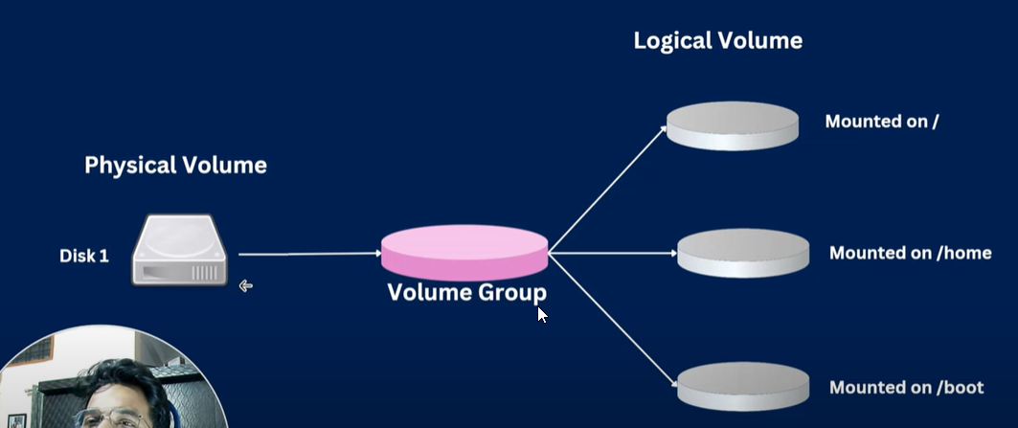

* In the above diagram we have Disk 1 say it’s a hard drive, its also known as physical volume
* We convert disk 1 into Volume Group
* Once we have the volume group created then we can partition it into multiple parts
* In the diagram, the first partition is mounted to root(/)
* Second partition is mounted to home
* Third partition is mounted to boot

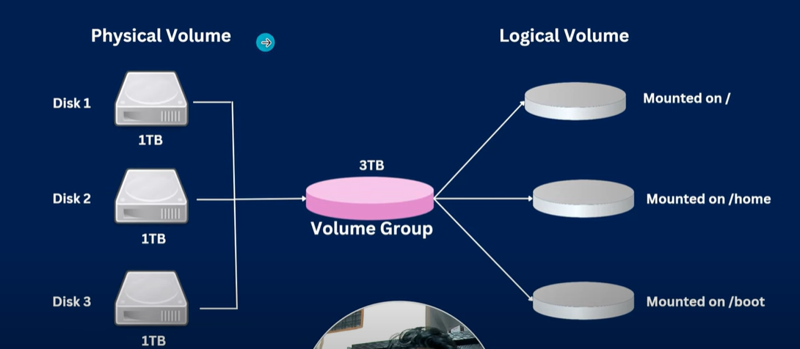

* In the above diagram we have 3 harddisks 1,2 and 3 we then combine all 3 into 1 Volume group and then we can partition the volume group into multiple partitions
* With the help of volume group, we get a bigger size and partitioning can be done easily then doing partitioning individually for each disk
* Advantage of LVM – If disk is running out of space, you can add a new disk without breaking partitions of your file system
* Possibilities of LVM –
  + New space can be created on a server for a new project
  + In case of low disk space we could increase the space
  + In case of extra space allocated to a partition, capacity can be reallocated(reduce capacity in one group and add it to another)

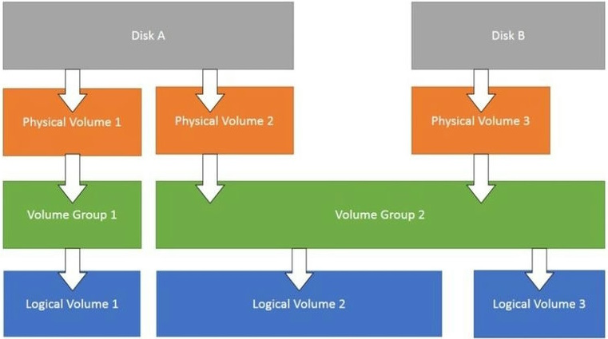

* In the above diag we have 2 disks Disks A and B
* Disk A has 2 partitions Physical Volume 1 and 2
* Now physical volume 1 is named as Volume group 1and physical volume 2 is named as Volume group 2
* Now disk B has one Physical volume named Physical Volume 3
* Now we add the physical volume 3 to Volume group 2, meaning we can merge multiple volumes into one volume group
* Now finally all the physical volumes can again come in as Logical volume 1,2 and 3
* **Simple Requirement for LVM** – We need to deploy two new applications app1 and app2 on our server and need a separate partition and space for each applications
* Steps to add a new space
  + Install a new hard disk drive – creating a virtual hard disk
    - Settings > Storage > Controller:SATA (Down we have add hard disk option)

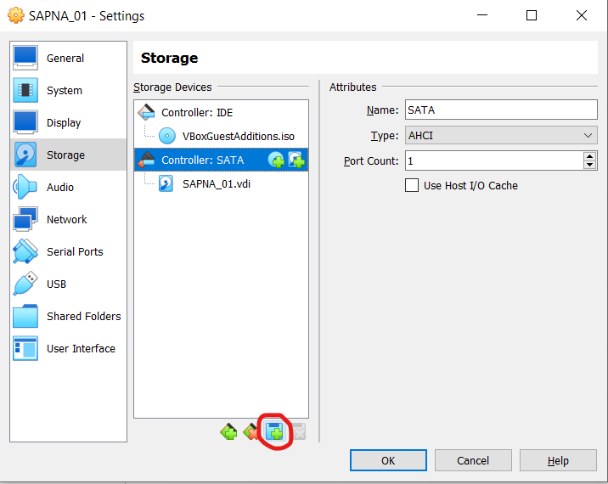

* + - We will create a new virtual hard disk
    - For virtual hard disk file type select VDI(VirtualBox Disk Image)
    - For storage on physical hard disk don’t select any option just next
    - File location and size – 2GB since we need 2 apps
    - Name of the virtual disk is named as Apps.vdi

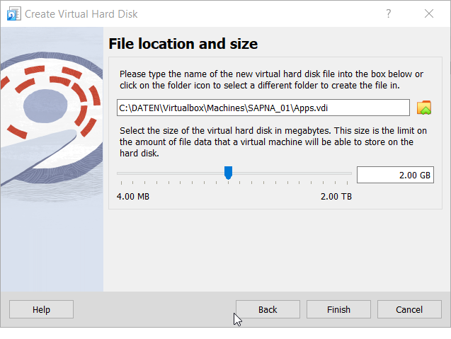

* + - Apps.vdi info –

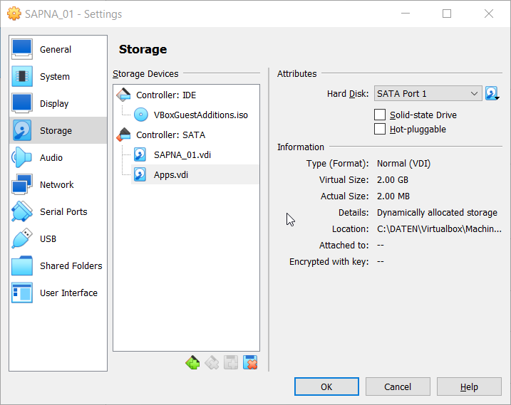

* + - Now we successfully created a virtual hard disk
    - Then we start the linux server(All changes done in SAPNA_01)
    - Next we will login as root
    - Then we will check if the new disk that we added is present or not using command – fdisk -l
    - We have /dev/sdb with 2GB size so we will use this disk

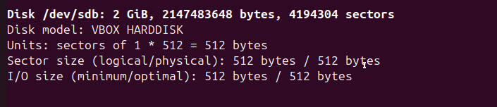

* + Make a partition to use it
    - Run command – fdisk /dev/sdb
    - Then to create a new partition press n
    - Partition type should be p means primary partition
    - Partition number will be 1
    - First sector – default 2048
    - Last sector – default (just press enter)

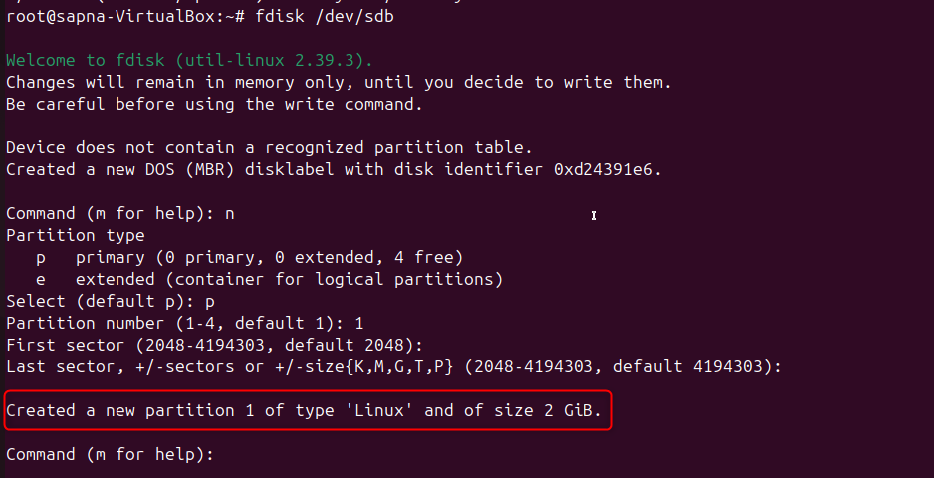

* + - Currently type of partition is Linux we will have to change the type to LVM
    - Then for command press t
    - For hex code type l and see all the different codes
    - 8e is for Linux LVM
    - This will help change the type to Linux LVM

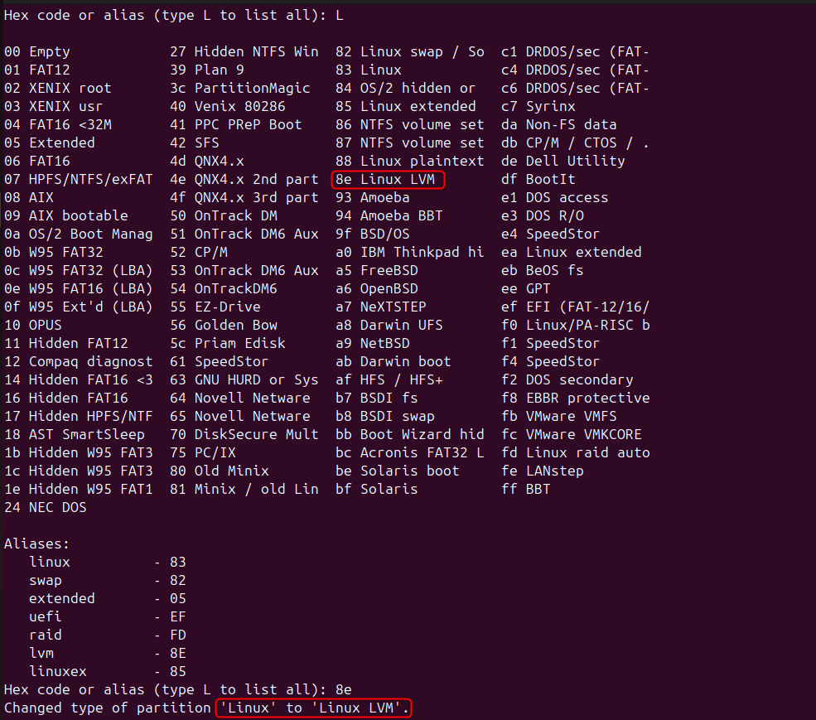

* + - Then we give command as w to write the partition table

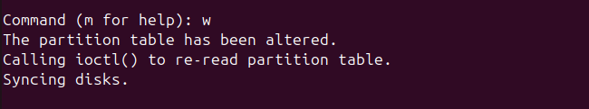

* + - Now when you run fdisk -l we see type as linux LVM

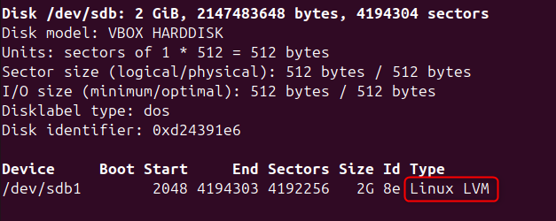

* + - Now since the disk uses partition 1, it is called /dev/sdb1 earlier it was called /dev/sdb
  + Designate physical volume (PV)
    - Command to create a physical volume – pvcreate /dev/sdb1(To run the command make sure lvm2 is installed using apt install lvm2)

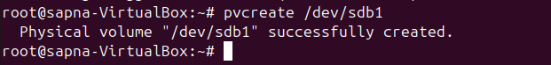

* + - Next to display PV Capacity and additional information run – pvdisplay

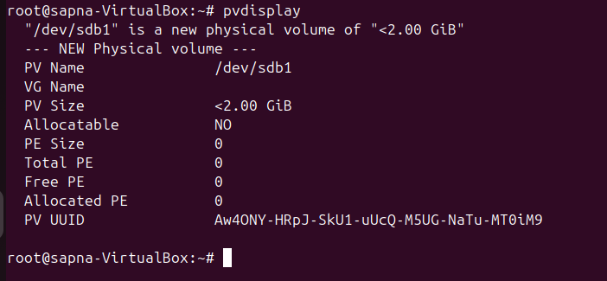

* + Manage volume group (VG)
    - VG must have at least one member – vgcreate <name> /member_name
    - Example – vgcreate vgapps /dev/sdb1
    - To display information for VG – vgdisplay vgapps

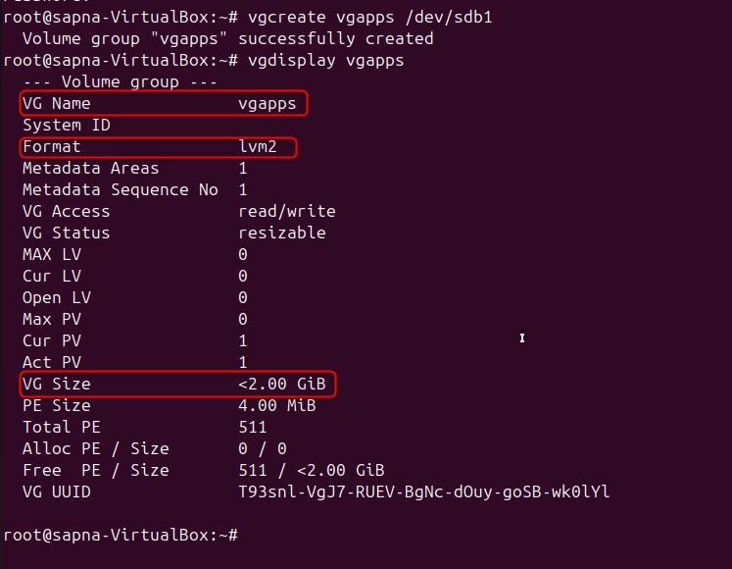

* + Manage logical volume (LV)
    - To create a logical volume – lvcreate -L size(1G or 1T) -n <lvname> <vgname>
    - Example – lvcreate -L 1G -n lvapps vgapps
    - Here we need 2 apps so we will create separate LV for each app
    - Command for LV1 – lvcreate -L 1G -n app1-lv vgapps
    - Command for LV2 – lvcreate -L 1G -n app2-lv vgapps
    - Here lv1 is created with 1GB of space, LV2 has 996M space since enough space isn’t present for the VG

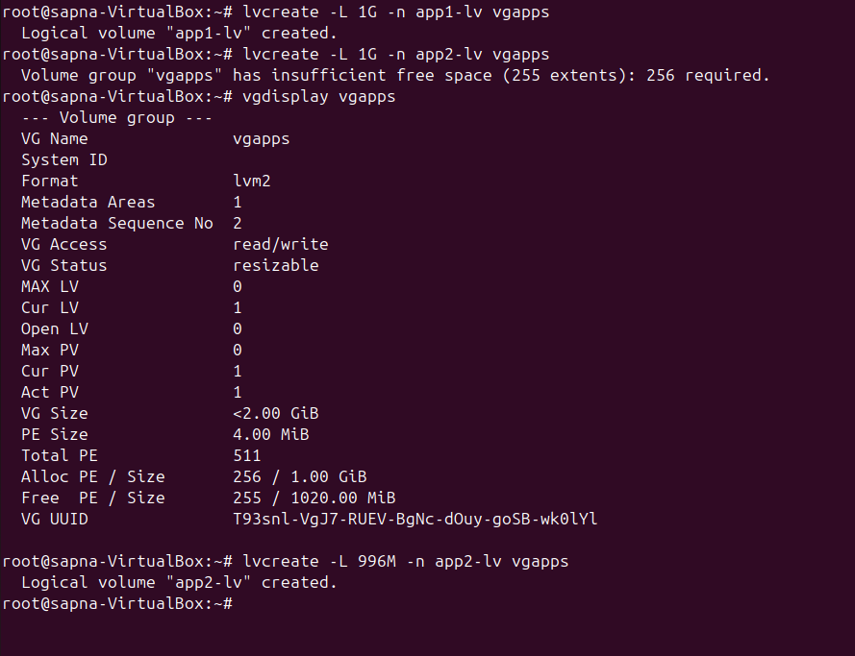

* + - To display information for an LV – lvdisplay /dev/vgapps/<lvname>
    - Example – lvdisplay /dev/vgapps/app1-lv

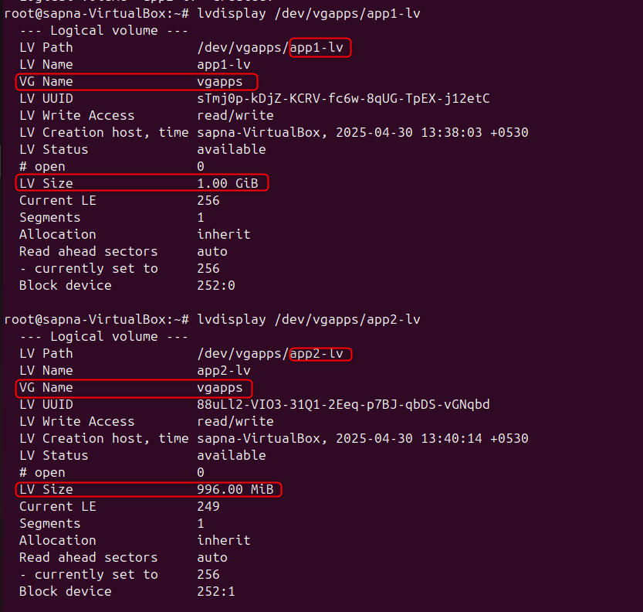

* + Apply a filesystem
    - Run mkfs.ext4 command for each LV
    - Example – mkfs.ext4 /dev/vgapps/app1-lv

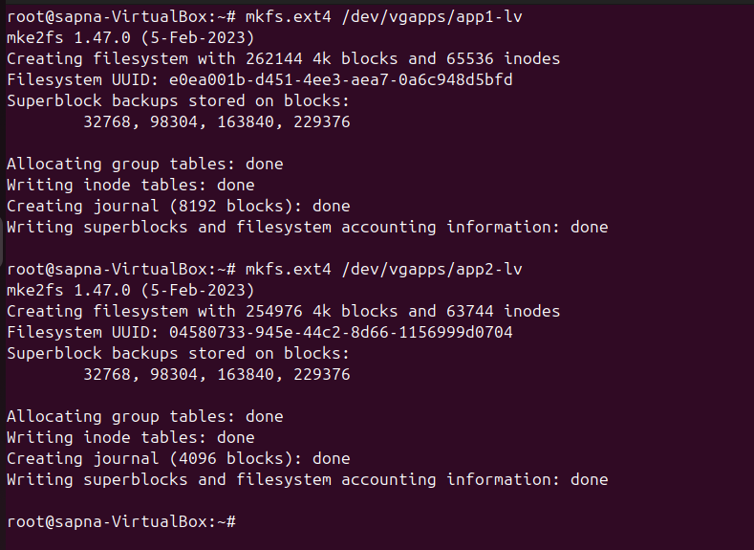

* + Set a mount point
    - Next we create a mount point by using mkdir – mkdir /app1 /app2

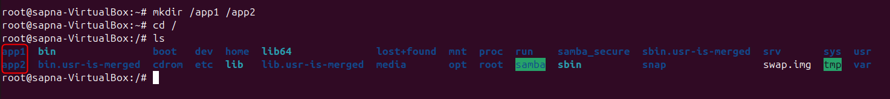

* + - Manually mount the volume using the mount command or the /etc/fstab file to mount the volume automatically when the system boots
    - Command to mount app1-lv – mount /dev/vgapps/app1-lv /app1/
    - Command to mount app2-lv – mount /dev/vgapps/app2-lv /app2/
    - To verify whether app1 and app2 lv are mounted run – df -Th command

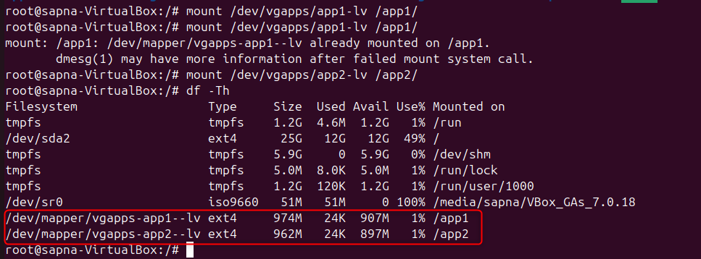

* + - Note that the mount commands we used now is only for temporary mounting, once you restart all these mount points will be gone so to make sure mounting is permanent we need to modify the /etc/fstab file
    - To mount permanently –
    - First lets check if the mount points are present in location – cat /etc/mtab

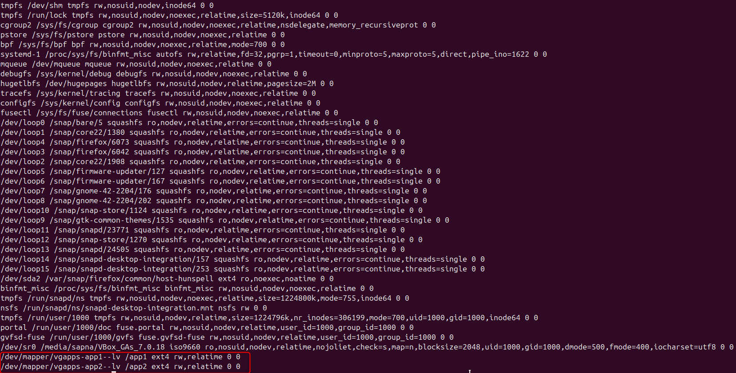

* + - Copy the 2 lines –

/dev/mapper/vgapps-app1--lv /app1 ext4 rw,relatime 0 0

/dev/mapper/vgapps-app2--lv /app2 ext4 rw,relatime 0 0

* + - Then next open the /etc/fstab file – nano /etc/fstab
    - Copy the above 2 lines here
    - Instead of rw,relaytime write defaults
    - New lines (Updated) –

/dev/mapper/vgapps-app1--lv /app1 ext4 defaults 0 0

/dev/mapper/vgapps-app2--lv /app2 ext4 defaults 0 0

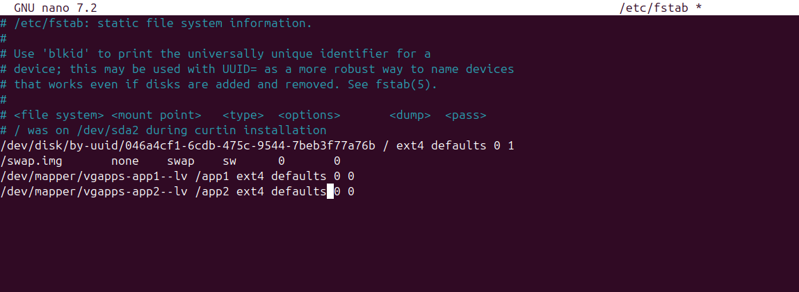

* + - Next save the file
    - To verify whether the mount is permanent or not – mount -av
    - Here app1 and app2 are already mounted

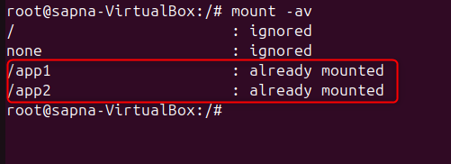

* Extending a disk using LVM –
  + First we will have to create a virtual hard disk again lets keep the size as 1G for now(Follow the same steps given above)
  + I named the vdi as Apps_extra_space.vdi

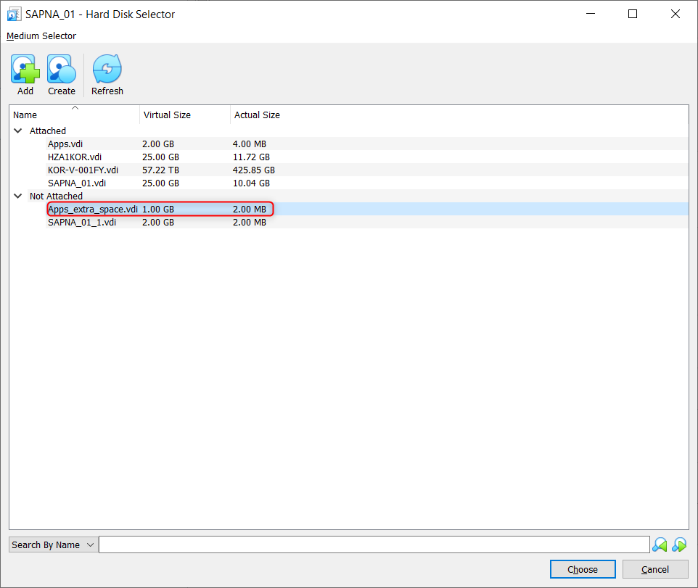

* + First lets check if the extra hard disk is added or not using – fdisk -l command
  + I have /dec/sdc of size 1Gb now

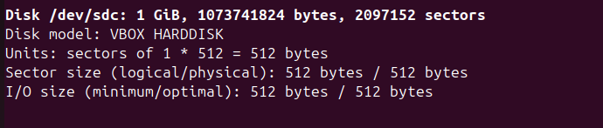

* + Then we create partition using – fdisk /dev/sdc
  + Press n for new partiton
  + Partition type keep as primary since we will extend it in LVM
  + Partition first and last sector will be default values, just press Enter

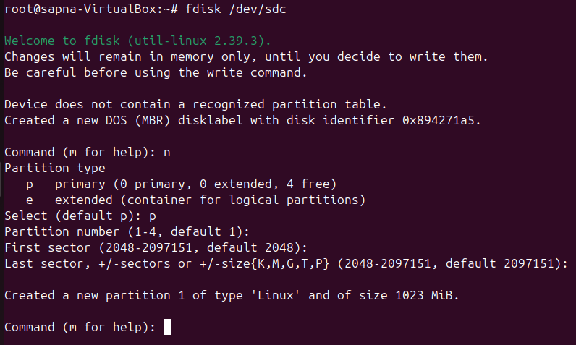

* + Next to change the type to linux LVM press t
  + Hexcode is 8e

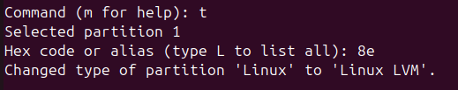

* + You can press p to print the partition table

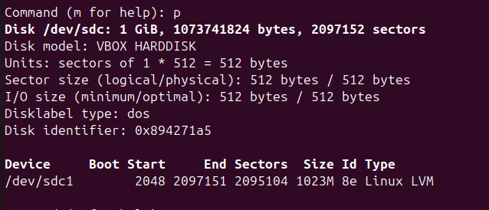

* + Then give w to write the partition table to disk

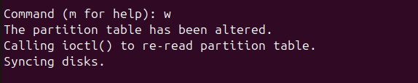

* + Then we create a physical volume again – pvcreate /dev/sdc1
  + Now we don’t have to create a volume group again, we already have the volume group named vgapps
  + Now we will just extend the volume group with this extra space
  + To extend the VG size – vgextend vgapps /dev/sdc1

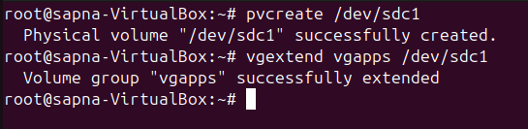

* + To add space to the app2-lv – lvextend -L +4M /dev/vgapps/app2-lv
  + To make this space available for filesystem for ext4 – resize2fs /dev/vgapps/app2-lv 1G

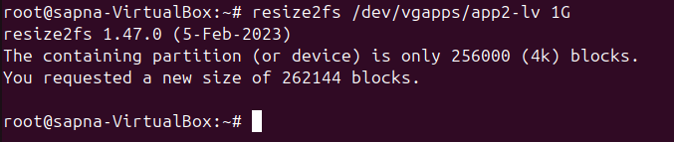

* + Instead of 1G give 1000M and it will work
  + Updated command - resize2fs /dev/vgapps/app2-lv 1000M

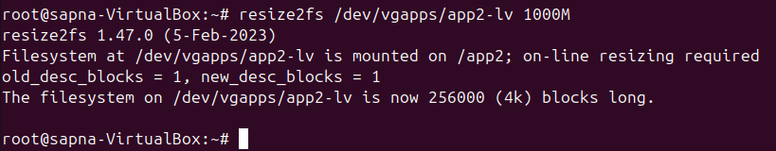

* + For XFS (file system type) – xfs_growfs /dev/vgapps/app2-lv
  + Next check the disk size using – df -Th command

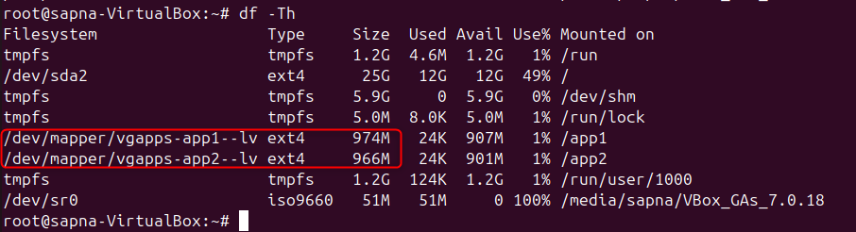

* + Now app2-lv size is updated from 962M to 966M