**Ultimate DNS Server & Apache Setup Guide with Custom Domain | DNS Config with Example | MPrashant**

* DNS or Domain Name System is the internet service that translates human-friendly domain names like [www.example.com](http://www.example.com) into machine readable IP address
* Example – when we open browser and type [www.google.com](http://www.google.com) and search this name, browser still doesn’t have any idea what this name means
* Browser has no idea from which server should this website be brought from
* Because the server address are usually ip address and not like google.com and all
* So first the browser goes to DNS Server
* In the DNS server mapping is done like [www.google.com](http://www.google.com) has ip 192.168.0.1
* Once the ip address is found on the DNS server the browser accesses the particular ip address

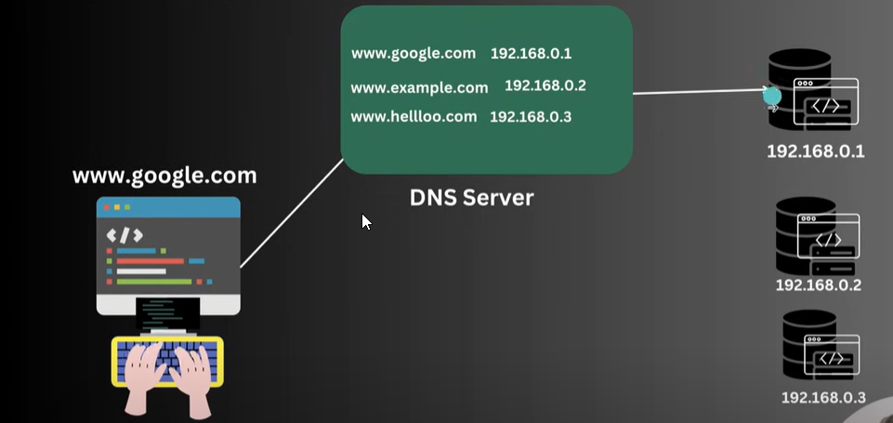

* DNS Server is same as the contacts in our phone/mobile
* We save the contacts with their names and we just search the names and call directly instead of remembering their phone numbers
* Similarly when we search for a website on the browser, the DNS server is like the contacts, it has all the names of websites along with their respective ip addresses
* **Let’s try to setup our own webserver**
  + Packages needed – apache2
  + systemctl start apache2
  + Enable httpd service In firewall – firewall-cmd --permanent --add-service=http
  + Reload the firewall – firewall-cmd –reload

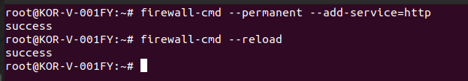

* + Just stop the firewall best idea
  + Now we will get the ip address of the linux server using ip addr command

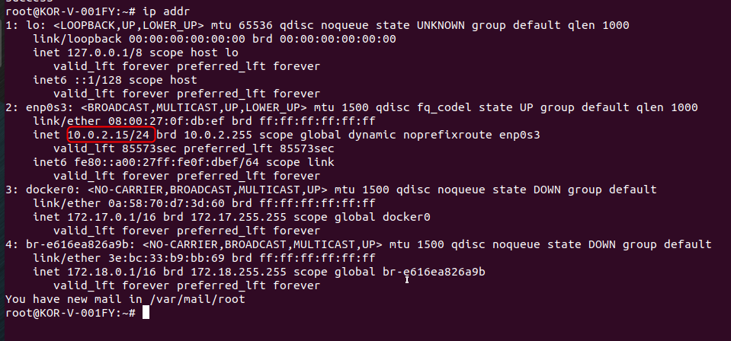

* + When we just run 10.0.2.15 on the firefox we see the apache2 web page being opened

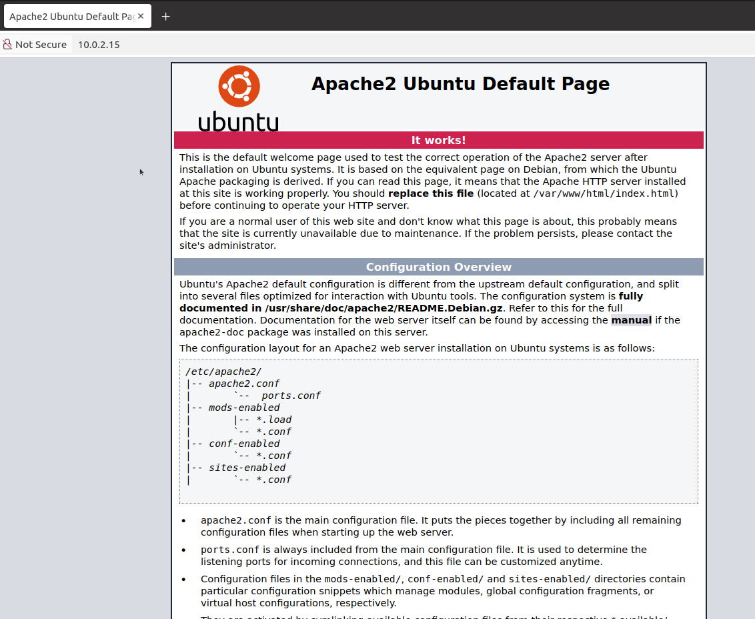

* + **The web server** config files are present under loc - /var/www/html/index.html and /etc/apache2/apache2.conf
* **Lets setup our own DNS Server**
  + First install all the necessary packages – apt install bind9 bind9-utils -y
  + Start the bind9 service – systemctl start bind9

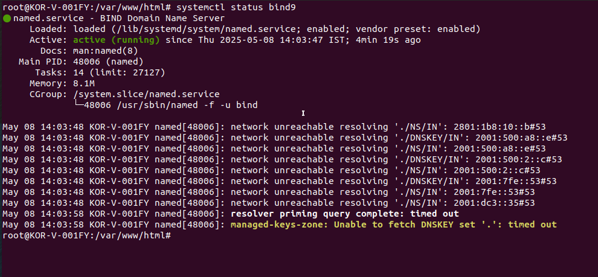

* + Next we enable dns on the firewall using command - firewall-cmd --permanent --add-service=dns --zone=docker
  + Reload the firewall – firewall-cmd --reload

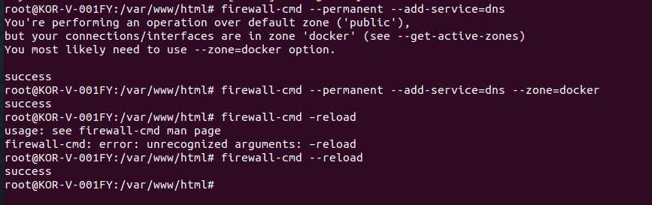

* + DNS config files are present in loc - /etc/bind/named.conf
  + /etc/bind/named.conf on Ubuntu is only a **stub** that *includes* the real files:
    - include "/etc/bind/named.conf.options";
    - include "/etc/bind/named.conf.local";
    - include "/etc/bind/named.conf.default-zones";
  + The port/interface settings live in **named.conf.options**
* **DNS Server config changes –**
  + Add the below lines in file named.conf.options to make sure DNS server listens on the below ips 10.0.2.15 and 127.0.0.1

// Listen only on this host-only adapter and on localhost

listen-on port 53 { 10.0.2.15; 127.0.0.1; };

listen-on-v6 { ::1; }; // or “none;” to disable IPv6

allow-query { localhost; 10.0.2.0/24; };

recursion yes;

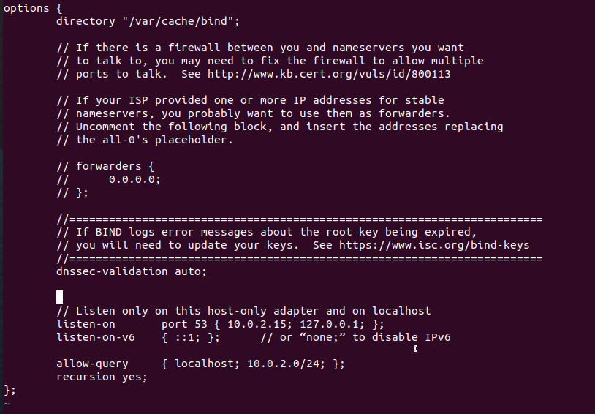

* + Check it using command - named-checkconf
  + Then reload - systemctl reload bind9
  + Next we have to declare our zones in named.conf.local file
  + named.conf.local file is meant for “local” data such as your own forward and reverse zones
  + content to add in named.conf.local file

zone "cafebloom.com" IN {

type master;

file "/etc/bind/zones/db.cafebloom.com.fzone";

allow-query { any; };

};

* + next we check the file – named-checkconf
  + next we need to create the db.cafebloom.com.fzone (also create zones folder inside bind )
  + to get info about bind9 you can also refer documentation - [bind9-docs](https://bind9.readthedocs.io/en/v9.20.8/chapter3.html%23soa-rr) (search for forward-mapped) in Chapter 3 section 5)

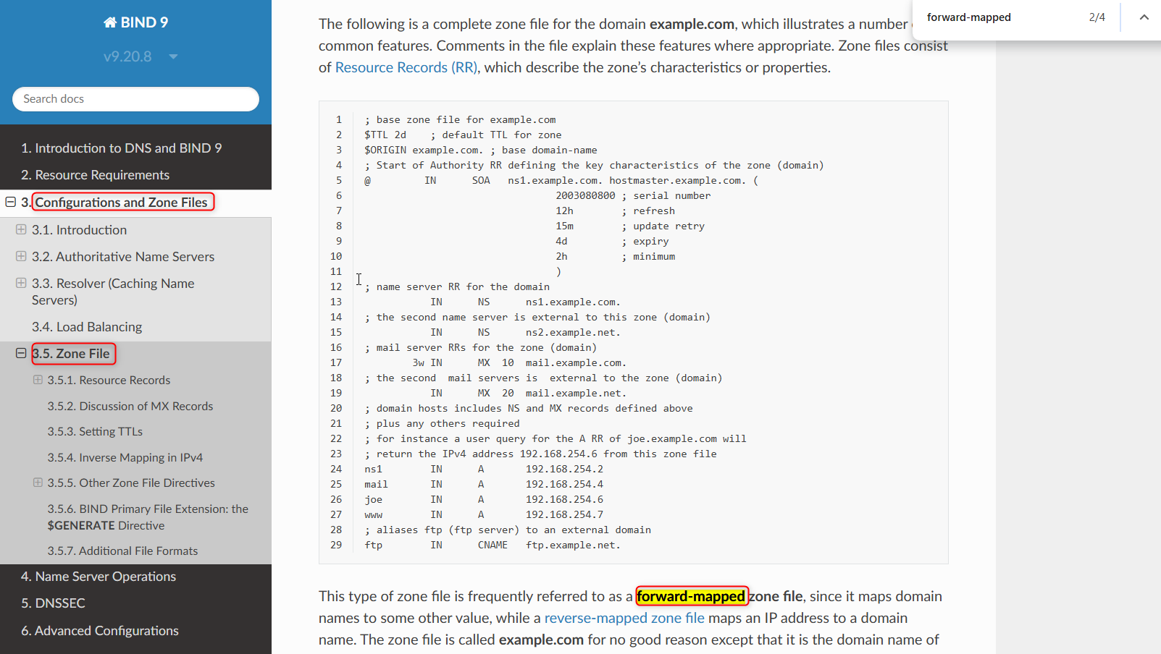

* + Copy the below content in db.cafebloom.com.fzone file

$TTL 2d ; default TTL for zone

; Start of Authority RR defining the key characteristics of the zone (domain)

@ IN SOA ns1.example.com. hostmaster.example.com. (

800 ; serial number

12h ; refresh

15m ; update retry

4d ; expiry

2h ; minimum

)

; name server RR for the domain

IN NS ns1.example.com.

www IN A 10.0.2.15

* + Then check it using command – named-checkzone cafebloom.com /etc/bind/zones/db.cafebloom.com.fzone

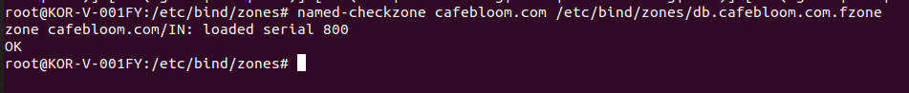

* + Then restart the service – systemctl restart bind9
* Next we verify the DNS setup
  + Here I cant really do it since there are issues with my dns, only the proxy values are there in /etc/resolv.conf
  + I am just gonna see what he is giving now
  + First he did nslookup command for google.com – nslookup [www.google.com](http://www.google.com)
  + Then he did nslookup for his website – www.mywebapp.com

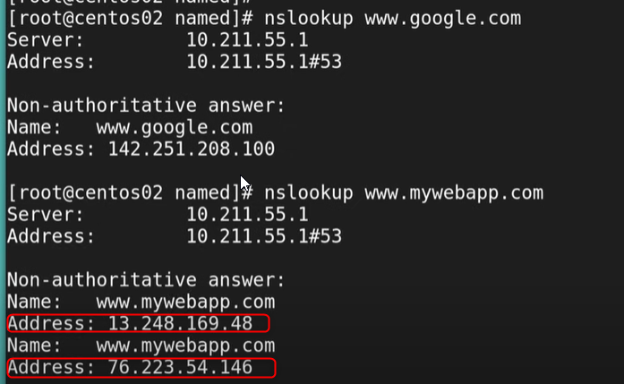

* + Currently the address for www.mywebapp.com are not mapped
  + So the addresses are coming as weird so we need to map the addresses
  + Next we need to edit the /etc/resolv.conf file with the new nameserver

nameserver 10.0.2.15

* + Now when we run nslookup [www.cafebloom.com](http://www.cafebloom.com) we should see the name and the address for cafebloom

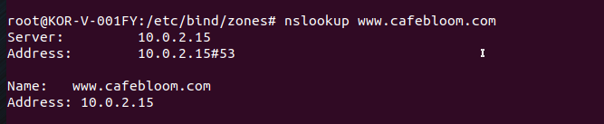

* + All the different ways to configure DNS

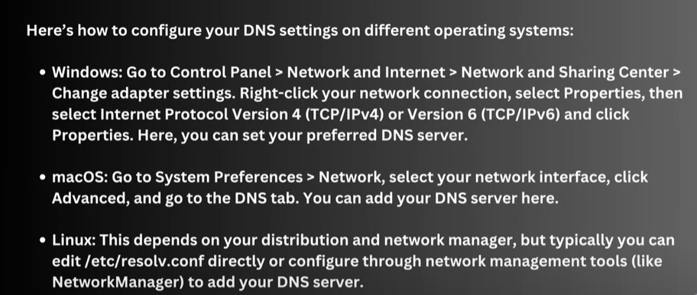

* + Then he just directly opened the [www.mywebapp.com](http://www.mywebapp.com) and it opened
  + It opened for me also Yyayayayyay
  + So I just went to Firefox setting > Privacy & Security > Enable DNS over HTTP using > Select Off

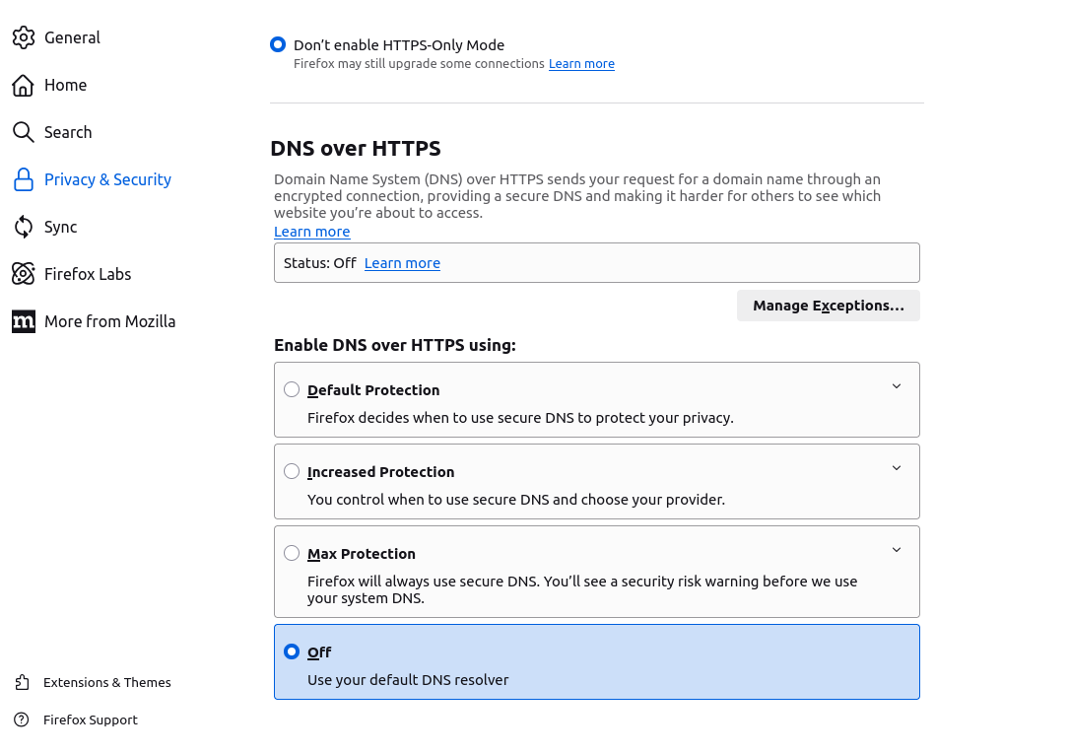

* + Next try opening [www.cafebloom.com](http://www.cafebloom.com) and voila

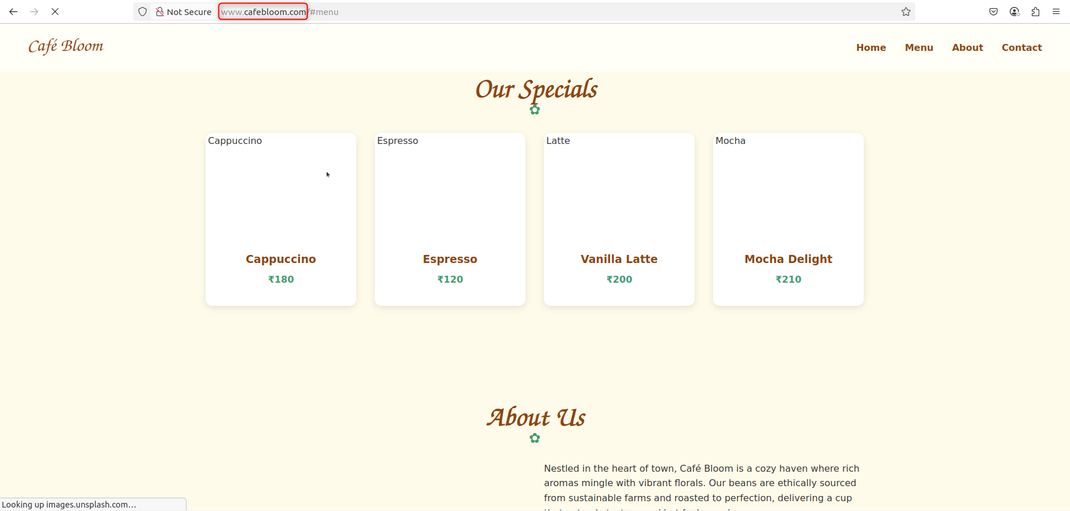

* Next he tried to access this site from another linux server
* So with the ip he was able to access the site
* But with the website name [www.mywebapp.com](http://www.mywebapp.com) he was not able to access It on another linux server
* In the /etc/resolv.conf file change the nameserver to **nameserver 10.0.2.15**
* Then do a nslookup – nslookup [www.cafebloom.com](http://www.cafebloom.com) and now the address would be 10.0.2.15
* Then try to access the site
* **DNS Translate –**
* Hostname to 192.168.1.2(Ip address) (Called A record)
* 192.168.1.2(IP address) to hostname( Called PTR record) PTR means pointer
* Hostname to hostname (Called CNAME record)
* **Zone files –**
* Forward zone – resolve domain to IP
* Reverse zone – resolve IP to domain