**Discover How to Access Your Linux Server with Ease - Linux Cockpit! A Web Interface for Linux Server**

* COCKPIT is a web interface for your linux server
* It is a user-friendly interface to manage and administer servers
* We can perform the below admin works –
  + Network settings
  + Configure firewall
  + Manage storage
  + Create VMs
  + Manage user accounts
  + Monitor logs
* COCKPIT supports multiple distributions like fedora, RHEL, CentOS, Ubuntu etc



* Cockpit installation steps –
* Install cockpit using – apt install cockpit
* Start the cockpit service – systemctl start cockpit.socket
* Enable the cockpit service – systemctl enable --now cockpit.socket

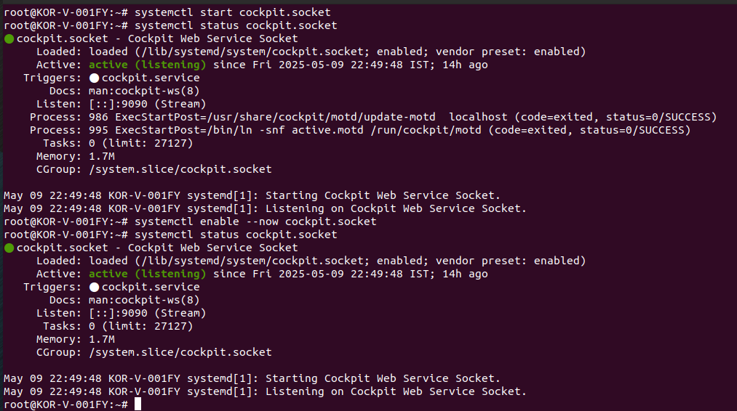

* To access cockpit, point the web browser to your computer or server ip on port 9090 – [https://10.0.2.15:9090 (Run](https://10.0.2.15:9090%20(Run) on vm’s firefox only)

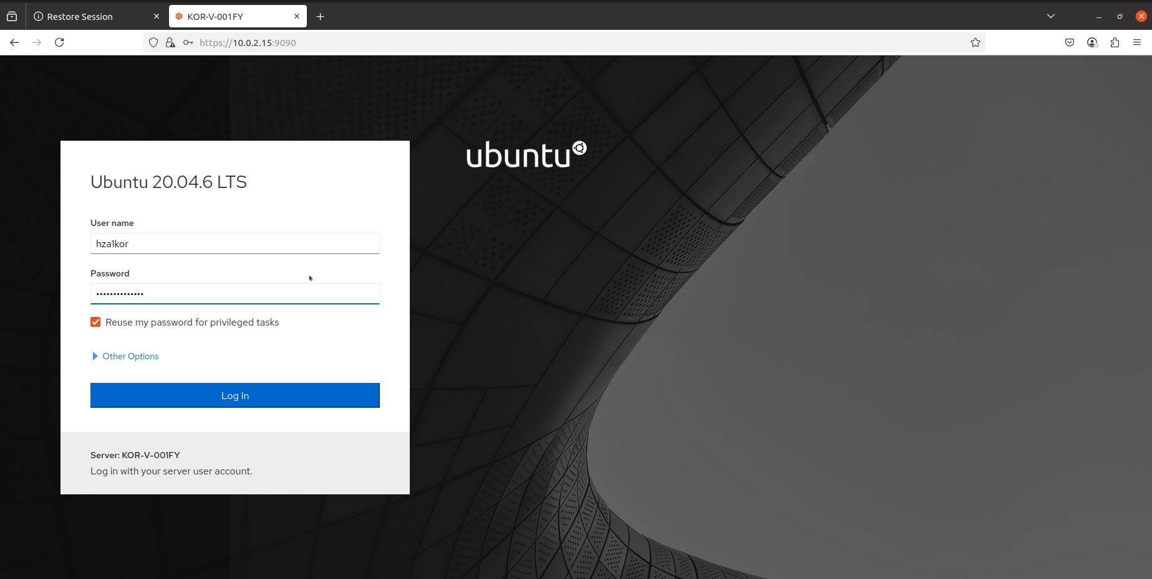

* Let me try accessing root now using cockpit

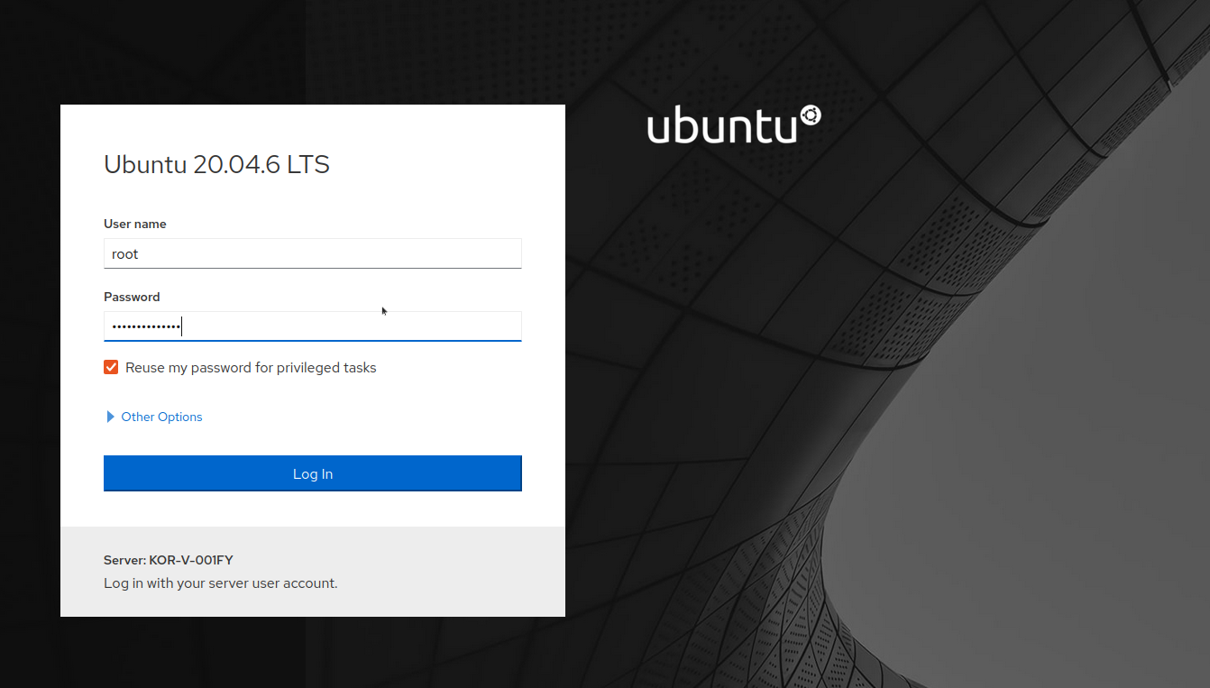

* In the overview section we have the health, usage and configuration

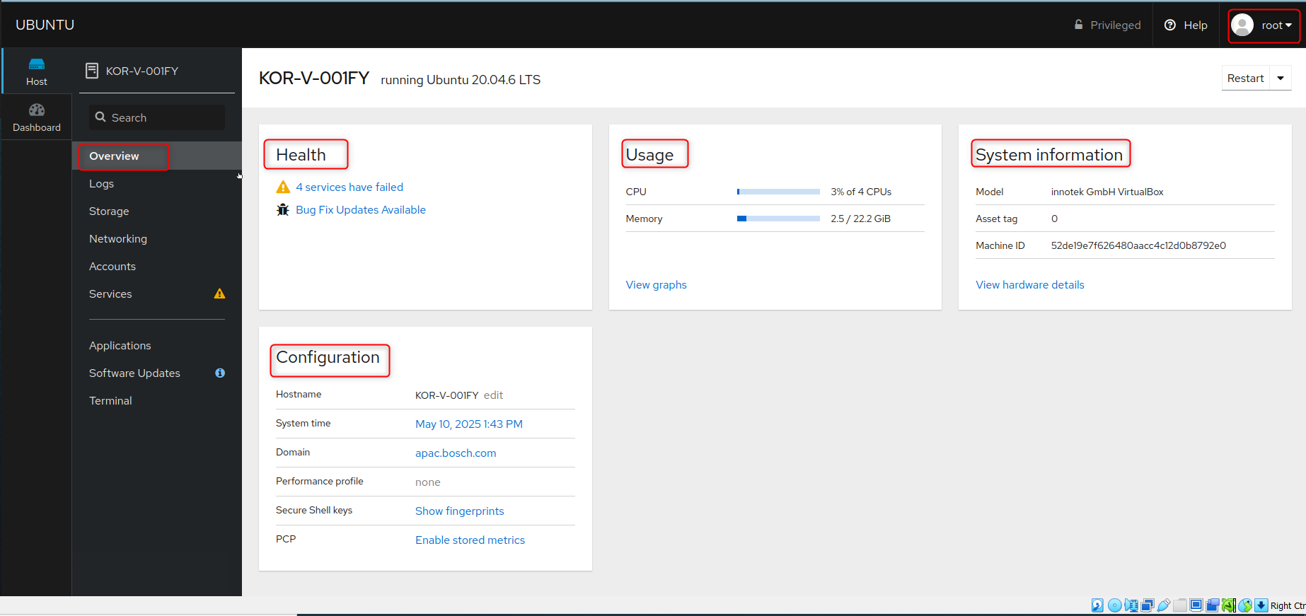

* In the logs section we have the logs present, you can check previous logs, the Severity also you can set based on requirement like Everything, critical, error, warning, notice, info and debug

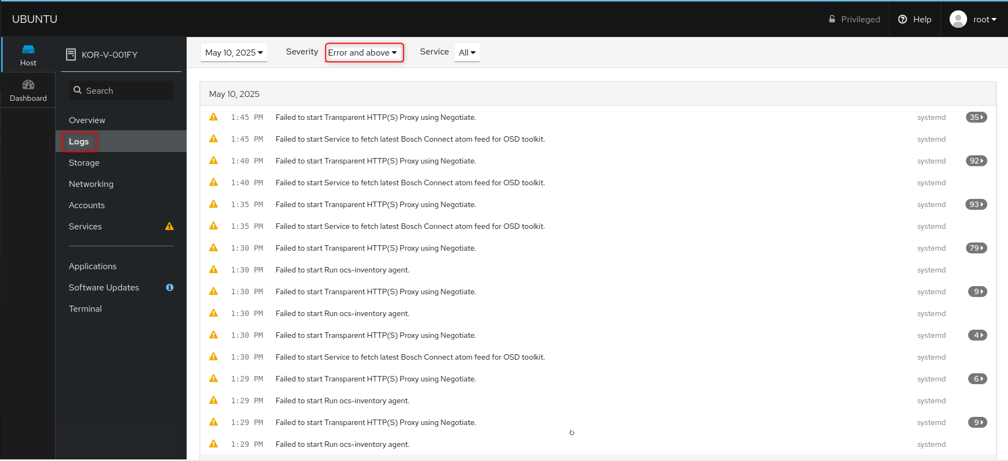

* Next we have storage options, info on filesystem partitioning info, devices , drives, NFS mounts information, logs related to storage

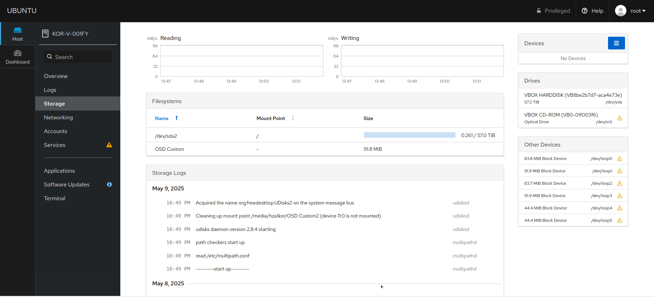

* Next we have Networking option to check whether firewall is enabled, info on the interfaces, network logs

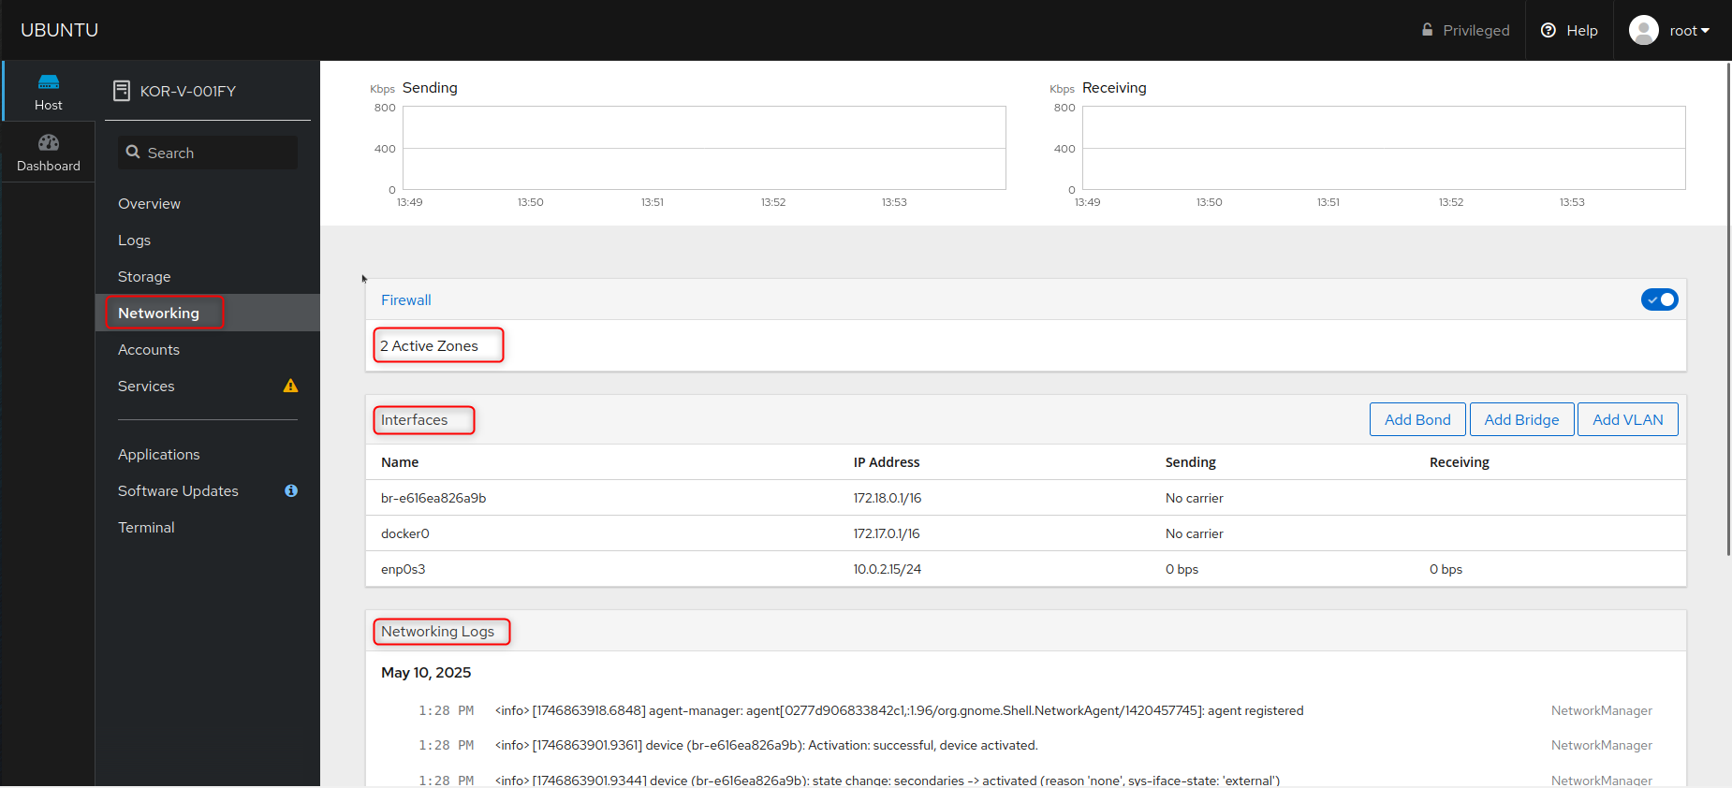

* In firewall if we click on the active zones we can see all the services enabled by firewall , in the image we can see that firewall has enabled cockpit hence we are able to access our setup via web interface

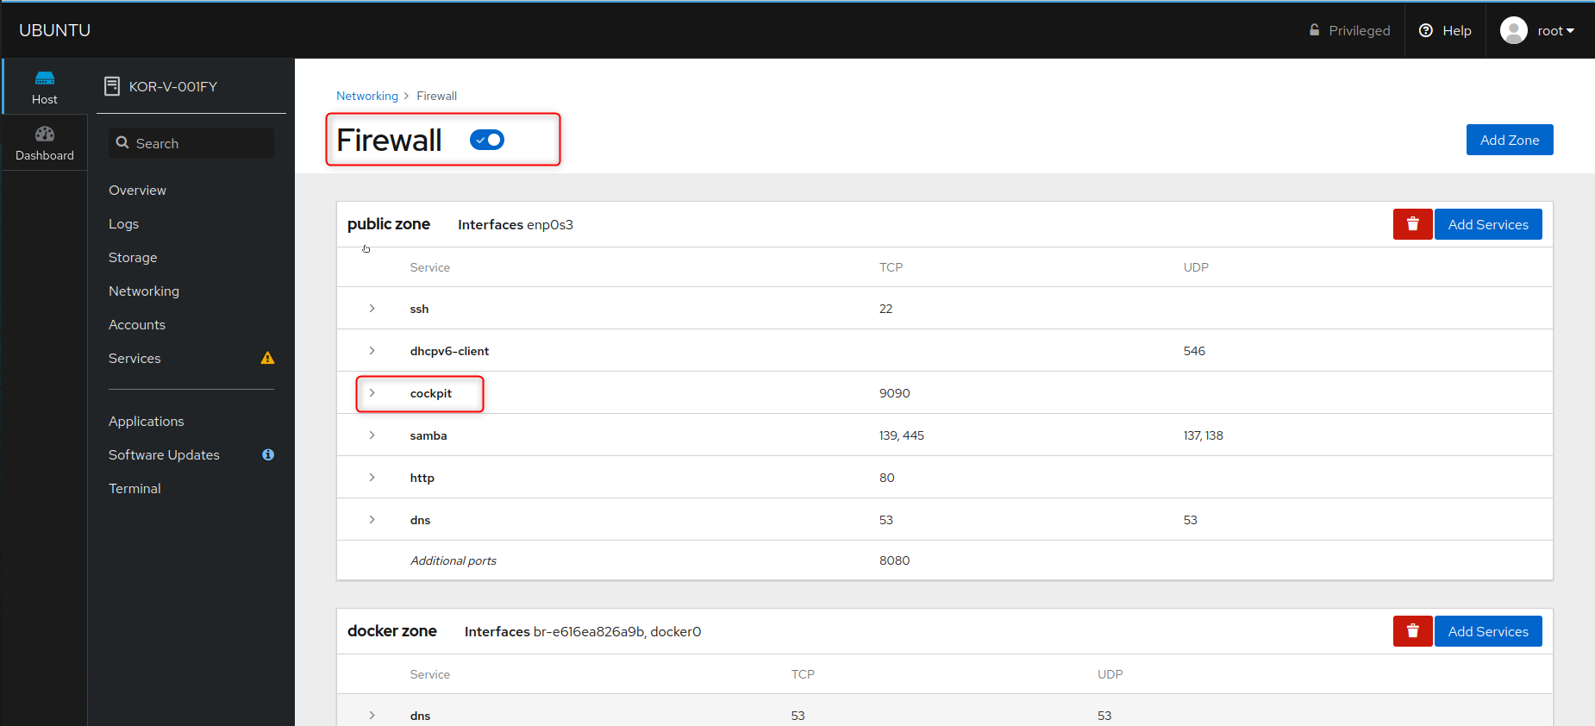

* Then we have Accounts tab which has all the accounts currently present(I don’t see any hza1kor account)

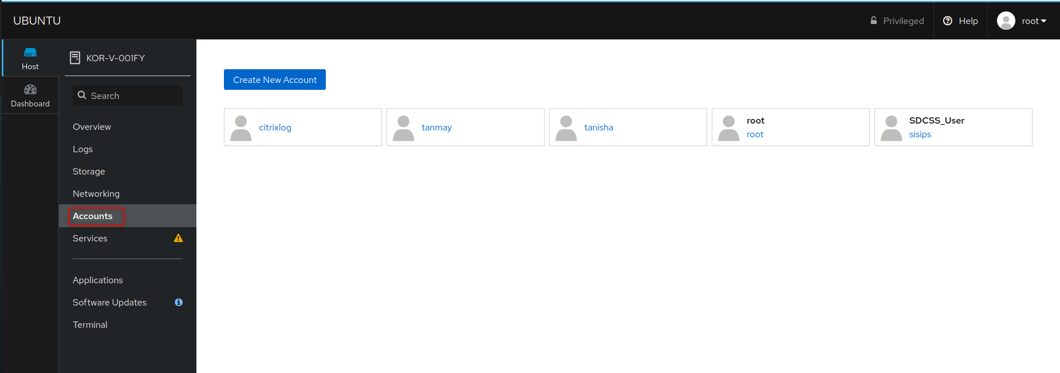

* We can also create a new account using the Create New Account option

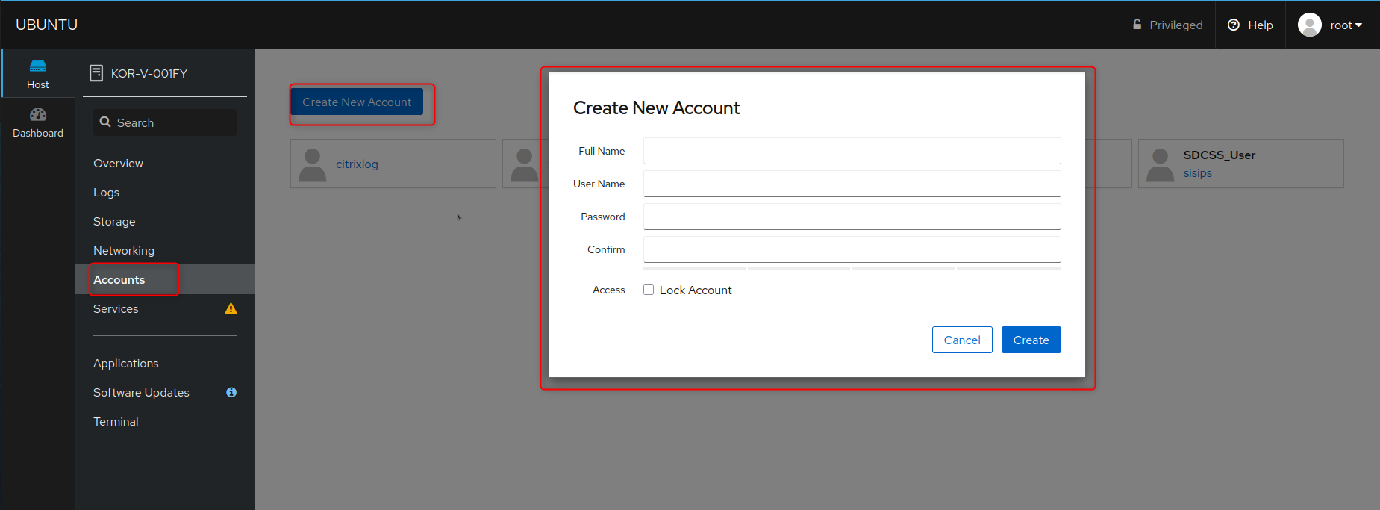

* All the current Services , sockets info are present in the Services Tab

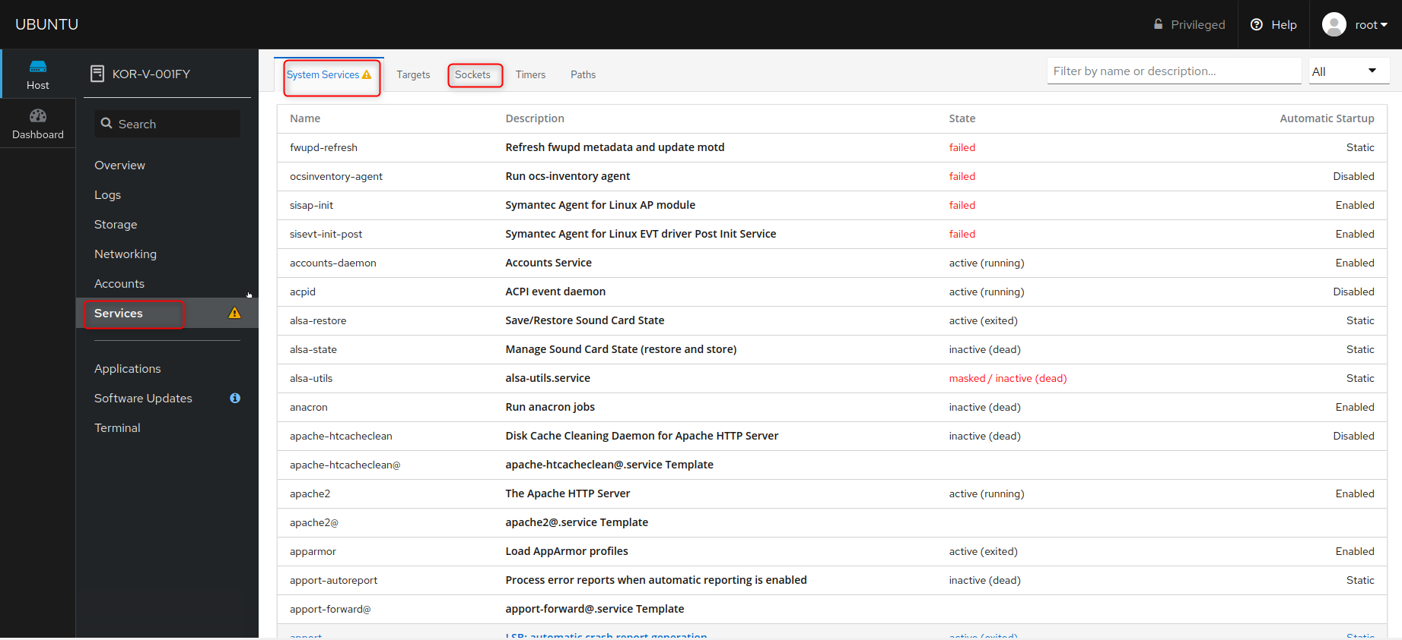

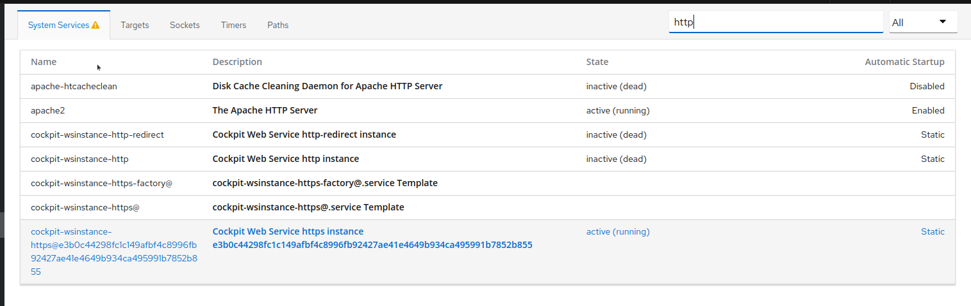

* Then we have a terminal tab , we can directly access the terminal from here

