**Linux Interview Question: How to Find Largest or Biggest file in a Linux Directory | In Hindi**

* This is an interview question find the largest file in a given directory
* We will cover three ways to find the largest file in a given directory
  + Using find command
    - First step is to find all the files in the current directory using find command – find . -type f

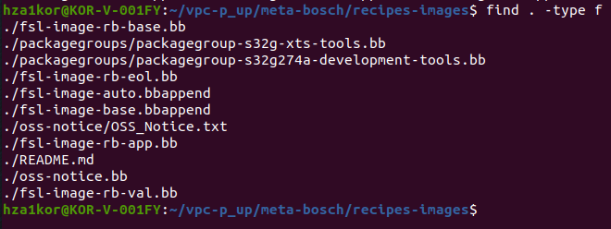

* + - In the above command it is also going to packagegroups folder and giving us all the files present in the other folders also , to make sure only the files present in recipes-images are printed we have to give max-depth as 1 using command – find . -maxdepth 1 -type f

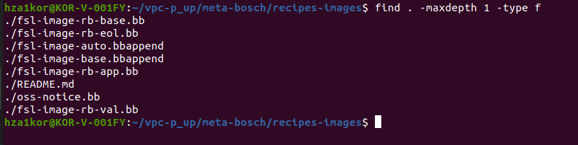

* + - Right now the sizes of the files are not being listed, to list all the sizes we have to add (**-exec ls -lh) in the command –** find . -maxdepth 1 -type f -exec ls -lh {} \;

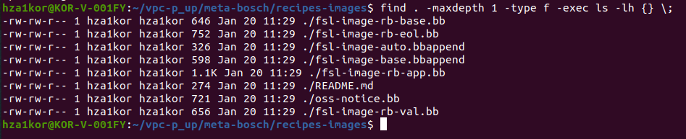

* + - Next we will have to sort these files based on the size, size is in the 5th column and we will do the sorting in reverse order so that the first file is the largest file(here -k5 means column 5, r means reverse and n means numeric)– find . -maxdepth 1 -type f -exec ls -lh {} \; | sort -k5rn
    - With ls -lh option sort -n only understands plain numbers, so it reads the “1.1K” size as **1.1** bytes, which is smaller than 274 bytes, 326 bytes

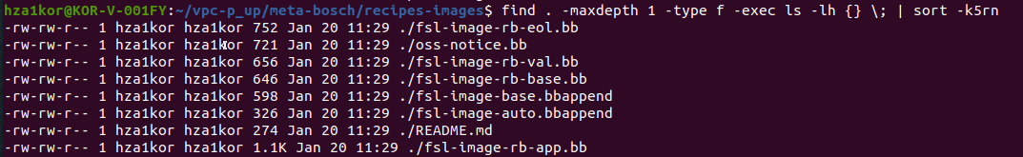

* + - I changed the command to ls -l instead of ls -lh since h is causing issue, new command – find . -maxdepth 1 -type f -exec ls -l {} \; | sort -k5rn

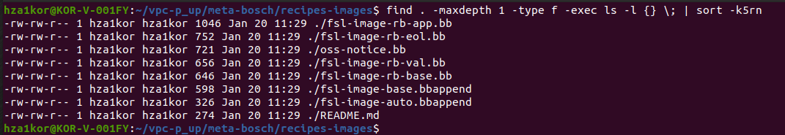

* + - Or we could also run command – find . -maxdepth 1 -type f -exec ls -lh {} \; | sort -k5rh (here h is short for human numeric sort)

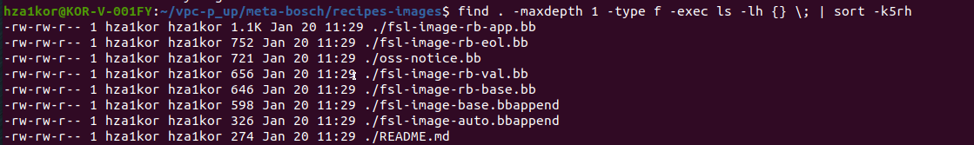

* + - Now we have the largest file in the first row so we can use head command to print only the largest file – find . -maxdepth 1 -type f -exec ls -lh {} \; | sort -k5rh | head -1



* + - Now there are permissions root user, group user date modified all of this, if I just want to print the name of the file we can use awk command – find . -maxdepth 1 -type f -exec ls -lh {} \; | sort -k5rh | head -1 | awk '{print $NF}'



* + - If I don’t want the ./ only the file name we can again use awk command – find . -maxdepth 1 -type f -exec ls -lh {} \; | sort -k5rh | head -1 | awk '{print $NF}' | awk -F/ '{print $NF}'



* + Using du command
    - Command – du -sh *
      * Here du means disk usage
      * -s means summarize or show a single total for each item instead of sub-item more like max-depth is 1
      * -h means in human readable format
      * * means expand all the directories and files in the current directory .

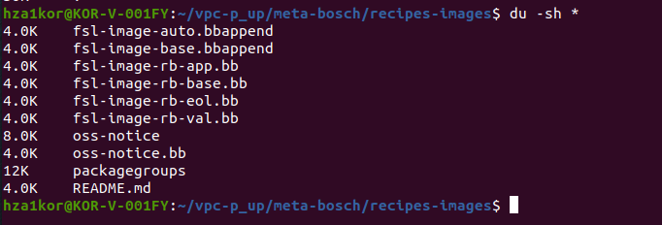

* + - Now to reverse sort and in human numeric format use – du -sh * | sort -rh(but here problem is folders packagegroups and oss-notice are also being showed)

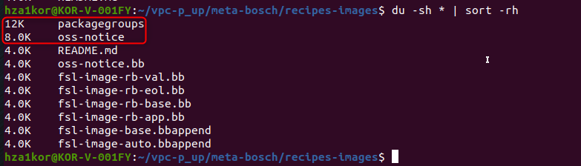

* + - Then to check the largest folder / file we can use head command – du -sh * | sort -rh | head -1



* + - Other commands also that can be run using du command - du -ahx . | sort -rh | head -n 3
    - One more command - du -ah | sort -rh | head -n 3

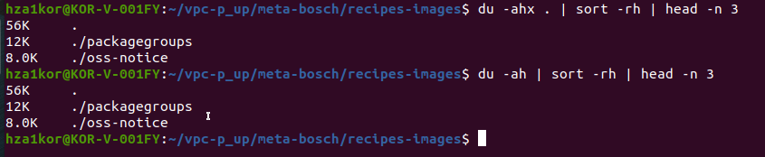

* + Using ls command – ls -lSh | grep -v total | head -1
    - S is used to sort the list in sorted way

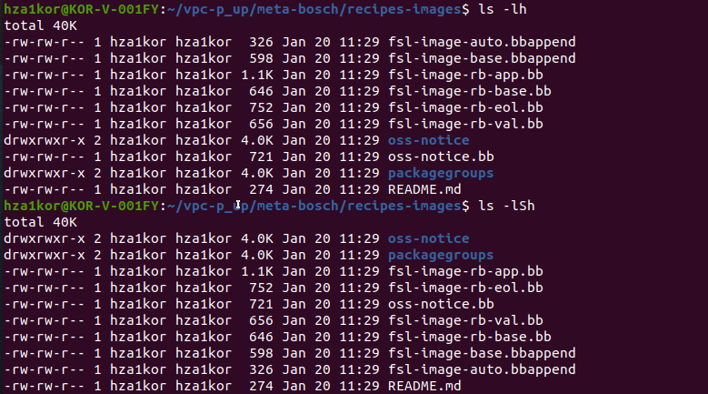

* + - With grep -v total it will print all the entries except for total

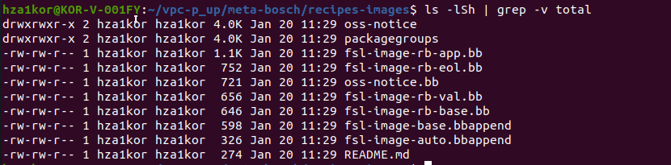

* + - Then with head -1 we can print the first largest or biggest file using – ls -lSh | grep -v total | head -1

