**Shell Scripting Project 1 | Linux Shell Scripting Project | Digital Clock Using Shell Scripting**

* When we run date command on the terminal we see the day, date, time and year

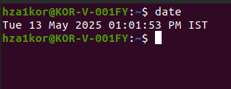

* But we are only focused on the time value
* To only see the time using the date command we can run – date +%T

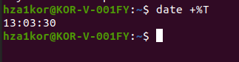

* Now when we keep running the command multiple times we see new time values

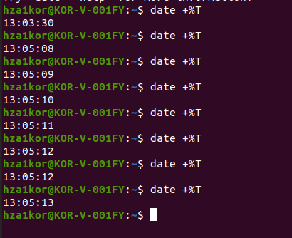

* But for the digital clock we don’t need the login multiple times, we should be able to just get the time values
* Now if we give a prompt such that once the terminal prints the time sleep for 1 sec
* Then the o/p will be something like this



* So it will sleep for 1sec and then give us the shell prompt
* Now if I do it twice –

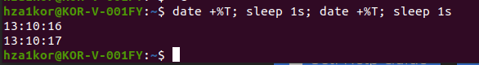

* Now the shell prompt comes after 2 time values are printed
* Now I want the old value to vanish and the new value to come every 1sec
* For that we can use clear command we date and sleep - clear; date +%T; sleep 1s; clear; date +%T; sleep 1s
* So now we know that we need to perform the clear, date and sleep operation multiple times
* For that we will use shell scripting
* Content inside digital_clock.sh

#!/bin/bash

while true

do

clear

echo $(date +%T)

sleep 1s

done

* This will keep printing the new time till we manually run ctrl+c



* Now the last part is to add color
* New changes in digital clock

#!/bin/bash

RED=$'\e[1;31m' # bright red

GREEN=$'\e[1;32m' # bright green

BLUE=$'\e[1;34m' # bright blue

YELLOW=$'\e[1;33m' # bright yellow

NC=$'\e[0m' # no color / reset

while true

do

clear

echo $RED $(date +%T)

sleep 1s

done

* In code I gave echo RED so it echoes clock in RED



* If I want green color just change the echo part to echo $GREEN $(date +%T)

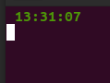

* Now to zoom in you just use Ctrl + Shift + +(on the top not the numeric keyword one)

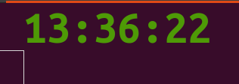

* Keyword buttons to zoom – ctrl + shift + **+**

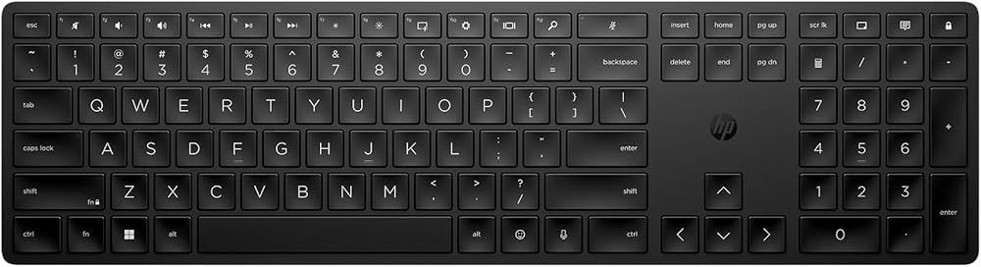

* To reduce the size use Ctrl + - (same on the top not the numerical keypad side)
* Or to get it to default size use Ctrl + 0