**How to Change Hostname in Linux? Change Hostname Ubuntu Hindi | MPrashant**

* To check the hostname run the command – hostname



* For changing the hostname we will need root login
* Command to change the hostname - hostnamectl set-hostname <name>
* Like I want to change the hostname from KOR-V-001FY to Sapna then I can just run - hostnamectl set-hostname Sapna

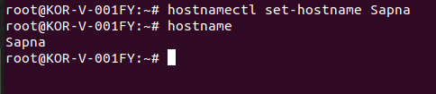

* Now if I login again as hza1kor and try to check the hostname again, it again as Sapna

