**Develop SQL for each of the queries below using correlated sub-queries.**

**Include results of executing your queries against the supplied set of tables.**

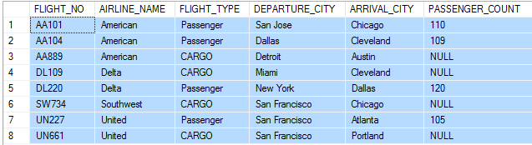

PASSENGER

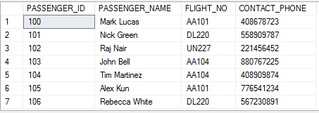

CARGO

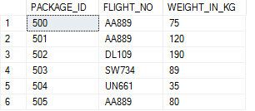

STAFF

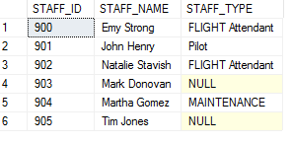

STAFF ASSIGNMENT

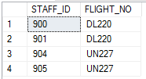

1. Find total weight in pounds of cargo packages for each flight departing from San Francisco (5 points)

SELECT C.FLIGHT_NO, SUM (C.WEIGHT_IN_KG)*2.2 AS 'Total Weight in Pounds'

FROM CARGO C

WHERE EXISTS (SELECT*

FROM FLIGHT F

WHERE F.DEPARTURE_CITY = 'SAN FRANCISCO'

AND C.FLIGHT_NO = F.FLIGHT_NO) GROUP BY C.FLIGHT_NO



1. Find the flight numbers, names and contact phone numbers of passengers traveling with American (5 points)

SELECT P.FLIGHT_NO AS 'Flight Numbers', P. PASSENGER_NAME AS 'Passenger Name', P.CONTACT_PHONE AS 'Contact Phone Numbers'

FROM PASSENGER P

WHERE EXISTS (SELECT*

FROM FLIGHT F

WHERE F.AIRLINE_NAME ='American' AND F.FLIGHT_NO = P.FLIGHT_NO)

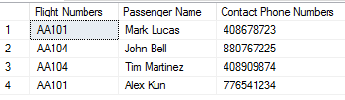

1. Find names of staff who are not assigned to any flight (5 points)

SELECT S.STAFF_NAME AS 'Names of Staff'

FROM STAFF S

WHERE NOT EXISTS (SELECT*

FROM STAFF_ASSIGNMENT SA

WHERE SA.STAFF_ID = S.STAFF_ID)



1. Calculate total cargo charge @$10/kg for each package from cargo flights heading to Chicago (5 points)

SELECT SUM(C.WEIGHT_IN_KG) * 10 AS 'Total Cargo Charges'

FROM CARGO C

WHERE EXISTS (SELECT*

FROM FLIGHT F

WHERE F.ARRIVAL_CITY = 'CHICAGO' AND

F.FLIGHT_TYPE ='CARGO' AND F.FLIGHT_NO = C.FLIGHT_NO)



1. Find names of airlines with no flights to Cleveland (5 points)

SELECT DISTINCT F1.AIRLINE_NAME AS 'Name of Airlines'

FROM FLIGHT F1

WHERE NOT EXISTS (SELECT F2.AIRLINE_NAME

FROM FLIGHT F2

WHERE F2.ARRIVAL_CITY ='CLEVELAND' AND F1.AIRLINE_NAME = F2.AIRLINE_NAME)



1. Find names of airlines whose fights are carrying the heaviest package (Note that multiple flights could have packages with the same weight and that is the heaviest). (5 points)

SELECT DISTINCT F.AIRLINE_NAME AS 'Names of Heaviest Airlines'

FROM FLIGHT AS F, (SELECT C.FLIGHT_NO AS HEAVIEST_FLIGHT_NO

FROM CARGO AS C

WHERE C.WEIGHT_IN_KG >= ALL (SELECT C1.WEIGHT_IN_KG

FROM CARGO AS C1

WHERE C1.FLIGHT_NO <>C.FLIGHT_NO))R

WHERE F.FLIGHT_NO = R.HEAVIEST_FLIGHT_NO AND F.FLIGHT_TYPE='CARGO'

