Sapna Maheshwari: W1175583

1. Banking Application:

Conceptual Model:



Logical Model:

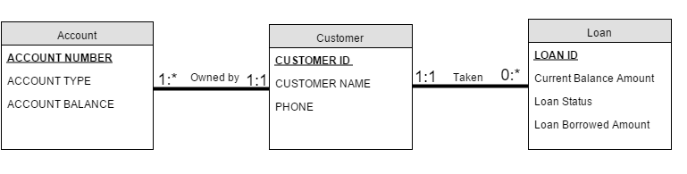

Physical Model:

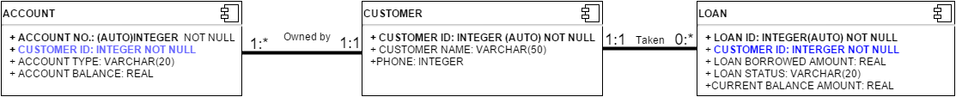

Note: Primary Key is indicated by black bold font and foreign key is indicated by the blue bold font.

Thus, the three tables formed are:

**Customer**:

CUSTOMER ID : (AUTO) INTEGER, NOT NULL, PRIMARY KEY

CUSTOMER NAME: VARCHAR(50)

PHONE : INTEGER

**Account**:

ACCOUNT NUMBER: (AUTO) INTEGER NOT NULL, PRIMARY KEY

CUSTOMER ID : INTEGER, NOT NULL, FOREIGN KEY

ACCOUNT TYPE: VARCHAR(20)

ACCOUNT BALANCE : REAL

**Loan**:

LOAN ID: (AUTO) INTEGER NOT NULL, PRIMARY KEY

CUSTOMER ID: INTEGER NOT NULL, FOREIGN KEY

LOAN BORROWED AMOUNT: REAL

LOAN STATUS: VARCHAR(20)

CURRENT BALANCE AMOUNT: REAL

Assumptions:

1. If an entry exists in the accounts or loan table, I am assuming that the customer always exists with the corresponding Loan, thus the NOT NULL constraint in the Customer ID

2)  Task Rabbit Application (20 points)

Assumptions:

1. I am assuming that the user will have different accounts if he/she wants to act as a customer and a Tasker as well.
2. For a single task, one tasker can place one bid and can update that bid if needed. Thus, (Task ID, Tasker ID) can be treated as the primary key for the Bid table.
3. If a Task exists, I am assuming that the Customer exists, and thus although Foreign Key is the Customer ID, it is also NOT NULL.
4. I am adding a paypal id in Tasker to show that he can be paid in that account.
5. All the IDs are treated to be Integral values.

Conceptual Model:

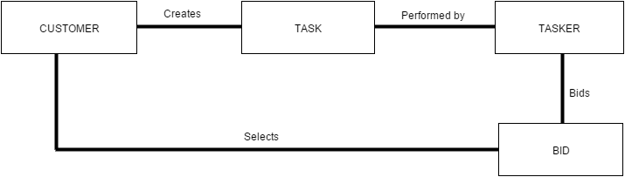

Logical Model:

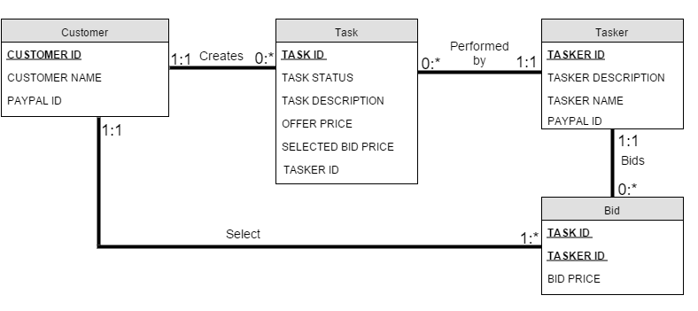

Physical Model:

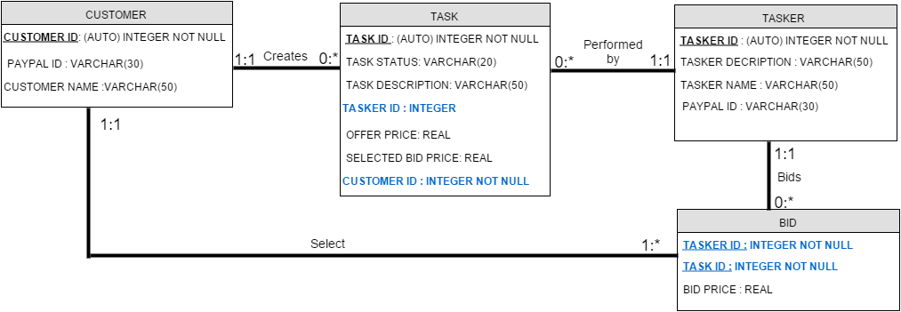

Note: Primary Key is indicated by black bold font and foreign key is indicated by the blue bold font.

Thus the 4 tables are:

**Customer**:

CUSTOMER ID: (AUTO) INTEGER NOT NULL, PRIMARY KEY

PAYPAL ID: VARCHAR(30)

CUSTOMER NAME: VARCHAR(50)

**Tasker**:

TASKER ID: (AUTO) INTEGER NOT NULL, PRIMARY KEY

TASKER DESCRIPTION: VARCHAR(50)  
TASKER NAME: VARCHAR(50)

PAYPAL ID: VARCHAR(30)

**Task**:

TASK ID: (AUTO) INTEGER NOT NULL, PRIMARY KEY

TASK STATUS: VARCHAR(20)

TASK DESCRIPTION: VARCHAR(50)

TASKER ID: INTEGER, FOREIGN KEY

OFFER PRICE: REAL

SELECTED BID PRICE: REAL

CUSTOMER ID: INTEGER NOT NULL, FOREIGN KEY

**Bid**:

TASK ID: INTEGER NOT NULL, FOREIGN KEY

TASKER ID: INTEGER NOT NULL, FOREIGN KEY

(TASK ID, TASKER ID): PRIMARY KEY

BID PRICE: REAL