Analytic managed database , it uses cloud sql . it is not transactional .. used for large volume data .

Used for data warehouses we can query and manipulate data using bq and gui .

BigQuery is a managed, petabyte scale data warehouse, which uses SQL. Bigtable does not support SQL. Cloud SQL and Cloud Spanner support SQL but are designed for transaction processing, not analytical applications like data warehouses.

Data Transfer service - to load data from saas product from google .

BI engine - to do analytic type querying .

**Bigquery ml :**

**Create ml model in sql**

Model supported ->

linear regression , binary and multiclass logistic regression , k mean clustering , time series forecast, matrix factorization , boosted tree and xgboost ,tensorflow , automl tables .

**Create mode options:**

Model type

Input label column

Regularization

Learning rate

Early stop

Standardize feature

Max tree depth

**Bigquery and iam .**

Grant permission to identity using role

Identity - user , service account , principal

Role - set of permission

Permission assigned to identity from role .

Type of role : predefined , custom , basic

Granting access :

Grant access at multiple levels - organization , projects , datasets , tables and views , roles and columns .

Permission apply to resource : dataset , job , ml model , tables ,

Operation allowed - get , list deleted , create .

Bigquery admin - create , manage jobs, all admin tasks .

Bigquery data editor role : read , list , update , delete ,

Bigquery user role :

BigQuery is an analytics database designed for data warehouse and analytics operations. It scales to petabyte sized databases and uses SQL for a query language.

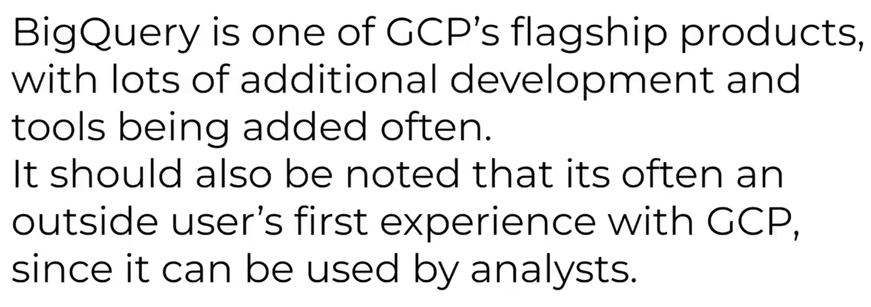

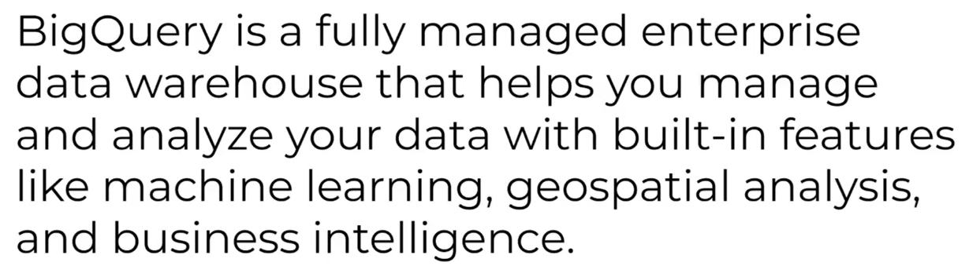

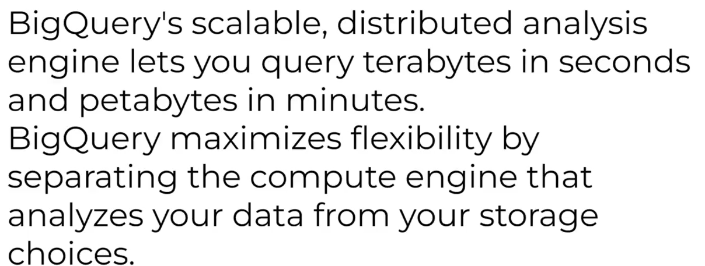

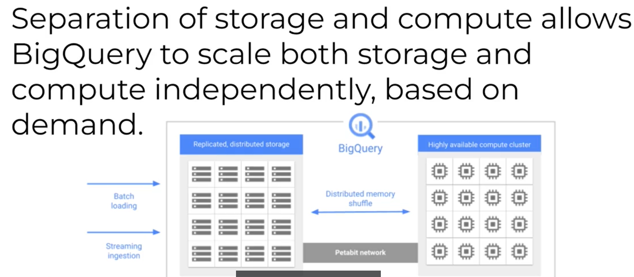

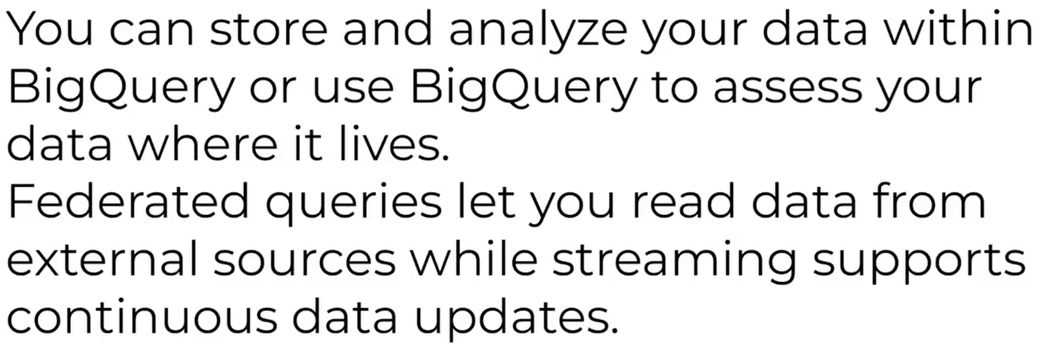

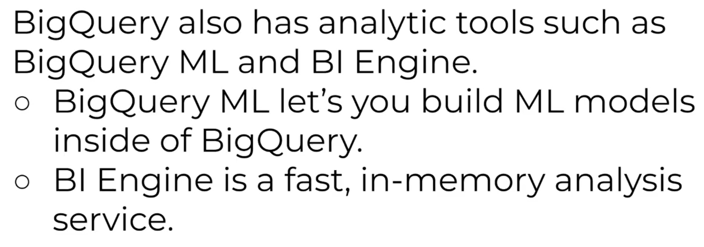

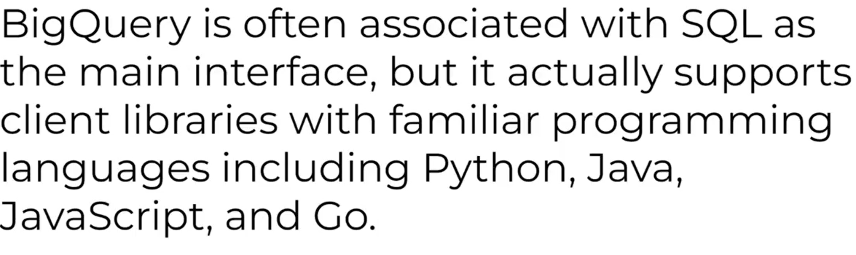

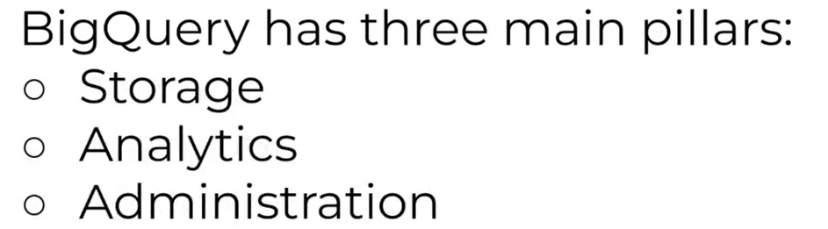

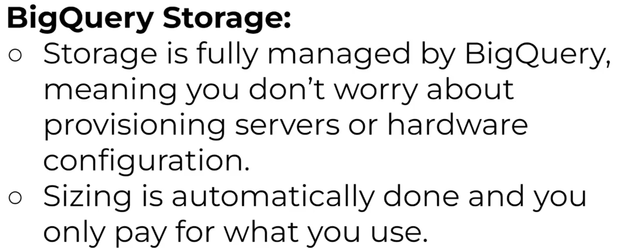

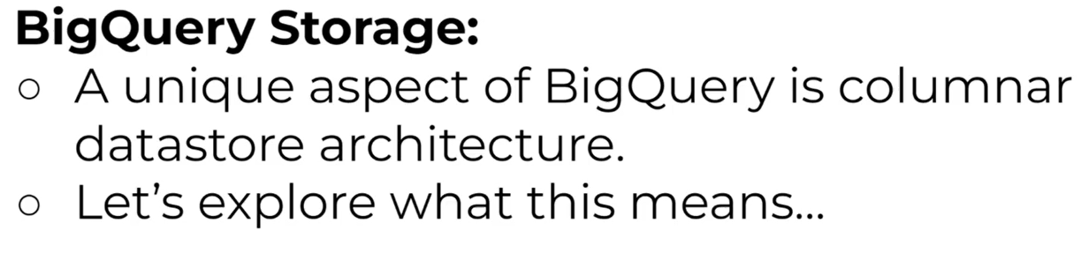

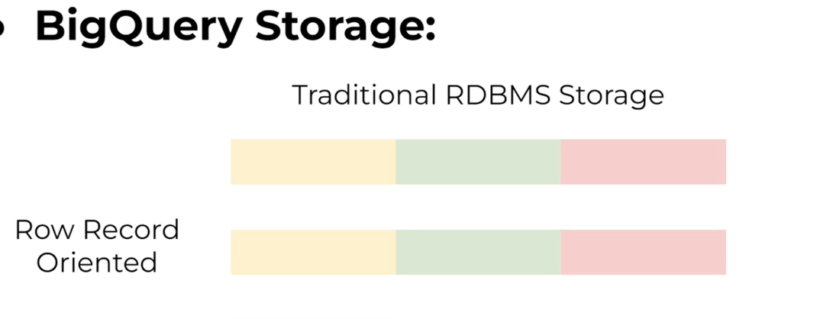

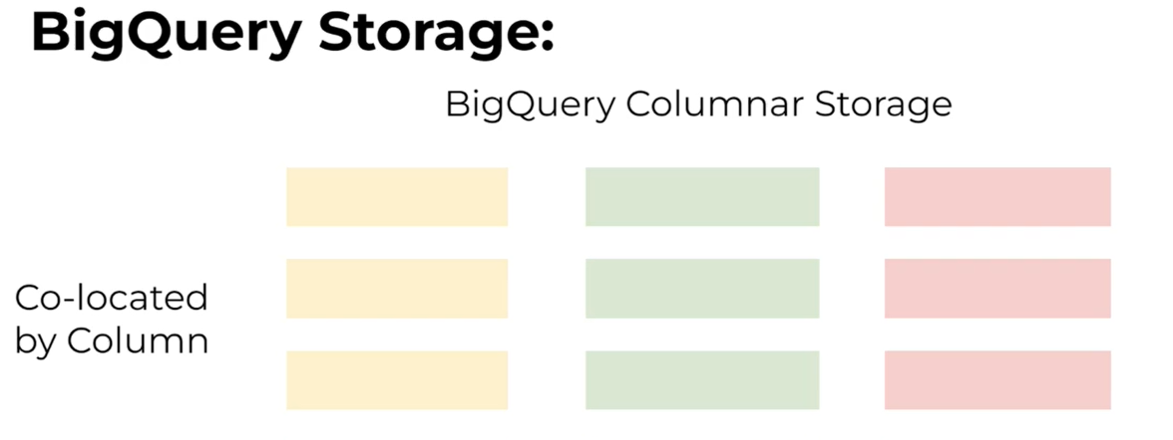

Bigquery uses a capacitor for above columnar processing .

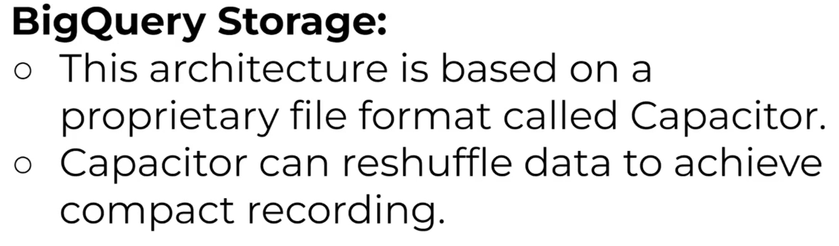

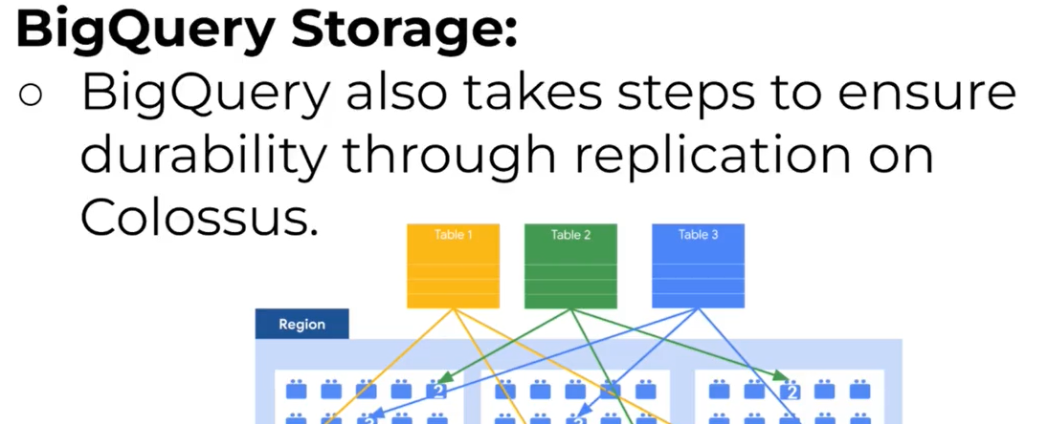

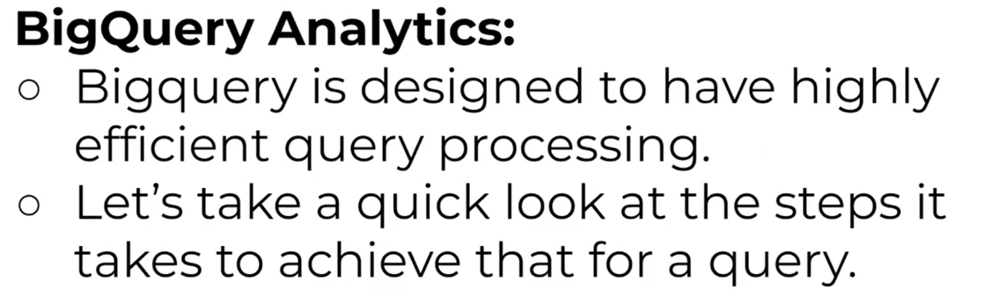

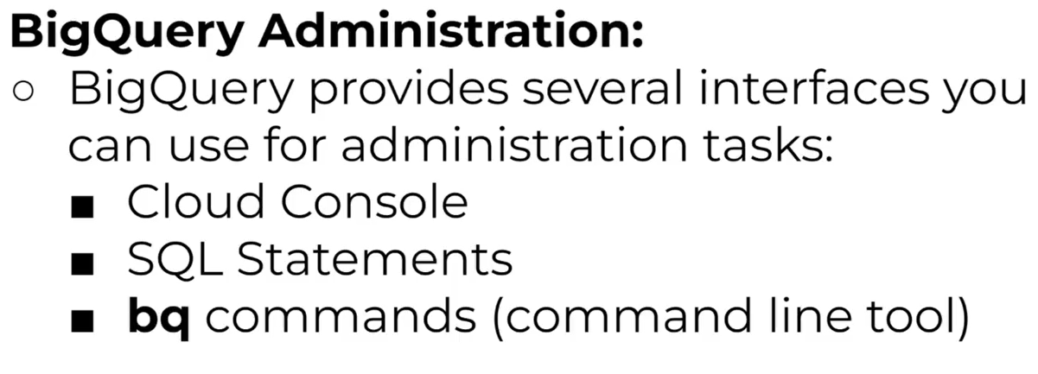



use the --dry-run option with the bq select command to know the estimated cost of running each query without actually running them