Azure Storage is a Microsoft's cloud storage solution for modern enterprises and applications to store data.

Advantages of Azure Storage

You need to know why you are learning Azure Storage and its advantages.

Azure Storage was the first service built among the Azure services. It is the fundamental building block of Azure. Following are the offerings of this service:

Scalability: It is easily scalable. You can start with a small size blob and scale to infinite size depending on the demand without affecting the production.

Durability: Data in Azure storage is very durable with multiple levels of redundancy in which you have just to mention the type of redundancy and Azure does the rest of the work for you.

Availability: Replication option enables you to store copies of your data in different availability zones, and in the event of zone or node destruction, the data is still available.

Security: All data in the Storage is encrypted; both in rest and transit. Also, with key vault, only you have control over encryption keys making your data more secure.

Accessibility: The data in storage can be easily accessed through the available SDKs in a wide variety of languages. Azure Storage supports scripting in Azure PowerShell or Azure CLI.

Management: Management is easy because Azure takes care of any critical problems and maintenance of the servers.

Azure unstructured data consists of disk storage, file store, sync, and blob storage.

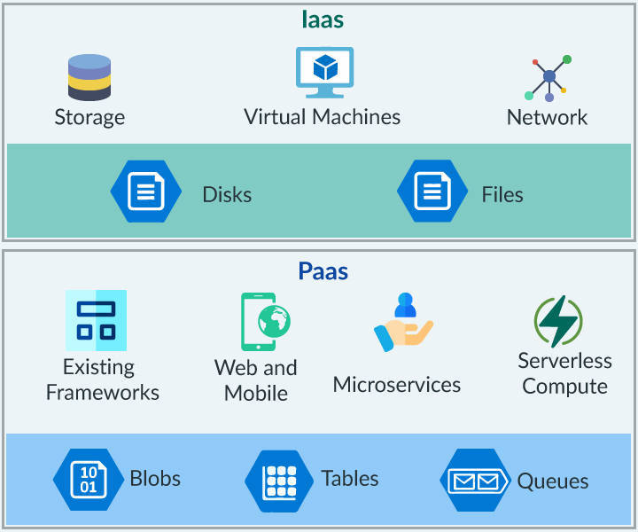

Storage Account: To use any of the Azure Storage services, you need to create a storage account within the Azure account. Resources in this account can be accessed by any language that can make HTTP/HTTPS request.

Azure Blob: Binary Large Object (BLOB) is a collection of binary data that may be a file, video, text, image, etc. Azure Blob storage is Microsoft's object storage solution for the cloud.

Container: A container provides a grouping of a set of blobs. All blobs must be in a container. A Storage account can hold an unlimited number of containers. Likeways, a container can store an unlimited number of blobs.

VM Disks: Virtual Machines in Azure use disks as a place to store, which is either Hard Disk Drives (HDD) or Solid-state Drives (SSD), based on the storage account type.

Standard Storage: Standard Storage account is a type of storage account backed by magnetic drives (HDD) that provide low cost per GB and can be used for all kinds of data (blobs, files, tables).

Premium Storage: Premium storage has high bandwidth with extremely low latency. It offers less than 1 ms read latency (cache), and uses SSD. Premium Storage supports only Locally Redundant Storage (LRS) Replication.

Storage Explorer: It is a useful GUI tool to inspect and alter data in Azure Storage. It can be used to upload, download, and manage blobs, files, queues, and tables from any platform, anywhere. It is provided by Microsoft.

Block Blobs: In block blobs, the blobs are comprised of blocks that are identified by unique block ID. The maximum size of blocks is restricted to 100MB, and each block blob can have 50,000 blocks which are ideal for storing text or binary files, such as documents and media files.

Page Blobs: Page blobs are the collection of 512-byte pages optimized for random read and write. These are used for storing VHD files of Azure VM as OS and Data disks. The maximum size of page blobs is 8TB.

Append Blob: This type is used to append blobs that are used for logging scenarios. The maximum size of append blob is 195 GB.

You know that Virtual Machines are part of Azure's Infrastructure as a Service (IaaS) component. Ever wondered where the data is stored in a VM? It is in "Disks".

A virtual machine uses three types of disks, they are:

Operating System Disk: It is created along with the virtual machine by Azure. It is generally mounted as C drive, which is 2 GB in size.

Temporary Disk: This disk holds temporary contents, although, you are not suggested to store anything there. If the VM is redeployed for any reason, the drive is wiped out and starts fresh. The primary function of that temporary disk is simply for the page file.

Data Disk stores all the data required to be worked upon. This disk is huge and has high performance.

Data Disks on VMs

So, apart from all the disks, the Data disks are crucial. Want to know how and why? Check out.

Data Disks are where the working data and all the application data reside. The size of VM decides the number of data disks that can be attached to a VM. Data disks are stored in a BLOB in an Azure storage account.

Data disks could be of type Standard or Premium, both of which may be again managed or unmanaged.

Standard storage uses HDDs with a maximum IOPS (I/O Operations per second) of 50000 and the number of disks up to 100 (each disk is of 4 GB).

Premium storage has an unlimited IOPS and has 35 TB of storage and 10 TB of snapshots.

**Snapshots :**

Snapshot in azure storage

In Azure Storage, a snapshot is a read-only copy of a specific version of a blob or a file that is created at a specific point in time. Snapshots are useful for various scenarios such as data backup, recovery, auditing, and archiving.

To create a snapshot of a blob or a file in Azure Storage, follow these steps:

Open the Azure portal and navigate to the storage account that contains the blob or file that you want to snapshot.

Click on the container that contains the blob or file.

Click on the blob or file that you want to snapshot.

Click on the "Snapshot" button in the top menu.

Enter a name for the snapshot, if desired.

Click on the "Create" button.

Once the snapshot is created, it can be accessed like any other blob or file in Azure Storage. However, the snapshot is read-only and cannot be modified or deleted. To restore a snapshot, you can copy the snapshot to a new blob or file or revert the original blob or file to the snapshot version.

**Data Disks on VMs**

With Managed disks, Azure does all the management such as storage account creation, replication and also makes sure disks are kept secure.

With unmanaged disks, you will have the additional responsibility of all these administering tasks.

Pricing is per storage: For Unmanaged model, it uses storage account pricing. For the Managed model, it is simply based on the size of the disk.

Azure CLI 2.0 Commands

Azure CLI 2.0 is known as a command line tool used for accessing the resources in Azure. The CLI is designed to make scripting easy, flexible query data, support long-running operations as non-blocking processes, and more.

**Creating Storage Account:**

az storage account create --name accName --resource-group ResGrpName --sku standard_LRS --location useast.

**Creating a Container:**

az storage container create --name mycontainer --public-access blob/container

Use "blob" to allow public read access for blobs. Use "container" to allow public read and list access to the entire container.

**Uploading a blob:**

az storage blob upload --container mycontainer --name blobname --file filepath.

**Downloading a blob:**

az storage blob download --resource-group resgrpName --name blobName --file savingPath.

**Deleting a Storage Account:**

az storage account delete --name accname.

**Creating a Virtual Machine (VM):**

az vm create --name vmname --resource-group resGrpName --admin-username username --admin-password password --image win2016datacentre/ubuntuLTS.

**Attaching a Disk to VM:**

az vm disk attach --resource-group resGrpName --vm-name name --size-gb 128 --sku Standard_LRS –new