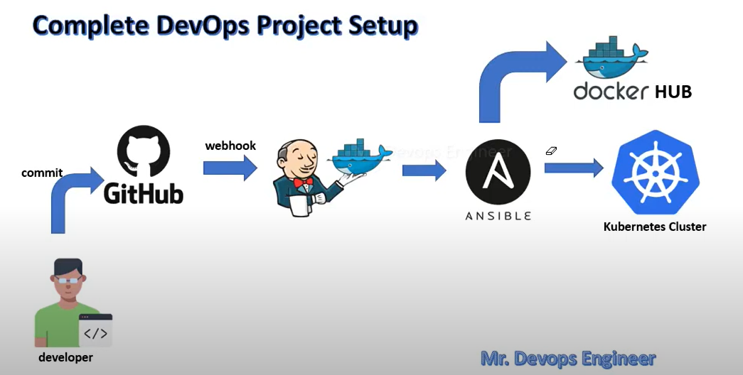

We will have deployment on Kubernetes cluster using Jenkins CICD pipeline .

CODE pushed to GITHUB -> NEW COMMITS WILL BE NOTIFIED TO JENKINS USING WEBHOOK -> JENKINS WILL SSH CODE TO ANSIBLE AND KUBERNETES SERVER -> ANSIBLE WILL READ DOCKERFILE FROM CODE , BUILD THE IMAGE , TAG IT , PUSH to docker hub -> ansible will run playbook to fetch latest image that will run Kubernetes service and deployment .

From image container will be built and application accessible will be done on Kubernetes using service.yml .

PRE – REQS :

GITHUB , LINUX , JENKINS , DOCKER , DOCKERHUB , ANSIBLE , KUBERNETES .

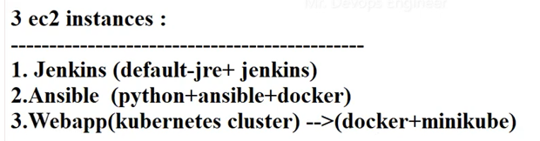

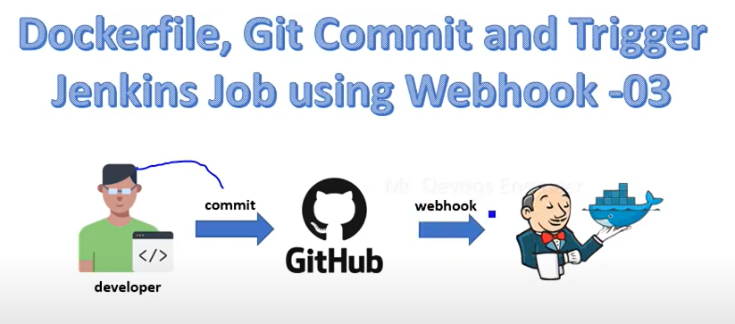

Jenkins will be notified of new commit by web hooks and it will trigger job automatically .

Create pipeline . – we will write descriptive pipeline .

New item > pipeline

Write pipeline script or we can use pipeline syntax also .

First let’s do git checkout of code using pipeline :

Once done .

To initiate webhook enable below property in pipeline .



Create Jenkins API token to add in webhook : 11e4ac4c53bebb287359df693a6b93027c

Also add webhook in github .

Now , Sending dockerfile to ansible using ssh agent and build docker images .

Add 1 more stage in pipeline :

