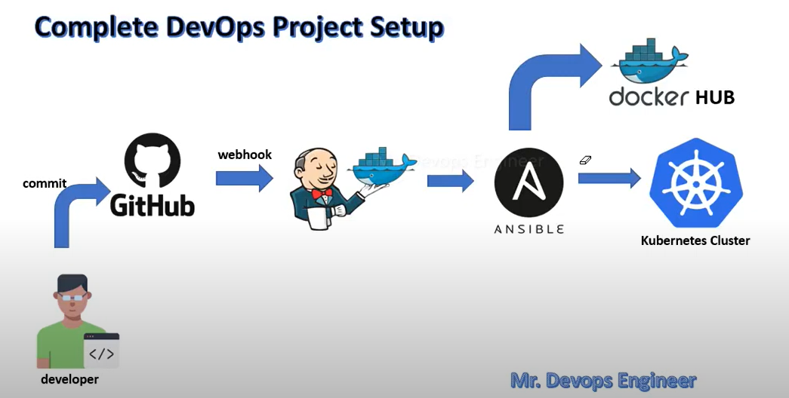

We will have deployment on Kubernetes cluster using jenkins CICD pipeline .

CODE pushed -> GITHUB -> NEW COMMITS WILL BE NOTIFIED TO JENKINS USING WEBHOOK -> JENKINS WILL PULL CODE FROM GITHUB ANS SSH CODE TO ANSIBLE SERVER -> ANSIBLE WILL READ DOCKERFILE FROM CODE , BUILD THE IMAGE , TAG IT , PUSH to docker hub -> ANSIBLE will ssh to Kubernetes cluster server and ansible will run playbook to fetch latest image . From image container will be build and application accessible will be done on Kubernetes using service.yml .

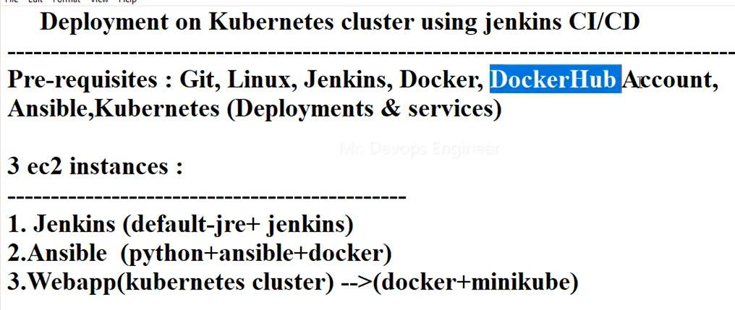

Create 3 server in AWS .

FOR - ANSIBLE , JENKINS – t2.micro – UBUNTU / LINUX .

MINICUBE single node server FOR WEBAPP – t2.medium – UBUNTU / LINUX

Install Jenkins in Jenkins server .

INSTALL ansible in server .

KUBERNETES CLUSTER WEBAPP:

Install docker and minikube in server as kubernetes uses docker .

Installing docker :

sudo apt-get update

sudo apt install docker.io

sudo snap install docker

docker --version

systemctl start docker

docker run hello-world

sudo docker images – list of images

sudo docker ps -a : list of containers

We can also add docker repo in default repo list of server to install docker .

Vi /etc/yum.repos.d/docker.repo

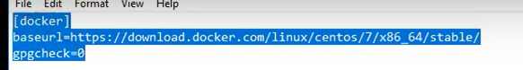

Yum repolist – to update repo list .

Yum install docker-ce

Installing minikube :

Minikube for Kubernetes Development.What is minikube Minikube is a tool for running a Kubernetes cluster locally on your computer for development and testing purposes. It is designed to make it easy for developers to run and experiment with Kubernetes features without needing access to a full-scale, production-grade Kubernetes cluster.Minikube works by creating a single-node Kubernetes cluster inside a virtual machine on your local machine. It provides a simple command-line interface for starting and stopping the cluster, and for interacting with the Kubernetes API and running applications on the cluster.With Minikube, developers can test their applications in a Kubernetes environment, experiment with Kubernetes features like service discovery and load balancing, and gain experience with Kubernetes concepts and terminology. It is a popular tool among developers and DevOps engineers who work with Kubernetes

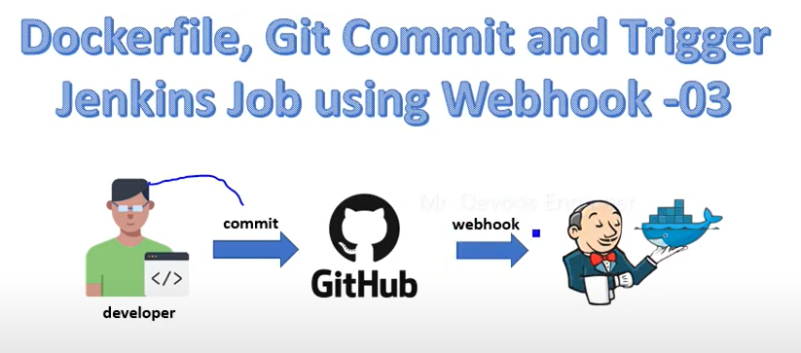

Jenkins will be notified of new commit by web hooks and it will trigger job automatically .

<https://github.com/vikash-kumar01/Kubernetes_Project.git>

Create pipeline . – we will write descriptive pipeline .

New item > pipeline

Write pipeline script or we can use pipeline syntax also .

Script for git .

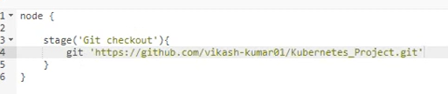



To initiate webhook apply this in pipeline .

Also add webhook in github .

In payload url add jenkins url and api token . for that generate api token .

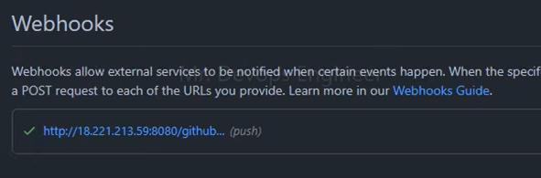

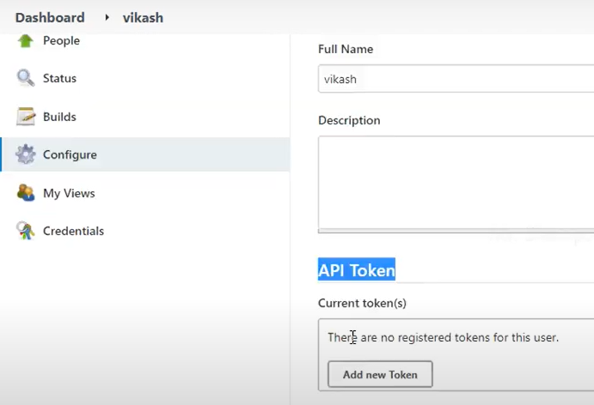

Sending dockerfile to ansible using ssh agent , build docker images .

Now add 1 more stage in pipeline .

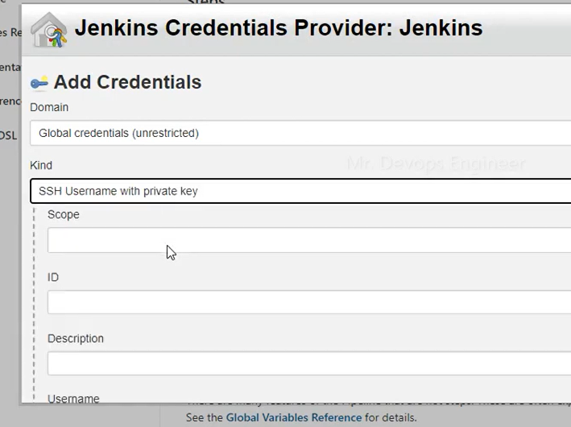

Add private key manually .

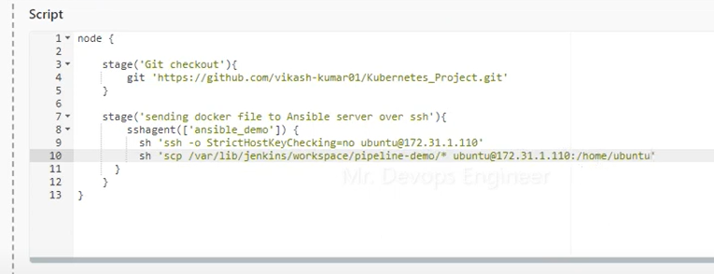

Save and build pipeline .

Now scp is done to ansible server .

Ssh -o stricthostkeycheckingThe "ssh -o stricthostkeychecking" command is used to set the level of strictness for checking the host key of a remote server when connecting through SSH. By default, SSH will prompt the user to confirm the host key fingerprint when connecting to a new server for the first time. This prompt is designed to protect against man-in-the-middle attacks, which can occur when an attacker intercepts the SSH connection and poses as the remote server.When you use the "ssh -o stricthostkeychecking" command, you can set the level of strictness for checking the host key of the remote server to either "yes", "no", or "ask"."yes" will cause SSH to automatically reject the connection if the host key does not match the known key for the remote server."no" will cause SSH to automatically accept any host key presented by the remote server, without checking it against the known key."ask" will cause SSH to prompt the user to confirm whether they want to connect to the remote server, based on the host key presented by the server.It's important to note that setting the "stricthostkeychecking" option to "no" can be dangerous, as it removes the protection against man-in-the-middle attacks. Therefore, it's recommended to use the "ask" or "yes" options, unless you have a specific reason to use "no".has context menu

Build and tag docker images .

Ansible will build and tag images using dockerfile that is transferred from Jenkins . To maintain version based on build we will use tag in docker image .

Now add 1 more stage in pipeline .

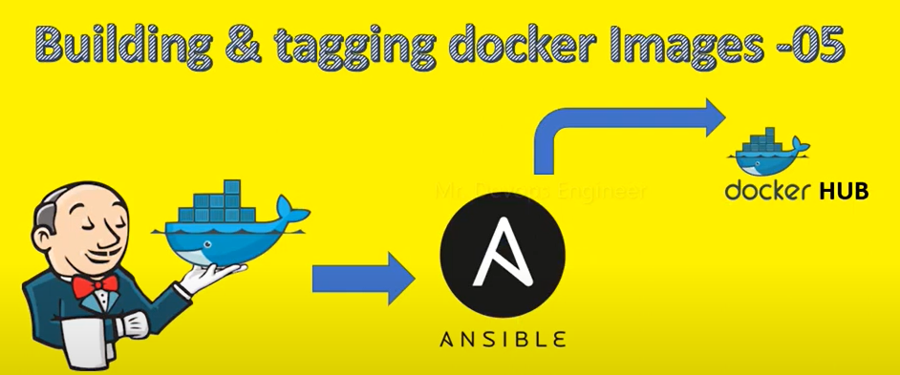

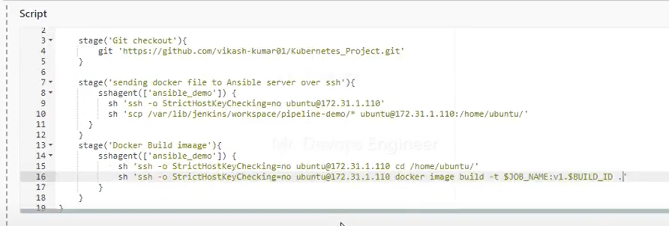

$JOB_NAME – it will use job name of this particular pipeline as docker image name .

$BUILD_ID – it will use build number of this build as version for tagging docker image .

Once build is successful go to ansible server and check docker image :

docker image ls

Now push docker image to docker hub , so for that we have to tag image .

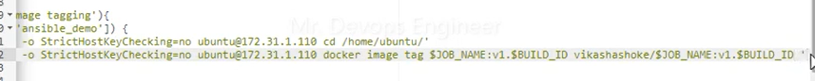

In place of vikas add your docker hub profile name so image will be tagged with your profile name .



We will add 1 more tag to get latest image .

Now build pipeline and check whether image build is done in ansible server or not .

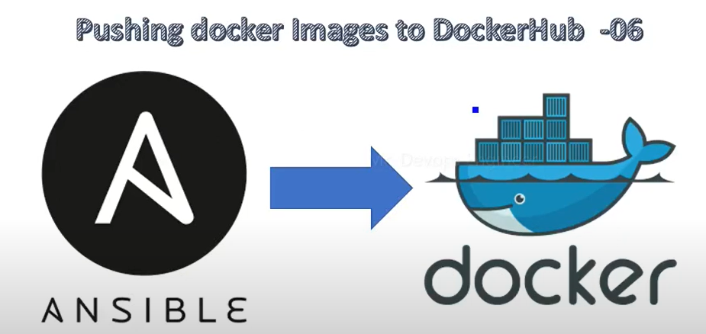

We will push docker image to docker hub from ansible server .

Add new stage in pipeline .

As our image reside in ansible server first we have to ssh to ansible server from jenkins , after that login to docker hub from ansible

We have to provide password in jenkins script but we cant provide password as it is so we can check syntax for creds in jenkins .

And generate pipeline script .

Using above script, we will login to docker hub and push image .

Now check in docker hub image will be pushed .

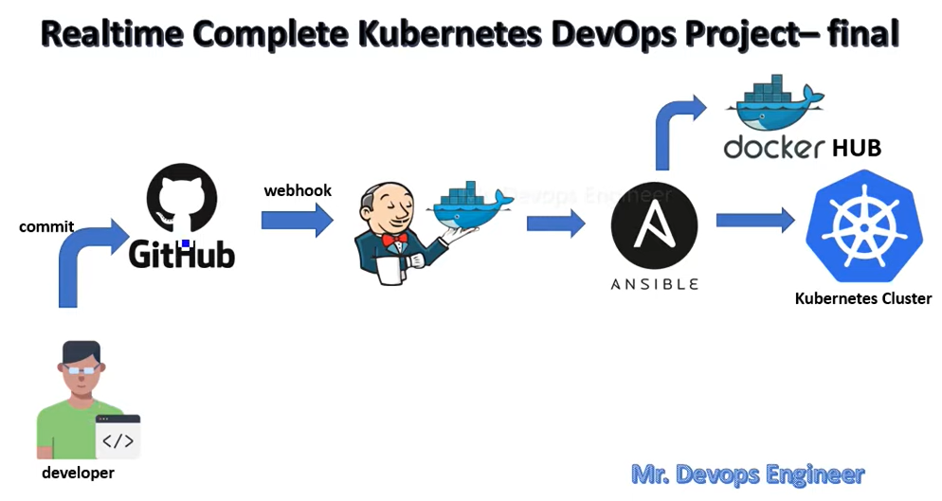

Now ansible will run playbook on Kubernetes cluster – service.yml & deployment.yml & ansible.yml

Kubernetes cluster will pul latest image from docker and will build container using image .

And container will be accessible to user from ip port which we will expose .

In deployment.yml use same image name as the one in docker hub .

We will not provide any tag so that it will use latest tag image .

Containerport to specify what port we are exposing for container .

IN service.yml we can define port details targetport is same as conatinerport . nodeport will also be specified

We will be using service type as loadbalancer

In ansible.yml use Kubernetes ip as host .

Now jenkins will transfer service.yml , deployment.yml ans ansible.yml file also to ansible server .

Now lets make ssh connection between ansible ans Kubernetes server .

In Kubernetes server :

Set password for root user :

Passwd root

Vi /etc/ssh/sshd_config – in this file

 we enable root login

 and enable password authentication .

Now restart the server : service sshd restart

Now generate ssh key for ansible server . ssh-keygen and copy public key of ansible server to Kubernetes server for setting up passwordless connection .

Ssh-copy-id -I username@kubenertedserverip – public key will be added to Kubernetes server and passwordless will work now .

In ansible server install ansible .

Vi /etc/ansible/hosts

In host file add Kubernetes server Ip as

[node]

Kubernetes-ip

Try to ping the node if it works or not

Ansible -m ping node .

Now we have to move service.yml and deployment.yml to Kubernetes server so that it can run there from ansible-playbook .

Create 1 stage in pipeline to copy file from ansible to Kubernetes server .

Using pipeline syntax generatr create syntax .

Now we want to ssh to Kubernetes server .

Sshagent > add creds > add private key for Kubernetes server and generate syntax .

Now instead of copying from ansible we will copy files from jenkins to Kubernetes server .

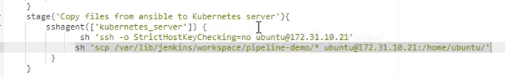

Now set passwordless between jenkins and kubernetes .

Also we can delete local images from docker after images pushed to docker hub – update in push to docker hub stage of pipeline .

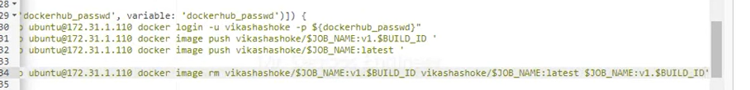

Now run pipeline .

If public ip is changed for jenkins then update that in github webhooks .

If we permission issue for any docker file then do chmod 777 file-for-docker .

Now add stage to execute playbook in ansible server

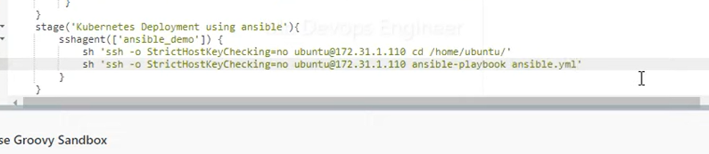

Make sure to add host key fingerprint between Kubernetes and ansible server . – do ssh once between ansible and Kubernetes .

Also install ansible in Kubernetes server also . – apt install ansible

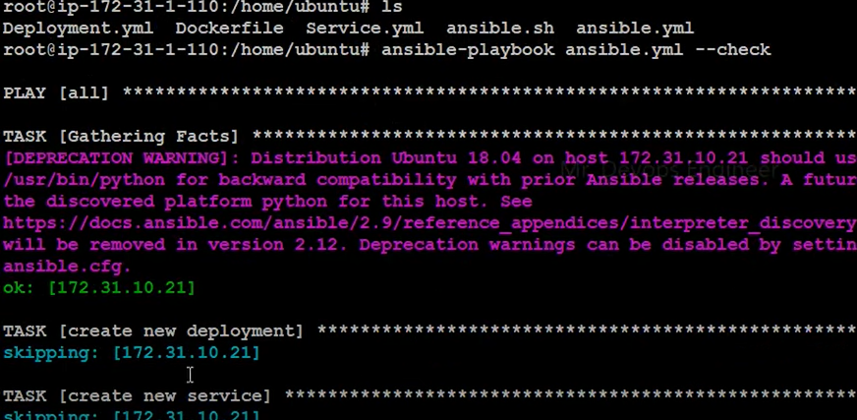

Use –check to perform dryrun for ansible .

Minikube start – to start minikube server .

Also make sure to install ansible using ubuntu only not from root .

Once done check in Kubernetes server

Kubectl get all

Kubectl get pods

Kubectl get svc

We can access pod service from browser using pod port and webapp ip .

Docker image ls

Also if we push new docker file then also old service.yml and deployment will be used for creating new pod since we have not added any code to delete these files from Kubernetes server and ansible server .

So update ansible.yml to delete old service and deployment files .

And now new image will be run as pod in Kubernetes and service will be accessible .