**Installation Instructions**

Follow install and download NodeJS library for working in there: <https://nodejs.org/en/download/package-manager.>

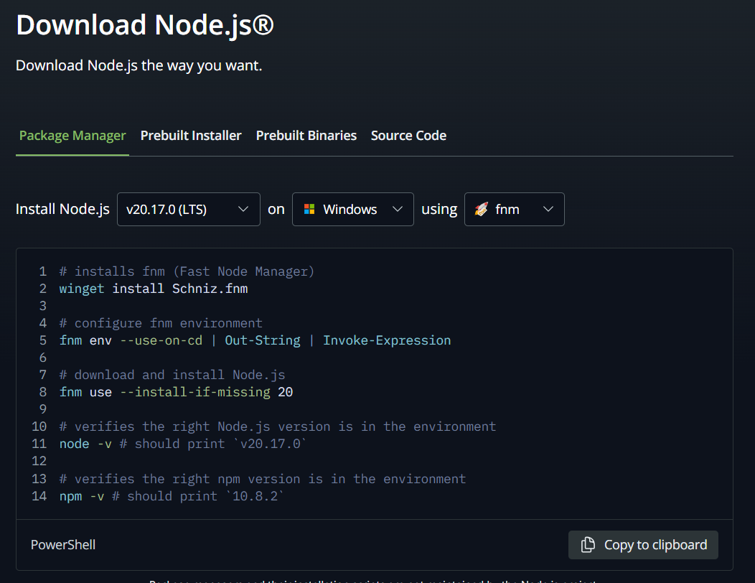

Download the zip file and start by clicking on the file you want to extract and select extract to a specified folder.

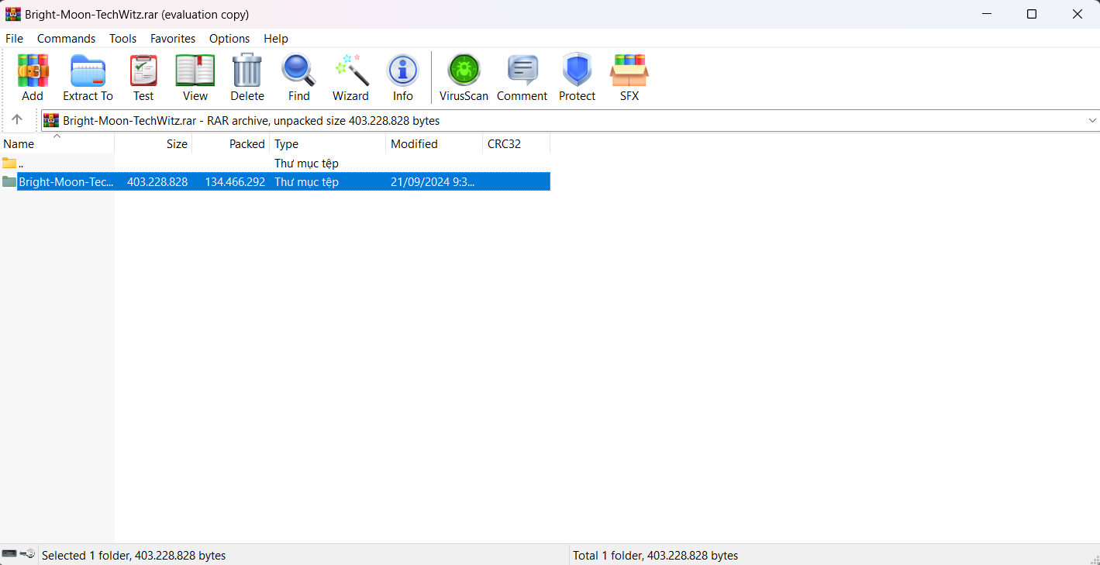

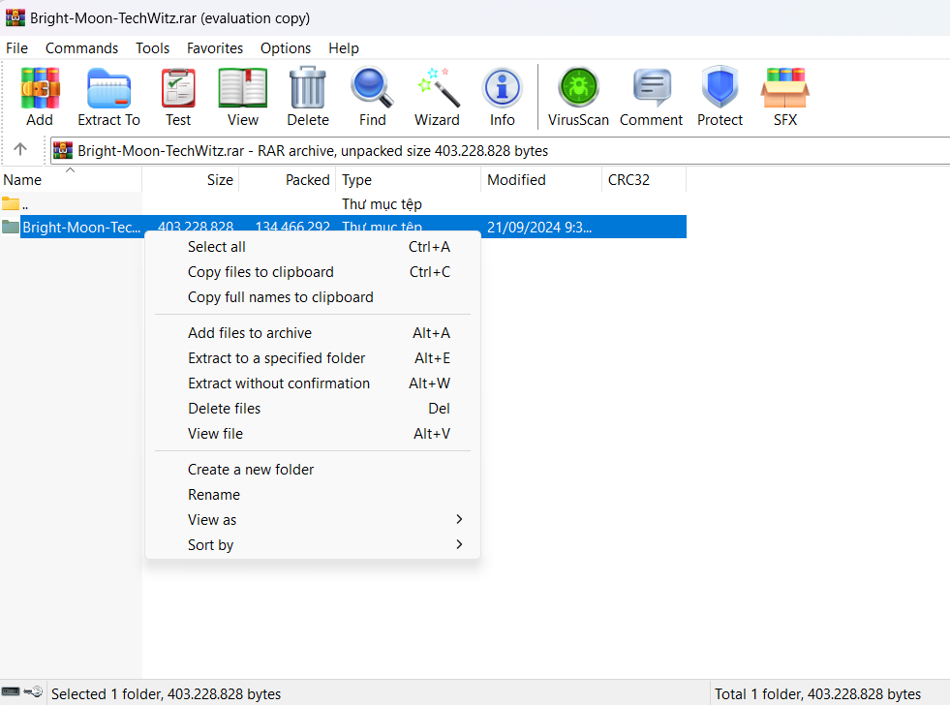

Select the downloaded file in the folder Bright-Moon-TechWitz go to the source section then E-project section, mouse to the top and highlight and type cmd.

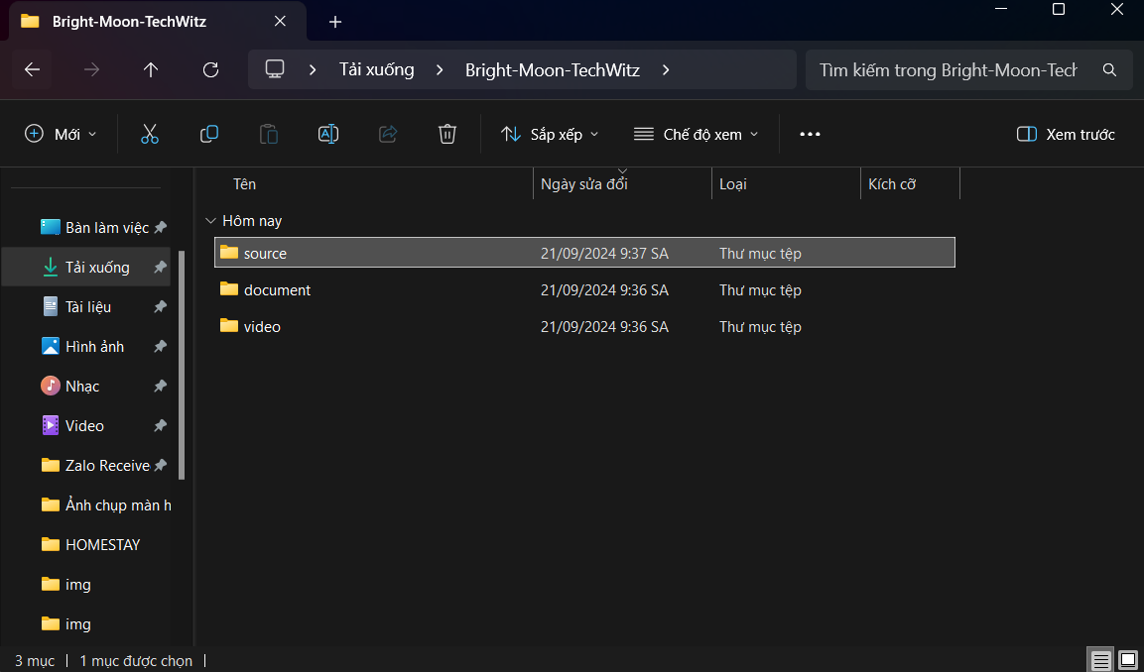

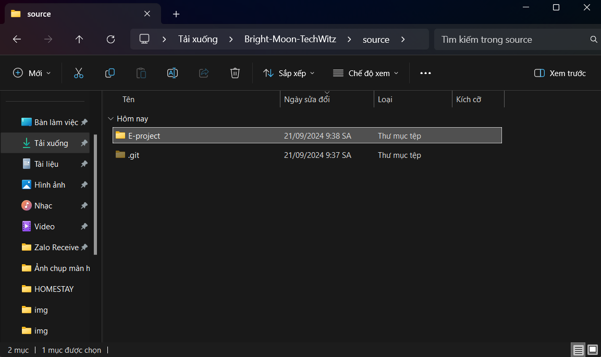

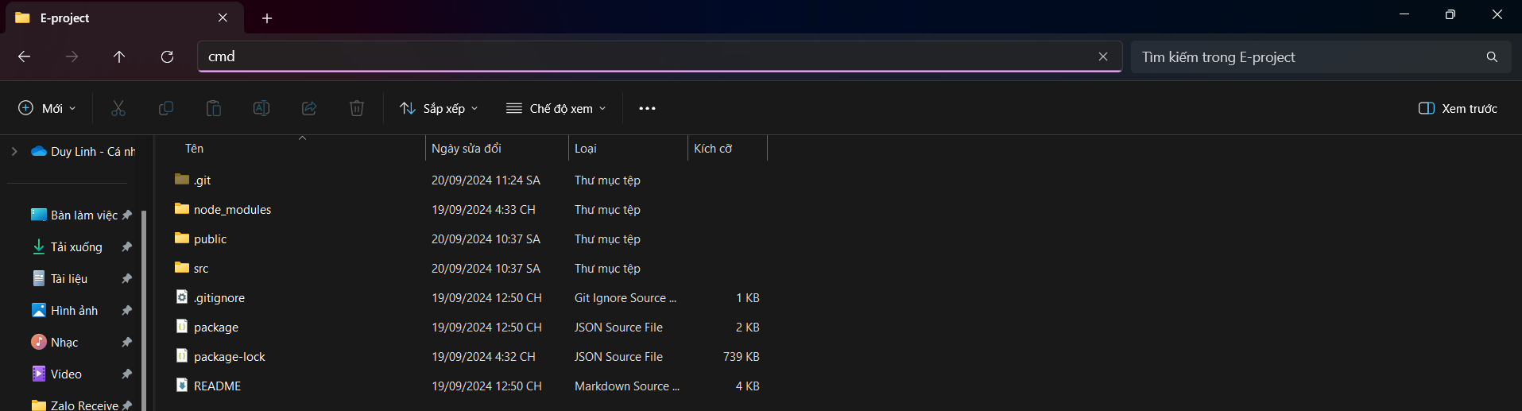

When the cmd panel appears, we type the command npm install and the command code. It will display Visual Studio Code.

In VS Code if you dont hava node_modules file, write in the terminal command: npm install. It will download node_modules library.

When Visual Studio Code appears, we will select package.json then right-click and select open in integrated terminal and it will display a table below and write the command npm run json with the command npm start.

