NOTGATE 2023066453이정민
- Vhdl

LIBRARY ieee;
USE ieee.std_logic_1164.all;

ENTITY not_gate IS
PORT (
a : IN std_logic;
y : OUT std_logic
);
END not_gate;

ARCHITECTURE TypeArchitecture OF not_gate IS
BEGIN
y <= NOT a;
END TypeArchitecture;

- circuit
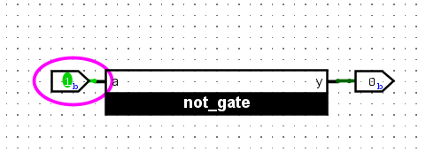

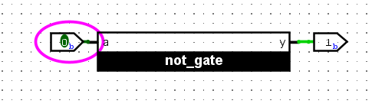

- result
The simulation results confirmed the expected operation of the NOT gate: $a=0→y=1$ and $a=1→y=0$.

