CA2 Individual Report
Name | Yak En Quan Jayden
Student Id | P2520519
Class | DCDF/FT/2B/21
Github Repository URL | https://github.com/AY26S1-ST0503/ca2-jayden140408
Github Account ID | jayden140408

- For each competency, provide a brief description and 1-2 of your best implementations with a URL link as evidence for what you’ve done.
e.g. https://github.com/expressjs/express/blob/master/examples/static-files/index.js
- Theme & Concept
Description:
Castaway Chronicles is a raft-survival game where players sail across a 3D ocean, collect debris, craft equipment, improve their raft, complete quests, and survive dangerous events. The two main mechanics are the debris-to-upgrade progression loop and the ocean-event and quest system.
Best implementation 1:
The README clearly explains the game concept, gameplay loop, quests, debris collection, crafting, upgrades, and unexpected events.
Evidence: Game concept and main systems
Best implementation 2:
The voyage engine implements server-connected debris collection and automatic ocean events inside the Three.js world.
Evidence: Voyage gameplay implementation
- Architecture
Description:
I organised the backend into routes, controllers, models, middleware, configuration, database, and utility layers. The frontend is separated into page entry points, page renderers, reusable components, shared libraries, and ocean-related modules.
Best implementation 1:
The Express entry point registers global middleware, public routes, protected routes, catalogue routes, Swagger documentation, and the global error handler.
Evidence: Express application structure
Best implementation 2:
Multi-step gameplay actions are divided into small controller steps and executed through shared transactional pipelines.
Evidence: Gameplay controller pipeline
- Database Design & ERD
Description:
I designed 11 related tables for users, item types, inventory, debris, collection logs, crafting recipes, raft upgrades, quests, quest progress, ocean events, and event history. The schema includes foreign keys, default values, a required password column, and a unique user-and-quest index.
Best implementation 1:
The user, inventory, debris, collection log, crafting, and raft-upgrade tables support authentication and the debris-to-upgrade gameplay loop.
Evidence: Users, inventory, debris, crafting and upgrade schema
Best implementation 2:
The quest and ocean-event tables store individual player progress, reward claims, event consequences, defensive upgrades, and event history.
Evidence: Quest and ocean-event schema
- RESTful APIs
Description:
I designed resource-based routes using GET for reading, POST for creation and gameplay actions, PATCH for partial updates, and DELETE for removal. Protected player routes act on the authenticated user instead of trusting a user ID supplied by the browser.
Best implementation 1:
The authenticated player router provides profile, inventory, upgrades, quests, debris collection, crafting, ocean-event resolution, and quest-reward endpoints.
Evidence: Authenticated player API routes
Best implementation 2:
The item catalogue demonstrates standard RESTful CRUD using GET, POST, PATCH, and DELETE with request validation and authentication for writes.
Evidence: RESTful item catalogue routes
- Server–Database Interaction
Description:
I used Drizzle ORM for filtering, joining, inserting, updating, deleting, sorting, and returning database records. Important gameplay actions are transactional so all related changes succeed together or are rolled back together.
Best implementation 1:
Debris collection atomically claims a player-owned debris record, updates materials, inserts the collected item, records an audit log, and returns transformed response data.
Evidence: Atomic debris collection
Best implementation 2:
Raft upgrades and quest rewards use transactions to update player resources and insert related records without leaving incomplete database changes.
Evidence: Atomic upgrades and quest rewards
- Error Handling
Description:
I used a reusable application error class, central error codes, validation middleware, request logging, and a global error handler. The API returns informative status codes and messages for validation failures, missing resources, conflicts, cooldowns, authentication failures, and internal errors.
Best implementation 1:
The shared AppError class and global error handler convert application errors into consistent JSON responses containing the code, message, and status.
Evidence: Global error-handling implementation
Best implementation 2:
Every request receives a correlation ID, and completed requests and errors are logged with the method, path, status, duration, and error details.
Evidence: Request tracing and error logging
- Functionality
Description:
The two core mechanics work across the frontend, API, and database. Players can sail over server-generated debris to collect it, encounter ocean hazards, advance quests, return to camp, craft items, upgrade their raft, and claim rewards.
Best implementation 1:
The voyage engine loads server-authored unexpected events, resolves them through the API, displays their effects, updates player status, and announces completed quests.
Evidence: End-to-end unexpected-event flow
Best implementation 2:
The voyage engine loads debris from the server, detects collisions with the raft, submits the debris ID, updates the interface, and reloads the collectible field.
Evidence: End-to-end debris collection flow
- Registration, Login & Authentication
Description:
Registration validates and hashes passwords using bcrypt. Login compares the submitted password against the stored hash and generates a JWT. Protected routes verify the Bearer token and obtain the authenticated player ID from the verified payload.
Best implementation 1:
The bcrypt middleware hashes passwords with 10 salt rounds and compares login passwords with the stored hash.
Evidence: Bcrypt password hashing and comparison
Best implementation 2:
The JWT middleware signs tokens with configurable expiry and algorithm settings, validates Bearer tokens, and stores the verified user ID for later middleware.
Evidence: JWT generation and verification
- Frontend
Description:
I built a vanilla JavaScript frontend that communicates with the Express backend using fetch. It provides separate login, registration, camp, voyage, and leaderboard pages while sharing reusable API, session, notification, world-clock, and interface logic.
Best implementation 1:
The shared API client handles login, registration, authenticated requests, Bearer headers, JSON request bodies, response normalisation, logging, and localStorage sessions.
Evidence: Frontend API and session client
Best implementation 2:
The camp page provides navigation and user actions for quests, inventory, crafting, upgrades, profile management, voyages, account deletion, and logout.
Evidence: Camp frontend implementation
- Code Quality & Documentation
Description:
I separated reusable logic from route-specific code and documented the project structure, setup, gameplay, authentication flow, frontend pages, and API endpoints. Shared rules and documentation are maintained centrally to improve consistency and maintainability.
Best implementation 1:
The README documents the project structure and explains the route, controller, model, middleware, utility, and frontend organisation.
Evidence: Project structure and controller documentation
Best implementation 2:
Swagger documentation is generated from the registered Express routes and served through the API documentation page.
Evidence: Swagger API documentation setup

- For each competency, provide a self-rating.
The purpose of this self-rating is to encourage you to reflect on your level of understanding and the strength of your implementation. The self-rating is not used to determine your marks.
- I have limited understanding of the specific competency
- I have basic understanding and only able to replicate examples from tutorials/practicals.
- I have adequate understanding and can extend from what you have learned to fulfil specifications.
- I have solid understanding in the specific competency, able work on the requirement without much references.
- I have excellent understanding and implemented the requirement according to latest industry guidelines, best practices and documentations.

No. | Competencies | Describe What Was Done | Self Rating
1 | Theme & Concept | My game, Castaway Chronicles, is a raft-survival game where players sail across a 3D ocean and develop their raft. The first core mechanic is the salvage progression loop: players collect server-generated debris, gain materials and items, craft equipment, and purchase raft upgrades. I designed this loop to give players a clear sense of progression, where every collection contributes towards improving their raft. The second mechanic is the ocean-event and quest system, where players encounter hazards such as shark attacks, tsunamis, and heavy rain, use defensive upgrades, complete quests, and claim rewards. I included this system to make voyages less repetitive and give players reasons to prepare different upgrades before sailing. | 5/5
2 | Architecture | I organised the backend using a layered structure. Routes define endpoints and validation, controllers manage the request flow, models perform Drizzle database operations, and middleware handles authentication, validation, transactions, and request logging. I chose this structure to separate responsibilities, making the project easier to understand, maintain, test, and extend. Configuration and reusable game rules are stored separately under the config and utilities folders so that important values do not have to be repeated throughout the project. The frontend is divided into page entry points, page renderers, reusable components, API and session libraries, ocean logic, and CSS files. Multi-step gameplay actions use transactional middleware pipelines and pass intermediate data through res.locals, allowing each controller step to remain focused while still sharing the information needed by the next step. | 4/5
3 | Database Design & ERD | My database contains 11 related tables covering users, item types, inventories, debris, collection logs, crafting recipes, raft upgrades, quests, quest progress, ocean events, and event history. I separated these records into different tables to reduce duplicated data and allow each gameplay system to be updated independently. Foreign keys connect player-owned records to the user and catalogue tables, helping prevent inventory, quest, or event records from referring to users or items that do not exist. A unique index prevents duplicate progress records for the same user and quest because each player should only have one progress state for each quest. The users table includes a required password column that stores the bcrypt hash instead of the original password, protecting the player’s credentials if the database is exposed. | 4/5
4 | RESTful APIs | I used resource-based routes such as /api/users, /api/item-types, /api/quests, and the owner-scoped /api/me routes. I followed RESTful conventions because predictable routes and HTTP methods make the API easier for the frontend and other developers to understand. GET reads resources, POST creates resources or performs gameplay actions, PATCH makes partial updates, and DELETE removes resources. I used PATCH instead of replacing entire records because the frontend often changes only one field, such as a username or item quantity. The API uses status codes such as 200 for successful requests, 201 for created records, 204 for successful deletion, 400 for validation errors, 401 for authentication errors, 404 for missing records, 409 for conflicts, 429 for event cooldowns, and 500 for server errors. Express Validator checks request data before it reaches the main logic, while the /api/me routes and ownership checks prevent players from accessing or changing another player’s records. | 4/5
5 | Server–Database Interaction | I used Drizzle ORM to perform filtered queries, joins, inserts, updates, deletes, ordering, and returning queries. I chose Drizzle because it provides structured query building while still keeping the database operations clear and close to SQL. Models join inventory records with item details and combine quests with player progress so the frontend receives useful information without making many separate requests. Public user queries select only safe fields and exclude password hashes because authentication information should never be included in an API response. Controllers transform database values into frontend-friendly data, such as parsing collected-item data and calculating the time between collection attempts. Gameplay actions such as collecting debris, crafting, upgrading the raft, resolving events, and claiming quest rewards run inside transactions so all related changes succeed together or are rolled back together, preventing incomplete or inconsistent player progress. | 5/5
6 | Error Handling | I created a shared AppError class and global error handler that return structured error information. I centralised error handling so controllers do not need to build different error responses repeatedly and the frontend receives more consistent feedback. Validation errors are collected through reusable middleware so invalid information is rejected before any database changes are attempted. Invalid or missing JWTs return 401, missing records return 404, conflicts return 409, event cooldowns return 429, and unexpected errors return safe 500 responses. These different status codes help the frontend decide whether to display an input error, end the player’s session, or ask the player to try again later. The frontend extracts readable messages and displays them through forms, activity logs, and toast notifications. Request IDs and server-side logging are included so an error shown to a player can be matched with the related server log during debugging. | 4/5
7 | Functionality | Both core mechanics are connected from the frontend to the backend and database. During a voyage, the frontend loads debris created by the server, detects when the raft reaches it, and sends its debris ID to the backend for collection. I made debris server-owned so the browser cannot decide its own reward amount or collect the same debris repeatedly. The backend confirms the debris is available, updates the player’s materials and inventory, records the attempt, and advances relevant quest progress. Ocean events are also loaded and resolved through the backend, where defensive upgrades, item loss, cooldowns, event history, and quest progress are processed. I separated the voyage and camp experiences so the voyage focuses on sailing and survival, while the camp provides a clear place to manage inventory, craft items, purchase upgrades, monitor quests, and claim rewards. | 4/5
8 | Registration, Login & Authentication | Registration validates the username and password before hashing the password using bcrypt with 10 salt rounds. I used bcrypt because passwords should not be stored as readable text, and salting makes identical passwords produce different hashes. Login finds the user and compares the submitted password with the stored bcrypt hash instead of decrypting the password. After a successful login, the server generates a signed JWT with configurable expiry and algorithm settings. I used JWT authentication because the backend can verify each protected request without storing a separate server-side session. Protected routes require an Authorization Bearer token, and the JWT middleware verifies it, extracts the user ID, and loads the authenticated player. The frontend stores the token in localStorage so the player can remain signed in after refreshing the page, attaches it to protected requests, and clears the session when the server returns a 401 response. | 5/5
9 | Frontend | I created a multi-page vanilla JavaScript frontend that is served directly by Express. I used vanilla JavaScript because the project does not require a large frontend framework, keeping the deployment and project structure simpler. A shared API client uses fetch to communicate with the backend, attach JWT headers, send JSON request data, and process API responses. Centralising these requests prevents every page from repeating authentication and error-handling code. The camp page loads the player’s status, inventory, item types, recipes, and quests and provides actions for crafting, purchasing upgrades, and claiming rewards. The voyage page uses Three.js for raft movement, server-owned collectibles, ocean-event effects, status updates, and gameplay feedback because a 3D environment makes the sailing mechanic more interactive and engaging. Login, registration, leaderboard, camp, and voyage pages share reusable session, notification, clock, and interface utilities to keep their behaviour consistent. | 5/5
10 | Code Quality & Documentation | I separated responsibilities across routes, controllers, models, middleware, utilities, configuration files, frontend components, and page modules. I organised the code this way so each file has a clear purpose and changes to one part of the application are less likely to affect unrelated features. Reusable logic such as JWT verification, bcrypt handling, validation, request tracing, transactions, upgrade rules, debris spawning, DOM helpers, and notifications is stored outside individual routes. This avoids duplicated logic and ensures features follow the same rules and response behaviour. Important game values are placed in configuration files so they can be adjusted without searching through multiple controllers. The project also contains explanatory comments, JSDoc documentation, a detailed README, automated tests, and generated Swagger API documentation so the structure and endpoints are easier to understand, test, and maintain. | 4/5

Entity Relationship Diagram
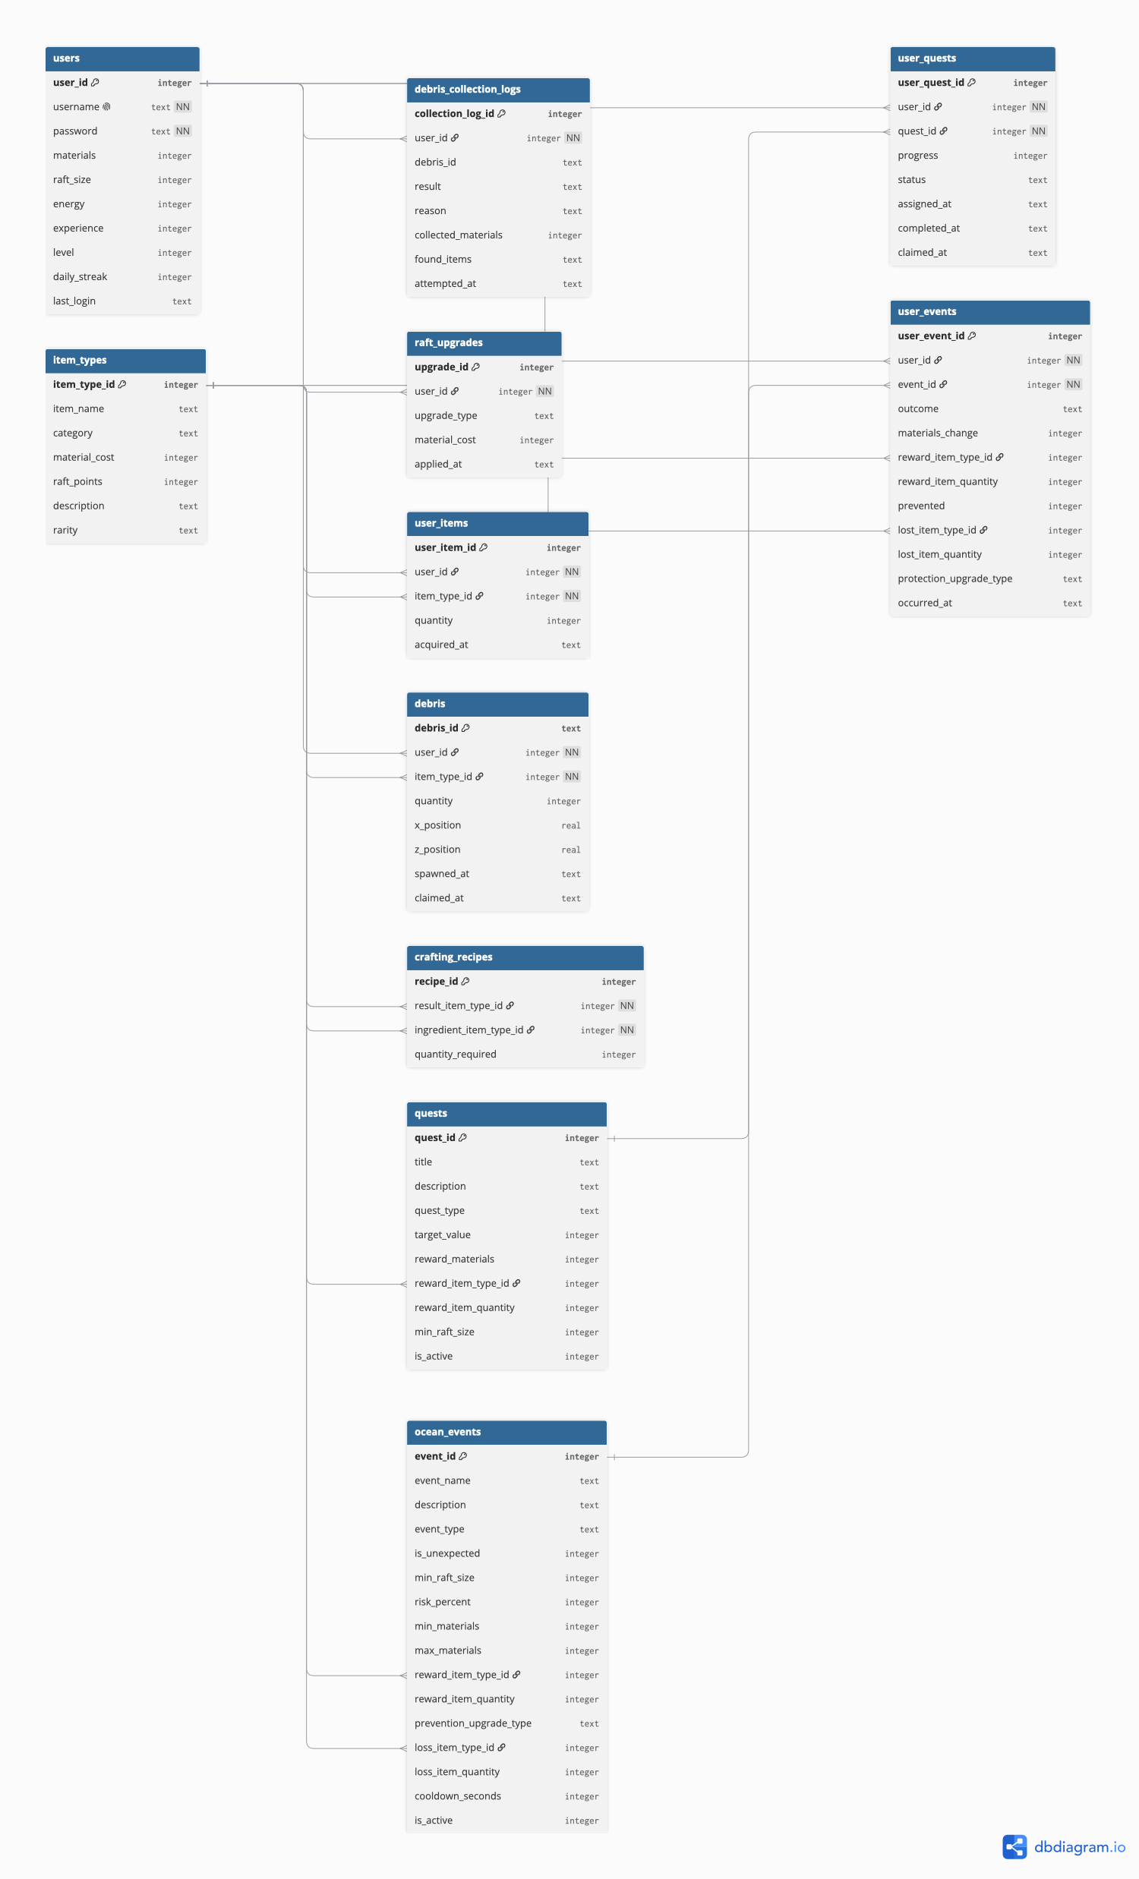
Video Walkthrough:
https://youtu.be/li9Mr9RQitQ

