Software Requirements Specification
for

TCSS 504 Dungeon Adventure, Release 1.0

Version 1.0 approved

Prepared by David Coughran and Andrew Innes

University of Washington-Tacoma
February 5, 2023

Table of Contents
Table of Contents ii
Revision History ii
1. Introduction 1
1.1 Purpose 1
1.2 Project Scope and Product Features 1
1.3 References 1
2. Overall Description 1
2.1 Product Perspective 1
2.2 User Classes and Characteristics 1
2.3 Operating Environment 3
2.4 Design and Implementation Constraints 3
2.5 User Documentation 3
2.6 Assumptions and Dependencies 3
3. System Features 3
3.1 Pre-Game Setup 3
3.2 Move 6
3.3 Interact with Room 6
3.4 Combat Mode 6
3.5 Consume and Inspect Items 6
3.6 Game Management & Control 6
4. External Interface Requirements 6
4.1 User Interfaces 6
4.2 Hardware Interfaces 7
4.3 Software Interfaces 7
4.4 Communications Interfaces 7
5. Other Nonfunctional Requirements 7
5.1 Performance Requirements 7
5.2 Safety Requirements 8
5.3 Security Requirements 8
5.4 Software Quality Attributes 8
Appendix A: Data Dictionary and Data Model 8
Appendix B: Analysis Models 12

Revision History
Name | Date | Reason For Changes | Version
Coughran/Innes | 02/01/24 | initial draft | 1.0 draft 1

Introduction

Purpose
This SRS describes the functional and nonfunctional requirements for the first release of the TCSS 504 Dungeon Adventure game software. This document will guide members of the project team who will implement and verify the correct functioning of the system. Unless otherwise noted, all requirements specified here are high priority and the project team will ensure release 1.0 meets these specifications.

Project Scope and Product Features
The TCSS 504 Dungeon Adventure is a single-player, turn-based, two-dimensional adventure game designed to be executed on desktop laptops and computers. The player inputs commands through a graphical user interface (GUI) in her attempt to navigate a computer-generated maze, collect key items, defeat monsters, avoid pitfalls, and arrive safely at the exit of the maze. The game design incorporates a variety of programming concepts intended for student developers to master in the final phase of this course. Some of these key concepts include Object Oriented Programming (OOP), data structures, recursive algorithms, SQL databases, applying design patterns, serialization/pickling, et al.

References
- Romano, Fabrizio; Baka, Benjamin; and Dusty Phillips. Getting Started with Python. Birmingham, Packt Publishing, February 2019.
- Moore, Alan D. Python GUI Programming with Tkinter. Birmingham, Packt Publishing, October 2021.

Overall Description

Product Perspective
The TCSS Dungeon Adventure is a standalone, GUI-driven one-player adventure game. The game will run on any computer with a Python programming interface/environment. The context diagram in Figure 3 illustrates the internal game structure. In essence, the player carries out three distinct actions: moving into different rooms, interacting with that room (i.e. collecting items or defeating monsters), consuming potions, and then repeating until the player wins or loses the game. This is significant because, though the game may evolve with additional features, this cycle is the overarching pattern inherent to the product’s game engine. We anticipate this game will evolve over several future releases, thereby requiring that it be modular and able to incorporate future upgrades.

User Classes, Key Personnel, and Characteristics
Player (favored) | The “player” is the end user and consumer of the game. The Dungeon Adventure developers intend this game to be playable by anyone; there is no intended age, ethnicity, gender, or income demographic targeted. However, the principle “players” will be members of the faculty staff at the University of Washington-Tacoma School of Engineering & Technology. The Dungeon Adventure is a graded, summative assignment of TCSS 504, Software Engineering and Development Techniques. Therefore, the overall user experience is secondary to demonstrating learned programming techniques, strategies, and application of key concepts from the software development engineering course list.
Developers | The development team consists of two students in the software development graduate certificate program. These students are also the authors of this document- Dave Coughran and Andrew Innes. At times, the development team may consult with other students in the course. However, any significant contributions from outside this core development team will require the proper citation in this software requirements specification document.
Code Review | Mid-point through the development of Dungeon Adventure, key faculty in graduate certificate program will carry out a “code review” of the game program and its features. These faculty members will act as both “client” and “mentor,” ensuring that the game development is on a sustainable path to meet the requirement list while pointing out any functional shortcomings in the code.

Operating Environment
OE-1: The Dungeon Adventure will have the capability to run on any operating system implementing Python version 3.12.1 or later. Additionally, the game will run on any environment for Python using this specified version, including but not limited to Pycharm Community, Pycharm Pro, Venv, Conda, et al.
OE-2: Later versions of Dungeon Adventure will be installation based. This means the program can run on systems without Python or an associated environment. This means the Dungeon Adventure should successfully run on any Windows, Mac, or Linux based operating system released within the last ten years.

Design and Implementation Constraints
CO-1: The system’s design, code, and maintenance documentation does not conform to a supervisory document.
CO-2: The program will utilize Structured Query Language (SQL) to interact with an external database.
CO-3: There are no specifications or features requiring a connection to or utilization of the Internet.
CO-4: Dungeon Adventure will not require any scripting.

User Documentation
UD-1: The Dungeon Adventure will provide instructions to the player at the onset of the game. These instructions will cover the game content, commands, and the criteria for both winning and losing a game. The same instructions will be available to the player at later stages in the game should she wish to review them.
UD-2: The game will not offer any tutorial. Instead, Dungeon Adventure will encourage learning through playing and active experimentation in the game.

Assumptions and Dependencies
AS-1: Dungeon Adventure players will have a baseline level of computer literacy including using a mouse, keyboard, and basic graphical user interface.
DE-1: Dungeon adventure will be able to incorporate new material and features through the SQL external database. As an initial placeholder for the first release, stats and information concerning the opposing monsters shall be stored on the external database.

System Features

Pre-Game Setup

3.1.1 Description and Priority
The player will start the Dungeon Adventure game either by running the code from the environment console or starting the executable file associated with the installed software. The system will provide a brief introduction regarding the rules and the goal of the game. Following this, the game prompts the player to enter her name and choose her class of character, briefly explaining the difference between the various classes (i.e. warrior, priestess, thief, et al). This sequence terminates when the player enters her name and begins the game in the initial room of the dungeon. Alternatively, the system will allow the player to load a previously saved game.

3.1.2 Stimulus/Response Sequences (New Game)
Stimulus: System provides a rules explanation and goals of the game. The explanation also provides an option to allow the player to load a previously saved game.
Response: Player understands gameplay, how to win, and how to lose the game. Alternatively, the player selects a previously saved game.
Stimulus: System provides an explanation of the various character classes (i.e. warrior, priestess, rogue, et al) and prompts the player to choose her class for this game.
Response: Player chooses her character class.
Stimulus: System prompts the player for her name.
Response: Player enters her name.
3.1.3 Functional Requirements
Setup.Rules: The system provides a rules explanation so that the player understands the game, how to win, and how to lose. The game then proceeds to the next requirement.

Setup.Class: The system explains the various character classes and prompts the player to choose one. This character class remains constant for the remainder of the game and only the special abilities of that specific class are available to the player.

Setup.Name The system prompts the player to enter her name. This name remains constant for the remainder of the game.
Setup.Dungeon.size: Dungeon Adventure will randomly generate a dungeon environment for the player. The initial dungeon is a grid of rooms with a constant width and length. A 6x7 dungeon, for example, consists of a block of rooms six rooms wide and seven rooms deep for a total of 42 rooms. The system presets will ensure each dungeon has between 25 and 64 total rooms to explore. Each room has four doors, one on the North, South, East, and West, facing wall. The doors are all locked, meaning at this phase of the game it is impossible to transverse one room to another.
Setup.Dungeon.Maze: The system generates a maze that incorporates every room in the dungeon. The maze begins in the northwestern-most corner room, where the player begins the adventure, and builds out by strategically opening various doors between the rooms. The maze incorporates dead ends and has at least one viable solution to reach the exit of the maze. As the system generates the maze, it will populate the four “Pillars” of OOP within four distinct rooms. Each pillar will drop at an appropriate interval of the maze generation to ensure gameplay is balanced. Stated differently, the player must have explored the first 20% of the rooms before finding the first pillar, 40% of the rooms before the second pillar, leading up to over 80% before finding the last pillar and then the exit. As the maze generates, the system will also drop potions, monsters, and pitfalls in the rooms at random, pre-selected intervals. Pitfalls will only occur at dead-ends within the maze. The parameters for the incidence rate of potions and monsters must be easily updateable within the program code so that developers can easily optimize gameplay experience. For the first release, the system will have Ogres, Gremlins, and Skeletons. Stronger enemies guard more valuable items such as pillars.
Setup.Player: The system places the player in the Northwestern-most corner room of the dungeon. The player has no potions and no pillars in her inventory. Lastly, the player has a randomly generated amount of health points. This amount is at its maximum at the start of the game, but may drop based on interactions within the different rooms. Despite taking regenerative potions, the maximum amount of health cannot exceed the original values randomly generated at the beginning of the game.
Setup.GUI: Once the player-character is situated in the room, the GUI will present itself to the player. The GUI is a 2x3 grid that both provides information and allows the player to input commands through buttons. (See Figure 1.0 for additional details.)
Setup.Load: If a previous game is saved and available, in lieu of starting a new game, the character can load

Move
At this phase, the game design loops on itself. The player ultimately moves into new rooms, interacts with that room (i.e. collects items or battles monsters), has the option to consume resources (i.e. potions), and then moves to another room until she finds the exit with all four pillars in her inventory.

Move.North: The player enters a command through the GUI having the player character move North. This is the cardinal direction toward the top of the screen. The system prevents the player from moving North if there is a ‘locked door,’ depicted as a wall, between the current room and the Northern room. The system also ignores this command if the movement would put the player-character beyond the boundary of the map.
Move.East: The player enters a command through the GUI having the player character move East. This is the cardinal direction toward the right of the screen. The system prevents the player from moving East if there is a ‘locked door,’ depicted as a wall, between the current room and the Eastern room. The system also ignores this command if the movement would put the player-character beyond the boundary of the map.
Move.South The player enters a command through the GUI having the player character move South. This is the cardinal direction toward the bottom of the screen. The system prevents the player from moving South if there is a ‘locked door,’ depicted as a wall, between the current room and the Southern room. The system also ignores this command if the movement would put the player-character beyond the boundary of the map.
Move.West: The player enters a command through the GUI having the player character move West. This is the cardinal direction toward the right of the screen. The system prevents the player from moving West if there is a ‘locked door,’ depicted as a wall, between the current room and the Western room. The system also ignores this command if the movement would put the player-character beyond the boundary of the map.
Move.Update.Map: As the player moves through rooms, the GUI will update the map. Previously explored rooms will show their entries/exits while unexplored rooms will be tiled gray. Additionally, the map will identify which room the player character is currently standing. If the player character finds and takes a vision potion, the map will reveal itself to the player in its entirety, including the location of the remaining pillars in the dungeon. (See Section 3.5 for additional details.)
Move.Reveal.Map: Dungeon Adventure incorporates a feature to allow graders and developers to reveal the map as though they drank a vision potion. The GUI will accommodate this through a discreet feature identified during the game instructions.

Figure 1.0: Graphical User Interface
(For illustrative purposes only.)

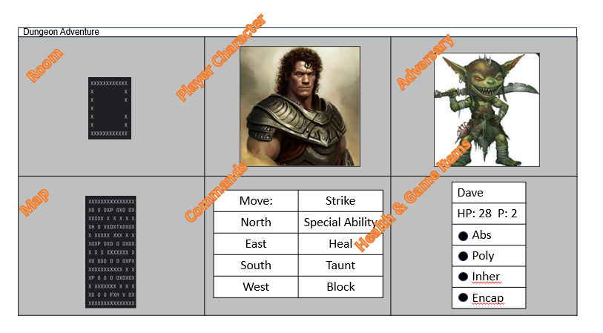

Interact with Room
Interact.Depict.Room: When the player enters a room, the system will give a depiction of that room through the GUI. The player will see if there are open doors to adjacent rooms that she can transverse. Additionally, she will see items in the room represented by characters: “P”=Pillar, “H”=Health Potion, “V”=Vision Potion, and “T”=Pitt Trap. If the player collects items from a room, they are no longer visible if she leaves and then returns to the same room. The player character cannot collect Pitt Traps; they remain fixed in the dungeon maze. The GUI will represent rooms as tiles that reveal themselves to the player when she first visits that room.
Interact.Gather.Items: As the player enters a room, the system will automatically update so that items transfer from the room to the player character’s inventory. This includes pillars and potions.
Interact.Pit.Damage If a player character enters a room with an instance of a pit trap, the system will adjudicate the negative impact on the player’s health. The game will base this impact on a random variable determined when the pit was instantiated in that specific room.
Interact.Combat: If the player character enters a room with a monster instantiated in the room, the system will transfer to a combat mode. See below for additional detail. Combat mode will take place immediately if the player character enters a room with a monster, before any other transactions take place.

Combat Mode
When the player character enters a room with an instantiated Monster, the system will transition to combat. This mode will open a new set of commands to the player through the GUI. Combat is essentially a turn-based game where the player character and the monster have opportunities to inflict damage on each other and/or heal, based on probability tables. (Note: If time permits multiple iterations of development, character classes and monster classes may have their own unique attacks, abilities, resistances, etc.)

Combat.Attack: Both player characters and monsters will have the ability to attack each other in a turn-based format. The number of attacks and their distribution between turns depends on the relative attack speeds between the two combatants. Combat mode bases successful attacks on probability tables (chance to hit) inherent to the player character and monster.
Combat.Adj.Damage: In combat mode, the Dungeon Adventure system will adjudicate damage from attacks based (1) whether a hit was successful and (2) probability tables inherent to the player class and monster (minimum and maximum damage). In combat, successful attacks dealing damage will lower the player character and the monster’s health.
Combat.Heal: Both player characters and monsters will have the ability to heal themselves in a turn-based format during combat. If a player chooses to heal, she chooses to heal in lieu of attack, meaning attack speeds also affect heal speeds. Combat mode bases successful healing attempts on probability tables (chance to heal) inherent to the player character and monster.
Combat.Adj.Healing: In combat mode, the Dungeon Adventure system will adjudicate healing from (1) whether a heal was successful and (2) probability tables inherent to the player class and monster (minimum and maximum damage). In combat, successful heals increase the player character and monster’s health.
Combat.Adj.Battle: Once in Combat Mode, the game cannot progress until the player character wins the fight (i.e. has health remaining while his/her opponent(s) do not). The system must adjudicate a winner of the combat engagement. If the player wins, the system will inform her and she may continue playing the adventure game. The non-combat series of commands (such as move, take potion) will become available again. If the player loses (i.e. loses all health while the monster survives the battle), the game is over.

Consume and Inspect Items
Dungeon Adventure will allow the player to take potions and inspect their inventories.

Item.Potion.Heal: If the player character has a health potion in his or her inventory and is not in combat mode, the GUI will allow the player to consume the potion to replenish health. The amount of healing will correspond to a random value determined when the potion was instantiated and placed in a room. The system will inform the player she has either successfully taken the potion or tell her she does not have one in her inventory. A consumed potion no longer exists in the inventory.
Item.Potion.Vision: If the player character has a vision potion in his or her inventory and is not in combat mode, the GUI will allow the player to consume the potion to reveal the map. The GUI will display the maze in its entirety, regardless of which rooms the character player has visited. Additionally, the vision potion will reveal the location of the remaining undiscovered pillars on the map. A consumed potion no longer exists in the inventory.

Game Management & Control
While the game progresses, the Dungeon Adventure system must observe different criteria to see if the game is won, lost, if the player wishes to save, or if the player wishes to start a new game.

Manage.Game.Status: The game must monitor, both in combat and when the player character is exploring, the status of the game. If the player character’s health drops to zero or below, the character dies and the game ends. If the character finds the exit (instantiated as an item in the last room of the maze) while possessing the four pillars of OOP, the game ends.
Manage.Game.Win: If a player wins the game (see box above), the system will provide a congratulatory message and ask if she would like to play another game.
Manage.Game.Lose If a player loses the game (see top box), the system will inform the player her character has died. The system will ask if she would like to play another game.
Manage.Game.Save: If the player is not in combat mode, the GUI will provide the option of saving the game by pickling the current state of the environment.

External Interface Requirements

User Interfaces
UI-1: The Dungeon Adventure GUI shall conform to the Tool Command Language (Tcl) Programming Language.
UI-2: All commands necessary to play the game are available through the GUI; there is no interaction with the console..

Hardware Interfaces
Developers have not identified any necessary hardware interfaces.

Software Interfaces
SI-1: Operating System
SI-1.1: Dungeon Adventure will create, store, or modify any necessary files on the user/player’s computer, requiring compatibility with all major operating systems (i.e. Windows, Mac, Linux, et al.).

SI-2: SQLite
SI-2.1: Dungeon Adventure will store information, particularly for monster classes, in an external database on the player’s computer.

Communications Interfaces
None Identified.

Other Nonfunctional Requirements

Performance Requirements
Visuals and processing speeds to not warrant any special consideration; Dungeon Adventure is minimally resource intensive in terms of computing. Therefore, the game should run on any system running on a modern (i.e. released within the last ten years) operating system.

Safety Requirements
None Identified.

Security Requirements
None Identified.

Software Quality Attributes
None Identified.

Appendix A: Data Dictionary and Data Model
door | = | The concept of a door is an ‘object construct.’ Each room contains four doors. However, the a door does not open or close. The existence of a door signifies that traversal in that direction is closed to the player character.
instantiate | = | Everything the player character interacts with in Dungeon Adventure is an ‘object.’ This includes potions, doors, monsters, rooms, and even the dungeon itself. ‘Instantiate’ is a developer term for creating an item/object in the initialization of the dungeon for a specific game.
character class | = | The player may choose one of three different types of character classes for their game. For the initial game release, the classes are warrior, priestess, and thief. Each of these has unique characteristics and abilities.
health potion  OOP | =  = | The health potion is a consumable item which will return some of the characters health points in the Dungeon Adventure game.  Object Oriented Programming
Pillar | = | Collecting the four pillars of Object Oriented Design (OOP) is the goal of the game. A ‘pillar,’ for short, refers to one of these items instantiated in the dungeon of that game. The four pillars are abstraction, encapsulation, inheritance, and polymorphism.
player | = | The term ‘player’ refers to the physical human being entering commands during the Dungeon Adventure game.
player character | = | The ‘player character’ is the hero (object) the player controls in the game. The player character has a name the user enters and a distinct class.
room | = | A ‘room’ is an instantiated object in the Dungeon Adventure. A room contains items such as pillars and monsters that interact with the player character. The game will design the connection of rooms as maze the player must navigate.
Figure 2
Data Model

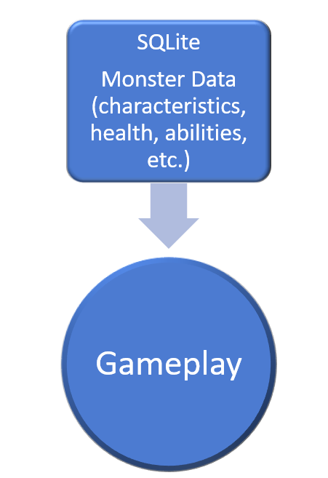
Figure 2
Data Model

Appendix B: Analysis Models

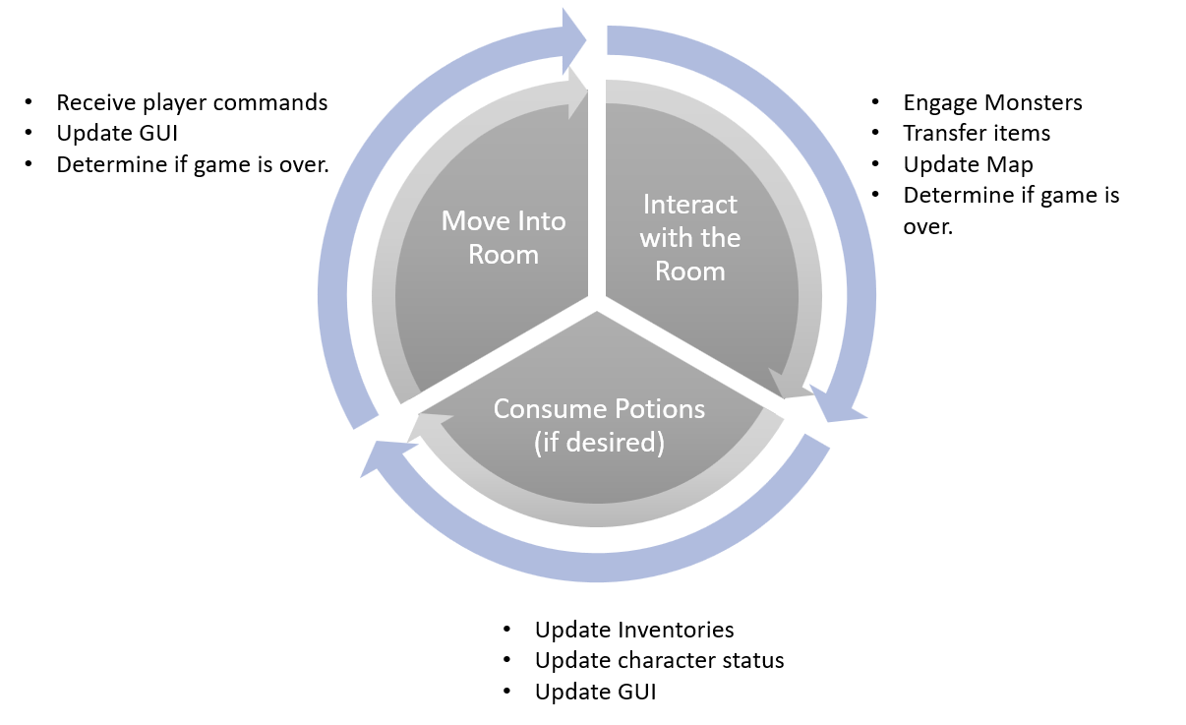
Figure 3
Cyclical analysis model of Dungeon Adventure game

