Business Requirements Document

for

ABC Bank

Online Banking System

Prepared by:

Swapna Guduru

07/22/2022

TABLE OF CONTENTS

Business Requirements Document 1

TABLE OF CONTENTS 2

1. Summary/Overview 3

2.    Business Objectives 3

3. Scope 4

Proposed System: TO-BE 11

6.    Non- Functional requirements 11

7.    Assumptions 12

8.    Limitations 12

9.    Risks 12

10. Appendix A – Glossary of Terms 12

**Version:**

|  |  |
| --- | --- |
| **Author/Co-Author** | **Version** |
| Swapna Guduru | 1.1 |
|  |  |

**Contributors:**

|  |  |
| --- | --- |
| Business User | Kathy Green |
| Stakeholders | Saurabh Bhatia |
| Project Manager | Paul Adams |
| Sponsor | Alex Hall |
| Developers | Jack Hasting  Mini Mathur |
| QA | Sudha Pillai  Girish Pai |

**1. Summary/Overview**

ABC Bank, born during the techno-economic paradigm shift in Global Capital Market, is focusing all it synergies on providing Software solutions to manage this transformation, using cutting edge technology and deep rooted Domain experience. ABC Bank core strength lies in the wealth of talent it possesses in the form of its team. Culled from among the best in the industry, their raw dynamism and their devotion to progressive e-knowledge acquisition, coupled with incessant urge to evolve through innovation gives the company a definite edge over other players in the industry. The result - a high performance, high calibre team turning out top-of-line solution impacting global Capital Markets and Banking Industry! In short, delivering value to those we serve is what we strive for. Always. ABC Bank is certified for ISO 9001:2000 by KPMG for Quality Assurance. It has recently completed its 4th successful Surveillance Audit for continuous registration. Various aspects of quality control mechanisms are defined in SDG’s quality Management System (QMS) outlining the Quality framework, Organizational Structure, Quality policy, Quality objectives and QMS structure.

ABC Bank has about 200,000 customers for both personal and commercial banking account. The is located and caters to areas in the mid-west.

**2.    Business Objectives**

The main objective of the proposed solution is to be automated the various functions and activities of the bank through Internet. The solution will facilitate to the bank employees and the account holders with the different modules. This solution is very much necessary for the private sector banks and the corporate sector. The banking industry will take a new shape and explore like never before. Using the solution the bankers and account holders can generate various kinds of reports.

**3. Scope - INSCOPE**

**List down the High level requirements that we will offer to client**

1. The Existing system can be accessed from any part of the world, as opposed to stand alone or manual system, and provides information at anytime, anywhere round the clock to the Users.
2. If you’re a customer of our Bank and if your Branch is enabled then you are on to becoming an e-customer.
3. The customer needs to register, by which he is given user name and password through which he can login and do the transactions whatever he wants to do. It provides easy to use and user friendly interface for the user.
4. The system provides freedom to the user to move freely around various screens and status of the system returned, as it was when he left the screen by expert personalities maintaining the web site.
5. The user can access the system at any time, because it’s 24-hour online from anywhere in the world.
6. Online banking through a website, which is accessed through a browser both system/mobile.
7. Feature available for both personal banking and commercial banking.
8. Current release is for online banking is to check balances and do transfers.
9. The Current release includes the features like Login, Balance Check, Statements, Transactions, Transfer Fund, Update profile, Logout.

**Out of Scope**

1. Building a mobile application will be taken up in Phase 2
2. Remittances
3. Photo scan for a cheque deposit will be added in next release.
4. QR scan feature for a quick/instant pay will be taken in Phase 2.

**4 Business requirements**

Use case Diagram

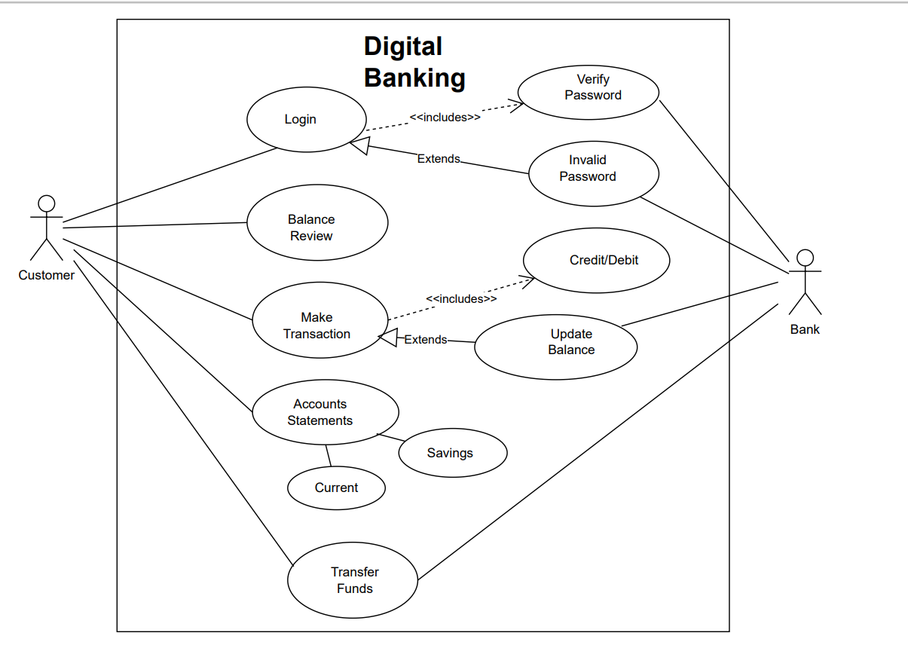

**Business Requirements**

Business requirements describe the tasks the users must be able to accomplish with the product. Business requirements reflect business processes and are generally written in the format verb + object.

|  |  |  |  |  |
| --- | --- | --- | --- | --- |
| **Req ID** | **Business Function/Feature** | **Requirement Description** | **Priority** | **Complexity** |
| BR.1.0 | Login | Ability to provide login with successful /valid credentials. |  |  |
| BR.2.0 | Balance | Ability to check the balance of the accounts existed. |  |  |
| BR.3.0 | Transactions | Ability to do online transactions such as amount received and payment done. The user must able to see the transactions in following modes:  1. Credit  2. Debit |  |  |
| BR.3.1 | Transactions- Credit | Ability to check the amounts received from others to the current account which are sorted by date or any range that user selected from provided calendar. |  |  |
| BR.3.2 | Transactions - Debit | Ability to check the payments done to others from the current account which are sorted by date or any range that user selected from provided calendar. |  |  |
| BR.4.0 | Statements | Ability to provide the user to check the statements that is list of transactions done. This can be in different modes:   1. View 2. Download 3. Email |  |  |
| BR.4.1 | Statement-View | Ability to view the statements monthly, yearly or any specific range of date that has been selected from provided calendar. |  |  |
| BR.4.2 | Statement-Download | Ability to download the statement in the specified pdf/excel format |  |  |
| BR.4.3 | Statement- email | Ability to send statement to the email across the registered email address in pdf format which will be password protected. |  |  |
| BR.5.0 | Transfer Fund | Ability to provide the user to transfer funds to other third parties or to any nominees added by the user. |  |  |
| B.R.6.0 | Update Profile | Ability to provide the user to edit/ update their personal information such as contact number, address ,email which is validated through OTP password received to the registered mobile number or email address. |  |  |
| BR.7.0 | Logout | Ability to provide the user to logout completely from the web page in a secure way. |  |  |

1. **Gap Analysis/AS-IS – TO-BE**

Existing System: AS-IS

The existing process is a scenario where the User shall only do transaction from the branch. The process below is completely manual and happens with complete human interaction. The current process also puts a lot of stress on the bank resources and they are focussed on the bank services than sales and business improvement.

Proposed System: TO-BE

Identification Of Need: The Net Banking is a web-based application some of its features are pointed out here:

1. The proposed system can be accessed from any part of the world, as opposed to stand alone or manual system, and provides information at anytime, anywhere round the clock to the Users.
2. Even though it is a web-based application it will keep the details of its clients private and nobody is allowed to tinker with the details.
3. The User needs to register, by which he is given user name and password through which he can login and do the transactions whatever he wants to do. It provides easy to use and user friendly interface for the user.
4. The system provides freedom to the user to move freely around various screens and status of the system returned, as it was when he left the screen by expert personalities maintaining the web site.
5. The user can access the system at any time, because it’s 24-hour online from anywhere in the world.
6. The User can do all the work online without persisting him to go to the bank like he can deposit the money, transfer amount from account to another account, can get this available balance, able to see the transaction reports that has done etc to mention a few.
7. The User can save his money and time that is a valuable one in today’s day- to – day life.

**6.    Non- Functional requirements**

Searching Capabilities:

For the account holder’s convenience and on hand information, this solution provides certain searching and checking features for his account. The account holder can any time and any number of time can log on and search for various details as the account’s balance, details of transactions, interest amounts, debits / credits, etc. The account holder will have his unique id and password for logging on to the account’s information.

Usability:

The webpage gives an easy understanding of every feature included and can easily navigate through different tabs.

Compatibility:

The Online banking system webpage supported by different browsers such as chrome, IE, Edge.

Security:

Gives a proper security login, transactions taken and logout through proper secure gateways.

Performance:

After the sign in, the landing page of the Online banking system shall open within 10 secs.

Any transactions made or occurred has an immediate balance update.

**7.    Assumptions**

1. The User shall have access to Internet.
2. The User shall have computer/laptop/smartphone which has a browser.
3. The User shall have knowledge of internet navigation.
4. The User shall have idea of how to open the webpage in a browser and login information.
5. The User shall have the knowledge of basic banking terminology.

**8.    Limitations /Dependency**

[LIMITATIONS TEXT]

Identify any limitations in terms of time, personnel, technical details, or other things that limit the scope, time, and cost of the project being discussed.

1. The current release will provide online banking web page which can be accessed by laptop/computer/mobile through URL link.
2. The current version does not provide the mobile application to download in mobile.

UI specification will be shared by the client .

Regulators will provide the input in regulation of policies

**9.    Risks**

[RISKS TEXT]

Risks:

1. Due to open nature of internet, Online Banking are subject to risks such as online theft of User ID, Password.
2. Virus Attacks.
3. Fraudulent Transactions.

Ways to Mitigate Risks:

1. The passwords should be frequently changed and only known to the User who is using.
2. Install personal firewall and antivirus software and regularly update them.
3. Be Aware of unexpected scam emails with attachments and suspicious websites.
4. **Appendix A – Glossary of Terms**

[GLOSSARY TEXT]

Add a Glossary of Terms if there are a lot of technical terms that need defining to add clarity to the document.